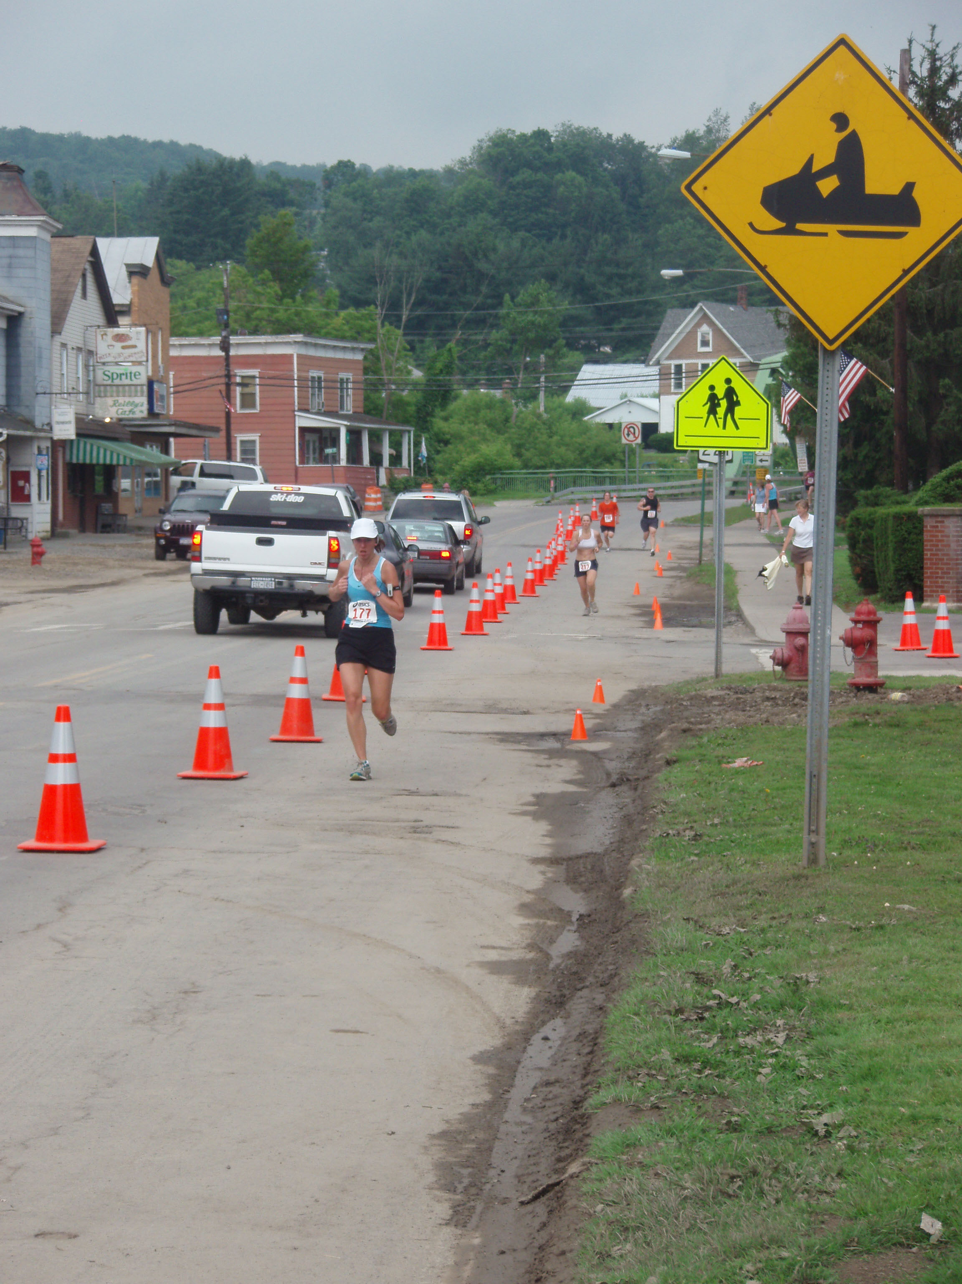Marathon Community Scholarship Foundation
5K Race Scholarship Application Form
PO Box 1
Marathon, New York 13803

Phone: 607-849-4680 E-mail: pifry1685@gmail.com

APPLICANT

Last Name First Name MI

Street Address

City State Zip Code

Telephone ( ) Date of Birth Gender

Email

ACADEMIC PROFILE

High Schools

Street Address

City State Zip Code

Does your school offer honor courses? Yes No Advanced Placement classes? Yes No

GPA Class Rank SAT Scores

List all senior year courses on the grid below. If applicable, check honors or advanced placement.

Subject: Final Average Honors or Advanced Placement
Subject: Final Average Honors or Advanced Placement
Subject: Final Average Honors or Advanced Placement
Subject: Final Average Honors or Advanced Placement
Subject: Final Average Honors or Advanced Placement
Subject: Final Average Honors or Advanced Placement
Subject: Final Average Honors or Advanced Placement
Subject: Final Average Honors or Advanced Placement

What is the Name of the College you will be attending in the Fall?

What is your course of study? What is your intended career choice?
SERVICE TO THE COMMUNITY–GRADES 9 THROUGH 12

List volunteer work or community service performed, without pay, over the past three academic school years. (You will not receive credit in this section if you fail to list your hours as instructed.)

Total Hours Served | Date of Participation | Type of Service | Name of Organization
 | = Grand Total Hours of Service

Rank, in order of importance, your three most significant community service projects.

1 2 3

SCHOOL ACTIVITIES–GRADES 9 THROUGH 12

Include scholastic, extracurricular and civic activities and the grade in which you participated. Please do not abbreviate activities.

1
2
3
4
5
6
7
8
9
10
11
12
13
14

HONORS AND AWARDS–GRADES 9 THROUGH 12

Include scholastic, extracurricular and civic honors and awards. State the nature of award and grade in which it was won. Please do not abbreviate names of awards.

1
2
3
4
5
6
7
8
9
10.

OFFICES AND POSITIONS OF LEADERSHIP–GRADES 9 THROUGH 12

State full name of organization, office, and grade(s) office was held, starting with the most recent,
i.e., Chess Club, Treasurer, 11.

1
2
3
4
5
6
7
8
9
10.

COMMUNITY ORGANIZATIONS–GRADES 9 THROUGH 12

Include all scholastic, extracurricular and civic organizations that you participated in during grades 9 to 12. State name of organization and the grades you were involved: i.e. Boy Scouts, 9, 10, 11.

1
2
3
4
5
6
7
8
9
10.

RELEASE

By signing this application, I agree, if asked, to provide additional information that will verify the accuracy of my completed application. If I purposely give false or misleading information, I will be disqualified from this contest. I agree to the use of my name and any information contained within the application, for advertising, promotional and publicity purposes without consent or compensation. I understand that the decision of the Marathon Community Scholarship Committee with respect to the selection of award winners is final.

Applicant’s Signature Date

RETURN THE SCHOLARSHIP APPLICATION WITH YOUR COMPLETED RACE APPLICATION TO THE ABOVE ADDRESS OR THE BUSINESS OFFICE AT THE HIGH SCHOOL NO LATER THAN June 15th, 2016.

