Eastern Rowan Saddle Club’s
Saddle Up for St. Judes Wagon Train
14210 Old Beatty Ford Rd, Rockwell NC 28138
April 26-28, 2019
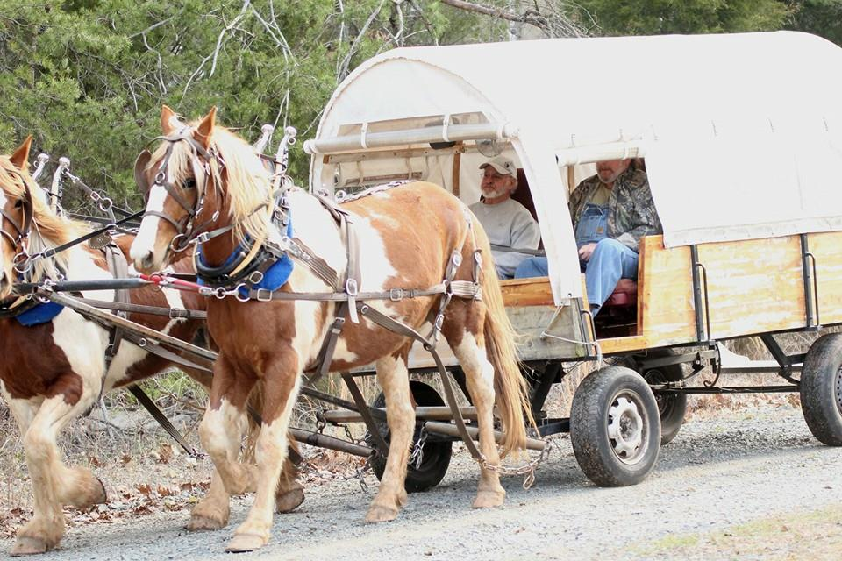

Admission (includes lunch and dinner on Saturday)
$15 for ages 18 & up
$11 for ages 11-17
Ages 10 & under are free

Poker Run on Saturday
$5 Entry, 50% Payback

Obstacle Competition
Saturday @ 7:30 PM
$10 Entry fee
Prizes awarded

Live DJ on Saturday night
Family fun for all ages!
100% of proceeds go to St. Jude Children’s Hospital

Schedule
Friday, April 26th
4 PM - Gates Open
6 PM - Dinner served (extra $)
7 PM - Bingo starts ($1 per game)

Saturday, April 27th
7 AM – Breakfast served ($2-$5 extra)
9:30 AM – Ride leaves (16 miles)
11:30 - 12 – Lunch served at Circle K Arena
4-5 PM – Ride returns
6 PM – Dinner served
7 PM – DJ begins, Corn hole boards at clubhouse
7:30 PM – Obstacle Course Competition ($10 entry fee)

Sunday, April 28th
7 AM – Breakfast served ($2-$5 extra)
9:30 AM – Ride leaves (6 miles)
11:30 AM – Break in Historic Gold Hill
1:30 PM – Ride returns

Rules
- No camping hook-ups. Generators are allowed. Bathrooms available
- Must have negative coggins. Will be checked at arrival
- Alcohol is permitted, but not openly displayed
- Riders must stay between pilot car and lead wagon at all times
- This ride will be a mixture of dirt roads and paved roads with minimal traffic.

For more information, visit
www.eastrowansaddleclub.com

