April 2017 At a glance
Full descriptions of activities in bulletin.

Sun | Mon | Tues | Wed | Thurs | Fri | Sat
26  Worship  11:15  Potluck  Cong. Care  Speaker  Russell away - Arizona | 27  AA 7:30 pm  Meditation  7 pm | 28  Cards  9:30  TOPS  6:30 | 29  Lent  Service  7 pm  Community Study Night  8 pm | 30  Craft/Study  1:30 | 31 | 1  Wascana Presbytery  9 to 4:30 pm  Sikh Temple  4 pm
2  Worship  11:15  Communion  Special education for kids re communion  Remits pres | 3  AA 7:30 pm  Meditation  7 pm | 4  Cards  9:30  TOPS  6:30 | 5  Soup Supper  6 pm  Lent  Service  7 pm  Faith Expl. 7:30 pm | 6  Craft/Study  1:30  Family Dinner  6 pm  Faith Formation 7:30 pm | 7  Hindu Temple  7 pm | 8  Women’s Breakfast  8 am  Easter Egg Hunt! 1 pm
9  Worship  11:15  Open Hearts Jar | 10  AA 7:30 pm  Meditation  7 pm | 11  Cards  9:30  TOPS  6:30 | 12  Community Study Night  8 pm | 13  Teaching Seder at LSC 7 pm | 14  Good Friday Memorial Wake  7 pm | 15  Easter Vigil at St. Paul’s Cathedral 10 pm
16  Sunrise Service and potluck breakfast  5:45 am Worship  11:15 | 17  AA 7:30 pm  Meditation  7 pm | 18  Cards  9:30  TOPS  6:30 | 19  Faith Expl. 7:30 pm | 20  Craft/Study  1:30  LT Meeting  7 pm | 21  Film and Faith | 22  IMCF Breakfast  9 am to 12
23  Worship  11:15  Transfer of Membership  POTLUCK  Cong. Care  Speaker | 24  AA 7:30 pm  Meditation  7 pm | 25  Cards  9:30  TOPS  6:30  Russell at Inhabit Conference | 26 | 27  Craft/Study  1:30 | 28 | 29
TOPS = Take Off Pounds Sensibly
AA = Alcoholics Anonymous

ANNOUNCEMENTS
March 26, 2017

306-761-0556 eastsideunited@sasktel.net
Like us on facebook (Eastside United Church)
Follow us on Twitter @Eastside_united
www.eastsideunited.ca

W
elcome to Eastside United. May our opportunities of ministry offer you rest, challenge and peace on your Christian journey.

Ministers:
Minister: Ken Powers
Greeting: Jim Fallows and Leif Riesach
Congregational Care Greeter: Elaine Hill
Prayers: Heather Balfour
PowerPoint: Heather Balfour
Piano: Michelle Dickie
Attendance last week: 54

Russell’s e-mail address: russell.eastside@sasktel.net

Office Hours:
Tuesday through Friday from 8:30 am to 3:30 pm
Russell will be on holidays in Arizona from March 25 through 31.

Brewed Awakening Office Hours, Wednesday afternoons from 2 to 4:30 pm. At Woodhams Drive location for the month of April.
Scripture Reading: 1 John 4: 7-12, 16-19

Songs:
All Who are Thirsty MV #4
Like a Healing Stream MV #144
Sow Seeds
Spirit of Gentleness VU #375
Called by Earth and Sky MV #135 chorus
Draw the Circle Wide MV #145
Spirit Song

TODAY! Congregational Care Speaker Series: Living out our Faith. Join us following potluck lunch as we hear from Jim Fallows about his work with Regina Open Door Society.

Arcola East Senior Bridge Club: Looking for a fun way to get out and socialize with other seniors? The Arcola East Senior Bridge Club gathers for social bridge each Monday at 1 pm at the Living Spirit Centre (3018 Doan Drive). No prize money; weekly fee is $1. For more information, please contact Bill Jeske at 306-789-2430 or Alma Pockrandt at 306-789-5981 or apockra@yahoo.ca.
Join us for Easter
Worship

April 9 Palm Sunday
A Walk through Holy Week All Ages Service
11:15 am

April 13 Maundy Thursday
Teaching Seder with Bread of Life
7 pm

April 14 Good Friday
Memorial Wake with IMCF
Featuring Creator’s Sacrifice Paintings
7 pm

April 15 Easter Vigil
At St. Paul’s Anglican Cathedral
with St. Philip Anglican
10 pm

April 16 Easter Sunday
Sunrise Service 5:45 am at LSC
Easter Worship 11:15 am

LSC Meditation Group: The Meditation Group gathers at 7 pm Monday evenings in the East Sanctuary. Feel free to bring a friend, and dress comfortably.

St. Philip Senior Ministry Outreach card playing program, Tuesday mornings at 9:30 am in the East Sanctuary at the Living Spirit Centre. Whist and lessons to those that would like to learn. Come out and enjoy fellowship, coffee and card playing. If you need a ride call Rod 306-789-1388. Everyone is welcome.

Eastside’s Craft/Study Group Thursdays at 1:30 pm in the Multipurpose Room! Join us as we share in discussion, handiwork and coffee time following. We are reading Grounded by Diana Butler Bass. This is a fun time of study, crafting, and refreshments following.

Join us for our weekly Lenten service Wednesday evenings at 7 pm. These short services take place in the East Sanctuary. Wednesday, March 29 will be “A Lenten Journey with Poetry and Image” and abbreviated Holden Prayer with Pastors David Kaiser and Frank Armistead. All are welcome!

Community Easter Egg Hunt, Saturday, April 8, 2017.
Last year's Easter Egg Hunt was a huge success and we are excited to offer this event to our community again this year. We need helpers the day of and donations of chocolate. Let's work together to ensure this unique and popular event continues as a gift to our neighbourhood families! Let Russell know if you can help.

All are welcome to join the Faith Exploration group as we visit the holy places of other faith traditions: Saturday, April 1 at 4 pm, Sikh Temple at 3905 Princess Drive; and Friday, April 7 at 7 pm, Hindu Temple at 3307 Pasqua Street.
St. Andrews’ United Church, Moose Jaw, celebrated becoming an Affirming Ministry, today at 5:30 with a Potluck and 6:30 Service of Celebration. Let us join in celebration with them!
Community Study Night, Wednesday, March 29 and April 12, from 8 to 11 pm. Coffee, tea and snacks supplied! Come for a quiet space to get some studying and homework done. Plug-ins for laptops available! See Taylor Balfour if interested and follow our Facebook event page:
https://www.facebook.com/events/157007284815470/
JOIN US FOR LENTEN SOUP: Wednesday, April 5 at 6 pm, Munch Café and Catering is again providing a simple soup meal prior to our evening Lenten worship. Vegetarian and meaty soup options and bread will be served. RSVP to eastsideunited@sasktel.net. $5 per person.

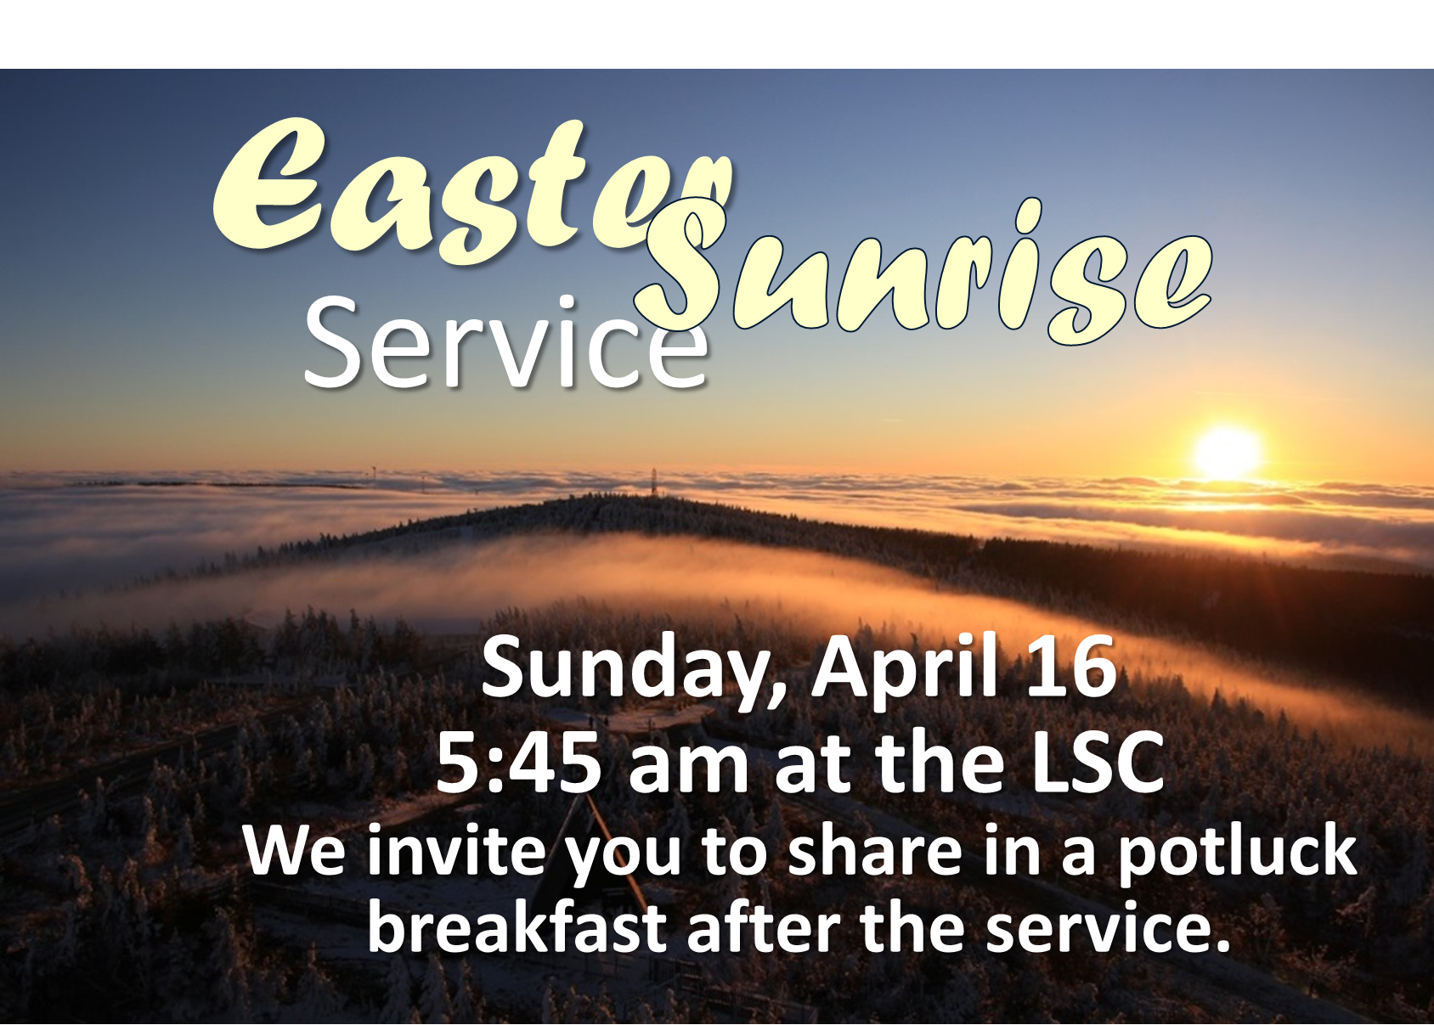
LSC Women’s Spirituality Breakfast, Saturday, April 8 from 8 to 10 am. Our guest speaker this month will be Sheila Fahlman on the topic of Grandmothers for Grandmothers (G4G) Regina. G4G Regina raises awareness and fundraises for the Stephen Lewis Foundation to support African grandmothers who are raising a generation of children orphaned by AIDS. All women are welcome to join us – please bring two toonies to help cover the costs of breakfast and a speaker honorarium.

A Night for St. Andrew’s Gala Dinner and Fundraiser, Tuesday, April 18, 2017 at the Wascana Country Club, 6500 Wascana Parkway. Gathering 5 pm, dinner 6:15 pm. Tickets $110 (partial tax receipt), ticket deadline April 10. See Leona Martin or contact the church office if interested. This year’s fundraiser includes an address by Right Reverend Jordan Cantwell, UCC Moderator, and music by Lori Erhardt and Corinne Groff!
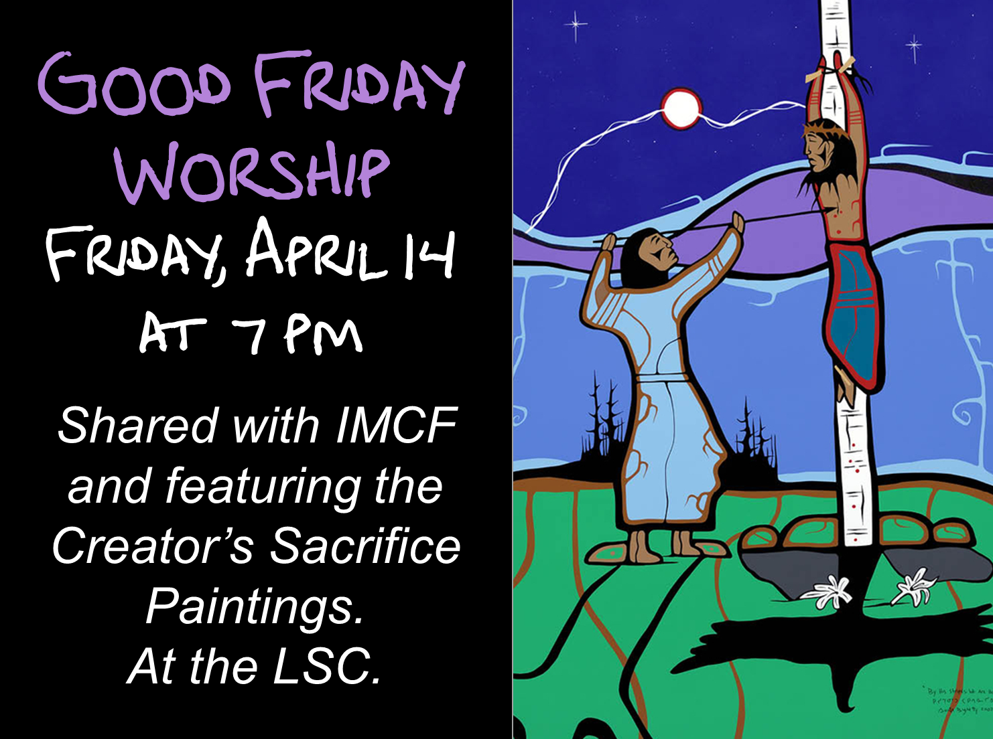
We’d love you to join our family! We are planning a Transfer of Membership service Sunday, April 23. If you are interested in being included or have questions, please let Russell know.

TIME OUT FOR BLESSINGS: A Christ-centred yoga retreat presented by Connie Moker Wernikowski of Big Fish Yoga. Friday, April 28 at 6 pm to Saturday April 29 at 5 pm. At the living Skies Retreat Centre in Lumsden, SK. This retreat will offer both active and restorative yoga; meditation; some free time for walking, resting, visiting; Christian chanting; and an intro to the First Ignation Spiritual Exercise. Cost is $193. Please complete a registration form found on any of the LSC bulletin boards, or by emailing mokerw@sasktel.net.
St. James United Church Players are holding their Annual Dinner and
Maundy Thursday Service with Rabbi Jeremy Parnes. April 13 at 7 pm at the LSC
Dessert Theatre, "Honestly, Now!", a comedy by Jack Sharkey. March 24, 25, 30, 31, April 1, 7, 8. Doors open at 5:30 pm, performance at 6 pm. Tickets $35, includes dinner. Dessert Theatre dates are March 26 and April 9. Doors open at 1:30 pm, performance at 2 pm. Tickets $20.
Reserve your tickets by calling St. James United Church office at 306-543-2626.
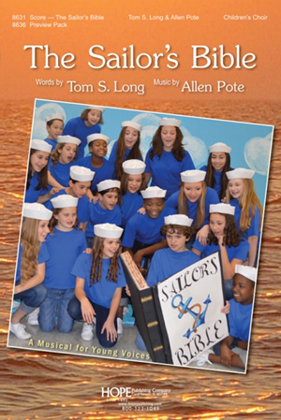
Join us for another LBC Musical
Cast members needed! May gathering intro with fall
rehearsals and performance before December.
Let Russell know if interested!

Community Study Night, Wednesday, March 29 and April 12, from 8 to 11 pm. Coffee, tea and snacks supplied! Come for a quiet space to get some studying and homework done. Plug-ins for laptops available! See Taylor Balfour if interested and follow our Facebook event page:
https://www.facebook.com/events/157007284815470/
JOIN US FOR LENTEN SOUP: Wednesday, April 5 at 6 pm, Munch Café and Catering is again providing a simple soup meal prior to our evening Lenten worship. Vegetarian and meaty soup options and bread will be served. RSVP to eastsideunited@sasktel.net. $5 per person.

LSC Women’s Spirituality Breakfast, Saturday, April 8 from 8 to 10 am. Our guest speaker this month will be Sheila Fahlman on the topic of Grandmothers for Grandmothers (G4G) Regina. G4G Regina raises awareness and fundraises for the Stephen Lewis Foundation to support African grandmothers who are raising a generation of children orphaned by AIDS. All women are welcome to join us – please bring two toonies to help cover the costs of breakfast and a speaker honorarium.

A Night for St. Andrew’s Gala Dinner and Fundraiser, Tuesday, April 18, 2017 at the Wascana Country Club, 6500 Wascana Parkway. Gathering 5 pm, dinner 6:15 pm. Tickets $110 (partial tax receipt), ticket deadline April 10. See Leona Martin or contact the church office if interested. This year’s fundraiser includes an address by Right Reverend Jordan Cantwell, UCC Moderator, and music by Lori Erhardt and Corinne Groff!
We’d love you to join our family! We are planning a Transfer of Membership service Sunday, April 23. If you are interested in being included or have questions, please let Russell know.

TIME OUT FOR BLESSINGS: A Christ-centred yoga retreat presented by Connie Moker Wernikowski of Big Fish Yoga. Friday, April 28 at 6 pm to Saturday April 29 at 5 pm. At the living Skies Retreat Centre in Lumsden, SK. This retreat will offer both active and restorative yoga; meditation; some free time for walking, resting, visiting; Christian chanting; and an intro to the First Ignation Spiritual Exercise. Cost is $193. Please complete a registration form found on any of the LSC bulletin boards, or by emailing mokerw@sasktel.net.
St. James United Church Players are holding their Annual Dinner and
Maundy Thursday Service with Rabbi Jeremy Parnes. April 13 at 7 pm at the LSC
Dessert Theatre, "Honestly, Now!", a comedy by Jack Sharkey. March 24, 25, 30, 31, April 1, 7, 8. Doors open at 5:30 pm, performance at 6 pm. Tickets $35, includes dinner. Dessert Theatre dates are March 26 and April 9. Doors open at 1:30 pm, performance at 2 pm. Tickets $20.
Reserve your tickets by calling St. James United Church office at 306-543-2626.
Join us for another LBC Musical
Cast members needed! May gathering intro with fall
rehearsals and performance before December.
Let Russell know if interested!

