ABOUT US

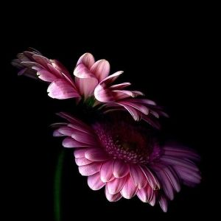
Angela Skeete-Davis -
A retired lawyer, entering the second phase of my life; I am determined to live fully, love completely, bring joy, spread beauty, and make a difference in this world. If this site manages to create one lasting, brilliant, wonderful friendship between at least women in business it will done what it was created to do… and I will be thrilled.

I am a writer, an artist, and a jewelry maker and designer. I do guided meditations and motivational speaking. I am determined to be all-in with all that I have been blessed with and to share it all with the world.
-- “stay grateful and take care of you, stay true to you, and always aspire to always be ALL-IN ... all the time, and in all ways possible.... “
Ang --
Noreen Hollingsworth - Life it what it is..... so make it all you want it to be.

Hi, I'm Noreen. I have been serving with the City of New York for the last twenty seven years. I love my job but it is time to do those things in life that I really appreciate.

After experiencing a series of life changing teaching moments, I find I have an urge to serve women. Women are so important to life and to being. In fact, how could human creation continue otherwise?

My sista girl, Ang and I created Sista Girls Cafe one spring evening over a conversation about whether or not there are other women who care for and support one another the way we do; friendships that really are family-ships created by the individuals involved.

Here we are on a quest to continue, to discover and to create an urgency around women supporting women, friendships, businesses ...... life.
-- “Loving the LIFE I'm LIVING”
NOR --

