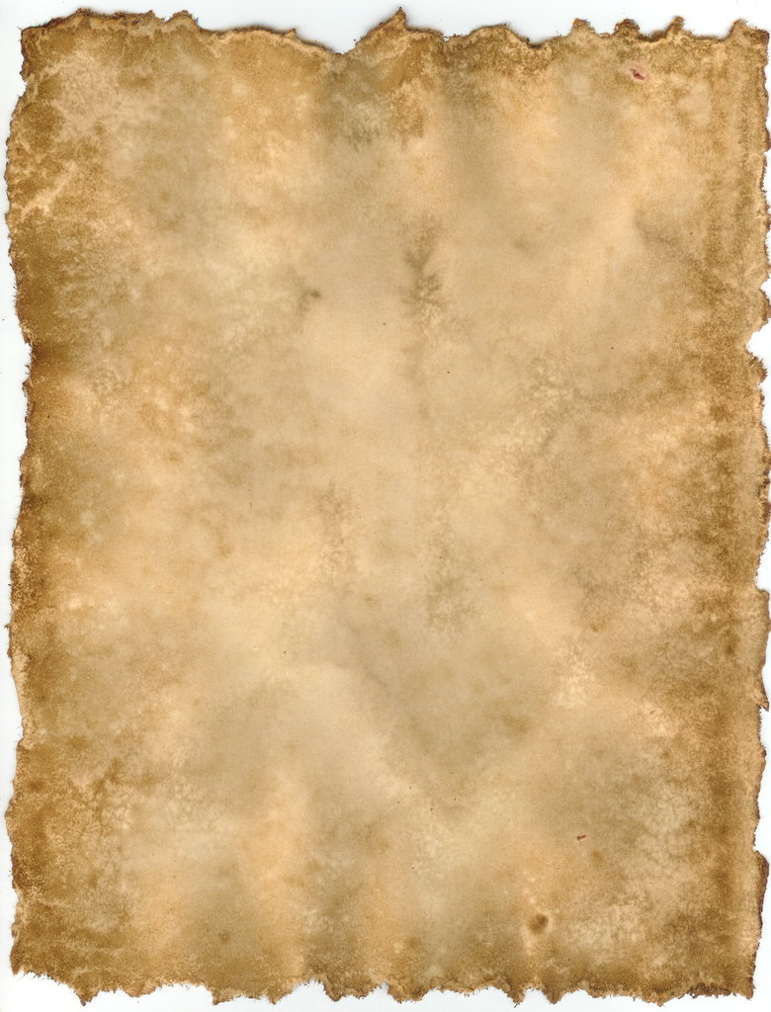

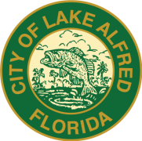**2nd Annual Lake Alfred Heritage Festival**

**Saturday, February 22, 2020**

(Festival located at E Pomelo and N Seminole Avenues, Lake Alfred)

**10 AM to 5 PM**

A unique blend of Lake Alfred’s history combined with

our rich American heritage over centuries and decades

**INTERESTING! ~ EDUCATIONAL!! ~ FUN!!!**

WELCOME VENDORS and/or AMERICAN HISTORY EXHIBITORS

To keep with the theme and purpose of this event, we are ONLY accepting OLD-WORLD, HAND CRAFT, and COTTAGE INDUSTRY Vendor Trades. A completed application form along with a $10.00 non-refundable application fee is required to become an approved Sales Vendor. **The $10.00 application is waived for American History Exhibitors, but a completed application form is required.** Vendors/Exhibitors who carry independent General Liability Insurance are asked to provide a Certificate of Insurance listing the City of Lake Alfred for this event and date. Vendors/Exhibitors who DO NOT carry General Liability Insurance, MUST sign the waiver at the bottom of the application. Any questions regarding qualifications should be directed to Event Coordinator, Judy Schelfo, prior to submitting application. Please refer to the event web site listed below for additional information, forms, history, photos . . etc.

REQUIREMENTS:

* Sales Vendors must present items that would be considered Old-World, Hand-Craft, and/or Cottage Industry trade and must also provide a clean and orderly set up. (Please include photo of set up, if available)
* To become an approved Sales Vendor you must submit this completed application including the $10.00 application fee, proof of General Liability Insurance naming the City of Lake Alfred as “additionally insured” for this specific event and date, OR SIGN and DATE the “General Liability Waiver” below. Applications must be received **no later than January 31, 2020,** and mailed to the address listed below marked . . ATTN: Heritage Festival
* Each approved Vendor will be provided a 12’ X 12’ space for set up. If additional space is needed, that MUST be communicated on the application.
* Sales Vendor set up MUST include a tent (white preferred), tables, chairs, and set up materials. Signage stating DBA Business Name is also recommended.

Approved Vendors providing ALL necessary information will receive detailed instructions regarding set up time, location, parking, etc. approximately (3) weeks prior to event.

We sincerely hope YOU choose to be part of our 2nd Annual Lake Alfred Heritage Festival, not only now, but for many years to come. YOUR presence will be an important part of our success!!

NAME(S):

Application For: SALES VENDOR AMERICAN HISTORY EXHIBITOR (Please Circle One)

BIZ NAME:

ADDRESS:

Email: Phone:

Insurance Certificate Attached?? Y N (If NO . . MUST sign waiver below)

General Description of Items: (Attach photo of set up, if available)

**GENERAL LIABILITY WAIVER:**

As a VENDOR/AMERICAN HISTORY EXHIBITOR at the Lake Alfred Heritage Festival on February 22, 2020, I state that I am not covered by independent General Liability Insurance for this event. I affirm that the City of Lake Alfred will not be held responsible for any damages to my person or my property or for any damage to others as a result of my participation. If such damages would occur, I assume full personal responsibility.

Signature: Date:

City of Lake Alfred, 155 E. Pomelo Street, Lake Alfred, FL 33850

PARKS and RECREATION DEPARTMENT (PH 863/291-5272)

Judy Schelfo, Event Coordinator (863) 602-2942 Cell / (863) 837-5250 Office ~ [JSchelfo@mylakealfred.com](mailto:JSchelfo@mylakealfred.com)

**www.lakealfredheritagefestival.com**