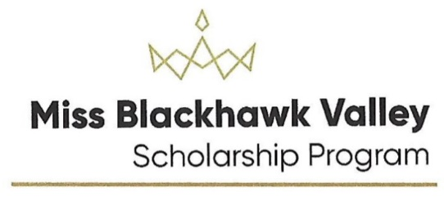

Miss Blackhawk Valley On-line Application
Miss Blackhawk Valley’s Outstanding Teen On-line Application

- Open file with Adobe Acrobat Reader
- Save to your hard drive
- Complete the form.
- Under Local Competition, enter “Miss Blackhawk Valley”
5. If you have not selected a platform title, type in “To Be Determined”
6. Save the form
7. Email the form to BlackhawkValley@mchsi.com

If you have problems, please contact Nancy at the above email address or call 309-762-0884. There is an answering machine at this number.

