Steppin’ into DECEMBER 2018 with Next Step Dance

***THANK YOU TO OUR 2018-19 COMMUNITY PARTNERS!***



**7550 Hendrick Auto Plaza**

**(704) 456-3200**

**Platinum Sponsor**



**8611 Concord Mills Boulevard #217**

**(980) 999-2774**

**Platinum Sponsor**

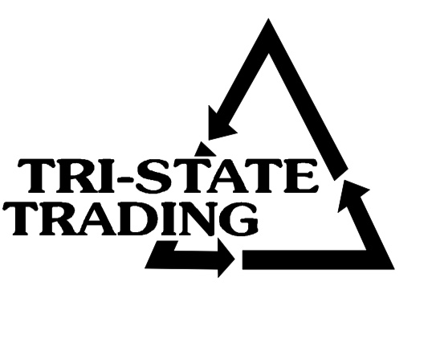

**8426 Medical Plaza Drive #100**

**(704) 971-2250**

**Silver Sponsor**

**#class of the month** C:\Users\Stephanie\Pictures\Microsoft Clip Organizer\j0416014.wmf

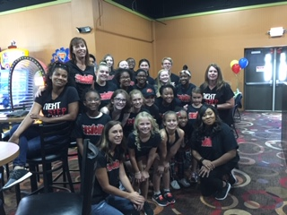

***COMPETITION CLASSES***

We salute this group of dancers as they embark on the 2019 season of competition!

**#Motivation** C:\Users\Stephanie\Pictures\Microsoft Clip Organizer\j0416014.wmf

“Be Humble. Be Hungry.

And always be the

HARDEST worker in the room.”

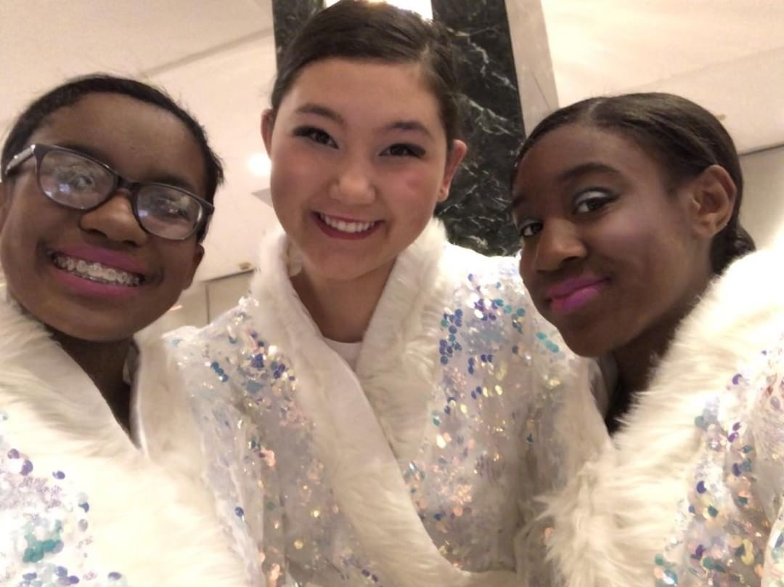

**WINTER REGISTRATION WEEK**

**Monday, January 14th-Thursday, January 17th**

Bring your friends, family, anyone that is interested in dancing in 2019! They can come in and pick up registration information, try out some classes to see what they like the best, and meet our teachers. It is time to pick out what you will be doing during the winter/spring of 2019. What a great way to keep fit and have fun at the same time plus you can make new friends along the way. Join us for this one week class pass as our gift. Decide which class or classes is a perfect fit and we can get you registered for the best sport in town.

C:\Users\Stephanie\Pictures\Microsoft Clip Organizer\j0416014.wmf C:\Users\Stephanie\Pictures\Microsoft Clip Organizer\j0416014.wmf

[**www.thenextstepnc.com**](http://www.thenextstepnc.com)

**7712 Sossamon Lane, NW Concord, NC 28027 (704) 786-7837 nsdcalendar@gmail.com**

**RECITAL 2019**

Both days will be at

Jay M. Robinson High School

300 Pitts School Road, SW,

Concord, NC 28027

Dress Rehearsal will begin at 3:00pm on Friday and Dance Recital will begin at 1:00pm on Saturday. Please continue to check emails for more recital information. Recital dates and info are currently posted on the bulletin board in the lobby.

**SAVE THE DATE** C:\Users\Stephanie\Pictures\Microsoft Clip Organizer\j0416014.wmf

Closed for Christmas-

12/19/18-01/01/19

Winter registration week-

01/14/19-01/17/19

Classes resume 01/02/19

GIFTS FOR THE SEASON

It is always the season for gifts. Check out our jackets, shirts, and other dancewear for a great gift that will be worn all year!

REMEMBER TO JOIN US ON

FB & INSTAGRAM!