APUSH Review Session
Where- UNC-Charlotte
(Woodward Hall Room 125 - Near Student Union)
When-Saturday (4/23)
8:30 am to 1:30 pm
What-APUSH Review
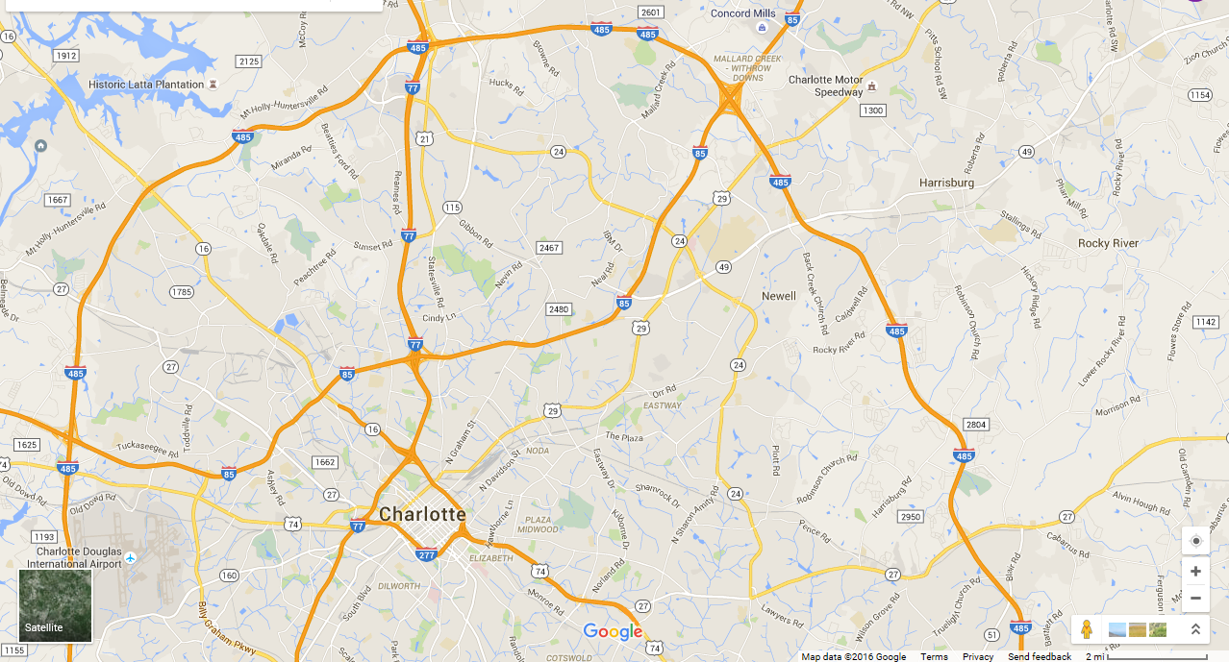Address: 9201 University City Blvd, Charlotte, NC
UNC-Charlotte
http://maps.uncc.edu/

