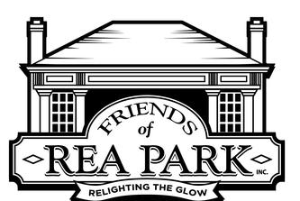
All Divisions Sponsored by:
Dan and Chris Hopkins
Friends of Rea Park, Inc.

Tournament Location

Rea Park and Terre Haute South High School Tennis Courts
3700 South 7th Street
Terre Haute, IN
In cooperation with:
Terre Haute Junior Tennis Association, Inc.
Terre Haute City Parks and Recreation
Vigo County School Corporation
Tournament Headquarters – Rea Park Tennis Courts
Dan Hopkins (Referee)
Information Call
812-239-5061 Cell Phone For Dan Hopkins

Events: Flighted Doubles: Three Rounds
Special Racquets to Winners

Entry Fees: $20 per person
All proceeds to go to the Friends of Rea Park, Inc.

Friends of Rea Park is a 501 c3
Non-For Profit Corporation and your donations are tax deductable.

Hat Draw Doubles Tournament

Starting Time – 9:00 AM

Free Friends of Rea Park T-Shirt

