REGULAR MEETING
DECEMBER 19, 2019
A Regular Meeting of the Town Board of the Town of Hampton, County of Washington and the State of New York was held at the Town Hall, 2629 State Route 22A, Hampton, New York on the 19th day of December 2019.

PRESENT: David K. O’Brien------------Supervisor
Tamme Taran----------------Councilwoman -absent
Donald Sady-----------------Councilman
Andrea Sweeney------------Councilwoman
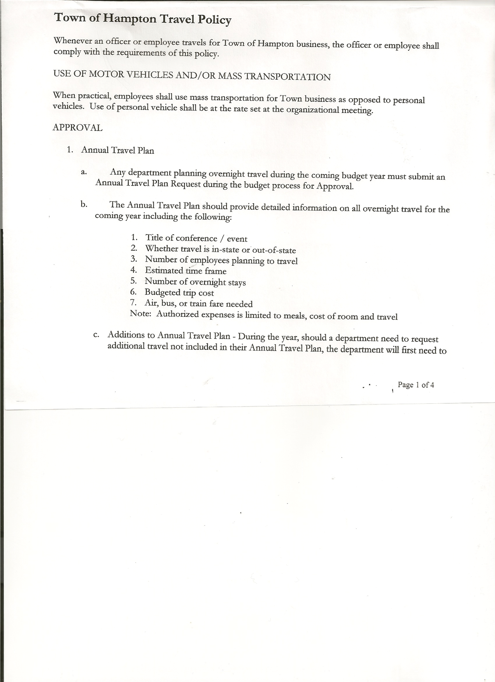
Roger Weeden---------------Councilman
Rebecca Jones---------------Town Clerk
Camilla Shaw----------------Tax Collector/Deputy Town Clerk
Herbert Sady, Jr.-------------Highway Superintendent

Planning Board Member(s): Matthew Pratt

Also present: See attached

The Regular Meeting was called to order by Supervisor O’Brien at 7:30pm, followed by the Pledge of Allegiance. Location of Fire Exits were given. Quorum of board members present.

RESOLUTION NO. 115-2019
APPROVAL OF THE MINUTES
On a motion of Councilman Sady, seconded by Councilman Weeden, the following resolution was
ADOPTED: Ayes 4 O’Brien, Sady, Sweeney, Weeden
Nays 0
Absent 1 Taran
RESOLVED, that the Regular Town Board Minutes for November 21st , 2019 are approved.

PERMITS/SUBDIVISION
Attorney Stephanie Bittner of Barlett, Pointiff, Stewart & Rhodes, P.C., Agent for Elaine Phillips came before the board regarding a Boundary Line Adjustment between Elaine Phillips and Charles and Beluah Saunders.

RESOLUTION NO. 116-2019
SHORT ENVIRONMENTAL ASSESSMENT FORM/NEGATIVE DECLARATION
On a motion of Councilman Sady, seconded by Councilman Weeden, the following resolution was
ADOPTED: Ayes 4 O’Brien, Sady, Sweeney, Weeden
Nays 0
Absent 1 Taran
RESOLVED, that the Short Environmental Assessment Form for Elaine Phillips is complete and to adopt a negative declaration and finding that there will be no adverse environmental impacts and to consider it a minor subdivision, therefore waving the public hearing.

TOWN BOARD MEETING
DECEMBER 19, 2019 PAGE 2

RESOLUTION NO. 117-2019
APPROVAL OF SUBDIVISION
On a motion of Councilman Sady, seconded by Councilman Weeden, the following resolution was
ADOPTED: Ayes 4 O’Brien, Sady, Sweeney, Weeden
Nays 0
Absent 1 Taran
RESOLVED, to approve the Phillips/Saunders Boundary Line Adjustment.

Larry Carman, Dog Control Officer submitted his report, which was read by Supervisor O’Brien, copy of report is attached for 11/18/19-12/16/19.

Camilla Shaw, Tax Collector – Bills for 2020 will be going out shortly. Zero balance. Submitted a Bank Statement to the Board for review and signatures.

Matthew Pratt, Member gave Planning Board Report…
- Meeting was held on December 11th, 2019 at the Town Hall.
- Jeff Kehoe from the State planning on attending January meeting to help/advise with the Ag plan.
- Bonnie Hawley, Chair and Renee Rountree, Member attended Planning Board
Training at the County Building
- Continuing to work on Farm Land Ag Protection Plan.
- Next meeting will be January 8th, 2020 @ 7:00pm at the Town Hall.

Herbert Sady, Jr., Highway Superintendent submitted his report, copy of which, is attached.
Equipment Report dated 12/19/19 is also attached.
Argyle’s Highway Superintendent, Robert Humiston died in an accident on December 17th. All Washington County Highway Superintendents were asked to bring one of their Town Trucks for the funeral on Saturday. Highway Superintendent Sady asked the Boards approval to take the 1-ton to the funeral.

RESOLUTION NO. 118-2019
BOARD APPROVAL TO HIGHWAY SUPERINTENDENT
On a motion of Councilman Sady, seconded by Councilman Weeden, the following resolution was
ADOPTED: Ayes 4 O’Brien, Sady, Sweeney, Weeden
Nays 0
Absent 1 Taran
RESOLVED, that Highway Superintendent Herbert Sady is authorized to take Hampton’s 1-Ton Truck to the funeral for Robert Humiston, Argyle’s Highway Superintendent, on Saturday, December 21st, 2019.

Paving….discussing Shared Service with the County. County considering helping Towns with paving to get it done earlier and less costly.

TOWN BOARD MEETING
DECEMBER 19, 2019 PAGE 3

SUPERVISOR’S REPORT/COUNTY UPDATES/COMMUNICATIONS

RESOLUTION NO. 119-2019
APPROVAL OF SUPERVISOR’S MONTHLY REPORT
On a motion of Councilman Sady, seconded by Councilman Weeden, the following resolution was
ADOPTED: Ayes 4 O’Brien, Sady, Sweeney, Weeden
Nays 0
Absent 1 Taran
RESOLVED that, the Supervisor’s Monthly report be accepted as submitted for NOVEMBER
10/31/19 11/30/19
ACCOUNT BALANCE RECEIPTS DISBURSEMENTS BALANCE
General Fund $ 46,479.25 $ 13,327.13 $ 7,163.18 $ 52,643.20
Highway Fund $ 94,222.79 $ 2,248.50 $ 20,657.84 $ 75,813.45
Equipment Reserve $ 29,851.92 $ 1.23 $ 0.00 $ 29,853.15
Fire #1 $ 20,808.00 $ 0.00 $ 0.00 $ 20,808.00
Fire #2 $ 3,878.00 $ 0.00 $ 0.00 $ 3,878.00
Cemetery $ 1,724.46 $ 1.09 $ 0.00 $ 1,725.55
Totals $196,964.42 $ 15,577.95 $ 27,821.02 $184,721.35
All Board Members present signed Supervisor’s Report.

Poultney Rescue Squad, Inc…. Letter and revised contract were received, copy of letter is attached. Poultney Rescue Squad has prorated their Contract for 2019. Contract was originally for $1200.00 for the year, they are only asking for $1000.00 for the months of coverage provided (January to October). The following resolution was introduced as a result.
RESOLUTION NO. 120-2019
CONTRACT REVISION-POULTNEY RESCUE SQUAD
On a motion of Councilman Sady, seconded by Councilman Weeden, the following resolution was
ADOPTED:
ROLL CALL VOTE AS FOLLOWS:
Supervisor O’Brien AYE
Councilman Sady AYE
Councilwoman Sweeney AYE
Councilman Weeden AYE
Councilwoman Taran ABSENT
RESOLVED, to accept Poultney Rescue Squads prorated amount for 2019.

PUBLIC/COUNCIL COMMENTS
Matthew Pratt of the Hampton Volunteer Fire Co. passed along a “Thank You” to the Hampton Highway Department for coming out and taking care of the road at the Carvers Falls Road fire (Bunker’s barn fire).

Councilwoman Sweeney asked that better signage be put up at the intersection.

TOWN BOARD MEETING
DECEMBER 19, 2019 PAGE 4

RESOLUTION NO. 121-2019

AUDIT OF CLAIMS
On a motion of Councilman Weeden, seconded by Councilman Sady, the following resolution was
ADOPTED: Ayes 4 O’Brien, Sady, Sweeney, Weeden
Nays 0
Absent 1 Taran
RESOLVED that the bills have been reviewed by the Town Board and are authorized for payment in the following amounts.
General Fund No. 156 through No. 171 $ 31,257.86
Highway Fund No. 117 through No. 131 $ 22,419.58
Total both funds $ 53,677.44

On a motion of Councilman Weeden seconded by Councilwoman Sweeney, the meeting adjourned at 8:29pm All in favor Aye.

Respectfully submitted,

Rebecca S. Jones, RMC
Town Clerk

