***Pleasant Township Board of Trustees Meeting Highlights***

**Date _December 10, 2024______________ Next Resolution No._ 81—12-10-2024_ _**

* **Call to Order -- The meeting tonight will also be on WebEx.**
* **Please stand for a moment of silence. --Pledge of Allegiance--Roll Call**
* **Visitors –**
* ***Hanna Poling*** with the Southwest Messenger via WebEx.
* **Minutes to approve**- No minutes
* **Financial Reports** – Paula
  + Motion to pay expenditures.
* ***Department Reports***
* **Franklin County Sheriff’s Dept-Community Liaison, Deputy Adkins, 1120- Cell: 614-809-5843**
  + Not available
* **Road Department****- Robert Bausch, Superintendent**
* Wind damage. – Still cleaning up some areas
* Finishing old projects.
* Equipment maintenance.
* 1 burial.
* 2024/2025 salt prices.-rock salt is $66.74 per ton, Brine is 19 cents per gallon & liquid chloride is 80 cents per gallon.
* *Any updates on Gay Rd. about repairs due to heavy rains washing the roadway and gravel away. (meeting on 8-8-23 we said we’d keep it on the agenda till resolved in some way.)*
* **Fire Dept. – Chief Whiting**
* Apparatus
* M-231 at Brawn.- getting the underbody sprayed.
* Apparatus has been sprayed with an underbody rust protection.
* Tanker-airline rupture replaced.
* The E-231 coolant line ruptured and has been replaced.
* C-231 vehicle-maintenance issue (mechanic is watching)
* Personnel
* Equipment
* Looking at AEDs for two vehicles (utilizing grant money)

Update-will be purchasing before the end of the year

* A cold-water exposure suit was ordered to replace a leaking suit.
* Training
* Station
* Miscellaneous painting and drywall repair.
* Bathroom- We are looking for contractors to assess and bid on the project.
* Community Risk Reduction
* Numerous building inspections
* Billing
  + Currently working on reporting that is required by the Feds. The required date was pushed back to May 31, 2025.
* Grant
  + Applied for $1000. A grant from OTARMA for equipment.
* Ohio Health employment drug testing refused an employee test saying we have not paid an invoice since June. Paula said the last invoice was for $94 and was paid. Randi said there have been problems with their billing at other places. Chief is going to investigate this further.
* Firefighter’s Pancakes with Santa is this Saturday, December 14th 9:00 am to noon at Darbydale Elementary School.
* **Old Business-**
* **New Business –**
  + HSA- Per the Firefighter’s Contract, *“Section 26.4: The Township will continue to provide insurance coverage for each Employee comparable to the coverage in effect as of January 1st , 2024. As such, the Township may implement the cost savings measures, such as high-deductible plan coupled with a HSA/HRA that provides comparable coverage and does not increase an employee's out-of-pocket costs for such coverage. Upon ratification of the 2024-2026 collective bargaining agreement, the Township shall fund each participating employee's HSA with $2,000 for individual and $4,000 for family coverage. Thereafter, HSAs shall be funded annually by the Township with $2,000 for individual and $4,000 for family coverage on January 1 of each year.”*

Resolution_81__ to transfer $54,000 from regular checking to HSA account to fund the fifteen (15) Pleasant Township employee accounts who are enrolled in the township insurance program according to individual and family plans and deposited in said accounts by January 1, 2025. To save Paula the hassle like last time of sending three different deposits on three different days, have the check ready by our next meeting and either Nancy or Chief Whiting will deliver it to them. If this resolution passes, Nancy will be by CME on Monday, 12/16/24.

* Next meeting is scheduled for Christmas Eve – Reschedule. Motion to cancel the regular meeting on 12-24-24 and reschedule for Monday, December 30. 2024 at 7:00 pm.
* **Clerk Updates**- Paula
* Miscellaneous correspondence
* Resolution__82__authorizing Paula to make budgetary adjustments for end of year expenses.
* 27 pays this year, usually 26, therefore no extra deductions such as to the HSA will be included unless you call Paula to let her know.
* **Announcements -**.
  + A person holding a wreath in a cemetery

    Description automatically generatedA group of people standing in a line

    Description automatically generated**A group of people standing in a line

    Description automatically generated****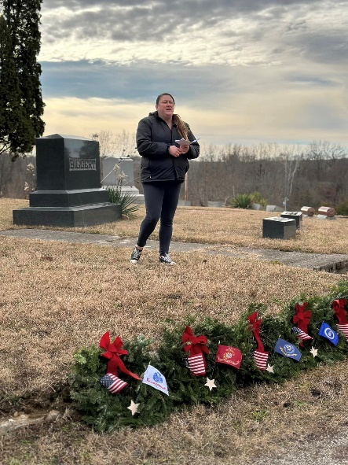**Thank you, Carrie Cole, for coordinating one of our largest township traditions, Wreaths Across America. We want to thank all those who donated to purchase 200 wreaths to honor our Veterans. This is enough for three of the Pleasant Township Cemeteries, Oak Grove, Ebenezer and Gundy. We hope you can join us this Saturday at Noon at Oak Grove Cemetery. Everyone is invited to place a wreath on a Veteran's grave.

**

* **Speaker Sheets-** (come to the podium to be heard on WebEx)
  + Angie Carpenter and Sandra Thomas from Madison County to talk about opposition to the Bio-digester.
* 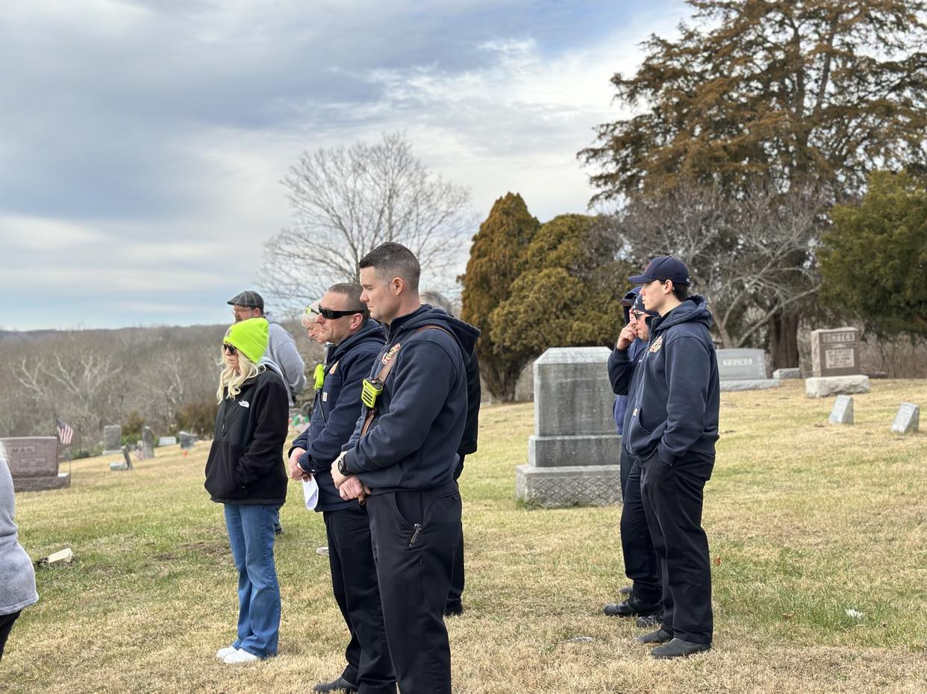A person kneeling in a cemetery

  Description automatically generated**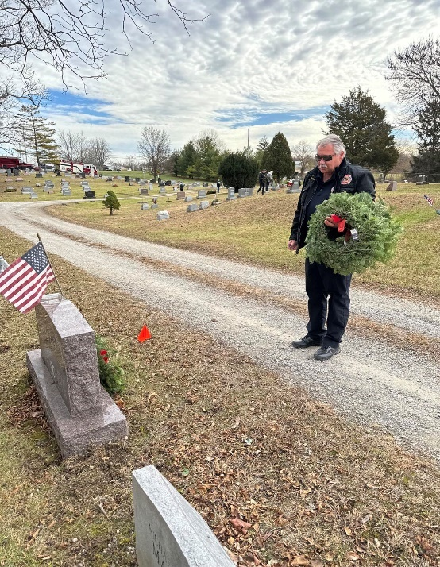Adjourn**