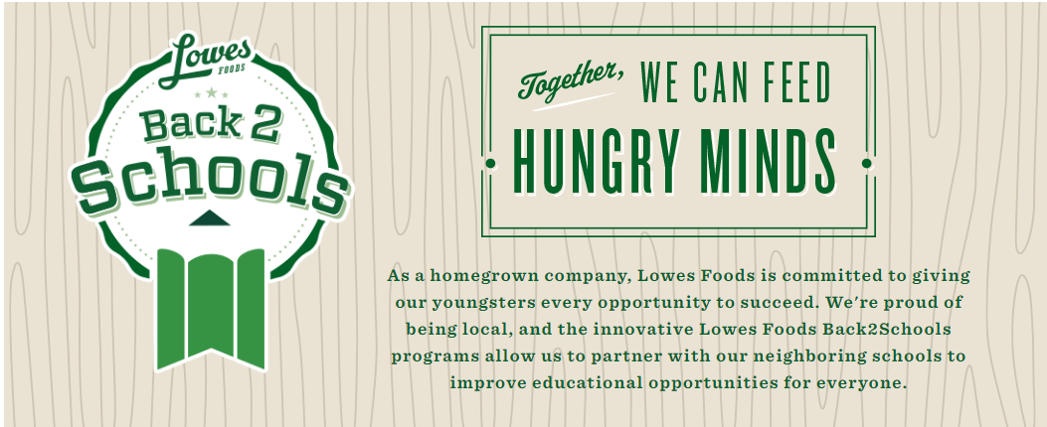

Link your Lowes Foods Rewards card to Moncure School!
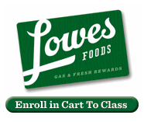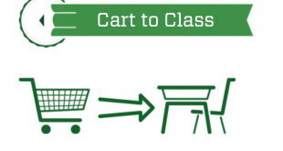
http://www.lowesfoods.com/back-2-schools

Enroll Moncure School on your Fresh Rewards card!

With Cart to Class, Lowes Foods will give up to a quarter of a million dollars to local schools this year. To participate, enroll your local school on your Fresh Rewards card, then the school will be rewarded based on the amount of Lowes Foods Private Label items you purchase. Don't have your card number? You can easily look up your customer information by entering the 10 digit telephone number associated with your account on the Cart to Class page!

