Confession and Absolution

496 Holy Spirit, Light Divine
1 Holy Spirit, light divine,
Shine upon this heart of mine;
Chase the shades of night away,
Turn the darkness into day.

2 Let me see my Savior’s face,
Let me all His beauties trace;
Show those glorious truths to me
Which are only known to Thee.

3 Holy Spirit, pow’r divine,
Cleanse this guilty heart of mine;
In Thy mercy pity me,
From sin’s bondage set me free.

4 Holy Spirit, joy divine,
Cheer this saddened heart of mine;
Yield a sacred, settled peace,
Let it grow and still increase.

5 Holy Spirit, all divine,
Dwell within this heart of mine;
Cast down ev’ry idol throne,
Reign supreme, and reign alone.
Text: Public domain

Stand

The sign of the cross may be made by all in remembrance of their Baptism.

P In the name of the Father and of the T Son and of the Holy Spirit.
C Amen.

P If we say we have no sin, we deceive ourselves, and the truth is not in us.
C But if we confess our sins, God, who is faithful and just, will forgive our sins and cleanse us from all unrighteousness.

Kneel/Stand

Silence for reflection on God’s Word and for self-examination.

P Let us then confess our sins to God our Father.
C Most merciful God, we confess that we are by nature sinful and unclean. We have sinned against You in thought, word, and deed, by what we have done and by what we have left undone. We have not loved You with our whole heart; we have not loved our neighbors as ourselves. We justly deserve Your present and eternal punishment. For the sake of Your Son, Jesus Christ, have mercy on us. Forgive us, renew us, and lead us, so that we may delight in Your will and walk in Your ways to the glory of Your holy name. Amen.

P Almighty God in His mercy has given His Son to die for you and for His sake forgives you all your sins. As a called and ordained servant of Christ, and by His authority, I therefore forgive you all your sins in the name of the Father and of the T Son and of the Holy Spirit.
C Amen.

Stand

Service of the Word

Introit Psalm 104:24, 27–28, 30; antiphon: Liturgical Text
Come, Holy Spirit, fill the hearts of the | faithful,*
and kindle in them the fire of your love. Alle- | luia.
O Lord, how manifold are your works! In wisdom have you | made them all;*
the earth is full of your | creatures.
These all | look to you,*
to give them their food in due | season.
When you give it to them, they gath- | er it up;*
when you open your hand, they are filled with | good things.
When you send forth your Spirit, they are cre- | ated,*
and you renew the face | of the ground.
Glory be to the Father and | to the Son*
and to the Holy | Spirit;
as it was in the be- | ginning,*
is now, and will be forever. | Amen.
Come, Holy Spirit, fill the hearts of the | faithful,*
and kindle in them the fire of your love. Alle- | luia.

Kyrie LSB 152
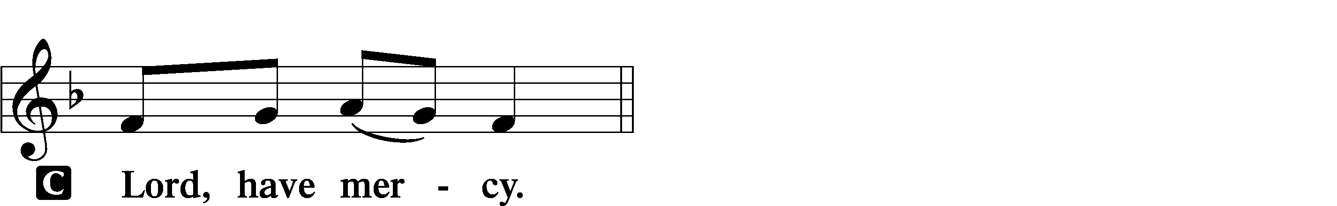

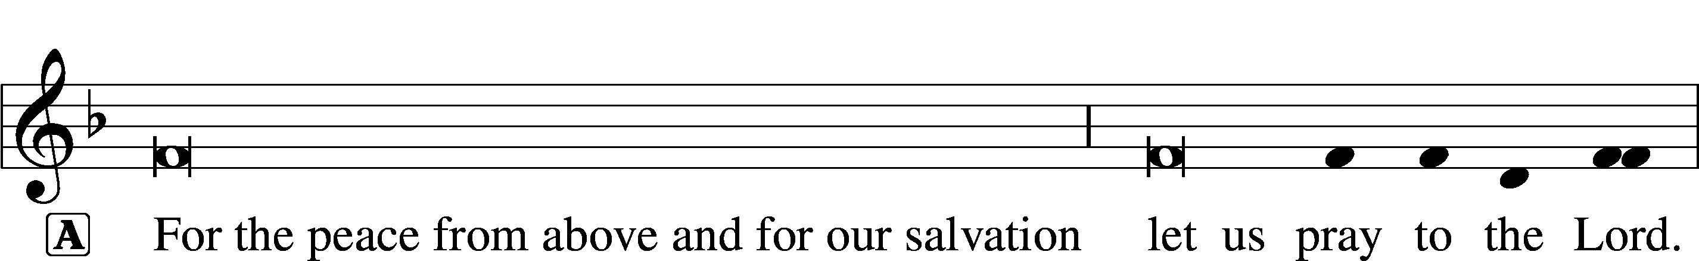
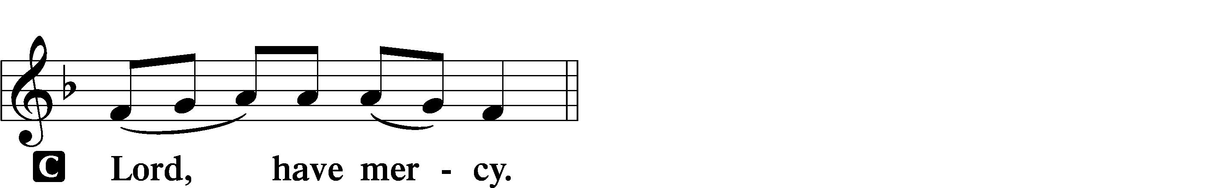

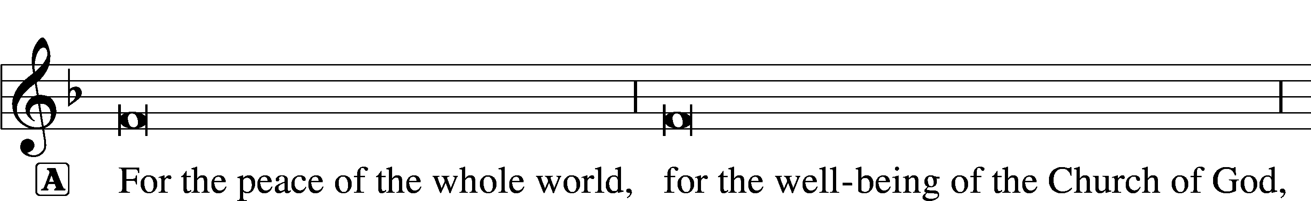
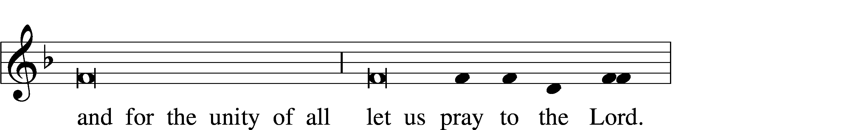
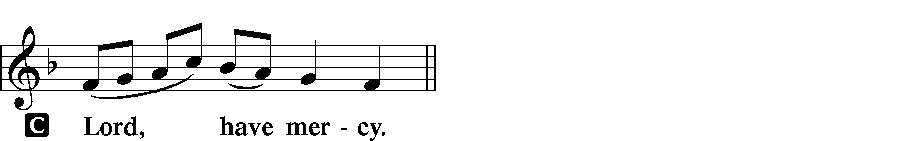

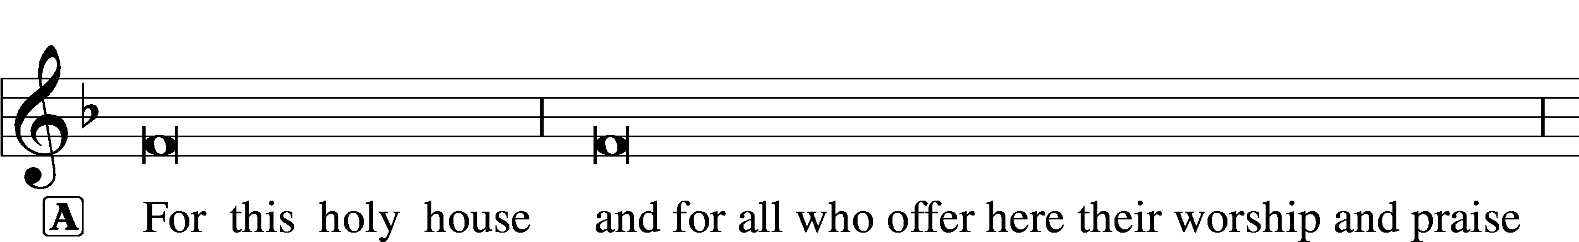
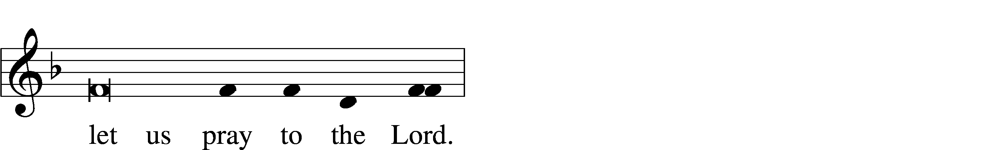
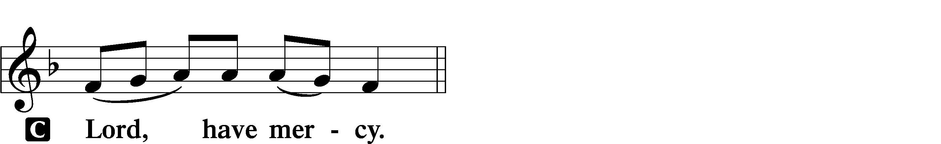

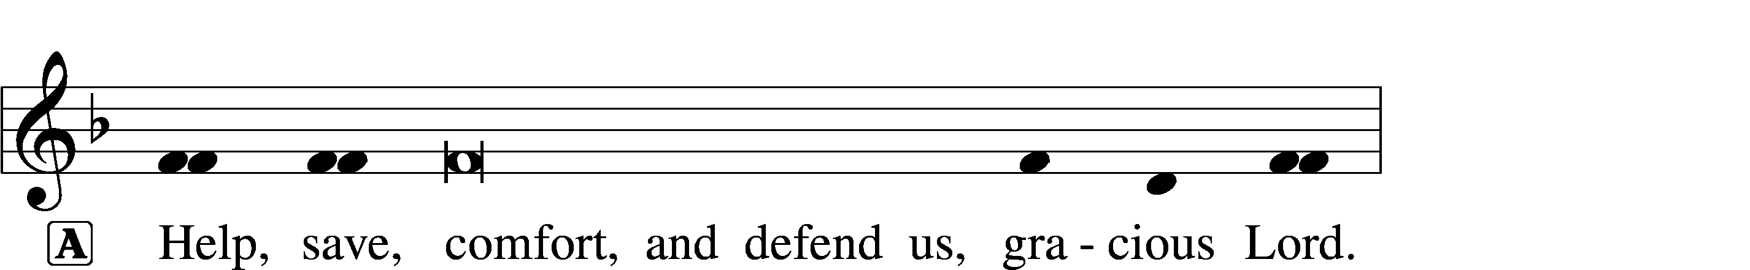

This Is the Feast LSB 155
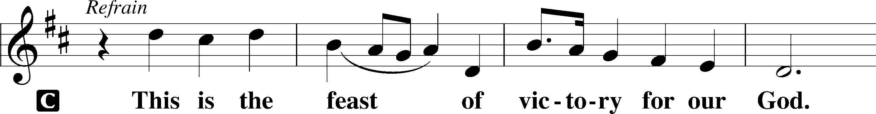
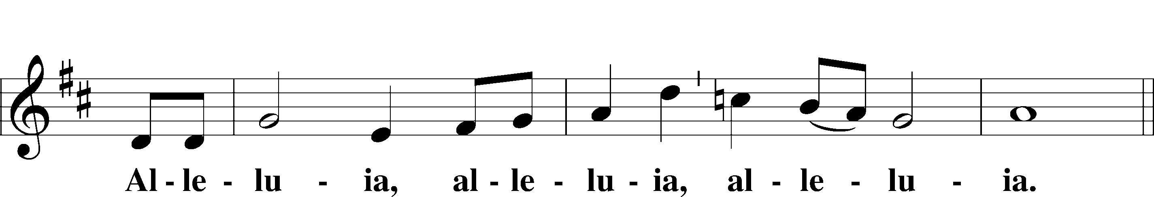
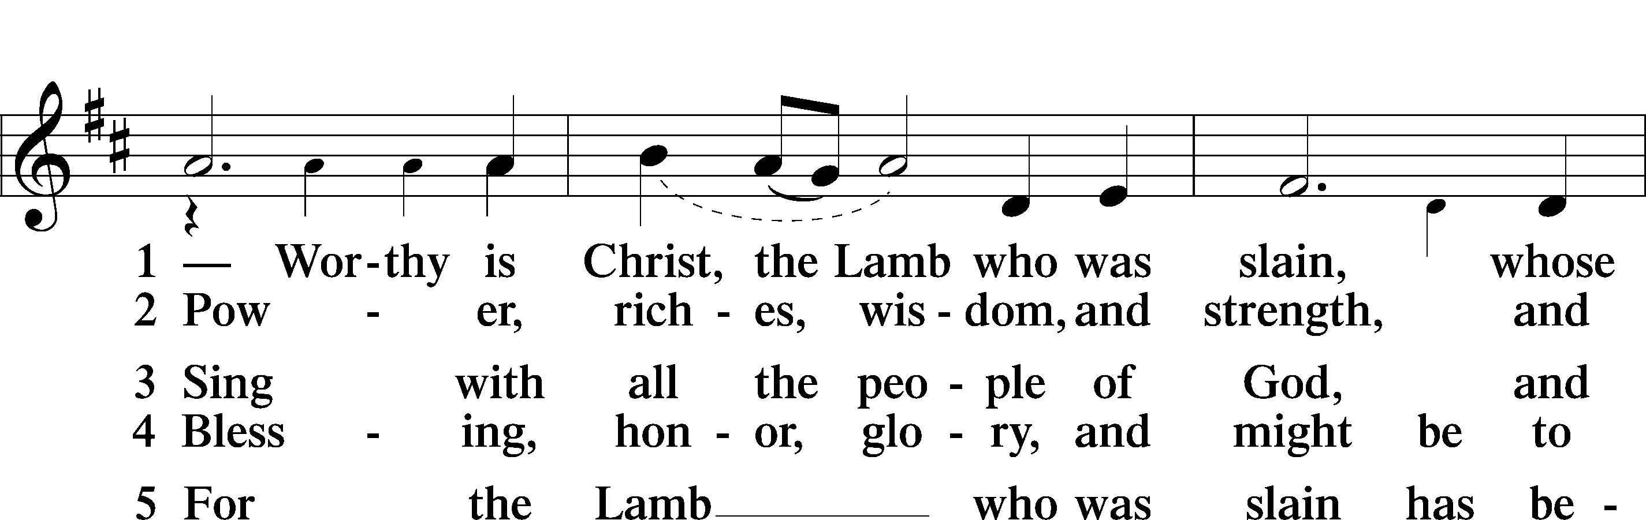
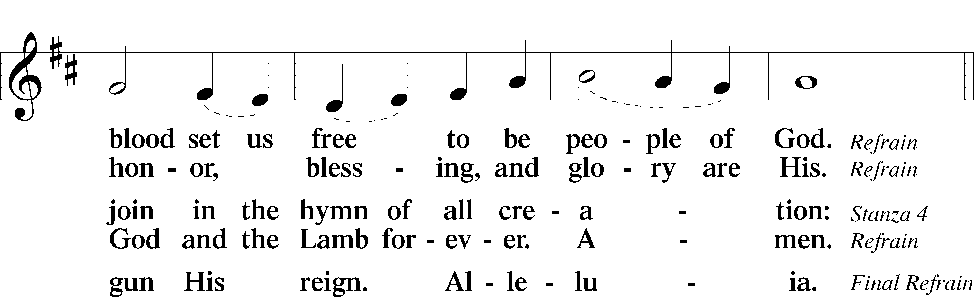
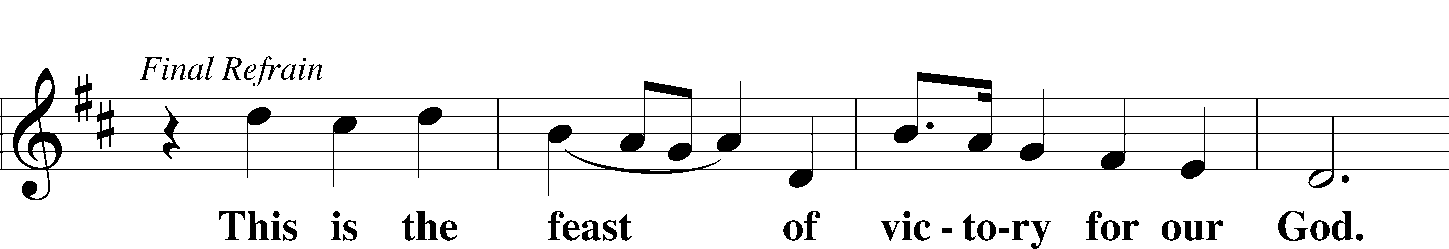
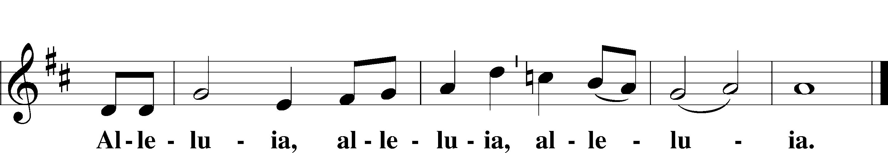

Salutation and Collect of the Day
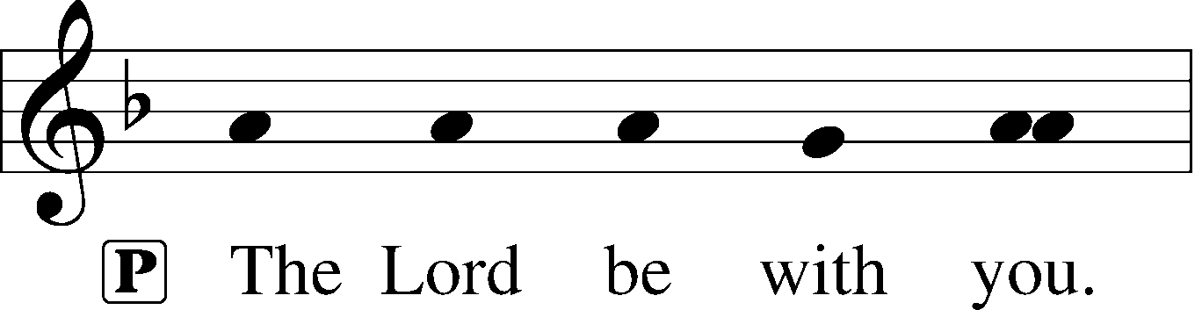
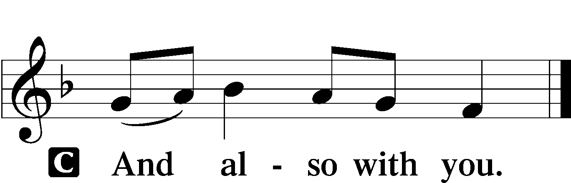

P Let us pray.
O God, on this day You once taught the hearts of Your faithful people by sending them the light of Your Holy Spirit. Grant us in our day by the same Spirit to have a right understanding in all things and evermore to rejoice in His holy consolation; through Jesus Christ, Your Son, our Lord, who lives and reigns with You and the Holy Spirit, one God, now and forever.

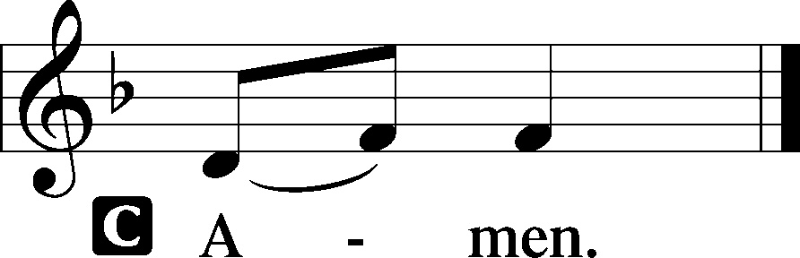

Sit

Old Testament Reading Numbers 11:24–30
24Moses went out and told the people the words of the Lord. And he gathered seventy men of the elders of the people and placed them around the tent. 25Then the Lord came down in the cloud and spoke to him, and took some of the Spirit that was on him and put it on the seventy elders. And as soon as the Spirit rested on them, they prophesied. But they did not continue doing it.
26Now two men remained in the camp, one named Eldad, and the other named Medad, and the Spirit rested on them. They were among those registered, but they had not gone out to the tent, and so they prophesied in the camp. 27And a young man ran and told Moses, “Eldad and Medad are prophesying in the camp.” 28And Joshua the son of Nun, the assistant of Moses from his youth, said, “My lord Moses, stop them.” 29But Moses said to him, “Are you jealous for my sake? Would that all the Lord’s people were prophets, that the Lord would put his Spirit on them!” 30And Moses and the elders of Israel returned to the camp.

A This is the Word of the Lord.
C Thanks be to God.

Second Reading Acts 2:1–21
1When the day of Pentecost arrived, they were all together in one place. 2And suddenly there came from heaven a sound like a mighty rushing wind, and it filled the entire house where they were sitting. 3And divided tongues as of fire appeared to them and rested on each one of them. 4And they were all filled with the Holy Spirit and began to speak in other tongues as the Spirit gave them utterance.
5Now there were dwelling in Jerusalem Jews, devout men from every nation under heaven. 6And at this sound the multitude came together, and they were bewildered, because each one was hearing them speak in his own language. 7And they were amazed and astonished, saying, “Are not all these who are speaking Galileans? 8And how is it that we hear, each of us in his own native language? 9Parthians and Medes and Elamites and residents of Mesopotamia, Judea and Cappadocia, Pontus and Asia, 10Phrygia and Pamphylia, Egypt and the parts of Libya belonging to Cyrene, and visitors from Rome, 11both Jews and proselytes, Cretans and Arabians—we hear them telling in our own tongues the mighty works of God.” 12And all were amazed and perplexed, saying to one another, “What does this mean?” 13But others mocking said, “They are filled with new wine.”
14But Peter, standing with the eleven, lifted up his voice and addressed them, “Men of Judea and all who dwell in Jerusalem, let this be known to you, and give ear to my words. 15For these men are not drunk, as you suppose, since it is only the third hour of the day. 16But this is what was uttered through the prophet Joel:
17“‘And in the last days it shall be, God declares,
that I will pour out my Spirit on all flesh,
and your sons and your daughters shall prophesy,
and your young men shall see visions,
and your old men shall dream dreams;
18even on my male servants and female servants
in those days I will pour out my Spirit, and they shall prophesy.
19And I will show wonders in the heavens above
and signs on the earth below,
blood, and fire, and vapor of smoke;
20the sun shall be turned to darkness
and the moon to blood,
before the day of the Lord comes, the great and magnificent day.
21And it shall come to pass that everyone who calls upon the name of the Lord shall be saved.’”

A This is the Word of the Lord.
C Thanks be to God.

Stand

Alleluia and Verse LSB 156
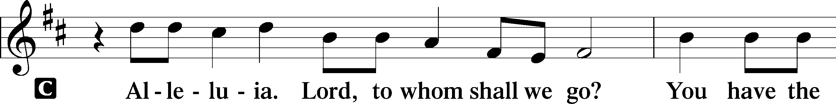
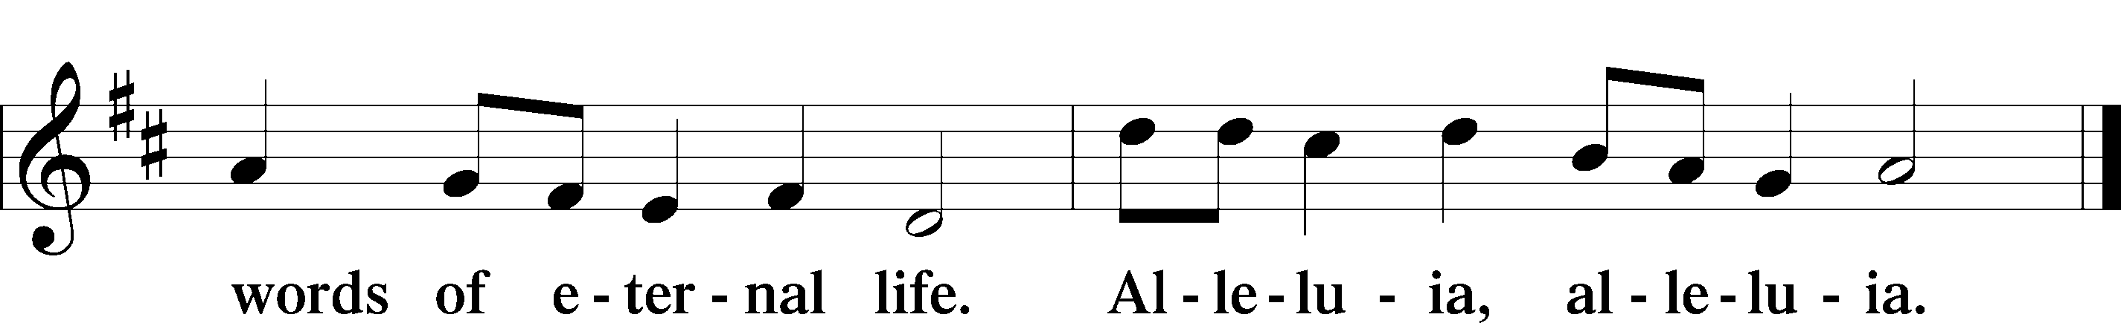

Holy Gospel John 7:37–39
P The Holy Gospel according to St. John, the seventh chapter.

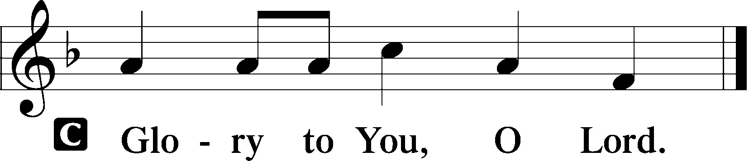

37On the last day of the feast, the great day, Jesus stood up and cried out, “If anyone thirsts, let him come to me and drink. 38Whoever believes in me, as the Scripture has said, ‘Out of his heart will flow rivers of living water.’” 39Now this he said about the Spirit, whom those who believed in him were to receive, for as yet the Spirit had not been given, because Jesus was not yet glorified.

P This is the Gospel of the Lord.

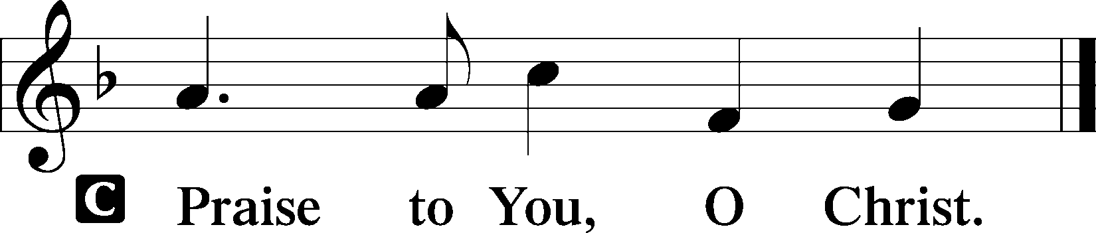

Sit

500 Creator Spirit, by Whose Aid
1 Creator Spirit, by whose aid
The world’s foundations first were laid,
Come, visit ev’ry humble mind;
Come, pour Your joys on humankind;
From sin and sorrow set us free;
May we Your living temples be.

2 O Source of uncreated light,
The bearer of God’s gracious might,
Thrice-holy fount, thrice-holy fire,
Our hearts with heav’nly love inspire;
Your sacred, healing message bring
To sanctify us as we sing.

3 Giver of grace, descend from high;
Your sev’nfold gifts to us supply;
Help us eternal truths receive
And practice all that we believe;
Give us Yourself that we may see
The glory of the Trinity.

D 4 Immortal honor, endless fame
Attend the_almighty Father’s name;
The Savior-Son be glorified,
Who for all humankind has died;
To You, O Paraclete, we raise
Unending songs of thanks and praise.
Text: Public domain

Sermon

Stand

Nicene Creed
C I believe in one God,
the Father Almighty,
maker of heaven and earth
and of all things visible and invisible.

And in one Lord Jesus Christ,
the only-begotten Son of God,
begotten of His Father before all worlds,
God of God, Light of Light,
very God of very God,
begotten, not made,
being of one substance with the Father,
by whom all things were made;
who for us men and for our salvation came down from heaven
and was incarnate by the Holy Spirit of the virgin Mary
and was made man;
and was crucified also for us under Pontius Pilate.
He suffered and was buried.
And the third day He rose again according to the Scriptures
and ascended into heaven
and sits at the right hand of the Father.
And He will come again with glory to judge both the living and the dead,
whose kingdom will have no end.

And I believe in the Holy Spirit,
the Lord and giver of life,
who proceeds from the Father and the Son,
who with the Father and the Son together is worshiped and glorified,
who spoke by the prophets.
And I believe in one holy Christian and apostolic Church,
I acknowledge one Baptism for the remission of sins,
and I look for the resurrection of the dead
and the life T of the world to come. Amen.

Prayer of the Church

Following the prayers, the people may greet one another in the name of the Lord, saying, “Peace be with you,” as a sign of reconciliation and of the unity of the Spirit in the bond of peace (Matt. 5:22–24; Eph. 4:1–3).

Sit

Stand

Service of the Sacrament

Preface LSB 160
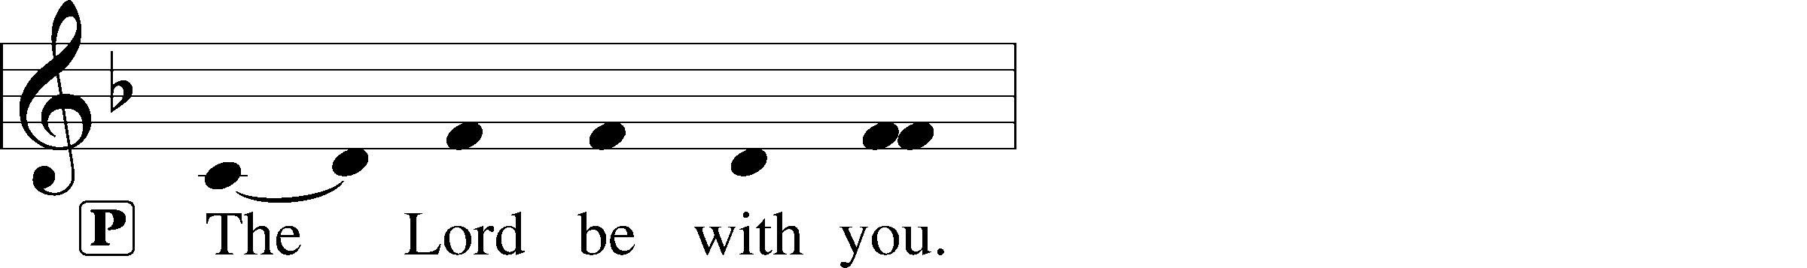
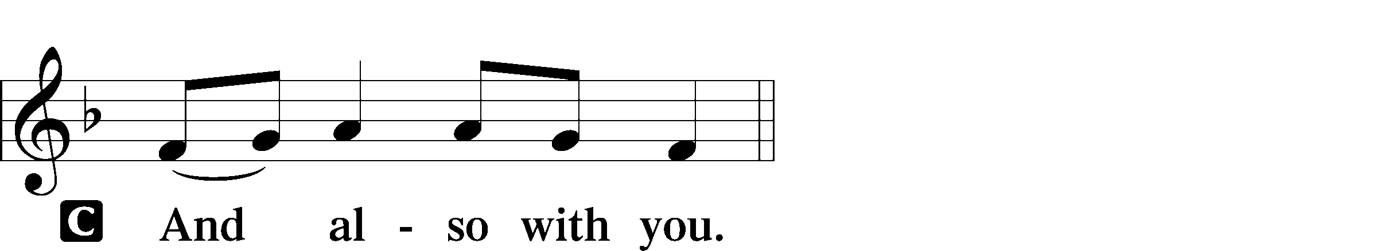
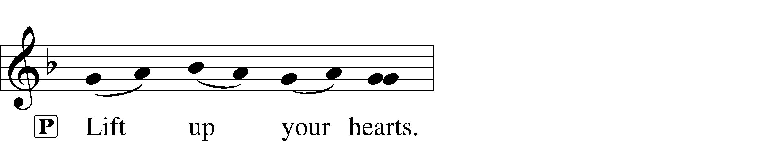
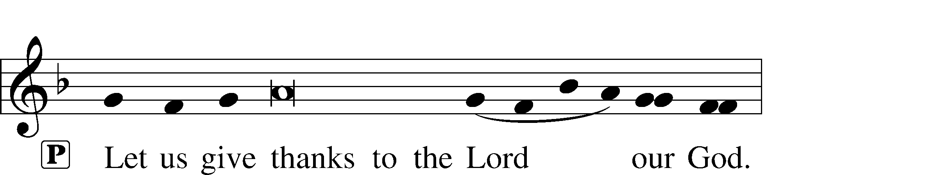
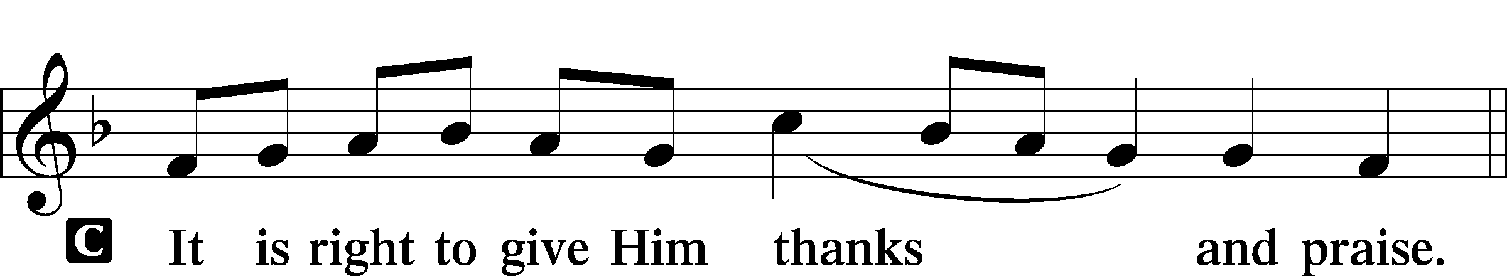

P It is truly good, right, and salutary that we should at all times and in all places give thanks to You, holy Lord, almighty Father, everlasting God, through Jesus Christ, our Lord, who ascended above the heavens and, sitting at Your right hand, poured out on this day the promised Holy Spirit on His chosen disciples. For all this the whole earth rejoices with exceeding joy. Therefore with angels and archangels and with all the company of heaven we laud and magnify Your glorious name, evermore praising You and saying:

Sanctus LSB 161
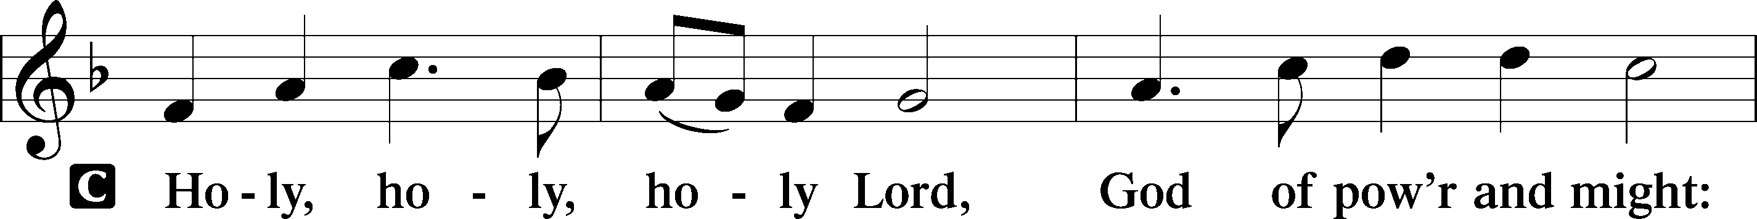
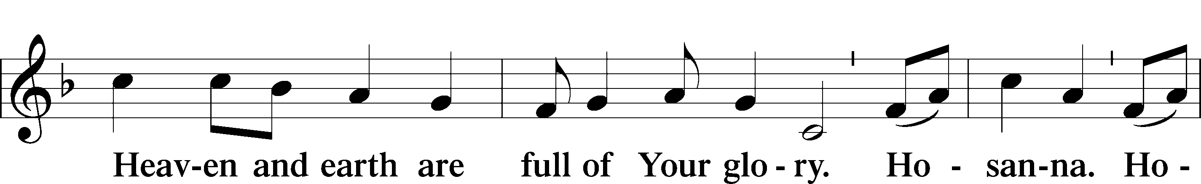
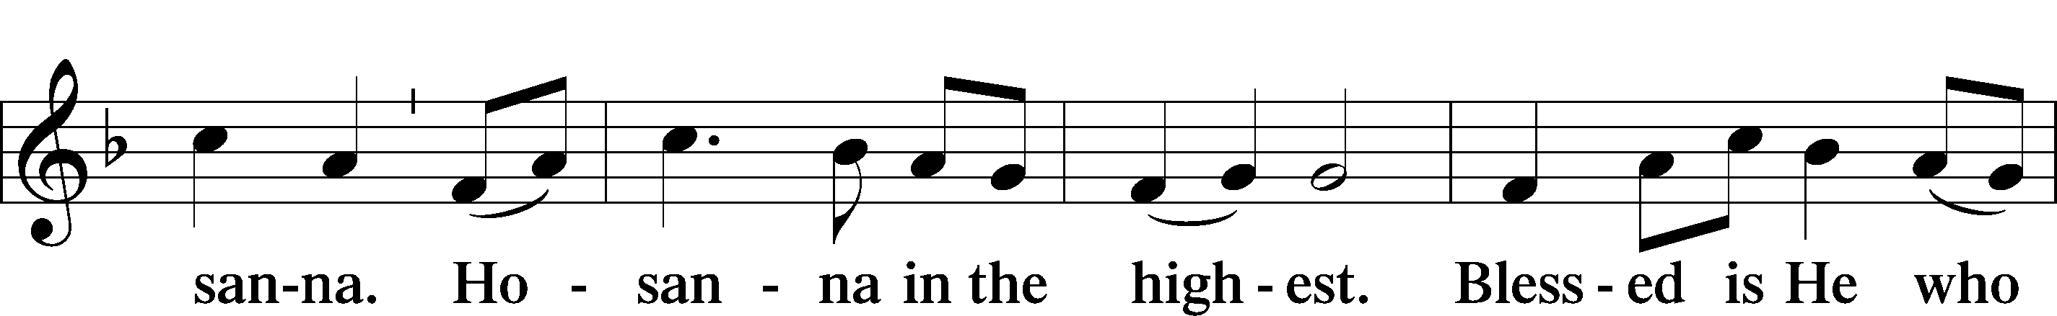
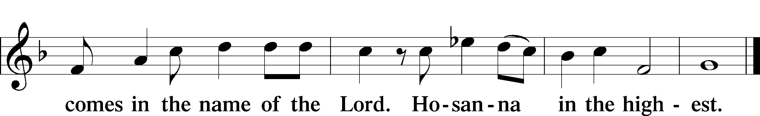

Prayer of Thanksgiving LSB 161
P Blessed are You, Lord of heaven and earth, for You have had mercy on those whom You created and sent Your only-begotten Son into our flesh to bear our sin and be our Savior. With repentant joy we receive the salvation accomplished for us by the all-availing sacrifice of His body and His blood on the cross.

Gathered in the name and the remembrance of Jesus, we beg You, O Lord, to forgive, renew, and strengthen us with Your Word and Spirit. Grant us faithfully to eat His body and drink His blood as He bids us do in His own testament. Gather us together, we pray, from the ends of the earth to celebrate with all the faithful the marriage feast of the Lamb in His kingdom, which has no end. Graciously receive our prayers; deliver and preserve us. To You alone, O Father, be all glory, honor, and worship, with the Son and the Holy Spirit, one God, now and forever.
C Amen.

Lord’s Prayer LSB 162
P Lord, remember us in Your kingdom and teach us to pray:
C Our Father who art in heaven,
hallowed be Thy name,
Thy kingdom come,
Thy will be done on earth
as it is in heaven;
give us this day our daily bread;
and forgive us our trespasses
as we forgive those
who trespass against us;
and lead us not into temptation,
but deliver us from evil.
For Thine is the kingdom
and the power and the glory
forever and ever. Amen.

The Words of Our Lord
P Our Lord Jesus Christ, on the night when He was betrayed, took bread, and when He had given thanks, He broke it and gave it to the disciples and said: “Take, eat; this is My T body, which is given for you. This do in remembrance of Me.”

In the same way also He took the cup after supper, and when He had given thanks, He gave it to them, saying: “Drink of it, all of you; this cup is the new testament in My T blood, which is shed for you for the forgiveness of sins. This do, as often as you drink it, in remembrance of Me.”

Pax Domini LSB 163
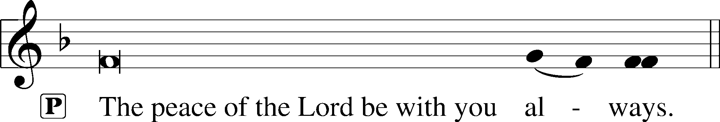

Agnus Dei LSB 163
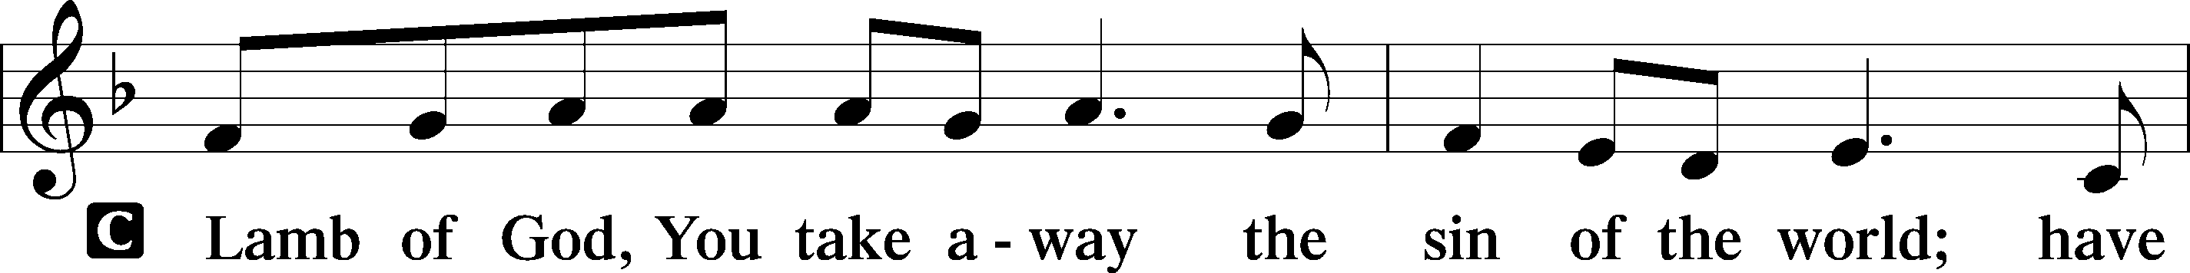
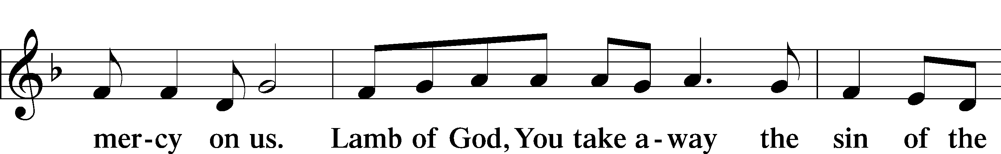
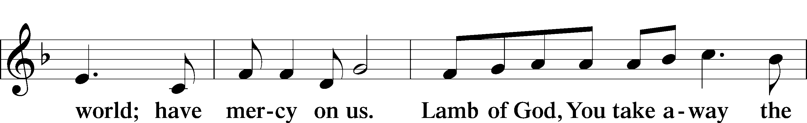
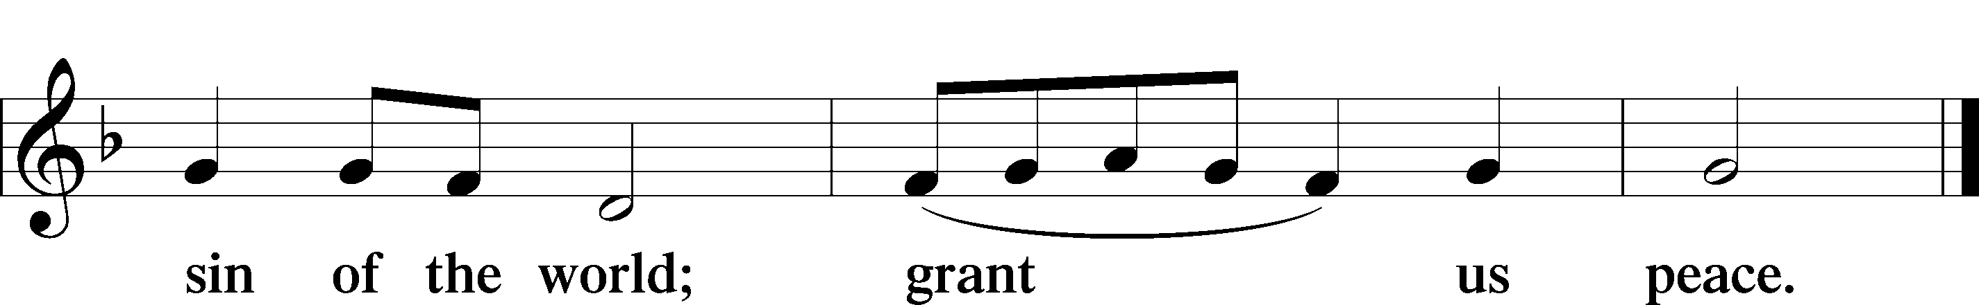

Sit

Distribution

The pastor and those who assist him receive the body and blood of Christ first and then distribute them to those who come to receive, saying:

Take, eat; this is the true body of our Lord and Savior Jesus Christ, given into death for your sins.
Amen.

Take, drink; this is the true blood of our Lord and Savior Jesus Christ, shed for the forgiveness of your sins.
Amen.

In dismissing the communicants, the following is said:

P The body and blood of our Lord Jesus Christ strengthen and preserve you in body and soul to life everlasting. Depart T in peace.
C Amen.

628 Your Table I Approach
1 Your table I approach;
Dear Savior, hear my prayer.
Let not an unrepentant heart
Prove hurtful to me there.

2 Lord, I confess my sins
And mourn their wretched bands;
A contrite heart is sure to find
Forgiveness at Your hands.

3 Your body and Your blood,
Once slain and shed for me,
Are taken at Your table, Lord,
In blest reality.

4 Search not how this takes place,
This wondrous mystery;
God can accomplish vastly more
Than what we think could be.

5 O grant, most blessèd Lord,
That earth and hell combined
May not about this sacrament
Raise doubt within my mind.

6 Oh, may I never fail
To thank You day and night
For Your true body and true blood,
O God, my peace and light.
Text: Public domain

Red Book 128

Stand

Thank the Lord LSB 164
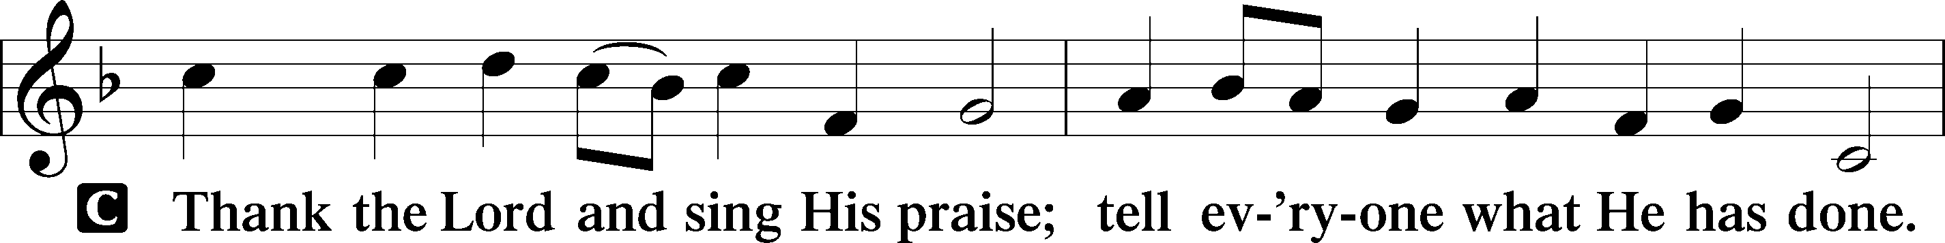
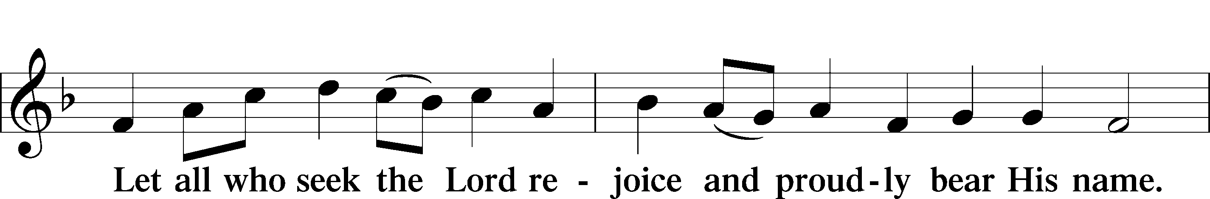
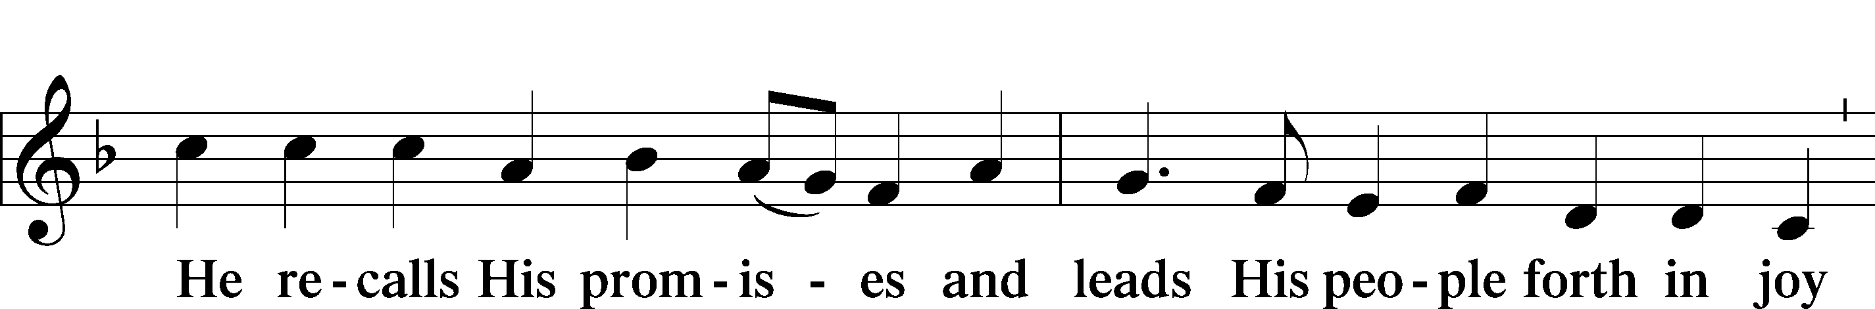
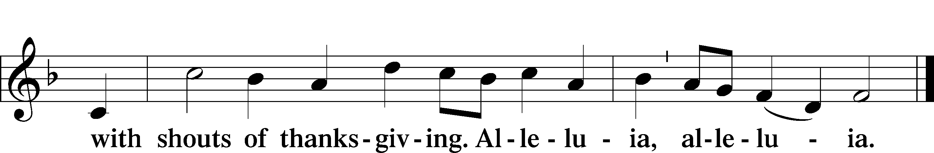

Post-Communion Collect
A Let us pray.
We give thanks to You, almighty God, that You have refreshed us through this salutary gift, and we implore You that of Your mercy You would strengthen us through the same in faith toward You and in fervent love toward one another; through Jesus Christ, Your Son, our Lord, who lives and reigns with You and the Holy Spirit, one God, now and forever.
C Amen.

Benediction LSB 166
P The Lord bless you and keep you.
The Lord make His face shine on you and be gracious to you.
The Lord look upon you with favor and T give you peace.
C Amen.

643 Sent Forth by God’s Blessing
1 Sent forth by God’s blessing,
Our true faith confessing,
The people of God from His dwelling take leave.
The Supper is ended.
O now be extended
The fruits of this service in all who believe.
The seed of His teaching,
Receptive souls reaching,
Shall blossom in action for God and for all.
His grace did invite us,
His love shall unite us
To work for God’s kingdom and answer His call.

2 With praise and thanksgiving
To God ever-living,
The tasks of our ev’ryday life we will face.
Our faith ever sharing,
In love ever caring,
Embracing His children of each tribe and race.
With Your feast You feed us,
With Your light now lead us;
Unite us as one in this life that we share.
Then may all the living
With praise and thanksgiving
Give honor to Christ and His name that we bear.
Text: © 1964 World Library Publications. Used by permission: LSB Hymn License no. 110001887

Acknowledgments
Divine Service, Setting One from Lutheran Service Book
Unless otherwise indicated, Scripture quotations are from the ESV® Bible (The Holy Bible, English Standard Version®), copyright © 2001 by Crossway, a publishing ministry of Good News Publishers. Used by permission. All rights reserved.
Created by Lutheran Service Builder © 2018 Concordia Publishing House.

2020 Yearly Budget - $186,000 approx. (Includes Missions)
HOME MISSION
Budget to Date $ 67,200.00 $ 7,350.00
Amt. Needed/Week $ 3,200.00 $ 350.00
Amt. Last Sunday $ 3,151.00 $ 173.00
Amt. Received to Date $ 54,479.00 $ 6,058.00
Amt. Ahead (Behind) $ (12,721.00) $ (1,292.00)

Other: Hoech $10.00, Building Fund $10

