Mission Statement  The mission of the Derrick City Volunteer Junior Firefighter Program is to maintain a safe environment for the youth of our community, to gather for learning many aspects of the fire service as well as provide avenues for social interaction.  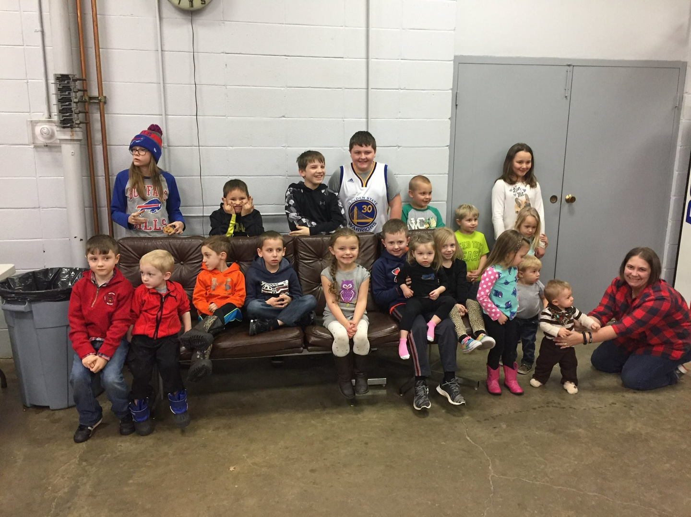  To build each junior up to their potential by focusing on leadership, character, team work and the community while providing an active and enjoyable program for our members, their family, and the youth of Foster Township.  Core Values  Accountability  Professionalism  Respect  Dignity  Pride  Honor  Friendship  Fun  Safety  Education  Team Work  Compassion  Integrity  Honesty  Self-Discipline  Service to others |  |  | Building character and leadership in today’s youth...  Junior Firefighter Program  Derrick City Volunteer Fire Department
  Thank you for your
  interest in the
  Derrick City Volunteer
  Fire Department Junior
  Firefighter Program
  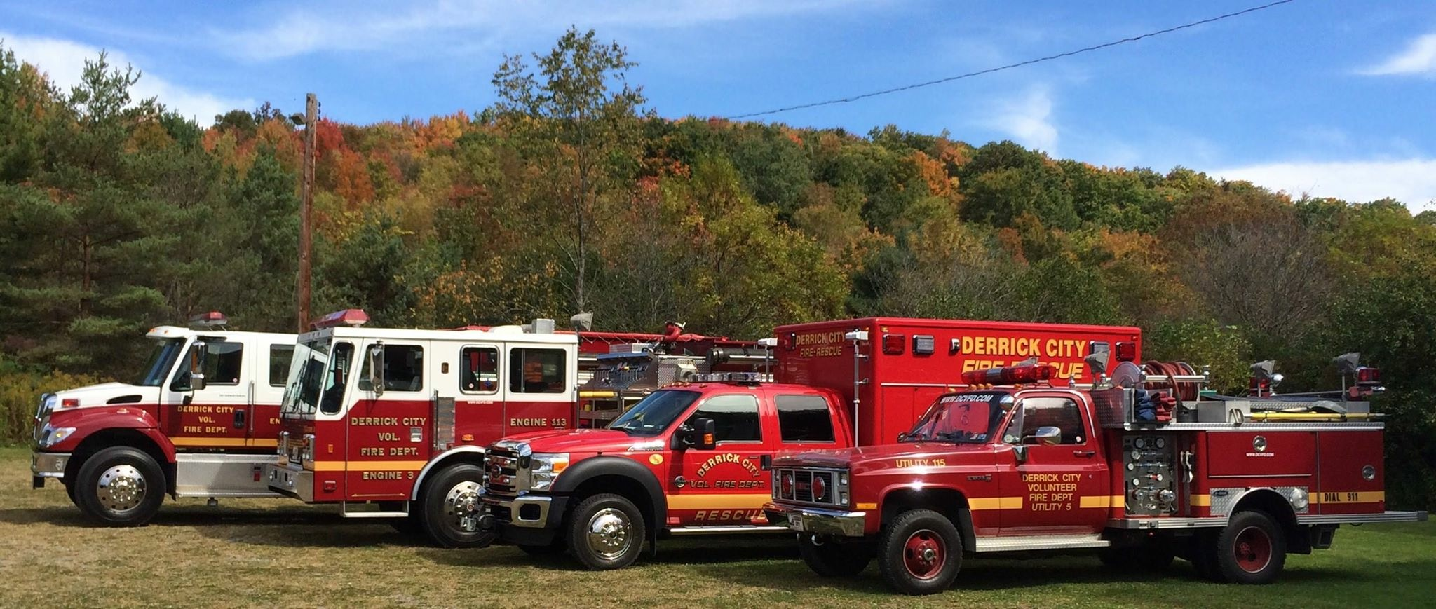
  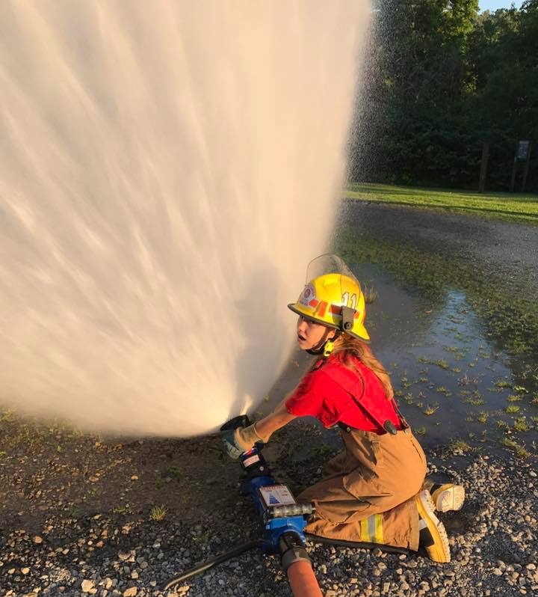
  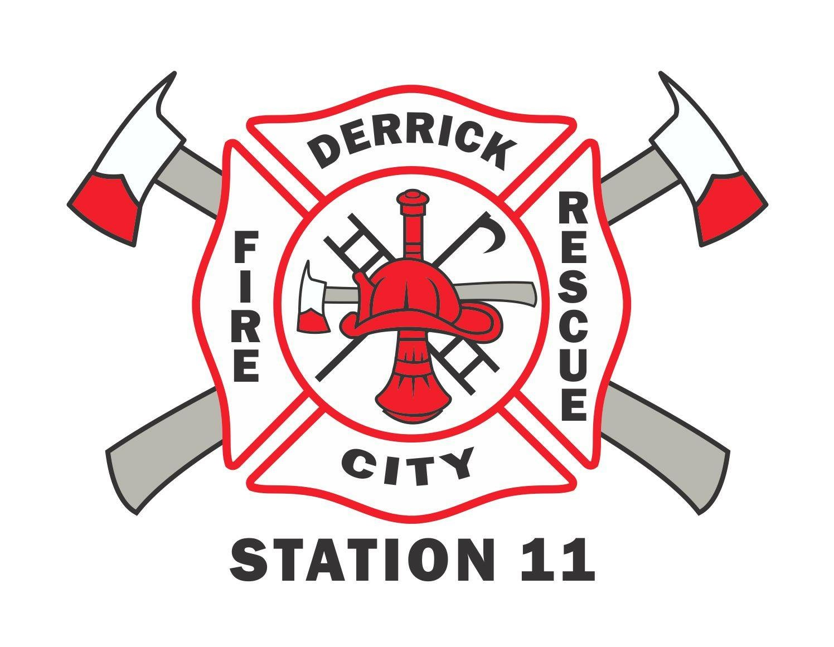 | Derrick city volunteer fire department  PO Box 58  Derrick City, PA 16727
  For more information about us please visit our website www.dcvfd.com or email at Campbell.dcfd@gmail.com
What is a Junior Firefighter Program?  Junior firefighter programs give young people the chance to learn about local fire, rescue, and emergency medical services response organizations in a safe, controlled, educational and fun way while providing departments with an excellent recruitment mechanism. Reaching out to members of the community when they are young has long-term effects and encouraging youth to take part in the emergency services is extremely beneficial to local communities and departments. Benefits of junior firefighter programs include:  - Allowing youth to gain insight and interest in becoming long-term members of the emergency services.  - Increasing awareness among youth about volunteering and supporting the fire and emergency services.  - Providing departments with additional help in accomplishing non-firefighting or non-emergency tasks.  - Instilling leadership for America’s youth who are tomorrow’s leaders.  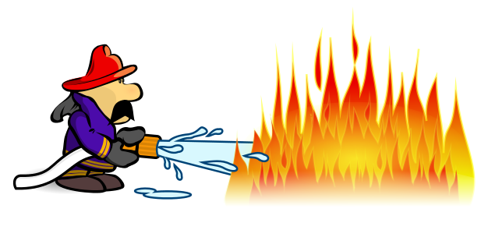  - Educating parents and mentors on the importance of encouraging volunteerism. | About the DCVFD Junior FF Program  The DCVFD Junior Firefighter Program grants members 14-17 the opportunity to learn firefighting and EMS skills in a safe and structured environment. Junior firefighters build strong bonds with peers while working together to meet common goals within the program as well as the community. The program is organized and facilitated by active members of the DCVFD. They lead, guide and teach the juniors throughout the program in various areas.  Although parents/guardians are not required to volunteer their time to the program, we love to get our member’s family involved. These volunteers are instrumental in the success of the program and because our members love to share their junior firefighter experiences with their families, the DCVFD junior program offers many ways for family members to get involved. Parents/Guardians may choose to become members of the DCVFD either by becoming active or becoming a social member. If neither sounds interesting, they can just help at various fundraisers when needed!  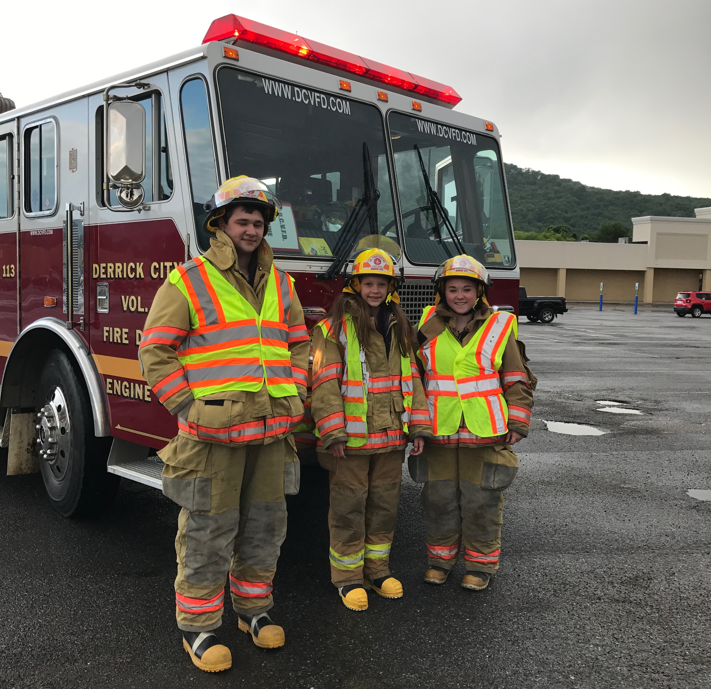 | What to expect with  our program…  - Training in Fire and EMS  - Participation in local parades  - Community Service  - Assisting during DCVFD events such as Bingo and fundraisers.  - Our yearly Appreciation Dinner to celebrate achievements of members.  What juniors are saying about our program…  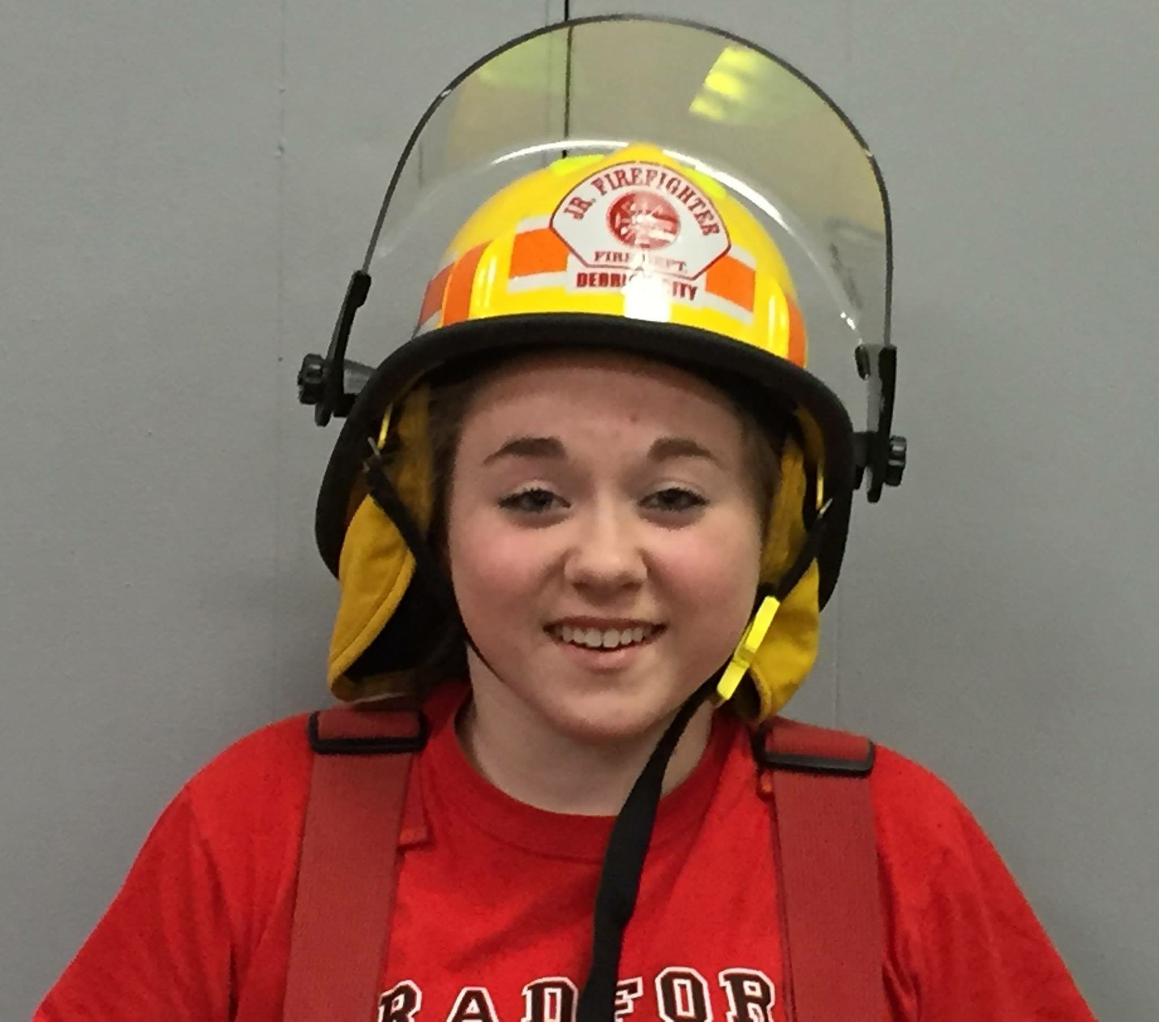  “I love being a part of a family like this and knowing that they have my back and  will help me with everything...”  –Abbie Kohler  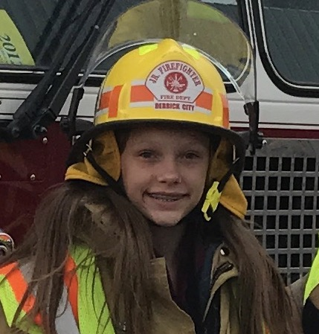  “I joined to make a difference in my community and have learned that working with a team is better than working alone…” – Kailei Mason  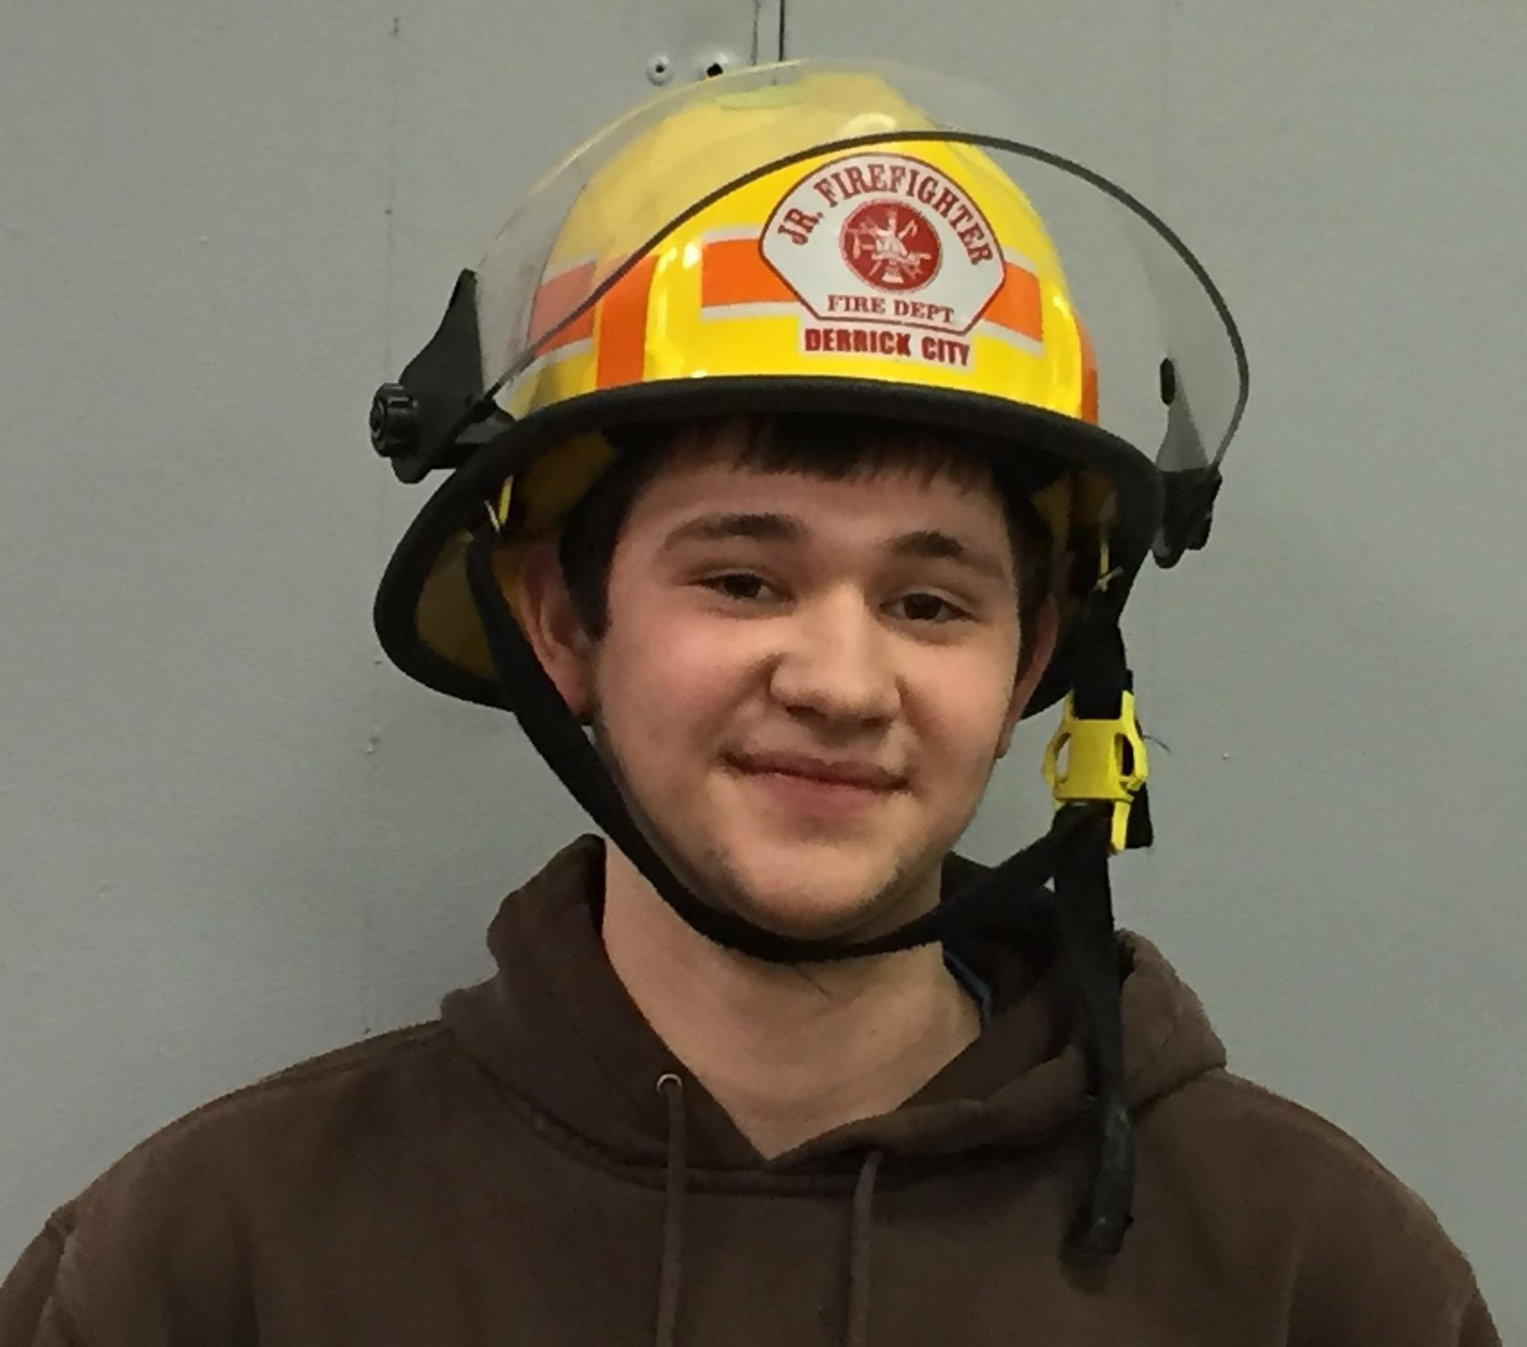  “I wouldn’t want to be a member anywhere but Derrick City. I love what we do, love that we are family and we take pride in what we do…” – Josh Drehmer  (past junior)  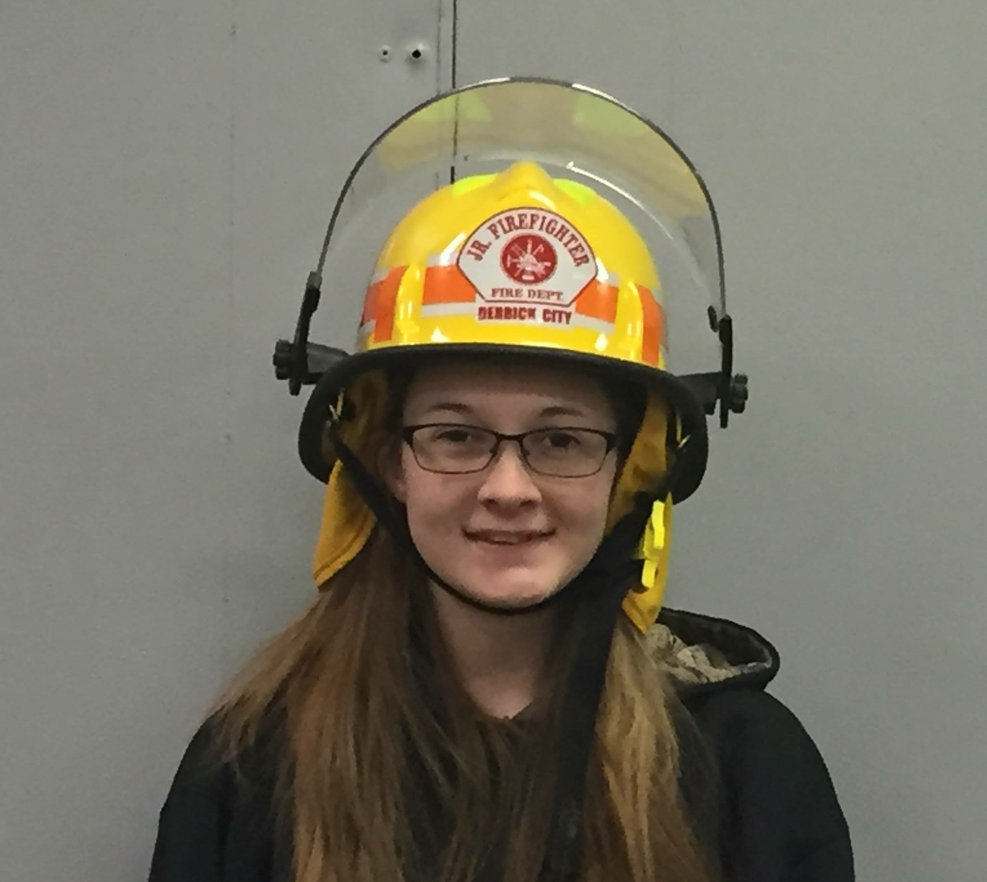  “I highly recommend joining the DCVFD if you’re looking to give back to the community, meet amazing people, and build many skills…” – Charlotte Greene (past junior)  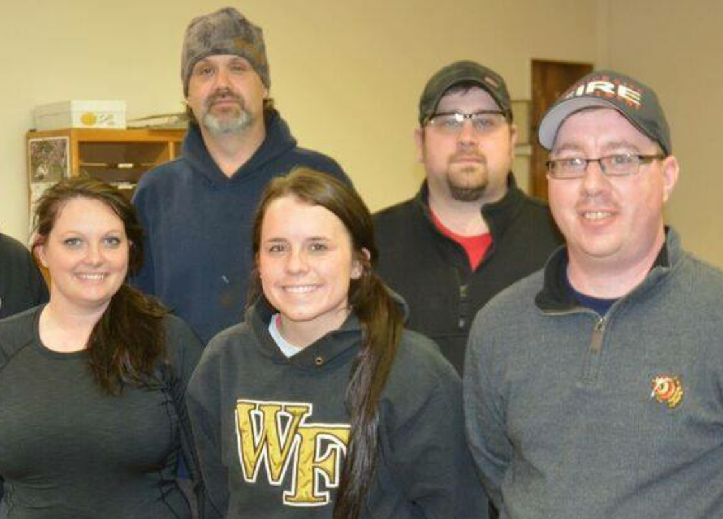  Pictured to the left is the Junior FF Committee (From L to R): Stephanie Scrivo, Ken Scanlon, Sierra Campbell, Jon Barrett, & Jim Kelley. (Not pictured: Tina Yohe)

