Ladies in Training: Session 13 – March 13th, 2015
Today’s lesson was all about area and circles!
Because Saturday, March 14th is a very special pi day that happens once every century (3.1415), we were taught circles along with the areas of different shapes. First, because the girls had some prior knowledge, they were given a pretest and learned more about finding the area of triangles, circles, and parallelograms!
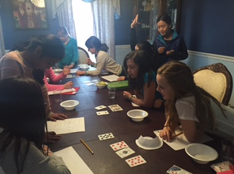
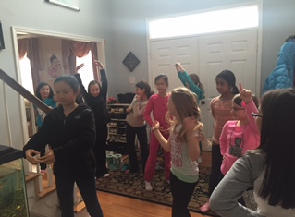
The girls also learned about circles,the different components of a circle, and the importance of pi with regards to the circle.
Afterwards, the girls played a math game in which they were given four cards and used addition, subtraction, multiplication, or division to achieve the number 24. Some of these pairings were extremely tricky, but the girls still got through and figured out the answers!

The girls then enjoyed a game of Statues in which one player acted as a security guard while the rest acted as statues. If the statues moved, and the security guard saw them, they were out.
The girls thought up quirky moves and poses to do!

