0-

**GSPCI Newsletter Pointer Post March 4, 2013**

**German Shorthair Club of Indiana**

Presidents Message:

It was nice to see everyone at the Annual meeting at the brickyard last January. I was pleased to hear that so many people were happy with the direction that the club was going with our new slate of officers I believe we will continue to move the club in a more positive direction. One problem that seems to be reoccurring is one of communication. I have received several e-mails stating that someone didn’t get the word about an event or missed a time. The Club officers are working on putting together a plan that will hopefully work through this problem, one solution would be to up-date our Web-Page that would allow individual club officers to up-date and post messages so any and all members could be kept up to date on all events. The second option which board member Laura Getzen is updating our Face-Book Page so for those of you have an account please send Laura a message so you can be a part of that or Just “Like US” and you will get the info that you need.

Our Annual Fun Hunt was hosted by Ron Ferris at his farm on Sat. Feb. 23rd Last Year’s Winner John Kennedy Made a valiant effort to retain his title as top Shot and Trainer but his time of 4 min. 30 secs was not enough, member Chris Webber and his dog Sydney bested John’s time with a very respectable 3 min. 06 secs. When asked after the event Chris was very complimentary about his dog Sydney and her ability to find and retrieve her birds. As we all know it is a pleasure to hunt behind dogs that make this sport most enjoyable. I myself can’t express how much fun it was to find my own dog on top of the hill that day staunch on point and waiting for me!!!! Priceless.

Our next big event will be our Spring Hunt Test held on March 23rd and 24th at Glenns Valley Conservation Club we will need as many food donations and help as we can get to make this event as successful as last fall. All the judges and preparations have been made so we Need Entries I would like to see as many of you out there as I can so save the date if for no other reason than to watch some good dog work.

I need some in-put on putting together another training day like we had last year with Bob and Jared from Boberosa Kennels. Do we want to try that again or perhaps find another format or trainer? Please e-mail me at [guerrini.vince@gmail.com](mailto:guerrini.vince@gmail.com) with your ideas. Well I hope that the winter hasn’t been too rough on everyone and you have had some time to spend with your family and dogs I look forward to seeing everyone in March so until then be SAFE!!! Vince

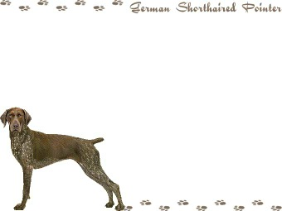

Board Members

**President** - Vincent Guerrini

[guerrini.vince@gmail.com](mailto:guerrini.vince@gmail.com)

**Vice President** – Kirk Johnson

**Secretary/Treasurer** - Debra Moline

[runmom1435@aol.com](mailto:runmom1435@aol.com)

**Board of Directors**

Larry Harris Mark Holzinger Ron Ferris

Laura Getzen Matt Cosgrove John Kennedy

Chris Weber Giles Hoyt Brittany Moline

Indiana Hunting Seasons

Deer Firearms: November 12th – November 27th Deer Muzzleloader: December 3rd – December 18th Deer Late Archery: December 3rd – January 1st, 2012

Wild Turkey (Archery Only): December 3rd – January 7th, 2012

Squirrel: August 15th – January 31, 2012

**Ruffled Grouse (Private Owned Lands): October 1st – December 31st**

**Ruffled Grouse (Public Lands): October 1st – November 11th**

**Pheasant (cock only): November 4th – December 18th**

**Quail (North of SR 26): November 4th – December 18th**

**Quail (South of SR 26): November 4th – January 15th, 2012**

Rabbit: November 4th – February 15th, 2012

Crow: December 13th – March 1st 2012

**“B R A G G I N R I G H T S”**

Let’s all get off to a Great start this year with our training and sharpening those rough edges. Some of the guys have ended the year with some great out of state hunts and new game; while others stay local enjoying some of the training grounds close to home. Due to weather our ***Steve Hammond Memorial Fun Hunt*** was delayed, to our benefit! The weather this year was great and gave the opportunity to enjoy being out with our dogs and each other.

C:\Users\Laura\AppData\Local\Microsoft\Windows\Temporary Internet Files\Content.IE5\9W9VH1NS\MC900329538[1].wmf

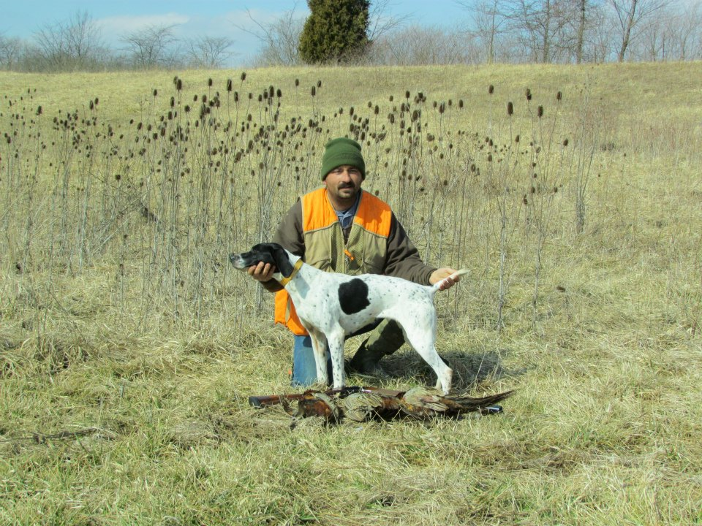

**Congratulations** to Chris Weber and his Sydney for their win at our Annual Fun Hunt. Winning Time 3.06 Fantastic grounds work between friends! Very Nice!

[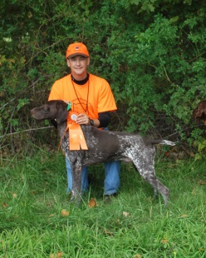](http://www.facebook.com/photo.php?v=10102531922942989)

Kirk Johnson and Deizel pulling out an amazing 3rd place at the Steve Hammond Memorial Fun Hunt with a time of 4.23

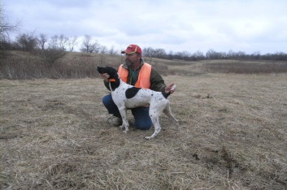

Great Job to John Shaw with Ferronhaus Marco. Diligently moving in on those birds at a fast 4.11 Nice Work!

**Our Club Veterans** 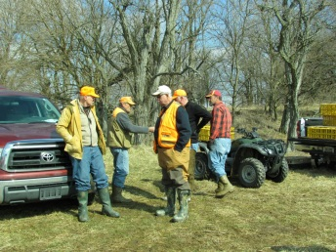deciding how to slow down the younger guys!

I think you taught us all to well, so, Thank you for all you do!

In Kentucky finishing Diezel’s SH Title. Now they are focusing on MH Title this year. Can’t wait to see that finished Title. Keep up the good work!

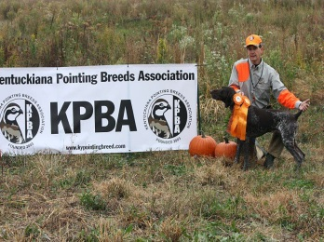

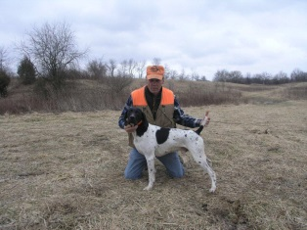

Ron Ferris with his Marco knocked out 4th place with a standing time of 5.22. Very Nice!

If you have a bragg that wasn’t included that doesn’t mean you were excluded. Please send any wins or Braggs you would like to have featured please email them to Laura Getzen, Newsletter Editor [markorlaura@comcast.net](mailto:markorlaura@comcast.net).

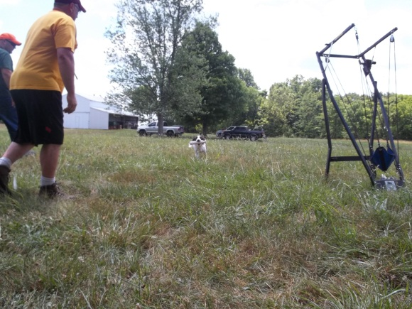

**Where did they come from?**

|  |  |
| --- | --- |
|  | |
|  | |

**Arko-Audi Legacy**

The tighter we wind the influence of these two great sires together, the better the results! Check out the results of the recent Steve Hammond Memorial Hunt:

1st place (Chris Weber) Sidney-Grand Daughter of Audi, Great Grand Mother was Audi’s littermate, Great Grand Daughter of Arko  
2nd place (John Shaw owned by Ron Ferris) Marco-Grandson of Arko, Great Grandson of Arko and DeeDee, Great Grandson of Coal (1/2 brother to DeeDee and Audi) Great great Grandson of Audi  
3rd place (Kirk Johnson) Diesel Grandson of Audi, Great Grandson of Audi       
4th place (Ron Ferris) Marko same as above  
5th place (Kirk Johnson) Izzy Mother of Diesel, Grand Daughter of Audi

Arko himself had a 4:11 run but his handler missed the birds- Arko turns 11 years old March 4, 2013. Older and slower but ability is still there. Audi will be 15yrs old in June, retired but still producing viable semen.  
As a breeder, I'm proud, to say the least, of what these two great sires have meant to the GSP breed here in Indiana and Nationally.

Ron Ferris  
Ferronhaus Kennel

**DON’T FORGET! Save the Date!**

**MARCH 23 & 24**

**Spring Hunt Test**

**Glenns Valley Conservation Club**

**Closing Club Notes**

**Our Annual Meeting**

We had another great meeting to start the year off. We said hello to a few new board members and sadly said good bye, as far as the board, too few as well. Many ideas were discussed and tossed around to get us all a little more involved and how to invite people into the club also. Facebook has already begun to be utilized and we look forward to implementing other fun ideas. Send any ideas you have to us so we can continue to grow the club. Think about, if you were to invite someone to join what would you tell them about us? What more can we be doing? Send and post your questions, stories and success to someone. Another great thing is to send in a great thing you have seen another club member doing and how it affected you and your dog. EMAIL, FACEBOOK or a CALL.

**Spring Hunt Test**

Spring Hunt Test held on March 23rd and 24th at Glenns Valley Conservation Club. Remember to be thinking about what food you want to donate and better yet……..Participate. Set the date and fill out your entry as soon as possible! See you there!

**Facebook! FB!**

Ok folks. Some fun changes have arrived. We are going to make better use of our technology. Here is how you can all HELP!

Monthly, until further notice, I need everyone to message Laura Getzen on Facebook a picture of your GSP. Be Fun with it. You have, every month, from the 1st to 24th to send me pictures on Facebook to Laura Getzen or email them to [markorlaura@comcast.net](mailto:markorlaura@comcast.net). Then I will post all of the pictures by the 25th of every month for a “LIKE” Contest. The contest will last until the last day of the month. Whoever gets the most “LIKE” ‘s will be our profile picture for the upcoming month. The winner will be posted on the 1st of every month for that month! This will generate buzz for the club. This will be a great way to get our club in people’s faces monthly. The greatest advertisement is word of mouth, so let’s have fun with this and get beautiful, funny, stunning, showy and hunty pictures. Pass the word to your friends! There is one catch, to enter; you must be an active member of the German Shorthair Pointer Club of Indiana.

**Like, Send and Post those Pictures!!!!!**

Breeders

Please make sure you email Christy Featherson if you have any litters available or coming. Christy is listed on AKC website as a Breeder Referral. Also for ***members only***, post your litters to the “German Shorthaired Club of Indiana” Facebook page.

Christy Featherston [artemisgsp@aol.com](mailto:artemisgsp@aol.com)

Volunteers

During the events we host or attend there is always room for help. May be it food, cleaning up, setting up or just offering. Contact is easy to make to offer any assistance where needed. There is no specific list for this, or maybe there is and were all on it!

Give where you can and lets all do our part to help things pull together. We have many members who already help and volunteer for many things we do. So a BIG Thank You to them and lets continue to all support and help with our efforts!

Our Dues are PAST Due!

The German Shorthaired Pointer Club of Indiana is a club dedicated to the celebration and advancement of the German Shorthaired Pointer. Our club members are made up of people who use their dogs to hunt, hunt test, show, agility, search and rescue, exercise, and have as the family pet. We feel this breed of dogs is pretty special, just ask us! Our club is active and sponsors several events throughout the year. Information to join is listed on this site. We feel the **$25** dues per year aremoney well spent. Application to the club is listed on this site. **Your dues are due in December; let’s make it a record year on how fast we can get our dues in!**

Thank you for all the help from each of our members this year.



Other informative sites; <http://www.bdarn.com/calendar/> <http://www.nstra.org/> <http://www.gspca.org/> <http://www.centralindiananavhda.com/> <http://www.glennsvalley.org/>