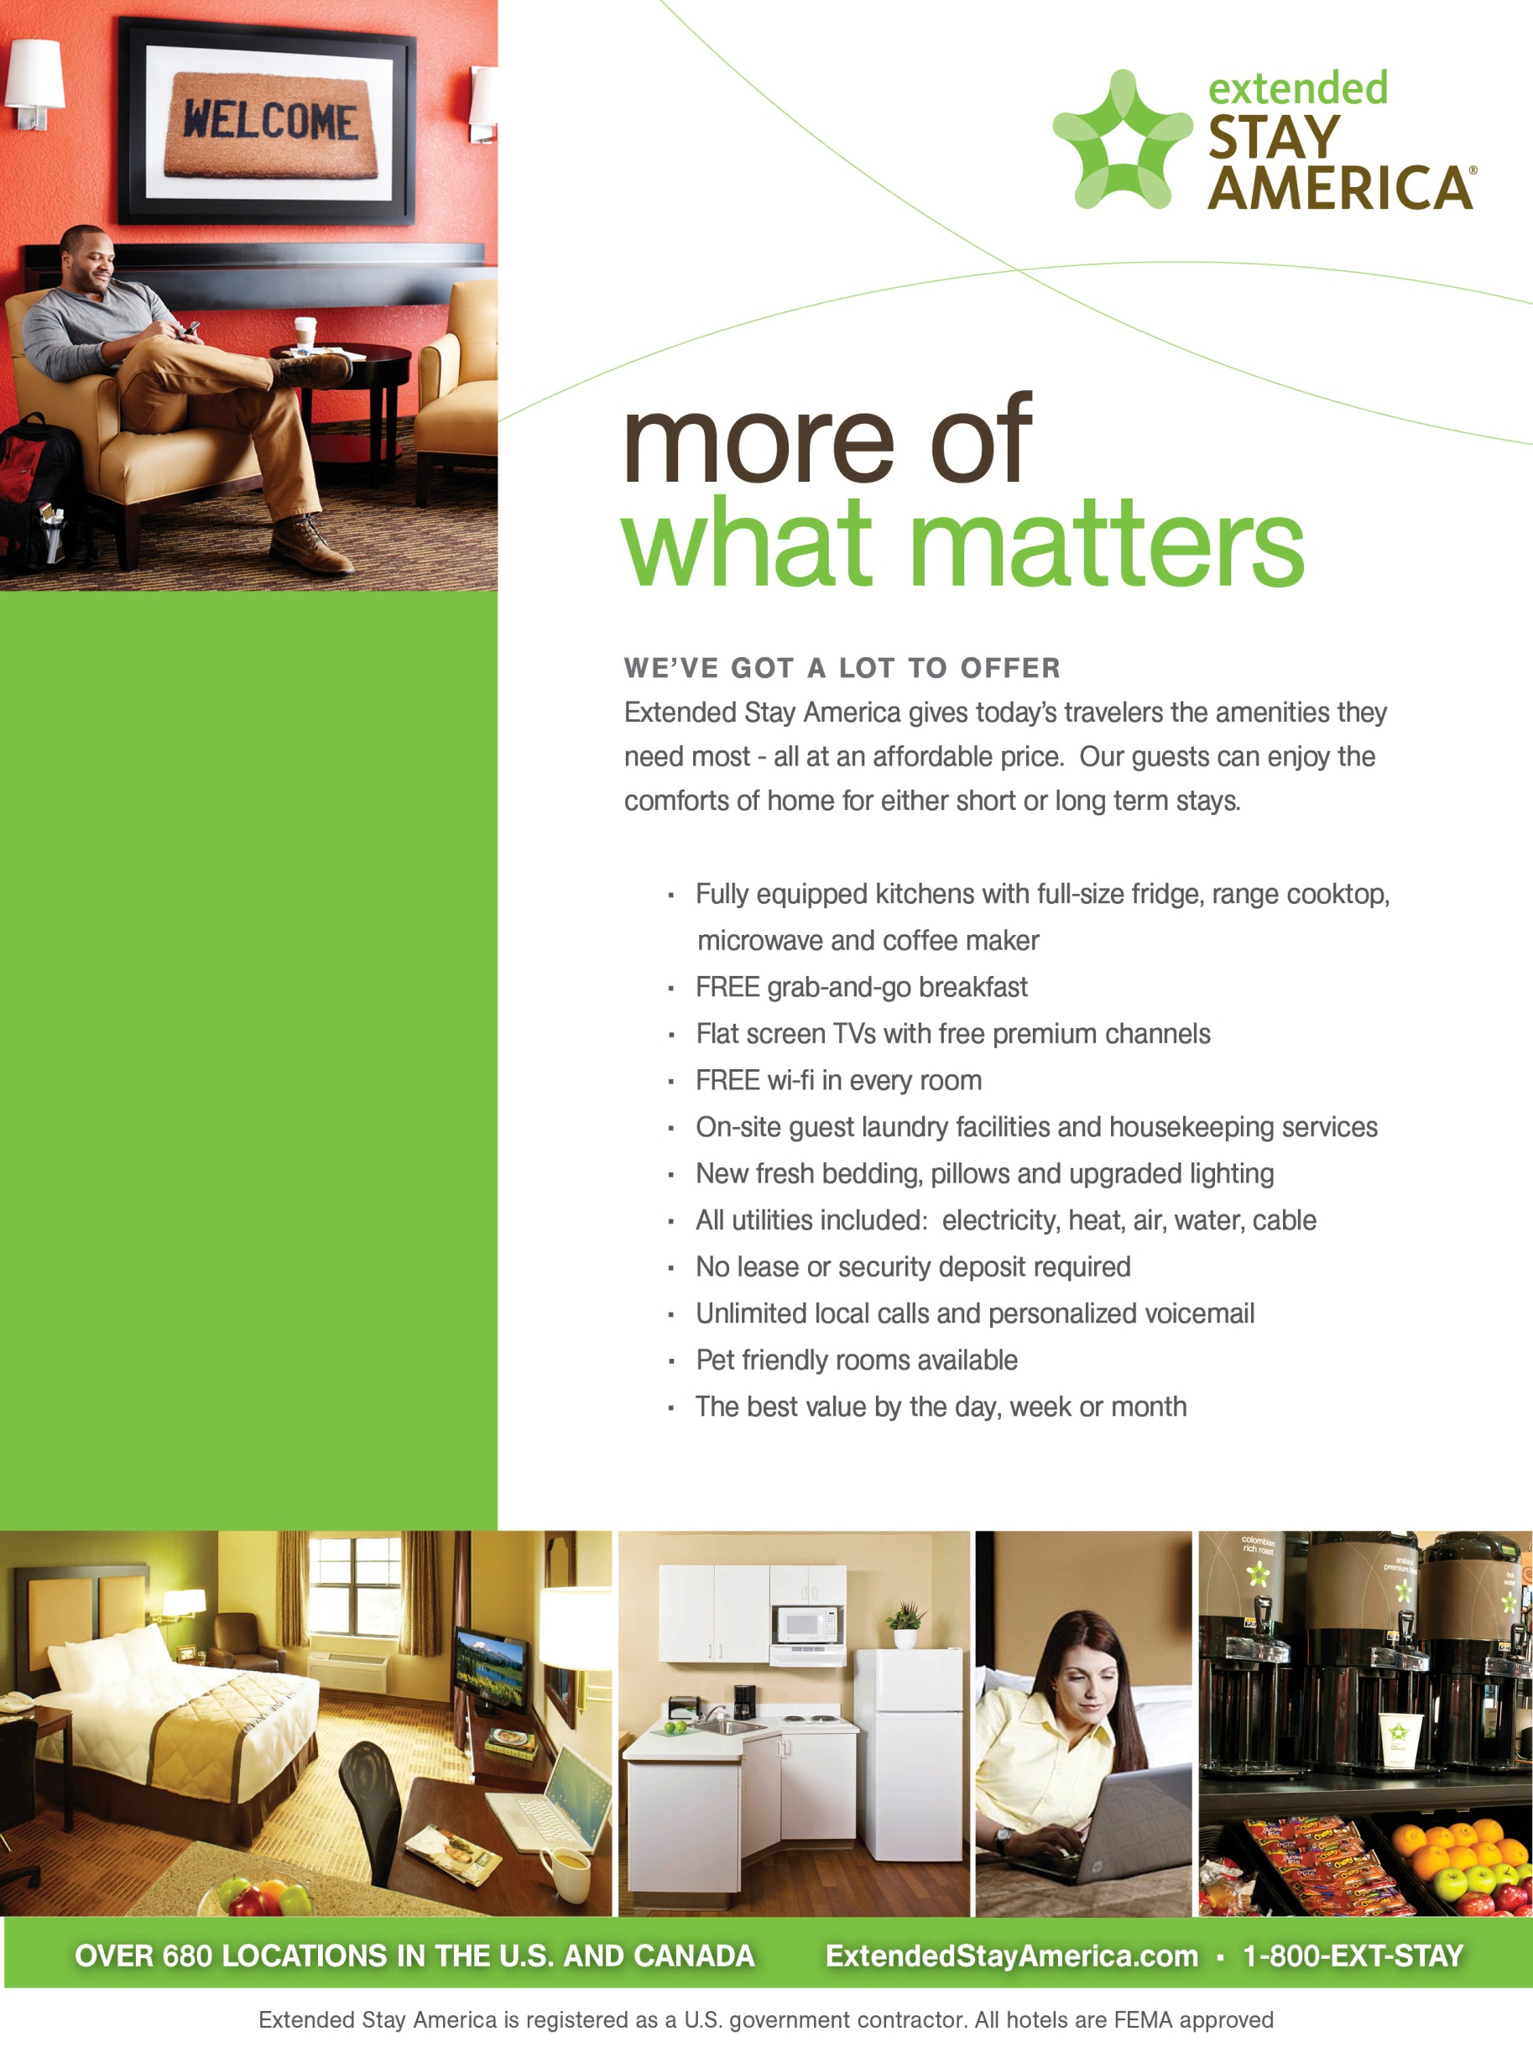

Walking Distantace to WSOP specia 2018 rates offered at ***Valley View***

$59 for 1-29 nights

$51.99 for 30+ nights one bed

$59.99 for 30+ nights two beds

***Extended Stay America Valley View***

**4270 S Valley View Blvd**

**Las Vegas, NV 89103**

**702.221.7600**

**Extended Stay America East Flamingo**

**1550 East Flamingo Road**

**Las Vegas, NV 89119 702-731-3111**

$61.74 for 1-29 nights

$60.93 for 30+ nights one bed

$79.49 for 30+ nights two beds

**Extended Stay America- Midtown**

**3045 S Maryland Pkwy**

**Las Vegas, NV 89109 702.369.1414**

$85.49 for 1-29 nights

$58.49 for 30+ nights one bed

$67.49 for 30+ nights two beds

All rates are subject to Change

*Rates

On line at [www.extendedstay.com](http://www.extendedstay.com)

Company code WSOP

**WELCOME WSOP Mention WSOP and get 10% off at our 3 Las Vegas Locations**

* Fully equipped kitchens with full-size fridge, range cooktop, microwave and coffee maker
* FREE Grab-and-Go breakfast
* Flat screen TVs with premium channels
* On-site guest laundry facilies and housekeeping services
* New fresh bedding, pillows and upgraded lighting
* Unlimited local calls and personalized voicemail
* Pet friendly rooms available
* The best value by the day, week or month
* Pool at Valley View and Flamingo locations
* Meeting rooms - Flamingo location only
* On-site Fitness Facility at Valley View and Flamingo locations