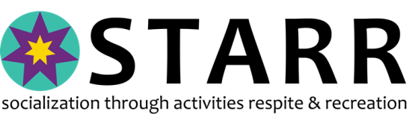

Super STARR Ambassadors Program

Mission: To provide select STARR participants the opportunity to promote STARR activities and participate in the acquisition of donated goods for events and fundraisers.

Criteria to be Super STARR Ambassador Chairperson:

- Seek out members (5 maximum on committee) and review recommendations for new members. Find them at our Recreation and Respite Events!
- Hold 1 meeting per month to set goals for Ambassadors for upcoming events Choice a day and time that works for you!
- Coordinate Donations This is to be sure we don’t ‘over ask’ for support.
- Provide a written report to Executive Director by 2nd Thursday of each month, which will be submitted via email to the Board of Directors A very simple form is provided!
- Supervise Ambassadors at events and fundraisers Have a blast here!

Criteria to be a Super STARR Ambassador:

- Display leadership skills
- Willing to speak to individuals and groups about STARR
- Willing to contact merchants about donations
- Have transportation to meetings (1 per month) and able to arrange pickup of donations
- Be a greeter at STARR events
- Introduce new guests to others at STARR events. Make sure they are not sitting alone.

Ambassadors & Chairperson will be provided:
- Purple T-Shirt to wear to events and fundraisers (unless there is a theme event)
- STARR Name Tag
This is a brand new program concept. We encourage the Team Leader to be creative & have fun with this idea. We hope to instill confidence, community engagement and socialization skills honing into our Ambassadors with this program. Contact us today!

