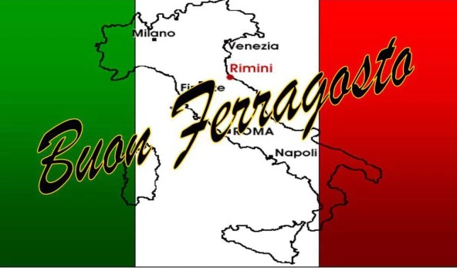

**Get together with friends and family at Nicola’s for a Ferragosto Ferragosto is an Italian tradition that is the beginning of several festivities that mark the end of the harvest season. Come enjoy the light summer dishes while sipping on some exclusive imported Italian Wines**

Wine andDine with Chef Nicola!

**Festa di Ferragosto!**

**Wednesday, August 8th 7:00 pm ~ 9 pm, $59 per person RSVP 614.459.7000**