Financial Security ©Robert H. Black 2016
Introduction:
There is no real security. As General MacArthur said:” There is no security there is only opportunity. “ The closest thing to security is portable skills. With the rapid change of technology any high skill profession is a treadmill. In times past a carpenter could acquire skills at an early age and they would last a lifetime. This is no longer true. Every trade and profession moves rapidly. Sometime back my friend Bob Bremkamp said that everything he learned about computers was no longer useful after five years. He had to constantly study to keep up. I am sure that the cycle time for computer knowledge is not getting longer. From a personal viewpoint there is only one answer: Learn, Work, Learn, Work, Learn, Work....

When you are young the best investment for financial security is development of marketable skill. Investing in skills in the arts may make for a good hobby but there are literally thousands of great singers, musicians, dancers, painters etc. for every one gainfully employed in his profession. Skill in technical fields like science, math, engineering, business, medicine and law are more likely to be in demand. Knowledge of history, science, math and economics are needed to be a good citizen.

From a macroeconomic viewpoint, when someone is retired, someone that is not retired provides all of their goods and services. People in retirement need to have a reason for people who are not retired to provide goods and services. Ownership in things that society sees as valuable can be sold to get money to obtain goods and services from these people who are not retired. If you are going to depend on Social Security for at least part of your retirement, then it is important that the burden on the people who are not retired is reasonable. The only way to do this is for the people who are not retired to be very productive. The ability for the government to improve productivity directly is very limited. The government can build roads, canals, bridges and dams. The government can advance science and technology by supporting these endeavors. It can also provide education for citizens that make them more productive. These things can improve the productivity of the society but these improvements are not useful without the efficient deployment of capital. Making the government more productive also helps. To the extent that the government is spending money the economic burden on the people who are not retired reduces both their productivity and their ability to provide goods and services to those who are retired. With lower taxes there is capital available and with the pressures of free market competition, businesses become more and more competitive and therefore more productive. The Fair Tax is the best idea. (I have added a short description of the Fair Tax at the end of this book. For more information, go to: www.fairtax.org) Unnecessary regulation has the same effect as higher taxes. When considering a regulation, the benefit must be weighted against both the burden on business as well as the cost of the bureaucracy needed to do the enforcement and the corruption that will creep into that bureaucracy.

In the present business climate and in the future, as far as I can see, the entrepreneur will grow the small businesses and create new products and new jobs. Large businesses will acquire these new small businesses and make them more productive. This is, probably, an accelerating phenomenon.

In summary, to have an acceptable retirement: Learn skills throughout life, work diligently, save by investing in things that have lasting and growing value, vote for candidates that will create an economic system that encourages increasing productivity and allows the market to be free.

To retire having debts is a real problem. As a life plan do the following:

- Not have any payments on appliances, furniture or electronics after age 23,

- Don't keep up with the Joneses; Start with used and low cost. Later buy selectively things that will last a lifetime. Buy the time you are 40, you will have the best stuff.

- Be a late adopter of electronic devices. They will cost less, be more reliable and have better features.

- Not have any car payments after age 25: After paying off the first car, keep the car and put the equivalent of a car payment into a savings account. Only buy a new car when the savings account builds to enable payment in cash.

- Have savings of at least 3 months of expenses on hand by age 30. These savings are in addition to any retirement funds.

- Not have any mortgage after age 50. Buying a first house at age 25 with a 20-year mortgage will allow attainment of that goal. Subsequent houses should be paid with savings plus the equity in the first house. Having children in college will delay payment.

In thinking about retirement it is important to have a plan.

Having financial security through life requires investing. To have the best return requires knowledge and care in investing. If anyone says they know exactly what to do they are not telling the truth. Every day there is at least one stock that goes up by at least 1 percent. If this stock had been known in advance, then it would be possible to make more than 1 percent per day. One percent a day for four years would turn $ 1,000 into $ 20,959,155. I am not that good and no one else is either. There are some things that can be known and it is possible to do quite well.

I had an early experience that has been of value all of my investing life. The first stockbroker I met with was older, wearing a well-worn suit and taking time with me to invest a few hundred dollars. I came to realize that he did not really know how to invest or he would be rich and not need my money

It is best to work out a complete budget. Below is the budget that I made before deciding I didn’t need to work anymore.

Expenses
Property Tax
House pest control
Alarm System
Insurance House
Boat
Cars
Umbrella
Blue Cross

Health care deductibles
Dental
Lawn Service
Lawn chemical service
Maid Service
Boat docking
Boat Maintenance
Boat cleaning crew
Accrual for new cars
Cell Phone
Dish Network
Comcast
Queens Harbour Dues
University Club Dues
Electric and Water

Total Fixed -------

Groceries
Car service
Gasoline
Clothing
Eating out
Miscellaneous
Travel
Cash
Church
Total Variable -------

Total expenditures ---

Income

Income
Investments X .065
Social Security
Pension
A
B
Total Income
Remaining (decrease of capital)

The bad and the ugly of investing

The prices in the stock market go through cycles called sector rotation. There are 98 sectors that will come and go in style. The market will overvalue steel, then toys, then oil exploration etc. It starts when a sector is reasonably valued or slightly undervalued. The pension funds, the insurance companies begin accumilating in that sector. When this starts to drive the price up the pension funds and the insurance companies stop buying but by that time the momentum investors have started buying. These are funds, trusts and individuals that buy what ever is going up. This is like a herd of cattle that is spooked by a clap of thunder. One cow will jump and start to run and the whole herd will stampeed. They do not know why they are running or where they are going. Soon the initial holders will start to sell and the price will plateau. The funds and insurance compamies will want out and take their profit. They can’t dump their stock on the market without driving down the price so that sell it through brokers through what are called black pools. This enables the sale of big blocks of stocks without tiping the market. The price is below the market price to give an incentive for the brokers to buy stock. The brokers then do what is called pump and dump. They tell their clients about this stock that is contining to go up. When it is all sold to the retail investor the price then heads down and the stock becomes out of style. The brokers change their recommendation from buy to hold and then after it is too late to sell. The price usually then moves below a reasonable valuation. Individuals that get in late and get out late lose big. The only good part for the individual investor is the ability to get in and out without effecting the market. The individual brokers that do this aren’t necessarly crooks but are selling what they are told to sell. Brokers are to the finance industry as car salesmen are to the automotive industry. In any case when we are buying, we are buying it from someone else that doesn’t want it at that price.

If this were not enough at the same time the stock market is being manupilated. For a small company it is easy to spook the market in order to either sell at a better price or buy at a better price. Below is the order book for DDE on December 11 at 2:16 PM

Bid Ask
Price | Price | Size
1.40 | 1.45 | 100
1.39 | 1.48 | 100
1.24 | 1.50 | 100
1.07 | 1.54 | 100
 | 1.66 | 100
Bottom of Form

Notice for less than $1,000 it is possible to drive the price up or down more than 10% . Since many buying and selling orders are at market your efforts would be aided by the at market orders and also the momentum crowd would join in. By doing this and what Cramer also recommends, publishing information on the company either bad or good the price could be made to move dramatically up or down. This is like spooking a herd of cattle. Now that you know that this is happening it is easy to see. Do not be one in the herd that stampeeds off of the cliff.

This is one reason that Warren Buffett says” The stock market is a mechanism for transferring wealth from the impatient to the patient.”
If you understand why you are investing in a stock it will be easier to not panick when the Cramers are at work.

The free lunch can be the most expensive you ever had. They are wonderfully effective salesmen. They will kill your retirement. Mostly they are selling annuities. Annuities are the favorite product of the free lunch salesmen. Annuities have an upfront commission as bad as 10% that the broker and the issuing institution share. By reading the agreements this can be spotted in the early surrender charge. Buying an annuity today and cash it in tomorrow will reduce your portfolio by about 10%. The annuity growth or imputed growth is low compared to alternatives. In short it is illiquid, low yield, and has a high management fee

Be careful of the free lunch or dinner with a lawyer. One of their tricks is to have you appoint them as the administrator. They will be able to bill to the estate forever. Your estate will become their retirement portfolio.

Insurance salesman will sell long term care (Sometimes called Custodial Care) insurance and sometimes they sell burial insurance. It is possible to prepay burial expenses. Insurance for burial is seldom a good investment. Insurance is good for someone that must provide an income for someone else. Good term insurance for someone working to provide for there family makes sense. Custodial care insurance is unlikely to be a good value. A good assisted living facility it is likely to be less expensive than your current cost of living. The reality is, no one lives very long in a nursing home. All other costs go away. All other insurance policies are combinations of annuities and term insurance. The insurance salesmen make good money, but they seldom provide value for people in retirement.

Because of the conflict of interest never use a broker as an advisor. What makes money for them seldom makes money for you. The investment advisor that charge a continuing fee are also to be avoided. Only use advisors listed on Financial Industry Regulatory Agency web site (FINRA) They can be found at finra.org and charge by the hour. This book is to equip you to be your own advisor.

Use one of the big discount brokers as custodian. Some to consider: Fidelity, Scottrade, E*Trade, TD Ameritrade, Charles Schwab. Always trade on line, it is lower cost. Full service brokers will not let you do what is best for you and only let you use their products. They also aggressively push what is best for them. Stay away from them. They include: Merrill Lynch, Edward Jones and Raymond James. Always use the bigger discount Brokers as custodians. There are two agencies that are set up to provide security for investors: FINRA and Securities Investor Protection Corp (SIPC). Users of small companies and those that give a broker control are not well protected. Never give a broker control in any case.

The Broker may be a crook, but even Brokers that are not outright crooks will have a conflict of interest. Brokers make money by:

- Selling mutual funds

- Selling initial public offerings and secondary offerings where they earn extra commissions,

- Selling Annuities,

- Churning your portfolio

- Pumping and dumping stocks from black pools

- Skimming from customer accounts (They are usually caught and even if some funds are recovered any possible growth in value is lost)

Mutual Funds have historically performed less well than the average of the market or simply random picks. They have high fees, they are not tax efficient and their customers drive them to buy high and sell low. The buy high and sell low public buys mutual funds when the market is up forcing the managers to buy high and sells when the market has a dip force the managers to sell low. Vanguard funds are the only mutual funds to consider and only for cases when there isn’t an Exchange Traded Fund (ETF sometimes called an Exchange Traded Portfolio to be explained later) The mutual fund companies always show funds that have done better than the market. They do this by continuing to add funds and delete funds. Added funds that happen to do well which is about 30% of the time are continued. Funds that do not do well are closed and the customers are placed in those that have done well. These then only do better than the market 30% of the time. When they say past performance is not an indication of future performance it is true. The Review of Finance did a study on the effect of the fund musical chairs and found the effect of mutual fund survivorship was to make the effect performance 20% lower when dropped funds are included.

Forbes did an analysis of the fundamental reason Mutual funds do not do well. They looked at the things weighting on a typical mutual fund holding.

For a Non Taxable Account:
Expense Ratio .90%
Transaction costs 1.44%
Cash Drag .83%
Total cost 3.17%

For a Taxable Account;
Expense Ratio .90%
Transaction costs 1.44%
Tax excess 1.005
Cash Drag .83%
Total cost 4.17

The analysis’s ability to predict the future value of stocks is worse than simple guessing. They are more often wrong than right the following article in Barron’s is only a recent example and was not a headline because it is not news:

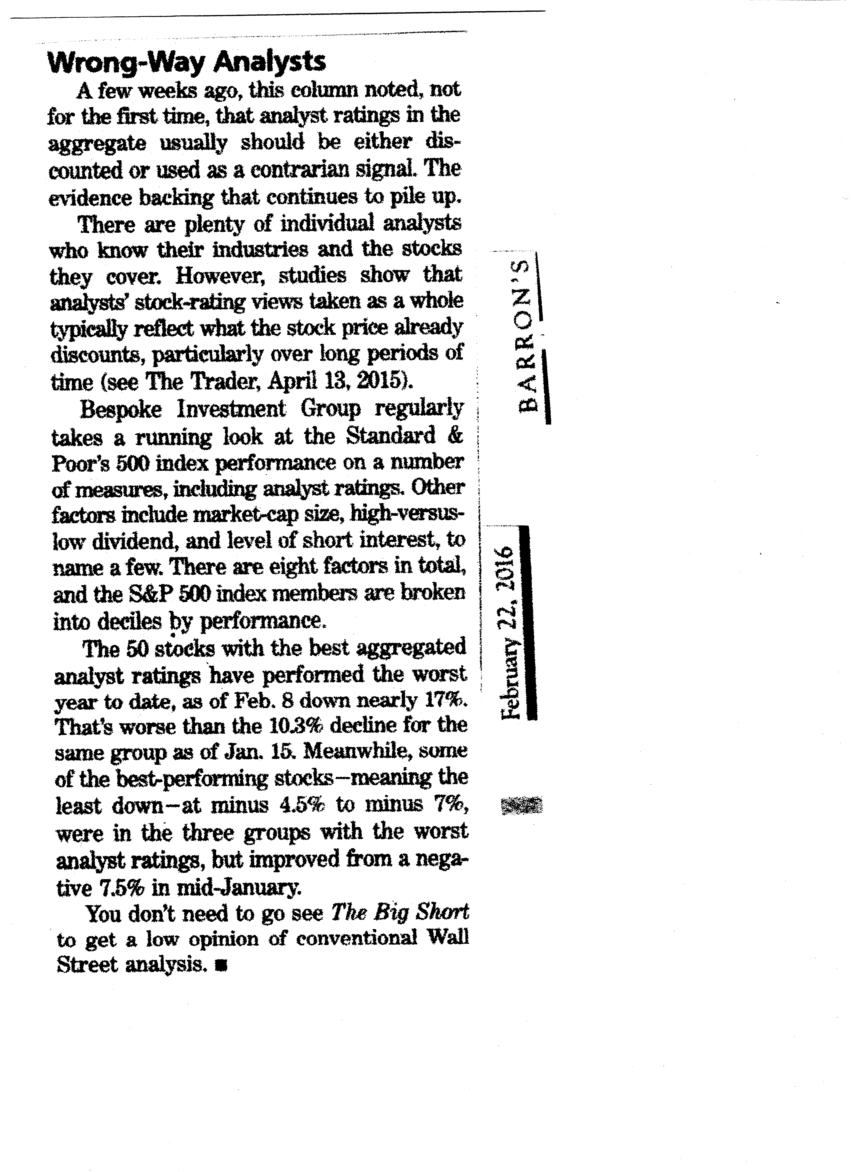
Even the experts paid to predict the overall market do no better than random. The chart below shows their skill. ( Or lack there of )
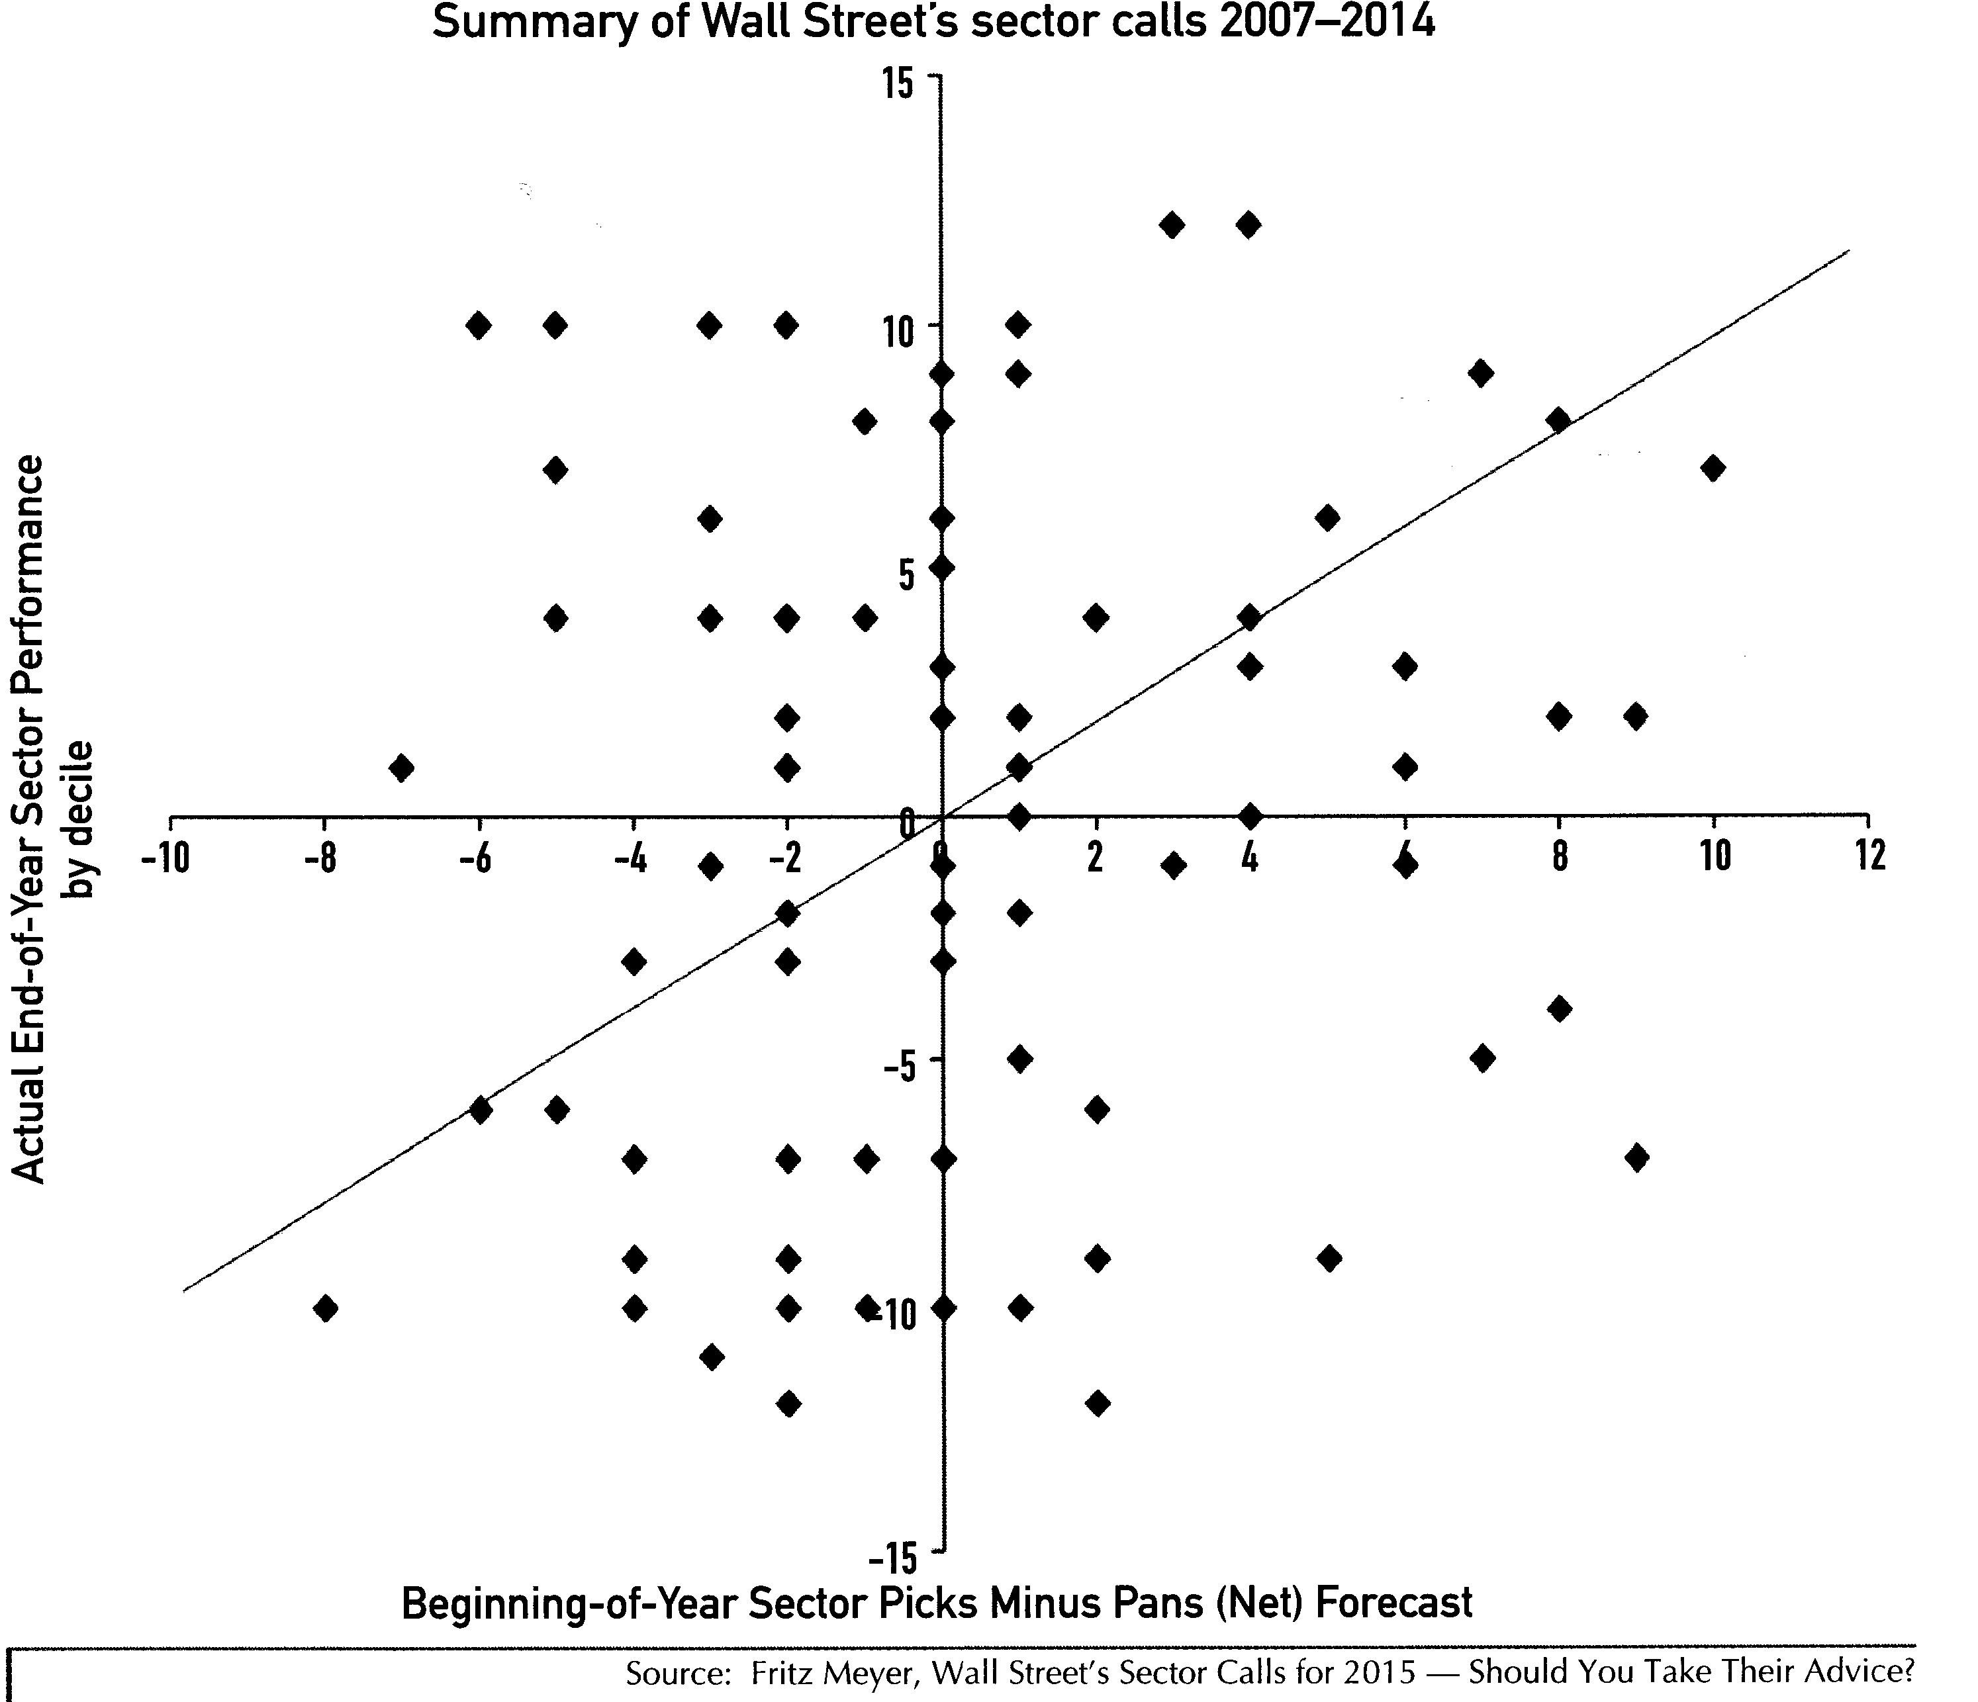

Big Players that drive the market:
There are many large institutions operating in the financial markets. The largest is the US government. The treasury prints money and sells bills and bonds. The Federal Reserve serves as a clearinghouse for inter bank transactions, like checks. The FDIC audits banks to see that they have the funds to cover deposits. The Federal Reserve also sets the discount rate that allows FDIC insured banks to borrow from the Federal Reserve. Lately the Fed has been loaning money to other than FDIC insured banks. This has allowed Wall Street firms to use Federal reserve money for more speculative activities. This rate setting is critical. With low rates the banks can lend at low rates and still make a profit. This leads to more speculative activity on the part of borrowers and banks. With higher rates the banks must charge higher rates and therefore the borrowers reduce activities. The Fed has been unsuccessfully trying to use this system for the last 100 years to stabilize the economy. By making the financial system more stable it leads to more deals with slimmer margins, which then leads to instability. Rather than short dips in the economy we have longer periods of stability followed by big dips. Foreign banks have used the US dollar in place of gold as what is called a hard asset. The current actions of the federal government and the Fed will probably bring this to an end.

The next larger players are the pension funds and insurance companies. These funds must purchase securities that can pay for the retirement benefits and the annuities that will come due. They must invest. This can provide some overall stability except sector rotation. These large players use what are called Black Pools to trade with each other. This is to disguise these transactions from the public. It is a way to allow the public to continue to buy at the top while they are selling at the top. Black Pools provide additional time to get out for the investors who are selling stocks that are in style but can no longer produce income to justify the price. For the investor that buys stocks in style, Black Pools provide a bigger trap.

Each portfolio needs a diverse blend of asset classes and instruments

Fixed Income Instruments

The first part of a portfolio is fixed income instruments. For the last 2,000 plus years, the zero risk rate of interest has been about 3% plus inflation. Things like US long-term government bonds should be at that level. In a stable market, a yield will look like the following:

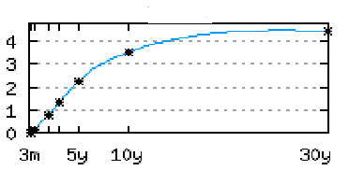

When a period of high inflation is anticipated the curve becomes steep. When inflation is high and it is believed to become lower in the future it can invert. An inverted yield is where short-term rates are higher than long term. We saw both a steep yield curve and an inverted yield curve in the Carter years.

It is prudent to keep some funds in a bank for immediate access. These funds will not earn much interest, so only a small portion of a portfolio should be in money market and checking. In the right bank, deposits will eliminate some bank charges like checking, safety deposit box, certified checks, notary fees, etc.

Bonds, T- Bills, TIPS

Bonds are a promise by the issuing authority to pay the face value at maturity and to make interest payments over the life of the bond. The interest payments are called coupon. At one time bonds had a series of perforated coupons attached to the bonds with a date on each. Coupons cashed like a check. Zero coupon bonds are sold at a discount and then pay the full value at maturity. Governments and private companies issue bonds. When looking at bonds on the secondary market, the factors are face value, coupon, yield to maturity, discount and revenue source.

The US government issues Treasury Bills (T-Bills) that are short term bonds that pay at maturity. These can be used as a safe way to park money that is to be used for a specific purpose, like the down payment on a house or purchase price of a car. The interest rates are too low for any significant portion of a portfolio for any time. Treasury bonds are seldom a good investment. The interest rates are low and taxable. Only when Interest rates are very high should these be purchased.

Buying a bond paying 6% in 1974 was a disaster for some. Buying bonds now ( 2016 ) Has a similar risk.

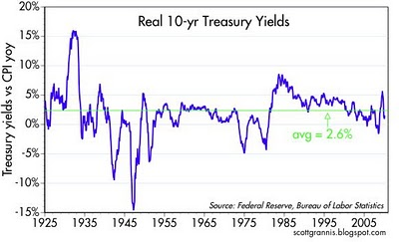

Real 10 year yields have been near the 3% that has been the average zero risk rate for the last 2,000 years. When this was written the interest rates are being kept artificially low. Notice that retirees to Florida lost a one half of their savings in the late 60s and 70s when inflation spiked up. The fed by buying bonds has artificially reduced the rates for bonds and as a result for any fixed income instrument.

The Treasury issues Treasury Inflation Protection Securities (TIPS). They pay a low interest plus the principle grows at the same rate as the consumer price index. These are available from the treasury directly at www.treasury.gov. They can be purchased in 5-year maturities. A good portfolio will provide safety from as many external events as possible. The biggest risk associated with fixed income securities is inflation. TIPS are insurance against this risk. Brokers can buy these on the secondary market. It is not as good but can also be used. TIPS funds can have too many levels of fees to be a good idea. TIPS are not tax efficient both the interest payments and the bond value increase are taxable.

State and local governments are allowed to issue bonds that are Federal Government tax-free. These bonds have good yields. The risks to all bonds are Interest rate, default and call. If purchased when interest rates are high the municipality can call the bonds and replace them with lower interest rate bonds. The investor obtains a return of the principle but is then only able to buy bonds paying a lower interest. The best way around this is to buy bonds on the secondary market with a low coupon that are heavily discounted and have a high yield to maturity. The interest payments are Federal tax-free and the payment at the end is a capital gain. Municipal bonds have a very low but not zero default rate. Look at the source of income and the guarantees. If it is tax revenue that pays the bonds, then the risk is tiny. If it is an industrial enterprise, the risk is usually low but not as good.

Companies issue bonds. The interest is taxable, and, as a result, they pay a higher interest. Corporate bonds can be good in a retirement account that grows tax-free. The same strategy of buying on the secondary market applies when it comes to avoiding call risk. The company should be researched to determine the risk of default. The required research is the same as researching a stock. For high yield bonds that have risk it is sometimes possible to buy a put on the stock so that if the company becomes bankrupt then the put will pay what the bond would have paid. This is an option strategy. Options are discussed later. Depending on the investors tax bracket, some of these outside a tax free retirement account may be appropriate. In order to get the best yield on an investment the initial price of the bond is important. Ziondsdirect.com buys bonds with less mark up than most and should be considered independent of the company holding a portfolio.

Convertible bonds provide an opportunity to gain if the stock appreciates. These can be a good investment if the premium being paid for the conversion privilege is low enough.

Preferred Stock are fixed income instruments that work like bonds except the company can skip dividend payments and there is never return of principal. The dividends are treated better than interest for tax purposes. It requires a high dividend rate to make these a good investment.

For all fixed investments the maturity dates should be spread over time. This is called laddering. This way the funds come available over time and over time the interest being earned will better match the inflation plus 3% historic rate.

There are closed end funds that are invested in both corporate and municipal bonds. They can usually be purchased below the price of the individual securities. The municipal closed end bond funds are the favorite of high wealth individuals. The web site cefa.com is the source for fixed income closed end funds. These can usually be purchased at a discount to the value of the fixed income securities in the fund, are high yield and are managed by investment firms that want to keep their clientele.

Closed End Funds
Closed End Funds are managed packages of investments that trade like stocks. They do not have the down side risks of withdrawal causing loss of value. They often trade at less than the value of the underlying investments. Closed fund aggregators determine a theme and obtain funds from high net wealth investors. After they have the funds committed, the funds buy stocks and bonds that fit the theme and issue shares that are nominally $ 10.00 worth of the assets. The shares sell like stocks and there are taxes only on distributions of dividends or interest. Shares are purchased from another owner and sold to a new owner. There is no need by the fund to sell or buy due to either redemption or fund purchase after issue. Since they don’t have the stampeding characteristics they can be better values in a downturn. The management is the key. The closed end fund association has a good web site: www.cefa.com the web site shows many that can be purchased at a discount to the underlying assets. Their advanced fund selector works well. Sometimes high wealth individuals dump their holdings to buy a yacht or heirs sell theirs. It is possible to take advantage of the temporary irrational dips in the price. Barron‘s is the best place for an overview. Yahoo is a good place for research on individual closed end funds.
“Should you find yourself in a chronically leaking boat, energy devoted to changing vessels is likely to be more productive than energy devoted to patching leaks.” Warren Buffett
There are some specialty investments to consider:

Royalty Trusts
Royalty Trusts hold rights to assets like oil and gas deposits. Their price moves with the price of the commodity. Since all of the commodity will finally be consumed, a portion of the dividends are considered return of capital. Royalty Trusts are purchased just like stocks. They pay high dividends since all of the profits must be paid to stockholders. HGT, MTR, SJT and CRT are some to look at. These trusts can make your retirement independent of the price of oil and gas. If you purchase the equivalent of a lifetime supply of oil and gas in the ground, then your dividends will go up and down with the price of gasoline and electricity. Look at your bills for electricity and gasoline. Estimate how much it would cost to make you independent of these prices in the future. These stocks require as much research as any other stock.

REITs

REITs are another type of trust. Real Estate Investment Trusts represent interests in property. Some specialize in one area like Florida or New Jersey. Some specialize in one type of property like shopping malls, apartments or office buildings. Their dividends carry with them the depreciation on the underlying assets. There are some that are not listed and sold through crooked brokers. Be careful. Buy only the ones that you can research on web sites like Yahoo and are listed on an exchange. The same research is required of REITs as any other stock. REITs are another way to hedge in retirement. If you live in an apartment you could purchase enough of an apartment REIT to pay the rent. This would make you independent of the price of rent since your dividends would move up and down with rent prices. Buy them when the class is down. Consider net lease REITs. Net lease REITs own the property occupied by the major retailers. The retailers agree to pay the REIT all of the occupancy costs plus a fixed fee. Because the buildings depreciate the returns include a tax advantage. The risk is the major retailer goes bankrupt or abandons a property even if they continue to pay. The real estate trusts that had the Linen and Things net lease properties lost a great deal. It is possible to go to some of the properties and see for yourself how they are doing. If you are going to buy a shopping mall REET go to a mall and look at how many of the stores are closed. Look at how many people are at the mall and see if they are buying. For an apartment REET look at some of the properties and see if they are run down and look at the neighborhood and see if it is becoming run down. Go to:Yahoo.com Finance, for REIT ETFs. For researching and studying REITs Yahoo.Com Finance under investing, stock, financial.

MLPs

Master limited Partnerships (MLPs) are limited partnerships or limited liability companies (LLCs) choosing partnership taxation which are traded on public exchanges. A share in an MLP is called a “unit,” and MLP shareholders are known as “unit-holders.” MLPs can be found on the major exchanges, as well as many regional exchanges. They combine the affordability and liquidity of corporate stocks and bonds with the advantages of investing in a partnership. MLPs generally pay their investors regular cash distributions, and many offer growth potential as well. There are over 100 MLPs on the market, the majority in industries related to energy and natural resources. They are more tax efficient than corporations since they do not pay corporate tax. The unit holders pay tax on the partnership profits. Most partnerships distribute more than the profits because of the depreciation of the assets. Distribution in excess of the profits reduce the basis for unit holders. If the units are sold the tax is based on the difference between the sale price and the basis. If they are inherited the basis is reset at the market price at time of death and the avoided taxes never need to be paid. Owning these adds to the complexity of filing income tax. There is also an issue of some taxes. For a list go to: http://naptp.org/PTP101/CurrentPTPs.htm There is an ETF for the partnerships. It is AMLP. It eliminates the tax complexity but the fees are high.

ETFs
ETFs ( Exchange Traded Funds) are packages of stocks that trade like stocks. The funds hold stocks based on a formula or a published index. Some of the newer ones use a complex formula that has been back checked to see that it would have picked companies that increased in valuation. Because of diversification they have less risks than individual stocks. There are some possible major hits when the holdings change. ETFs usually follow an index. The simplest Index is the Dow Jones Industrial Average. The DIA is 30 large companies in terms of the sum of the value of all of the outstanding stock and the bonds. They have been picked by the Dow-Jones company as being representative. This is available as the ETF called DIA. Research ETFs in one of the many finance web sites. I recommend: Morningstar.com if you do not have it with your broker account. The ETF Screener can be accessed free. It requires signing up and sharing your personnel data. I actually use the screener in my Fidelity account. Most of the good discount brokers have a similar screening system. For a good article on the DIA stocks go to: http://en.wikipedia.org/wiki/Dow_Jones_Industrial_Average Stocks come and go on the Dow Industrial Index. When they do the management of DIA must sell these holdings and buy enough of the replacement at a level with an equivalent value. If you know the replacement and buy it and sell the looser then it is possible to make money both ways. In a recent case Kraft split. The pieces were worth more than the whole. Selling ahead of time would not have worked. It only works with companies that are going off because of poor performance. Make your own ETF by buying all of the stocks. Better yet, leave off all of the potential losers. By studying the largest capitalized stocks, it is possible to buy what will be the next winner and sell what will be the loser. Making your own you will save the 0.2% fee charged by the management company. For a good analysis of ETFs go to: http://etfinvestmentoutlook.com/ It will also give a good list of ETFs by Ticker Symbol that can be researched on Yahoo Finance. When considering an ETF, study the holdings, expense ratio, turnover and size. High turnover and high expense ratios are a disaster. Here we want to find ETFs that have been losing value recently but have value and will come back. These are buy and hold, so a great deal of research is needed. By paying .2% as a management fee, the total effect over a 20-year retirement is a loss of more than 4%. With a 1% management fee, the total effect over 20 years is 22%. Fees add up over the years.
For an equity part of retirement buying the stocks of DIA and watching carefully for the laggards in terms of market capitalization works. Sell those before the DIA dumps theirs. Buy the potential replacements before the DIA has to buy them. Look at Capitalization of the top 50 companies to find a winning replacement.
For the novice or the person that wasn't want to spend time worrying about stocks and the market. ETF's are the best way to preserve wealth and still grow to protect from inflation. With a combination of the ETFs DIA and SPY it is possible to beat 70% of the mutual fund managers and only have a small management cost. To protect against US economy problems a portion should be in foreign ETFs.
“The best way to own common stocks is through an index fund.” - Warren Buffett

Options

Puts and Calls are options to buy or sell a stock at a fixed price. Options are ways to leverage stock market investments. In this case Puts and Calls are purchased or sold rather than the stock.

Calls are the right to purchase the stock from a seller at a preset price. It is an option to buy. You can buy or sell a call. If you have the stock and sell the call it is called a covered call. If the call is exercised you have to sell your stock at what is called the strike price. If you are confident that a stock will go up, you can buy the call rather than the stock and gain leverage. Selling an uncovered call is only a good idea when you want to sell.

Puts are the reverse of calls. They are the right to sell a stock at a fixed price. Selling a put is a risky business unless you want to buy the stock on a dip in price. If the stock goes down you must buy it or pay the difference between the stock price and the call price. The possible loss is uncapped. If you are confident that a stock will continue to go down, you could buy a put. Buying a put can be a good bet. If the stock does not go down, then the put becomes worthless. The most to lose is the cost of the put. If the stock tanks the rewards can be large.

A way to play the game is called a strangle. Buy both the put and the call. If the stocks makes a major change in any way, one of them will be worthless and the other may more than make up for the loss and the total will be a net gain.

Think of stocks that have reached a point where the business can no longer support the high price. Look at the Price Earnings Ratio (PE). Think of what the company would have to do to make this company become even an average company. Think of Starbucks at the peak, AOL at the peak etc. Buying a put makes sense.

Gold and Silver:

Gold is just like a secretary I knew. She was not productive and cost the company just to sit there looking pretty. In the long run gold does not keep up with inflation and doesn’t produce anything. In a recent commercial for a company selling gold the announcer said that if gold had kept up with inflation it would be worth over $ 2,000 per ounce. His point was gold was going to go to over $2,000 an ounce. But the reality was it did not keep up with inflation. It is not a good investment for the long run. Even in periods of modest inflation the zero risk rate for fixed interest rate securities will be about 3% plus inflation. Gold is insurance for run away inflation. In Germany during the inflation of the Weimar Republic one German Gold Mark become worth 1 trillion paper Marks. There are people, including me, that think we are in for substantial inflation and as a result I have some investments in gold and silver. Timing is the key. I don’t recommend more than 1% in gold

FOREX
This topic isn’t complete without discussing the foreign exchange market. Forex.com is all-electronic and operates 24 hours per day five days a week. The FOREX market trades trillions of dollars per day. It is the fastest way to make and lose money. Some of the currency exchange rates are rational. Things like a foreign leader having a bad day or the President of the US getting a cold can cause them to be irrational. Do not use your retirement funds to gamble in this market. If you are going to gamble in the foreign exchange market, use your Las Vegas funds.

Inflation Concerns

There have been run away inflation in many countries. Argentina, Brazil, Italy, Zimbabwe, Germany and the start of run away inflation in the United states.
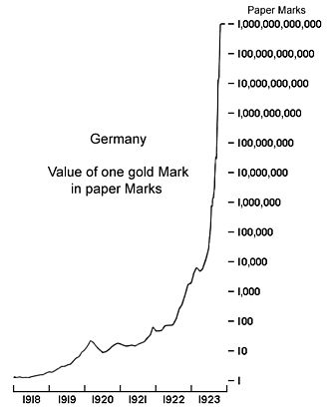
This is what it looked like
in the case of run away
inflation in Germany.

The stock market in Germany initially went up and did end higher with respect to US Dollars.
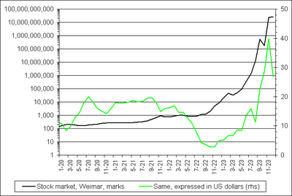

Those who had Gold were OK in the inflation but those in the stock market did better. In order to come out ahead the investor would have needed nerves of steel to hang on from March of 1922 until September of 1923 In the case of Germany stocks were a better hedge against inflation then gold.

Selecting a broker:

This is from Barron’s and is a good guide. For most of us, physical location is important. I use both Fidelity and Scottrade because they are an easy drive. I don’t trade enough make it pay to switch.

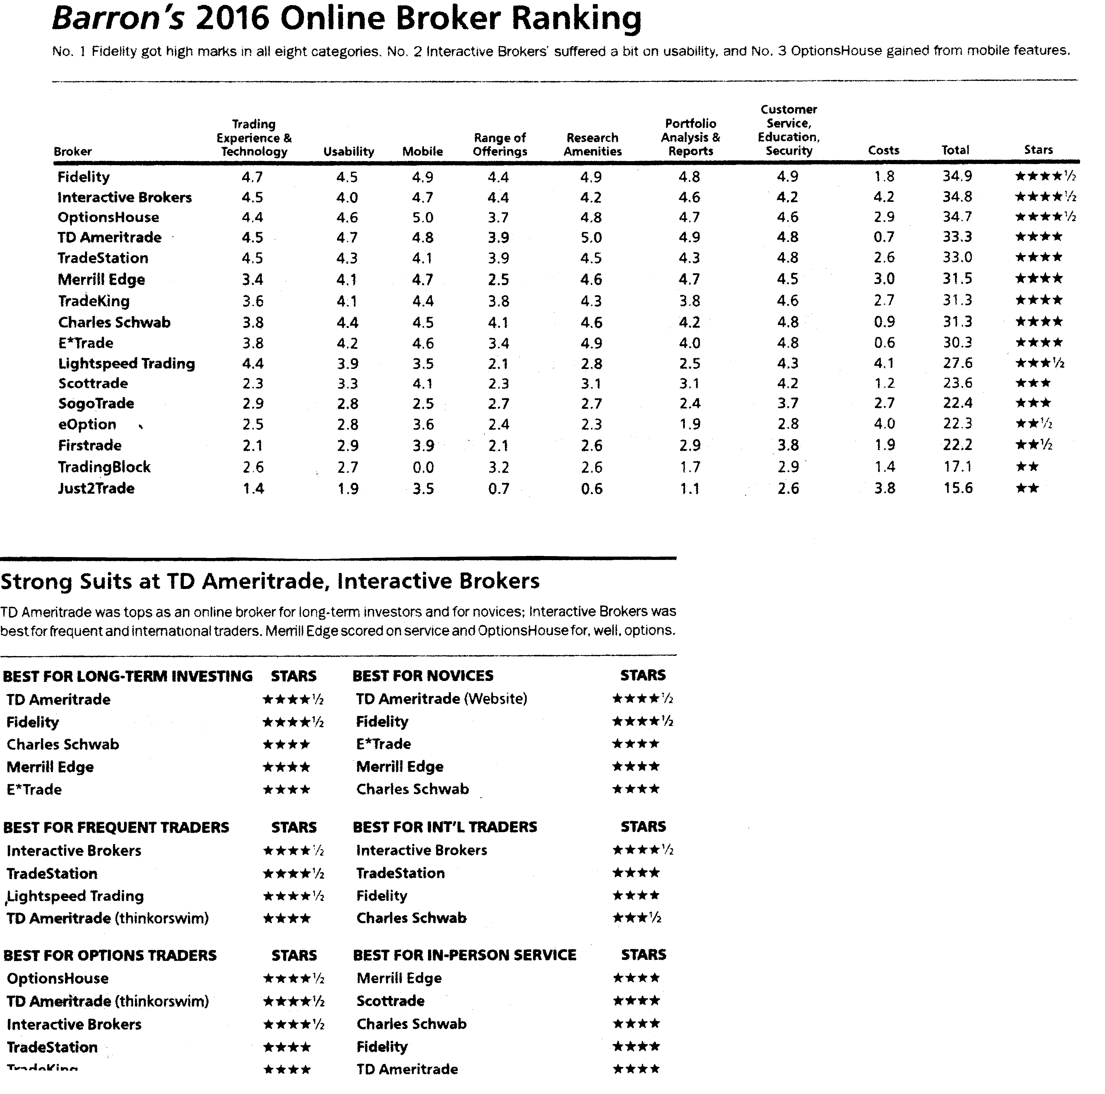
Stocks:

Stocks are equities and represent a part ownership interest. These should be a significant part of a portfolio. Over the long term, equities will appreciate at inflation plus a factor associated with risk.

Warning: If you can’t read and understand an income statement, balance sheet, cash flow statement, K8 and K10 do not invest in individual stocks. Use ETFs. or Closed end funds.
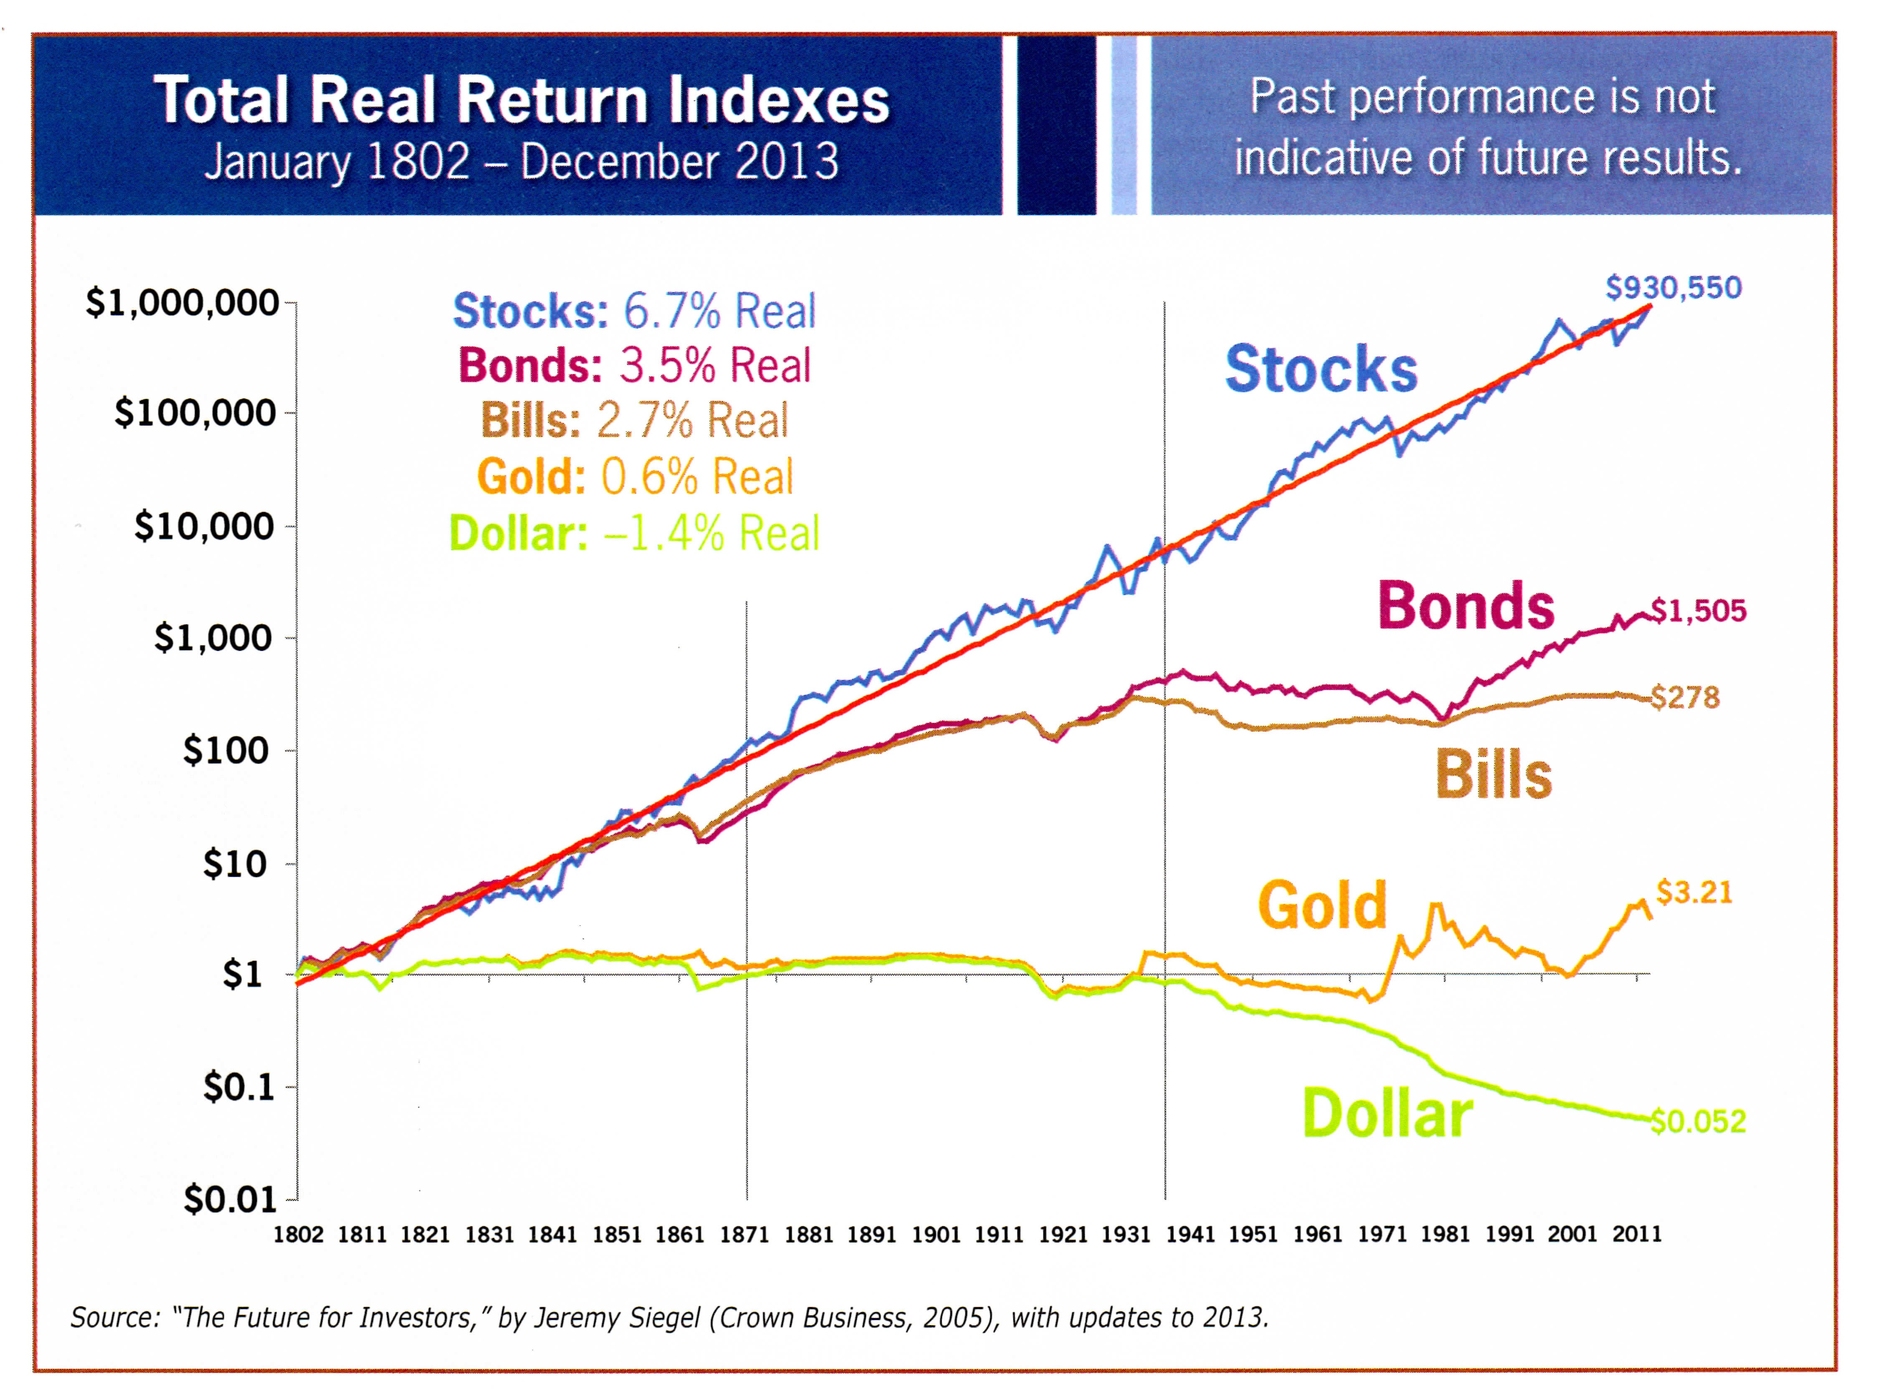

When looking at this chart keep in mind the gains are above inflation and the chart is logarithmic. The dips in the stock chart look small but are sometimes a factor of more than two. The worst thing to hold is dollars.

As you can see in the long run Stocks outperform every other investment type. There are several ways to participate in the stock market. Mutual funds, Exchange traded funds ( ETFs), Smart Beta ETFs and individual stocks. Here it is a case of each investor knowing their limitations. I like to compare it to swimming. It is possible to enjoy the kiddies pool or the shallow end of the grown up pool or the deep end of the grown up pool or swim in the ocean. In any case do not try to go beyond your skill level. I am going to discuss stock picking. If this is too hard don’t do it. If you are an amateur start small and do not risk a significant part of your funds before suffering some losses. Early on it is easy to confuse good luck with skill and to start swimming with too many sharks.

Timing and stock picking are the keys. Timing is mostly not catching a falling knife and not fighting the tape. Fighting the tape means buying stocks when the market is going down. Catching a falling knife is buying an individual stock when the individual stock is going down. To see if the market is going up or down go to go to www.stockta.com. This web site will do a complete analysis and will also give advice on buying and selling. Again enter SPY and look at what it says about whether the stock market is Bullish (Going up) or Bearish (Going down). SPY is an index fund that follows the S&P 500 index. This is the 500 largest stocks on the exchange. It is a good benchmark to see what is happening to the stock market as a whole or for comparing individual stocks. Stockta is to be used for timing. Don’t be a momentum investor. Having determined that buying will not be fighting the tape the next thing is picking a stock. Stock splits, stock buyback, stock given as part of a buy out or stocks distributed as part of a settlement can result in an oversupply or an under supply. Two examples are: When Winn-Dixie stock was given to creditors many of the new owners simply wanted money, making an oversupply. Several buy back programs have created a short supply. Buying Stock in companies with good value in a temporary oversupply can be a good move. Selling stocks that are in a buyback can be better than waiting until the market assumes equilibrium.

The stock market has style. There are 10 sectors and 98 sub sectors in the market. As mentioned earlier the market goes through sector rotation. Sectors will go in style and out of style. What is in style today can be depended upon to be out of style tomorrow. Some of this is due to externalities. Fracking made oil go out of style. Low fuel costs made airlines go in style. Some of the style is also irrational.

Avoid any stock that is in the news, recommended by a broker or a TV show. These stocks are looked at by both professionals and by the naive public. The professionals will see that these stocks are fully valued by buying them if they are a bargain. The naive public will get caught up in the buying frenzy and bid up the price. In the news means in style and there is no way for in style to go but down. The only exception when the news is bad and the stock or stocks go out of style. Stocks recommended by brokers are either in style or they are being pumped and dumped by the broker. Either way they are a bad deal. Sometimes bad news will unfairly drive down the price of a good company. When buying on bad news remember: “the stock market can be irrational longer than you can remain solvent.”

A stock screener is a good way to find potential stocks to purchase. Most of the brokerage companies have a tool to help Pick stocks. I will discuss using finviz.com but the principles are the same and will work with any of the good broker sites. Start by thinking about where things are and where they are going. For example, when this was first being written the building industry was in a major recession and real estate prices are depressed. This was the time to look at building materiel supply companies and Real Estate Investment Trusts (REITs). As of this rewrite the reverse is true. There are also some measures like price to sales. Companies with a high price to sales ratio are successfully selling products but not making much money. They have the opportunity to do well if they can either cut costs or increase prices. In all cases these techniques are a way to find stocks to look at and are only a first step. Return on assets is one of the favorites of Warren Buffett.

For each stock look at all of the information on Yahoo. Read all of the messages. Be careful, sometimes people sell short and put negative information on the message boards. There are sometimes positive things that are not true. Be careful of these as well as articles written by the finance media. The real story is in the numbers. The research reports are seldom needed. Try to decide what are the performance measures that would signal something bad happening.

To really understand a company, it requires knowing how to read the income statement and balance sheet. Read and understand every number on at least 100 balance sheets and income statements before investing in any company. The income statement shows sales, the cost of the goods or services, the cost of general operations, sales, administrative (GS&A). The balance sheet reports the condition of the company at an instant in time.

For timing go to www.stockts.com and see the current trends. It is good to buy at the bottom but the bottom is hard to find. It is safer to buy when the stock has been down and just starts up. Motifinvesting.com provides packages of stocks that are, in their opinion the best in each category for investors. They seem to be good stock pickers and looking at the lists for ideas is a good place to start.

“I don’t look to jump over 7-foot bars: I look around for 1-foot bars that I can step over.” Warren Buffett

Warren Buffett teacher Mr. Graham has some fairly strict criteria when choosing “value” stocks. The great thing about his strategy is that it’s fairly easy to screen stocks to find “Grahamish” stocks.

GRAHAM-INSPIRED RULES

1. P/E Ratio less than 15
2. P/Book Ratio less than 1.5
3. Book Value more than 0.01
4. Current Ratio more than 2
5. Annual EPS Growth (5-Yr Avg) more than 3%
6. 5-Year Dividend Growth more than 0%
7. 5-Year P/E Low more than 0.01
8. 1-Year Revenue more than $400 Million

http://www.milliondollarjourney.com/value-investing-like-benjamin-graham.htm

Like any of the mechanical ways to screen stocks that are well known, it is only a first step and it will miss the best bargains. Since many investors use this technique, the prices are moved higher and the stock will no longer meet the criteria. In the past when I researched companies, my last screen was the broker. If he liked it, I knew I was too late. If he hated it, I knew I had a winner. I no longer use a broker so that will not work for me. A systematic way to research a company is the following:

These are the things to look at first. PE is the price of the stock divided by the earnings of the company per share. I like to think of it as the inverse expressed as a percentage. For example, with a P/E of 10 the company would be making 10 cents for every dollar of shares. For 20 it would be 5 cents and for 50 it would be 2 cents.

Start with the sales year over year and then look at sales quarter by quarter. If the sales are increasing, then think of the hula hoop. What is the limit on growth? Is it a fad? When will growth end? Growing companies are priced in the market at a premium even when the growth is not sustainable. An example was AOL. Save that information for later. Watch for seasonality. Some company’s sales and profits go up and down with the time of year.

Inventory should increase and decrease by the square root of the sales. For example, if the sales increased by a factor of 2, the inventory should increase by the square root of two or 1.414. Retail companies often make most of their yearly profit at Christmas this should be considered when looking at inventories.

Look at Sales General and Administrative (SG&A). SG&A should grow less than the growth in sales. If it is growing more it is a red flag. Accounts payable and receivables should track sales. Growth of accounts receivable in excess of sales indicates that the customers are having trouble paying the bills or they are disputing the bills. Either is a bad sign. Growth of debt and deferred liabilities are only acceptable if there are tangible results in either income growth or improvements in margin. It is important to understand all of the numbers in the balance sheets and the income statements. There are things specific to each industry. In the case of retail, it is same store sales. Some companies grow by opening new stores. This can make it look like the company is growing even when the individual stores are not doing well. Most industries have specific factors that are good indicators.

Next look to see that the price is supported by the basic fundamentals. If the PE (price /earnings ) is not higher than the PE of the Dow Jones Industrial Average (DIA), it is a good buy if there are reasonable prospects of continued growth in sales and earnings. If the PE is above the Dow Jones Industrial average, then there must be some justification based on future growth in sales and earnings. In the long run, competition will drive a company to have an average return on sales. The market will also drive the P/E to be like the market.

Short interest is the number of shares that have been sold short. This may an indication that the people selling short believe that the stock will not do well. When they are wrong, and they have to buy the stock back, it can cause the stock to spike up. Sometimes the shorts (That is what they are called) gang up and cause the price to go so low that it is sold by the funds. The investor needs to understand what the shorts are seeing if there is large short interest. Look at the short interest and see if it is growing or shrinking. Some short interest is not necessarily bad. The hedge funds will short one stock and buy another in order to take advantage of events that will cause one stock to move more than another. This protects them from market movements that will affect both.

Forward P/E is interesting but remember, the analyst’s and the company can be optimistic. As a rule of thumb a 5% return on a company growing at 5% has the same value as a 10% return on a company not growing. Research and development trending down as a percentage of sales is a bad sign. R&D is the future

After analyzing the digested data on Yahoo and finding potential companies worthy of investment the next step is to use the data from the Securities Exchange Commission. Go to www.sec.gov and select: Search for company filings, Select Company or fund name. Then put in the symbol of the company that is to be researched. There will then be a directory come up that will display all of the information that the company has made public. A serious analyst should plow through all of this data. The truth is even the professionals get bogged down in the flood of information. Stock brokers never dig this deep. They cannot do it for every stock that their clients own. In most cases that do not even know that this information exists. There was an analyst, who did the research, and found that Enron was cooking the books. She did this one-year ahead of it becoming public. Her firm fired her after she published her report. Enron was one of their clients. This is something to think about when trusting brokerage firms.

That said, a review of the latest 10-Q will reveal a great deal about a company. Look for any part that equivocates. These are red flags.

Look for related party transactions. This is the way Enron and others have covered up massive frauds. Capital leases are a way to make a company look like it does not have debt when it is drowning in debt. Look at Capital Leases as debt when considering the total debt and evaluate the company's ability to pay it off. In the case of banks credit default protection issued and non-performing loans are serious concerns. All of the off balance sheet items need analysis. If they are hard to understand the average investor is better off simply looking at another stock. There are too many good companies with straight forward easy to understand accounting reports worthy of investment. There is no reason to invest in the ones that make their reports excessively complicated. The crooks always make it complicated. For at least one firm go through one year of the data. Pick a small, uncomplicated company. It is hard work but the exercise will be a good education.

When to sell is as important as when to buy. Do the same analysis as that done on buying a stock on each stock each quarter. If the stock has become overvalued it is time to sell. If the financial indicators like inventory, debt or increasing SG&A are out of line, sell. Decide why you are buying and sell when this changes.

Other than stock picking, there are three ways to invest in the stock market: Mutual Funds, Closed End Funds and Exchange Traded Funds.

On the other hand, look at stocks that are good companies and are down simply because the sector is down. When a sector goes out of style all of the stocks in the sector suffer. This is usually due to some major problem in the industry. A good example is banks. The sub-prime loan business has hurt most banks. All of the banks went down even though some did not have the problem. Buying the banks without the problem is good. Buying a call provides more leverage. The risk of a call is in the timing.

If you have a stock that is volatile, and you want to sell it consider selling the covered call. You get paid for the call and if the stock goes up you get the strike price. Some people write covered calls over and over for he same stock. It is a way to make money in a down or flat market. There are two down sides: 1) You will lose the opportunity for any large gains 2) If the stocks have major problems and you want to sell the stock you will have to buy back the call or take a chance that it will not spike up. All Covered Call funds have failed. Their stocks get called and they end up buying back in at a higher price.

Go to a stock on Yahoo Finance and click on options. Options are sold in units of 100 and the data on Yahoo is for each. If you place an order on www.scottrade.com, or www.fidelity.com the symbol will be different and the units will be 100s. It is confusing, but once you go through it, you will be OK.

I have two experiences in Options that are instructive. I reviewed companies by PE and found Starbucks was over 200, even McDonalds and Burger King were advertising upscale coffee, the joke was a $ 5.00 cup of coffee and the stock price was $ 35.00 per share. In order to justify the high price, the profit of Starbucks would have to grow by a factor of more than ten. I bought the Put. The herd was still running north, so by the time it fell off of the cliff, my Put had expired. I lost. Later after it had fallen to a more reasonable price the price went up in line with the growth. More recently I purchased some puts on Beat Buy believing (correctly) that the stock would not do well Christmas 2013. It went down in time for me to make a good profit.

I read an article about a company that was under a congressional investigation. Their business was operating a clinic for testing experimental drugs for the major pharmaceutical companies. The stock lost more than one half of its value. I dug deeper. The company had fire escapes blocked and there were many building code violations. I watched the revenue in the succeeding quarter. Revenue went up. Expenses went up slightly. There was a small amount of insider buying and no insider selling. This told me that their customers did not go away and they were spending what it took to fix the problems. I bought Calls. This time I was long enough and the stock nearly doubled before the Call expired. Between the three, I made money. I could have made more if I bought the Starbucks put further out.

I have been talking about American style calls and puts. These are the ones you will be dealing with but understand that there are others. American style are convertible at any time, cash settlement and the settlement value is the price first reported at closing vs. the option price.
An additional resource is: http://www.optionsmentoring.com/stockoptions/advanced-stock-option-strategies.shtml
For an individual investor buying and selling options like I have done is not a good strategy. It can be useful as a way buy a stock using a put to get the best price of a volatile stock or to use a covered call as a way to sell a stock.
Don’t get fixed on the exact distribution. Leave out anything that you do not understand and use some market timing to move into things when they are down. Spend time getting in so that you are in effect dollar cost averaging. You should be able to say why you invested and after investing be able to see if you were right. Explain out loud why you are investing in that instrument. Even if you only explain it to your cat, it will help you understand your reason for investing. If you were wrong, get out. If fixed income securities are not paying at least 3% plus inflation it is better to be in stocks like utilities that behave like fixed income securities but provide some inflation protection,

“The business schools reward difficult complex behavior more than simple behavior, but simple behavior is more effective.”
Warren Buffett

Risk

There are some that are so risk averse that they live in a rural area, have guns, ammunition and food stores. I am not that risk averse. I do try to limit risk even to the point of accepting the lower yield in the short term. There are some things that a reasonable person should do to protect themselves from the risks of extreme economic disruptions. Just like hurricanes, earth quakes and floods, it is a matter of when not if. A look into the past shows some of the things to cause concern. During Jimmy Carter's presidency the prime rate went to over 20%. At the time unemployment was high and inflation was double digit. Retirees to Florida lost more than half of the value and buying power of their bond and annuity portfolios. Carter's team did all the wrong things. During Franklin Roosevelt's first two terms the unemployment rate stayed nearly constant in the double digits. The wrong things were done by Hover before him and then by Roosevelt. The value of commodities and real estate plummeted. Germany was one of the most intellectuality-advanced countries in Europe during the Weimar Republic. This is when the German currency lost more than 99.999% of its value. High taxes and the resultant reduction of economic activity reduce tax collections. Increased tax rates and printing money faster than the growth of the economy will set off all of the above. Looking at the actions of politicians today it is easy to see that they have not learned the lessons of the past and are on the road to repeat them.

Thomas Jefferson recognized our path to destruction when said: “Our country is now taking so steady a course as to show by what road it will pass to destruction, to wit: By consolidation of power first, and then corruption, its necessary consequence.”

Owning Treasury Inflation Protected securities when the government retains the ability pay its debts can mitigate some inflation risk. Gold and silver metal and mines are a way to retain value. Commodities and commodities produced abroad and sold abroad retain value. Companies that will sell their products for more and therefore make the equivalent in buying power can also be a hedge against inflation. An example is Proctor & Gamble. If there is an inflation of 100% their costs will go up 100% then they will charge 100% more and the results will yield 100% more profit. It is prudent to examine each investment product in a portfolio to see what inflation would do. The investments most at risk are long term bonds and fixed annuities. Also at risk are REITs, preferred stock and utilities.

Loss of value of our currency can be protected by securities based on other currencies. Iron ore from Australia is sold to China and paid for in yuan. US dollars are not involved. Siemens makes products in other countries and sells them worldwide. Unilever has factories over seas and is not dependent on US currency. Unilever is only an example it is not a recommendation. Again each investment should be evaluated based on the impact of a currency loss of value.

High unemployment and the reduction of buying power can cause a reduction of consumer purchasing power and a loss of profits of all companies selling to the US market. This has the effect of decreasing the value of commodities and real estate. In this case the protection is the reverse of the inflation protection with respect to commodities, and things like gold do not work and will loose value like everything else. Treasury inflation protected securities will still work but not as well as having cash.

As this being written the politicians are promising higher taxes on business and crushing regulation. The only way to protect from these threats is to invest in companies outside the US. It is difficult to protect from government policies that destroy wealth.

Sectors will come in and out of style. Diversification will reduce the risk of being in a sector that falls out of favor.

It is not necessary to have 100% of a portfolio protected in every way. It is necessary to have enough protected to preserve a life style. It is necessary to do a, what if, for each investment under each scenario.

Look for between 4 % and 6 % real return on the investments and compare it with your budget. If it fits, you should have a good retirement.

“You can see a lot just by watching.” (Yogi Berra)

Learning to invest is just like learning to swim. You can wade in the kiddy pool, swim in the shallow end, swim in the deep end or swim in the ocean. In any case, do not go swimming beyond your ability and do not invest beyond your ability.

Do not get caught with long maturity bonds when the government is printing money to fight unemployment.

In summary: Buy when the market is down and the talking heads are saying gloom and doom. Buy things that will be good in the long run. By purchasing the right companies, they should be good to hold for many years. Review your entire portfolio on a schedule. Three months is a good time period. Be as unemotional as possible. You will lose the most on what you love. Every quarter do a complete analysis of every number in the income statement, balance sheet and cash flow statement of each company.

“Why not invest your assets in the companies you really like? As Mae West said: “Too much of a good thing can be wonderful”.” Warren Buffett

When starting the stock portion of a portfolio, a good starting place is the homemade DIA ETF. It still requires some management because, stocks have seldom been on the DJIA for more than 20 years.

“You do things when the opportunities come along. I’ve had periods in my life when I’ve had a bundle of ideas come along, and I’ve had long dry spells. If I get an idea next week, I’ll do something. If not, I won’t do a damn thing.” Warren Buffett

www.finra.org The outfit that operates this site wants you to use their members. It is a good way to check up on brokers. Go to www.finra.org/Brokercheck. The limit is the data on the site is removed three years after the offending broker is found to have done something wrong or lost his license. They can become an adviser and split commissions with a broker that hasn’t yet lost his.

An additional source is: www.nasaa.org. It has good advice on investor scams.
The FairTax plan is a comprehensive proposal that replaces all federal income and payroll based taxes with an integrated approach including:
A national retail sales tax.
A prebate to ensure no American pays federal taxes on spending up to the poverty level.
Dollar-for-dollar federal revenue neutrality.
Repeal of the 16th Amendment through companion legislation.
For a comprehensive understanding go to www.fairtax.org
The attached worksheet is for my students. It has terms that require explanation. There is an explanation sheet after he work sheet.

Stock Picking Work Sheet Life 401.com ©2016 Symbol_____

Check all items each quarter Red mark concerns

P/E:___ Forward P/E:____ P/S:___ Yield:_____%

Growth of sales: Yearly___ Last Quarter_____

Growth of Bottom Line: Yearly___ Last Quarter___

Inventory growing more than sales growth? Y___ N___

S, G and A growing more than sales? Y___ N___

Is this fighting the tape? Y___ N___ A falling Knife? Y___ N___

A hula Hoop? Y___ N___ Bowling alley limits? Y___ N___

Current ratio: ____

Recurring one-time charges? Y___ N___

Short Interest:___ days Inside buying, selling _____

Return on equity:____

6K and 10K alarms: Off balance sheet, Litigation, Related party

____________________________________________________________

Why am I buying? _________________________________________

What would make me sell? _________________________________

Effect on risk? _______________

Stock picking work sheet notes:

The price earnings ratio must be less than the P/E of the S&P 500 and sustainable or reasonably expected to become below the P/E of the S&P 500 in the near term.

The best performing stocks pay a dividend and pay out 40% to 60% of their earnings.

Companies with growing sales where this is sustainable will in the long run will grow in price. The stock market is irrational in the short run but not in the long run.

If the inventory is growing more than the square root of sales, there is a problem. If it is a company that is seasonal it should be compared with the sales last year.

Administrative and selling costs tend to get out of control before other bad things happen.

Do not jump in when the bottom is falling out, but do jump in when it starts up.

Is it a fad like the hula hoop? Is so stay out

Is the market going to become saturated bringing growth to a halt? How many burger joints can exist at one time?

Are they going to have to struggle to pay the bills? If so there will be pressure to do things for the short term that hurt the long term.

Is the P/E artificially low because they don’t count what they call one time charges that repeat?

A small level of shorts are OK. More than a few days required to cover requires investigation.

If insiders are buying it is a good sign. Selling is OK if it is at a steady rate where executives are cashing in stock options and it is considered part of the pay.

Return on equity is one of Warren buffet’s favorite measures since the stock is the equity and we want the best return.

It is necessary to read the latest 10K. If any of the alarms are there just move on.

What are called story stocks are usually a bad idea. The story usually goes that the company has some special advantage that will pay off in the future. Be super skeptical.

For investors that want to stay in the safe part of the pool I have prepared a portfolio that does not require any analysis or upkeep. Buy and forget.

Have a plan on what would make you sell.

Risk for most investors comes from lack of diversity. If everything is oil related or consumer related or internet related for example big losses can occur even in a relative calm market.

Buy and forget Portfolio

For those who want a place to start this portfolio can be a buy and forget. Do not use this without reading the next page.

Suggested portfolio for buy and forget Two Pages.

63% Broad US stock market:
40% S&P 500 Guggenheim Equal Weight S&P 500 RSP
12% Mid Cap Guggenheim Mid cap 400 Pure Value RFV
11% Small Cap Guggenheim Small cap 600 Pure Value RZV
8% REIT
8% ETF Vanguard REIT index VNQ

3% Royalty Trusts
1% Cross Timbers Royalty Trust CRT
1% Sabine Royalty Trust SBR
1% San Juan Basin Royalty Trust SJT

10% International
5 i shares MSCI Frontier FM
5 I shared Core MSCI EAFE IEFA

12% Fixed income:
12% Fidelity Total Bond Fund FTBFX

12% Alternate to fixed income
12% Vanguard Utilities ETF VPU

12% Second alternative to fixed
Vanguard Interm-Term Tx-Ex Inv VWITX

3% Partners
3% Alerian MLP ETF AMLP

1% Gold and Silver
1% Central Fund of Canada Closed end fund CEF

See notes next page
Notes:
There is risk in all investments. This portfolio is designed to be diverse, require minimal adjustment over the years and have minimal fees. It is designed for class members who understand the various products. It should be rebalanced yearly to be within 10% of the target distribution.

Broad US Equity Portfolio: This is to keep up with inflation and allow growth with the economy. It is where we spend our money. It also has components that depend on other countries. Many of the US companies have facilities overseas and sell gods and services overseas. The historic return is about inflation plus 6.7% The risk is about 30%

REIT These provide a good dividend with low taxes. These are mostly dependent on the US economy. The historic return is about inflation plus 4% growth + 4% in dividends The risk is about 35%

Royalty Trusts: These hedge the cost of energy. This includes gasoline and electricity. The historic return is about inflation plus 10% The risk is about 90%
Others to consider are: SDT, CHKR, PER, ROYT

International: The US is becoming a smaller part of the global economy. The international businesses have more room to grow. It has little China direct because most of the others are linked to China directly or indirectly. The historic return is about inflation plus 6% The risk is about 30% because of diversity

Fixed income: The large asset management companies run these. The cost to acquire is low and the returns should handle most inflation situations. There is however a good chance selling them will counteract the savings in buying them. The historic return is about inflation plus 3.5%. The risk is about 50% Periods where fixed income is paying less than inflation plus 3% consider using utilities as a substitute.

Limited Partners: Limited Partnerships distribute the taxes on their profits and distribute their cash flow to their unit holders. They make income taxes harder to fill out but tend to allow unit holders to pay lower taxes. The tax saving must be accounted for if the partnership is sold but if inherited the taxes not paid and never need to be paid. The historic returns are about inflation plus 8%. The risk based on history is about 25%.

Gold: and Silver: This is a cushion to the big swings. It allows a more peaceful sleep. It includes both Gold and Silver in approximately the ratio of their historical prices. The historic return is about inflation plus 0.6% The risk is about 50% Holding costs erase all gains.

Cash: The present return with respect to inflation is about –1.4%: The risk based on the same analysis is about 50%

Additional tools:

robertblack401@live.com

Web sites:

SEC Broker information: www.finra.org/Brokercheck
Advisors: (www.adviserinfo.sec.gov)
Fixed Income TIPS: www.treasurydirect.gov/indiv/indiv.htm
Fixed Income Closed end funds: http://www.cefa.com/
Stocks screener: Any of the disount brokers or finviz.com
Stock individual research: http://finance.yahoo.com/
SEC stock in depth research: www.sec.gov/edgar/searchedgar/companysearch.html
Technical analysis: http://www.stockta.com/
DIA top 25 components: http://en.wikipedia.org/wiki/Dow_Jones_Industrial_Average
Options: cboe.com
ETF Screener http://etfdb.com/screener/#
Bond screener http://screener.finance.yahoo.com/bonds.html
http://finance.yahoo.com/etf/lists/?mod_id
http://www.freestockcharts.com/platform/v1 ( You must activate silverlight )
Know what the chart followers know at stockta.com
Do not be a buy high and sell low, do the following:

Start by buying low.

Buy when the talking heads and the “Experts” are saying doom and gloom
Buy what the analysis’s think is bad
Buy what has recently gone down, not what has gone up
Buy those that are the recipients of bad news
Buy what is out of style

But, buy only what meets the criteria of having a reasonable path to a P/E lower than the P/E of the S&P 500, pays dividends and has the ability to continue to pay dividends.

End by selling High

Sell when “Experts” are expecting all time highs
Sell when the analysis’s say buy
Sell when there is good news
Sell when it is in style
Sell when the reason to buy is gone

Do Not’s:

Do not buy anything that you would not be willing to hold for a long time
Do not panic, remember we are buying what the “Smart” people are selling
Do not even think about buying what has gone up

Remember: reversion to the mean Mr. Secrest found that stocks that do the best in one period tend to do more like average in the next. Stocks that do worst in one period tend to do more like average in the next.

