REGULAR MEETING
AUGUST 20, 2020
A Regular Meeting of the Town Board of the Town of Hampton, County of Washington and the State of New York was held at the Town Hall and via Zoom, 2629 State Route 22A, Hampton, New York on the 20th day of August 2020.

Due to the Corona Virus, occupancy inside the Town Hall is limited at this time. Supervisor O’Brien did provide a link to join the meeting via Zoom.

PRESENT: David K. O’Brien------------Supervisor
Tamme Taran----------------Councilwoman – via Zoom
Donald Sady-----------------Councilman
Andrea Sweeney------------Councilwoman – via Zoom
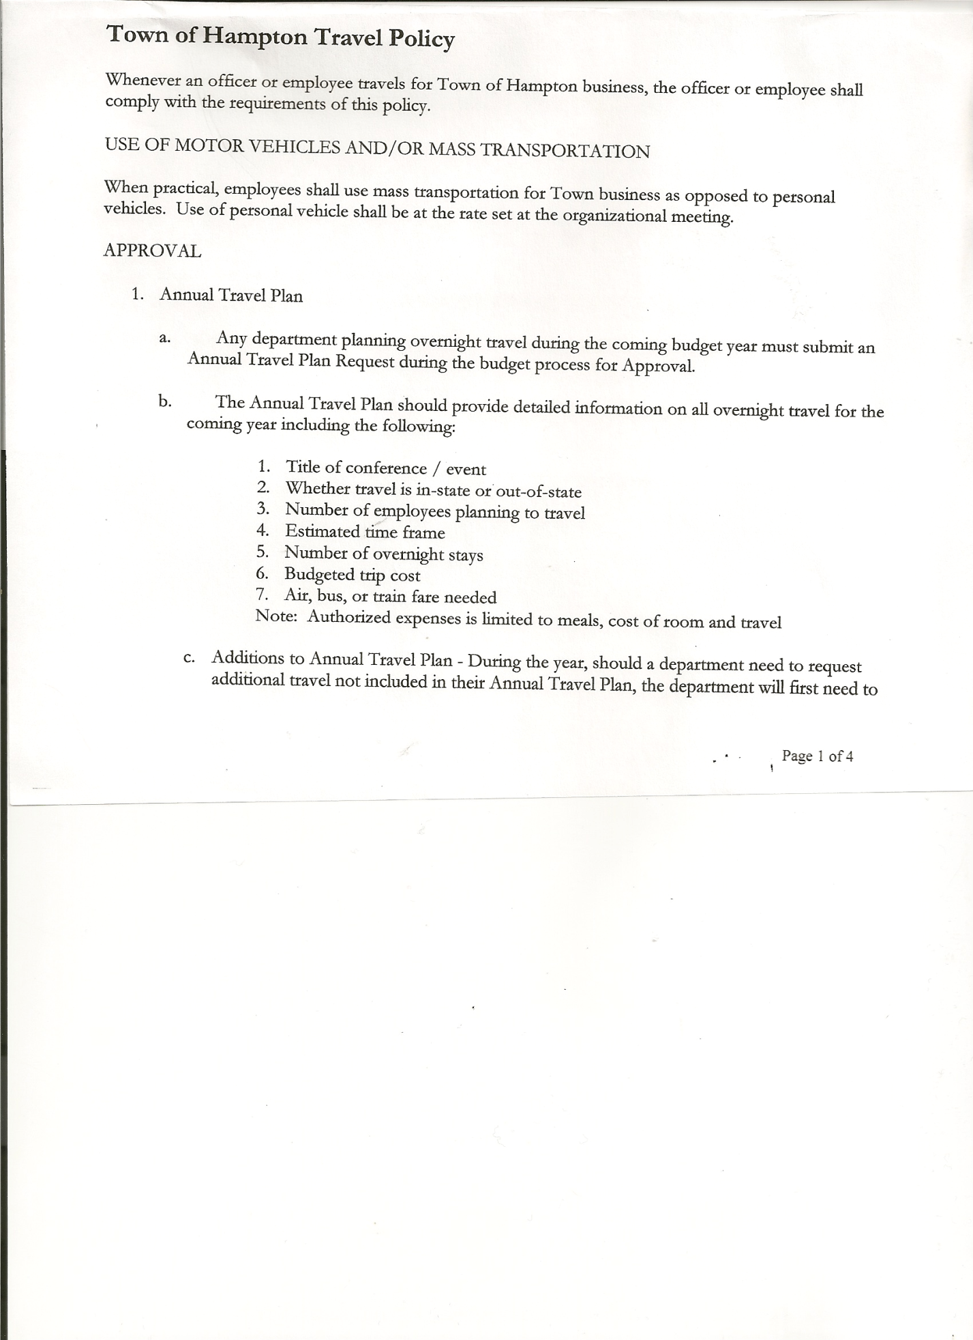
Michael Pietryka------------Councilman
Rebecca Jones---------------Town Clerk
Camilla Shaw----------------Tax Collector/Deputy Town Clerk
Herbert Sady, Jr.-------------Highway Superintendent

Planning Board Member(s): Bonnie Hawley (via Zoom) and Matthew Pratt

Others present at the Town Hall: Stuart & Lois Griffin; Artie Pratt and Leonard Reed.

The Regular Meeting was called to order by Supervisor O’Brien at 7:30pm, followed by the Pledge of Allegiance. Location of Fire Exits were given. Quorum of board members present.

Supervisor O’Brien asked for a moment of silence in memory of William Lawrence, resident of Low Hampton and previous Town Board Member from 1/1/2008 to 12/31/2011. He was also the Senior Citizen Representative for the Town of Hampton at the Office of Aging at Washington County.

RESOLUTION NO. 62-2020
APPROVAL OF THE MINUTES
On a motion of Councilman Sady, seconded by Councilman Pietryka, the following resolution was ADOPTED:
By Roll Call Vote: Supervisor O’Brien AYE
Councilman Sady AYE
Councilwoman Taran AYE
Councilman Pietryka AYE
Councilwoman Sweeney AYE
RESOLVED, that the Regular Town Board Minutes for July 16th, 2020 are approved.

Larry Carman, Dog Control Officer – no report submitted

Tax Collector’s Report – no activity. Submitted Bank Statement to the Board for review and signatures.

Mylar Map regarding Moore/Barber boundary line adjustment was received and Town Board Members present signed it.

Received from Washington County Planning Department the following Agreement and Resolution….”Exemption of Matters of Local Concern from County Planning Agency Review Agreement, 2020 Agreement Renewal”. There is one for the Planning Board to approve and sign and one for the Town Board to approve and sign.
Following the above discussion the following resolution was introduced:

TOWN BOARD MEETING
AUGUST 20, 2020 PAGE 2

RESOLUTION NO. 63-2020
Introduced by Councilman Donald Sady
who moved its adoption
Seconded by Councilwoman Tamme Taran

TITLE: EXEMPTION OF MATTERS OF LOCAL CONCERN FROM COUNTY PLANNING AGENCY REVIEW AGREEMENT

WHEREAS, the Washington County Planning Agency was created by the Washington County Board of Supervisors a provided by Article 12B of the General Municipal Law and subsection 220 of County Law; and
WHEREAS, the provisions of General Municipal Law Article B, Section 239 l and m (GML 239) require local municipal bodies in Washington County to submit certain planning and zoning actions to the Washington County Planning Agency for said Agency’s review and recommendation unless excepted by an agreement approved by the municipal body; and the County Planning Agency that such matter is of a local rather than an inter-municipal or county-wide concern; and
WHEREAS, it is in the interest of the County and local municipal bodies for a local municipal body to be able to act on matters of local concern without being bound by the referral requirements of GML 239; and
WHEREAS, having such an agreement for exception of matters which are not of an inter-municipal or county-wide concern is not detrimental to the County or the Town of Hampton Town Board; and
WHEREAS, the Washington County Planning Agency has established a process for exempting matters and actions of local concern from the referral requirements of GML 239; now, therefore, be it
RESOLVED, that the attached agreement entitled “Exemption of Matters of Local Concern from County Planning Agency Review Agreement” shall exempt actions of local concern under this agreement from the referral requirements of GML 239 shall exist between the County Planning Agency and the Town of Hampton Town Board; and be it further
RESOLVED, that said agreement shall apply to planning and zoning reviews and actions of the Town of Hampton Town Board; and be it further
RESOLVED, that a copy of this resolution with the attached agreement shall be provided to the Washington County Planning Agency; and be it further
RESOLVED, that this agreement shall take effect immediately.
DATED: August 20, 2020
By Roll Call Vote: Supervisor O’Brien AYE
Councilman Sady AYE
Councilwoman Taran AYE
Councilman Pietryka AYE
Councilwoman Sweeney AYE
A copy of the Exemption Agreement is attached.

Bonnie Hawley, Chair gave Planning Board Report…
- Planning Board meet on August 12th…working on survey to send to all residents
- Next meeting will be August 26th at 7:00pm at the Town Hall

Herbert Sady, Jr., Highway Superintendent submitted his report, copy of which, is attached.
Paving report….sent in all paperwork, hope to receive reimbursement in September. 340 yards of winter sand has been put up so far. NYS passed a salt reduction plan. Town is using a reduced salt/sand mixture. Herb has heard that there are grants for a building to cover the salt pile.

TOWN BOARD MEETING
AUGUST 20, 2020 PAGE 3

SUPERVISOR’S REPORT/COUNTY UPDATES/COMMUNICATIONS

RESOLUTION NO. 64 -2020
APPROVAL OF SUPERVISOR’S MONTHLY REPORT
On a motion of Councilwoman Taran, seconded by Councilman Pietryka, the following resolution was ADOPTED:
By Roll Call Vote: Supervisor O’Brien AYE
Councilman Sady AYE
Councilwoman Taran AYE
Councilman Pietryka AYE
Councilwoman Sweeney AYE
RESOLVED that, the Supervisor’s Monthly report be accepted as submitted for JULY.
06/30/20 07/31/20
ACCOUNT BALANCE RECEIPTS DISBURSEMENTS BALANCE
General Fund $ 64,855.06 $ 188.63 $ 4,792.34 $ 60,251.35
Highway Fund $ 125,941.66 $ 9989.33 $ 12,524.93 $ 123,406.06
Equipment Reserve $ 64,867.96 $ 2.60 $ 9984.00 $ 54,886.56
Fire #1 $ 21,224.00 $ 0.00 $ 0.00 $ 21,224.00
Fire #2 $ 5,000.00 $ 0.00 $ 0.00 $ 5,000.00
Cemetery $ 1,735.98 $ 1.18 $ 0.00 $ 1,737.16
Totals $283,624.66 $ 10,181.74 $ 27,301.27 $266,505.13
All Board Members present signed Supervisor’s Report.

OLD BUSINESS
Grant for the ramp cover was received, supplies have been ordered. Saturday, September 12th will start working on Ramp Cover. Following a discussion, the following resolution was introduced:
RESOLUTION NO. 65-2020
AUTHORIZE TO PAY MacLEOD LUMBER & HARDWARE BILL EARLY
On a motion of Councilman Sady, seconded by Councilman Pietryka, the following resolution was ADOPTED:
By Roll Call Vote: Supervisor O’Brien AYE
Councilman Sady AYE
Councilwoman Taran AYE
Councilman Pietryka AYE
Councilwoman Sweeney AYE
RESOLVED, to pay MacLeod’s Lumber & Hardware bill when received and include it on the next Warrant showing as paid.

Budget Sheets for 2021 handed out.
Fire Department Budget/report handed out to Board members and attendees.

The Town Clerk’s report for July 2020 was submitted to the Board. The Town Clerk had Board Members review and sign bank reconciliation statements for the Town Clerk Account and Special Clerk Account dated July 30th, 2020.

PUBLIC COMMENTS/COUNCIL COMMENTS
Councilman Pietryka inquired about “hot spots” with the internet for Hampton students. Guest networks are available at the Town Hall and Fire Department. Supervisor O’Brien asked and received Board’s permission to speak with Granville School Superintendent Mr. McGurl about students at the Town Hall for remote learning.

TOWN BOARD MEETING
AUGUST 20, 2020 PAGE 4

RESOLUTION NO. 66-2020
AUDIT OF CLAIMS
On a motion of Councilwoman Taran, seconded by Councilman Sady, the following resolution was ADOPTED:
By Roll Call Vote: Supervisor O’Brien AYE
Councilman Sady AYE
Councilwoman Taran AYE
Councilman Pietryka AYE
Councilwoman Sweeney AYE
RESOLVED that the bills have been reviewed by the Town Board and are authorized for payment in the following amounts.
General Fund No. 72 through No. 80 $ 1,260.72
Highway Fund No. 79 through No. 88 $ 63,831.64
Total both funds $ 65,092.36

RESOLUTION NO. 67-2020
MEETING ADJOURNED
On a motion of Councilman Sady, seconded by Councilman Pietryka, the following resolution was ADOPTED:
By Roll Call Vote: Supervisor O’Brien AYE
Councilman Sady AYE
Councilwoman Taran AYE
Councilman Pietryka AYE
Councilwoman Sweeney AYE
RESOLVED that the meeting adjourned at 8:19pm.

Respectfully submitted,

Rebecca S. Jones, RMC
Town Clerk

