**ISRAELI WOMEN ON THE MARCH FOR PEACE**

**by**

**Marguerite dar Boggia**

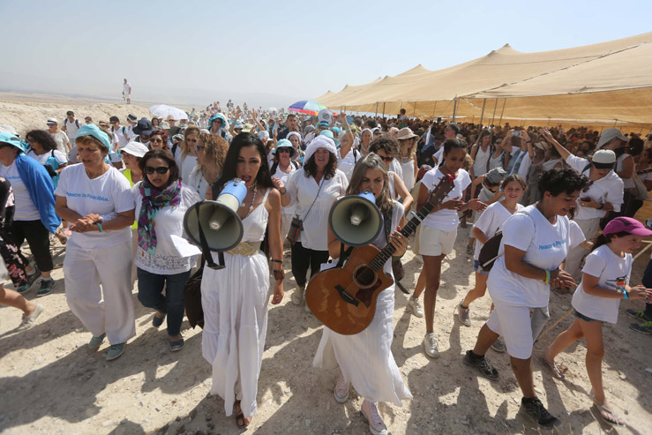

For almost fifty years Palestine has been occupied by Israel. After Israel's war on Gaza in 2014, Israeli women started a movement to build connections with Palestinian women. They also reached out to women and men of many other religious and political backgrounds. They believed that war will never bring peace and security. They are mothers. They do not want their children killed. They realized that, only through a just and viable solution to the Israeli-Palestinian conflict, can they express the potential of their society and country. They started a movement known as **Women Wage Peace (WWP)**.

It is a grassroots movement of different ethnic, social, political, religious and also geographic background. The movement has tens of thousands of members from the right, the center and the left of the political spectrum, Jews and Arabs, religious and secular. They have over 28,000 members in Israel with an additional 50,000 supporters world-wide. They are putting pressure on the leaders of Israel and Palestine to work towards a viable peace agreement. Their organized street demonstrations and their actions at junctions are impressive. They dress in white with a turquoise scarf.

WWP has as its basis two main objectives: To encourage peace negotiations between Israel and the Palestinian Authority and to urge the enforcement of UN resolution 1325 which "reaffirms the important role of women in the prevention and resolution of conflicts."

On September 24, 2017 30,000 Israeli and Palestinian women marched from Sderot in the Negev desert and passed through the territories to arrive in two weeks at the Jerusalem residence of Netanyahu, the President of Israel. The march included many who had been directly affected by the violence in the Israeli-Palestinian conflict. The Western media is so controlled by the forces for the status quo, that the march was practically ignored. The event in the Middle East was treated as insignificant, since it was only started by women!

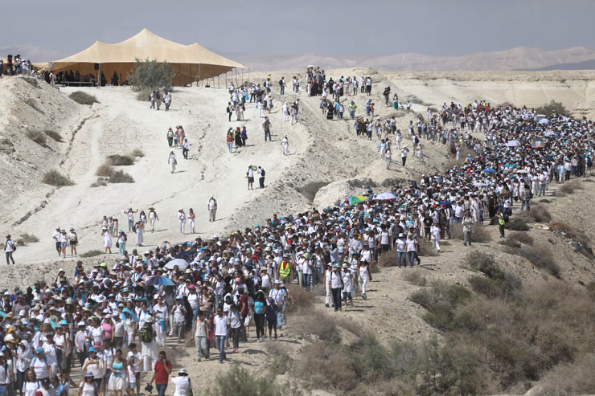

In past generations the public was told who to hate, to wit: the Jews, the Italian 'wops', the Niggers, the Japs, the Chinks, the Krauts, the Wetbacks and now it is the Moslems and 'the Russians are our enemy'. Today, people are realizing that it is not necessary to have an enemy for the politicians or the industrial/military complex to retain power and to survive.

Women, today, are no longer the 'weaker sex'. They believe that goodwill is a more effective method for maintaining harmony, than violence, injustice and the superiority of race.

With the development of 'free energy' and the new technology, we can surpass ancient civilizations in magnificence. This is our destiny, when we work with the harmonious laws of the universe.

We are told on page 430 of the book: *The Rays and the Initiations1* that in the maps of the spiritual Hierarchy, a dark cloud covers part of Europe and all of the Middle East. The ascended Tibetan Master D.K. asks: Can the wisdom of the US, the UK and the United Nations be enough to avoid this disaster?

The Master Hilarian in the book *Light on the Path,2* tells us to kill out separateness. We are one family, one humanity. He says: "Do not fancy you can stand 'aside from the bad man. He is yourself, though in a less degree than your friend or your Master. But if you allow the idea of separateness from any evil thing or person to grow up within you, by so doing you create karma which will bind you to that thing or person till your soul recognizes that it cannot be isolated. Remember that the sin and shame of the world are your sin and shame, for you are a part of it."

In the future, the demonstrations worldwide by the younger generation, will be to demand the end of wars, violence, religious bigotry, intolerance, racism, theft, greed, and self-interest. They will accept the new economic system prepared by the disciples of the Masters and will be ready for the "Golden Age" presaged by the Hindu and Zoroastrian sages.3

We are part of one humanity all striving to express the potential and goals of our Inner Self. Only by SHARING THE RESOURCES of the earth can we prosper and fulfill our destiny. Science has now proven that all sub-atomic particles are interconnected.4 It is the true basis for brotherhood.

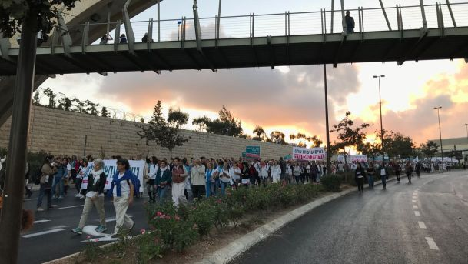

∆∆∆

*Marguerite dar Boggia* formerly served as Membership Secretary of ISAR, (the International Society for Astrological Research). She was past publisher of *Kosmos,* the ISAR Journal, as well as Secretary & Director of ISAR and UAC, (the United Astrology Congress). She is a co-founder of UAC and served as its Registrar at the first UAC’86 conference. Her articles have appeared in many journals. Her goal is to cooperate with the Spiritual Hierarchy of our planet and to work for and to serve humanity. She offers online **FREE**, three pages weekly of the Esoteric Studies as was known **by Pythagoras and by Plato**. She can be reached at her website: [**www.FreePythagorasTeachings.com**](http://www.FreePythagorasTeachings.com) which she created at the age of 90:

References:

1Bailey, Alice A. *The Rays and the Initiations*, Lucis Publishing Co. 1953, p. 430

2Collins, Mabel *The Light on the Path*, The Theosophical Publishing House 1911, p.1

3Dar Boggia, Marguerite *The Forthcoming Golden Age* under articles in my website: www.FreePythagorasTeachings.com

4Dar Boggia, Marguerite *Quantum Entanglement* under articles of my website.

[**30,000 Israelis, Palestinians take part in Women Wage Peace rally in**](https://www.google.com/url?sa=t&rct=j&q=&esrc=s&source=web&cd=8&cad=rja&uact=8&ved=0ahUKEwj_ydSi2ofYAhUW42MKHQWXACkQFghlMAc&url=https%3A%2F%2Fwww.haaretz.com%2Fisrael-news%2F1.816255&usg=AOvVaw1eRpxhD3XWrBkCKvf6P2t8)

[**Women Wage Peace - Wikipedia**](https://www.google.com/url?sa=t&rct=j&q=&esrc=s&source=web&cd=5&ved=0ahUKEwj_ydSi2ofYAhUW42MKHQWXACkQFghOMAQ&url=https%3A%2F%2Fen.wikipedia.org%2Fwiki%2FWomen_Wage_Peace&usg=AOvVaw2GZcqHIiLytWFpoxi-L--Z)

[**Women Wage Peace, but who knew? – Middle East Monitor**](https://www.google.com/url?sa=t&rct=j&q=&esrc=s&source=web&cd=10&cad=rja&uact=8&ved=0ahUKEwj_ydSi2ofYAhUW42MKHQWXACkQFghyMAk&url=https%3A%2F%2Fwww.middleeastmonitor.com%2F20171011-women-wage-peace-but-who-knew%2F&usg=AOvVaw1NdLIh4QIgaHx2nBDWFhkQ)