Pleiku MP Association Visit to National Museum of the United States Army.
Friday, October 16, 2020, 10:00 am-1:00pm. Part I below shows complimentary items. Part II details pay-per-use attractions with prices. Read carefully to calculate per person pricing. Items can be done separately or bundled together to save money; prices change with each ticket application. These are pre-paid so plan accordingly.

Part I – Complimentary attractions
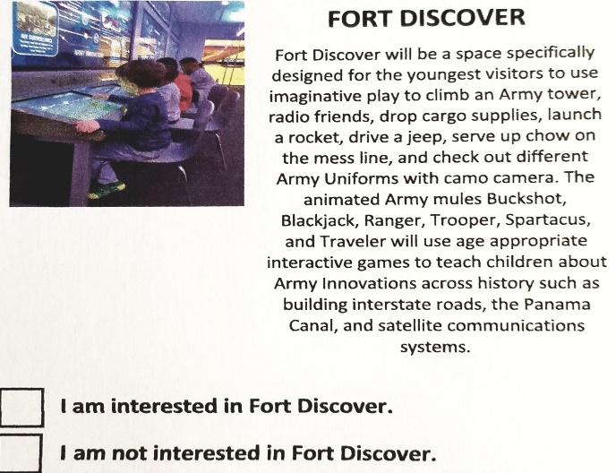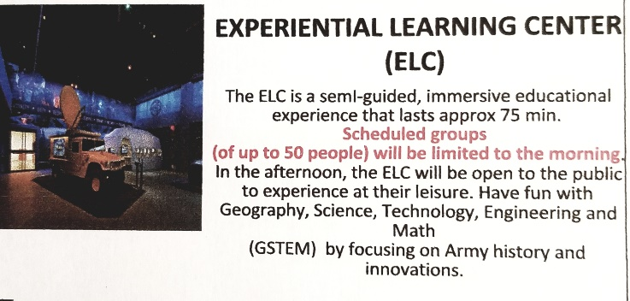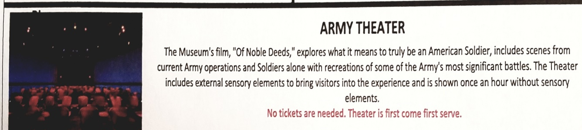
Part II – Paid attractions
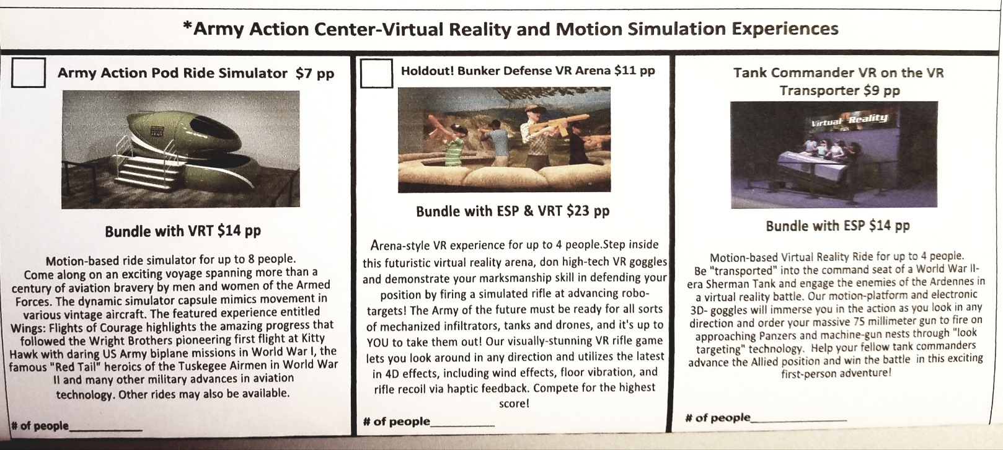
Bundled ticket prices per person: All three attractions - $23 Simulator plus VRTransporter - $14
Single attraction prices per person: Simulator - $7; Defense VR Arena - $11; Tank Commander VR - $9

