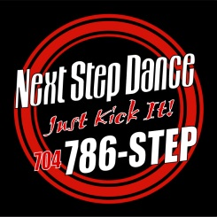 1 WEEK CLASS PASS
Please complete the information for enrollment at NSD. Registration is not complete until the online section and paid your registration fee(s). All policies on our website must be signed off by the parent(s) BEFORE classes begin and a credit/debit card must be on file.
PARENT/GUARDIAN SIGNATURE: _______________________________________________ DATE: ____/____/______

Student Name: ______________________________ Age:____ DOB:___/____/____Female Male
Address: ________________________________________City: ___________________, NC Zip: ___________
*HOW DID YOU HEAR ABOUT US? Website Friend Sign/Location/Drive by _____________
Mother’s Name: ________________________________________ Cell # _______________________________

Mother’s Email: _____________________________________________________________________________

Father’s Name: ________________________________________Cell # _______________________________

Father’s Email: ____________________________________________________________________________

CLASS SCHEDULE
1ST Trial Class: ______________________________________________________________

2nd Trial Class: ______________________________________________________________

3rd Trial Class: _______________________________________________________________

4th Trial Class: _______________________________________________________________

5th Trial Class: _______________________________________________________________

Next Step Dance 7712Sossamon Lane, Suite 110, Concord, NC 28027
704-786-7837www.thenextstepnc.com
Creating the Future…From the Present

