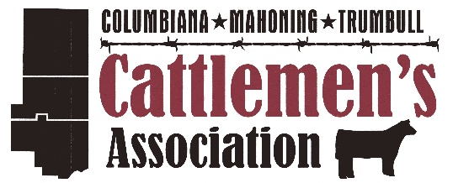

CMT County Line Cattle Blast

Board Sale

Place: Canfield Fair Grounds
Date of sale: Saturday October 12th, 2019
Time: 6:00 – 8:00 pm
Consignment Arrival: Friday Evening or Saturday Morning

Eligible Cattle include:
- Steers born after January 1st, 2019
- Open heifers born after September 1st, 2018
Sale Regulations
- Lot numbers will be issued in the order that the forms are received
- Individual Health papers must accompany every consignment and meet the health requirements of the State of Ohio.
- All heifers must be open.
- All consignments which are accompanied with registration papers must match tattoo and other ID points. To sell as registered, original copy of registration papers must be present.
- All steers and heifers must be halter broke and able to be presented in a professional manner.
- No bedding will be furnished in tie-outs
- Animals must be tie in designated display area by 6 p.m.
- The sale will begin closing at 8:00 pm with a racehorse finish.
- Every sale animal will be pre-registered to be shown on the Sunday in the market heifer or steer class.
Any questions please contact a sale committee director
Rich Boyd: (330) 692-9085
Todd Miller: (330) 921-5983

I.D. | Sire | Dam | Name  (if applicable) | Sex | D.O.B  (m/d/y) | Registered  (Y/N) | Breed

Consignor Name: _______________________________________________
Farm Name: _______________________________________________
Address: _______________________________________________
City, State, Zip code: _______________________________________________
Phone Number: _______________________________________________
A $40 per live lot (cattle) non-refundable consignment deposit must accompany consignment form.
Check #: ________ Date: ________ Total Amount Enclosed: $___________
I hereby Agree to all terms, regulations and conditions stated above.
Signature: _____________________________

Please mail entry form with payment (make checks payable to C.M.T. Cattlemen’s) to:
Pete Conkle at 10087 Gavers Road, Hanoverton, Ohio 44423

