GEN-840 (120V-2500W-10kW-60Hz) | Geneforce Emergency Power System
Product Features | 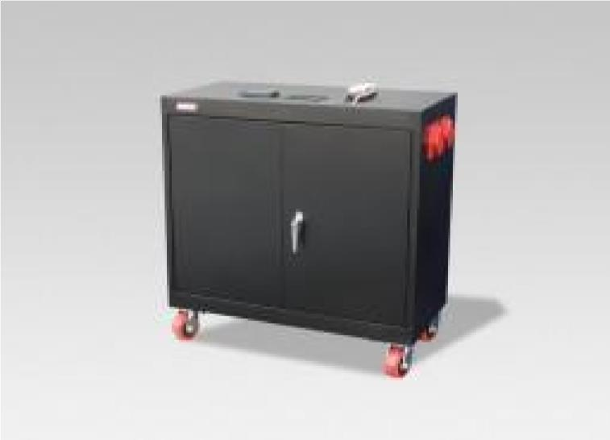
Silent operation.
Safe for indoors. No gas or emissions.
No Installation; No Maintenance; No Permits required
Arrives fully charged and ready to work.
Automatic & one-touch start.
Multi-colored LED displays state of charge, AC input, DC volts and DC amperage, etc...
Overheat Temperature Sensor & Automatic Shutdown feature.
Built-in voltage regulation system for sensitive electronics.
Built-in (120V/30A) Automatic A/C Transfer Switch.
Built-in 30A solar charge controller for solar panel charging.
Electrical Specifications | GEN-840 (120V)
Output power (continuous) | 2,500 W
Surge power (AC amps) | 7,500 W (62.5A)
Output frequency regulation | 60 Hz
Voltage regulation | 120 V +/-5% true RMS
Output wave form | Modified Sine Wave
Service Life (No Maintenance) | 7-8 years
Stored Electrical Energy | 10.03 kW (10,030 Watts)
AC output receptacles | Four (20A/120V) outlets & One 30A/120V outlet
12 Volt Power Outlet (optional - not included) | One 12 Volt Charger outlet
AC input plug (8ft cord) | One (120V/20A) side blade plug *(30A/120V)optional
AC input automatic transfer switch | 30 A (included)
Charge rate | 130 A DC
AC input voltage range | 90 - 130 VAC
Geneforce Charge control | 3-stage (Bulk, Acceptance, Float)
Solar Charge Controller | 30A/12V (~360 W per hour/sunlight) *(60A/12V-24V) optional
General Specifications
Optimal operating temperature range | 32°F – 104°F (0°C – 40°C) *derated below 0°C and above 40°C
Monitor | LED Display (reads V, DC amps, Power Share, etc.)
Dimensions (H x W x L) and Weight | (36" x 18 x 36") & (700 Lbs.)
Construction | Strong Steel, Four Casters, Color-Black
Warranty & Part Number | (2 Year) & (GEN-840-120-2500)
Regulatory Approvals & Protection
Safety - UL Listing | Components UL & cUL listed to 458 Standards
Voltage Regulation | Over voltage and under voltage protection
Temperature | Over-temperature protection
Output | Overload Protection
Electrical | Short circuit protection
Price | $7,997
Geneforce Incorporated www.geneforcepower.com (305)215-5443 email: sales@geneforcepower.com

