Build Your Own Sponsorship
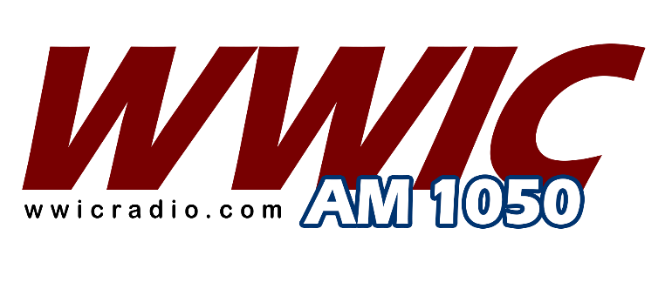
WWIC Radio is giving you the chance to build your own radio sponsorship. Your business can benefit from WWIC Radio programming with the choice of any (2) sponsorship combo’s for just CALL FOR INFORMATION per month billing.

Scottsboro Wildcat Athletics – includes #Scottsboro football, basketball, baseball and softball with programming airing August – May.
# - football sponsorship includes Friday night coaches’ interview, pre-game, post-game, Friday night scoreboard show.

Auburn Tiger Sports – includes football, men’s basketball, baseball, Tiger Talk coaches show with programming airing August – May.

Partyline – includes (1) ad per day, Monday-Saturday, 8:15am-9:00am.

Paul Finebaum – includes at least (2) ads per day, Monday-Friday, 2-6pm.

Headlines Radio Show – includes (2) ads per program, Tuesday’s, 9:15am-10:00am and
(2) ads per day, M/W/Th/F of each week for a total of 10 ads per week.

