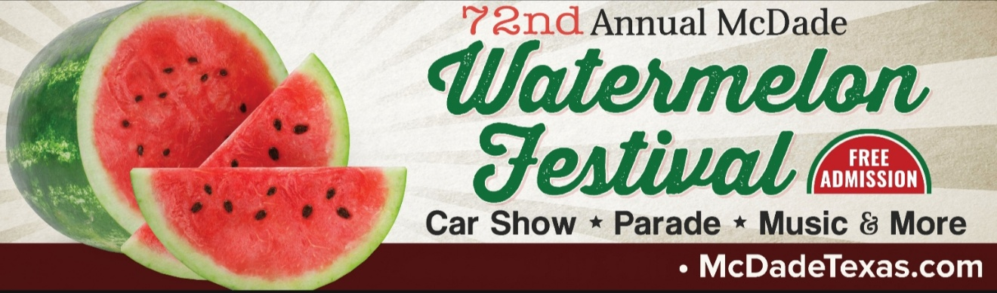

March 3, 2020

«AddressBlock»

On SATURDAY, JULY 11, 2020 we will celebrate the 72nd annual McDade Watermelon Festival. Your sponsorship of ________ last year contributed greatly to our success, and we would like to showcase your business again this year.

As in the past, all sponsors will be recognized on the Festival website, Facebook, programs, flyers, verbal announcements on Festival day, as well as posters portraying your business’s name in designated areas.

The festival’s profits continue to be used to award student scholarships to local graduates and grants to local organizations.

The following page includes several sponsoring levels. In order to meet the printers’ deadline and ensure your inclusion, please return it to us by April 10, 2020.

Thank you for your consideration and continued support of the McDade Watermelon Festival. Your donation is greatly appreciated. If you have any questions or would like more information, please do not hesitate to contact us.

Sincerely,

McDade Watermelon Festival Sponsorship Committee
Christi Walla
(512) 736-4302
Holly Schulz
(512) 557-3323

Our sponsoring levels have been revised to allow for additional options. Please select from the following:

Jubilee - $500_____ Double Platinum - $400_____

Platinum - $300_____ Gold - $250_____

Silver - $200 _____ Bronze - $100_____

Your continued support is so greatly appreciated!

Donated by:
«AddressBlock»

For your convenience, checks may be mailed in the enclosed envelope, made payable to “McDade Watermelon Festival Association” or MWFA.

Please mail to MWFA
PO Box 783
McDade, TX 78650

Please return this form by May 30, 2020.

