THE HOWLING DAWG
" a waste howling wilderness…" Deuteronomy 32:10

OCTOBER 2013
16th Georgia Volunteer Infantry Regiment, Company G
"The Jackson Rifles"
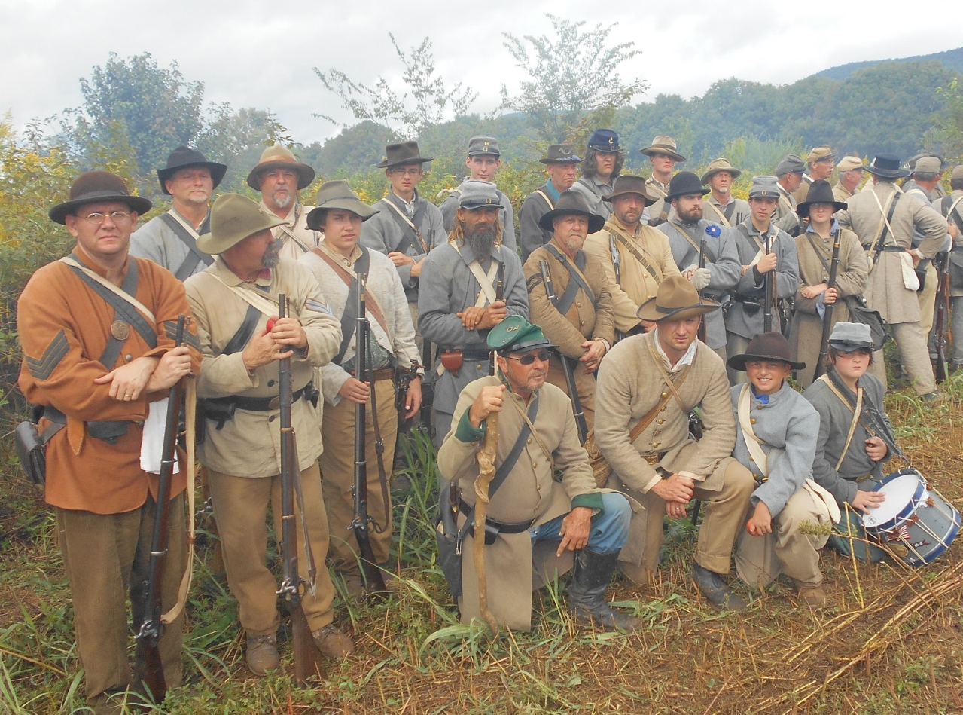

The "Jackson Rifles" at the 150th Anniversary Battle of Chickamauga

A YEAR OF CHALLENGES AND BLESSINGS
After our War Days event in Clinton, back in May, it took us some time to "dry out" emotionally, it seemed. Certainly, we are in the field all the time, in all types of weather, and we endure it, but we like fair days as much as anyone else - maybe more. Yet, we persisted and made preparations for our third national campaign in less than two years (Shiloh, Gettysburg and Chickamauga). Some attended all of these, others only one or two - a few did not get to any at all - times remain hard.
-1-
Our older vets still talk about Chickamauga anniversaries of the past as "Chickamuddy" or the "dusty one", (or chicken nuggets as Pvt. Jaden Thompson, the youngest of our ranks, called this one). We hoped, this would be the charm even though substantial rain was in the forecast. Advance elements of the 16th Georgia, Co. G, arrived on Thursday, September 19th and secured our area of encampment. The main body came on Friday and that very afternoon, we marched out on a warm, exhausting trek to a higher elevation and spent several hours at our posts, doing our duty but barely firing a shot. Walker County emergency services proved necessary during that time and throughout the weekend, dealing with multiple heat-related ailments. We were supposed to be the 3rd Brigade (Poythress') of King's Division but General King was apparently not present. 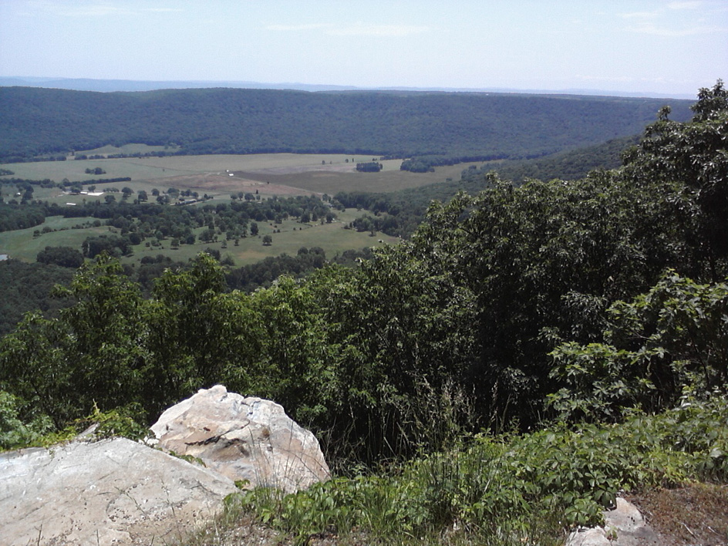
In the pre-dawn hours of Saturday, rain tapped on our canvas tents and by the time we arose the moisture was there in earnest. Thus, there was no drill that morning but an arduous afternoon battle (arguably the best of the weekend) did ensue after the rain began to move out toward mid afternoon. The damage, however, was done as trucks hauling artillery pieces into position had churned the wet byways into a marsh. Our battalion had no interest in the brief night battle. 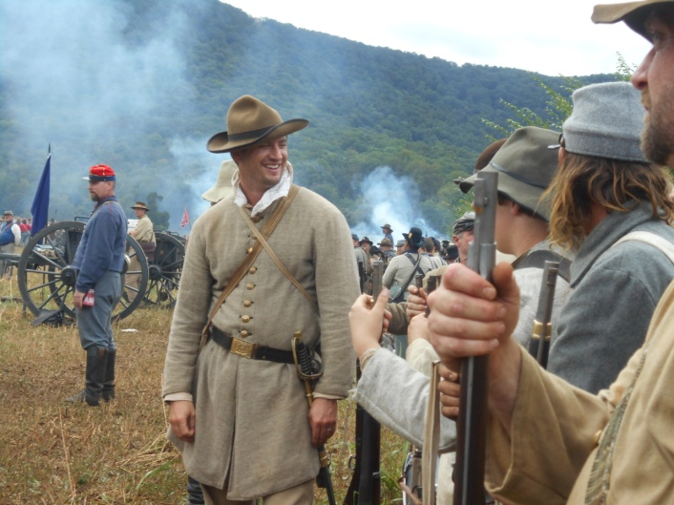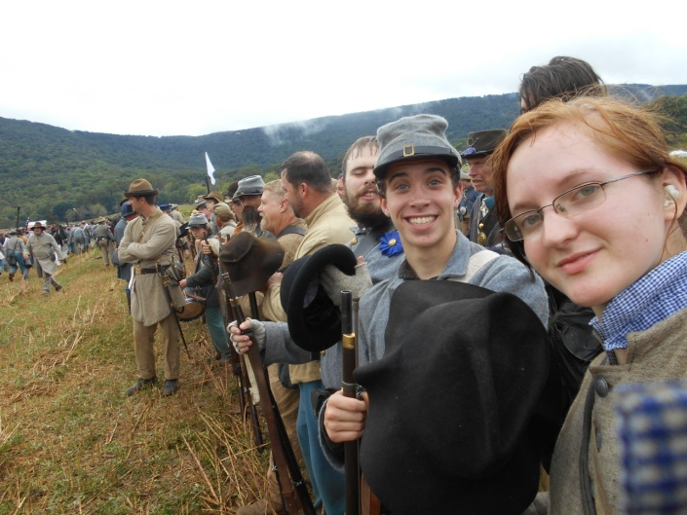
On Sunday morning the weather was much improved and after colors we saw seven precious souls come to know the Lord Jesus Christ as personal Savior in the service conducted by Reverend Joey Young. Later, in the warming afternoon, another long march - made more difficult by mud-covered roads - brought us to the concluding battles of the weekend which were Longstreet's Breakthrough and Snodgrass Hill. Some of us immediately exited the battlefield and hiked an incline to retrieve our vehicles, trusting that the road crews had been successful and that we would not be delayed. By 6:15PM, the last of our number was heading home.
Walker County’s purchase and renovation of Mountain Cove Farms was done partly in anticipation of this event and caused a great deal of excitement among county citizens who saw the long-term potential for the resort’s success and growth after the event passed. But, some re-enactment preparations were last-
-2-
minute and it showed; such as the RV parking lot which was delayed by EPD hang ups and only just finished. Though the overall venue (I have been to better and I have been to worse) was praised by some re-enactors and visitors, the weekend was not without its logistical difficulties on both sides. The biggest damper — Saturday’s seemingly endless downpour — was the fault of the weather alone, but many of the rain-caused difficulties were clearly the blunder of the event’s organizers. The very first spectator battle, a highly-anticipated re-enactment of cavalry action around Crawfish Springs, was slated to take place at 10 a.m. on 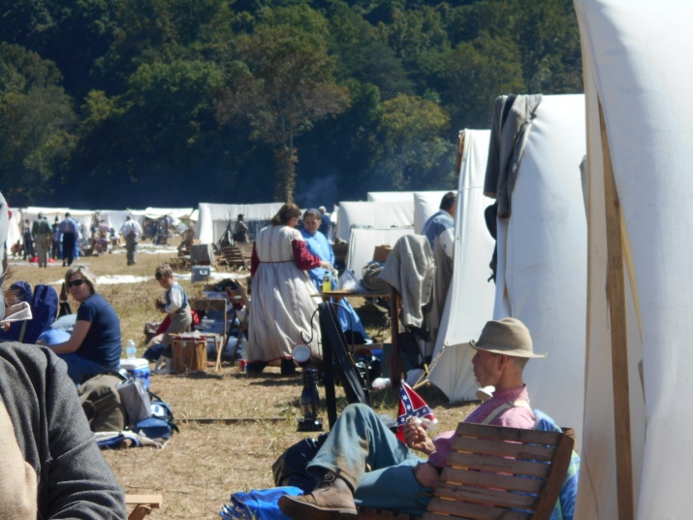
Saturday. Instead, it never took place at all and was washed out by heavy rain and fog after approximately 20 minutes of halfhearted fighting. One mounted soldier and his horse took a tumble off a bridge into a rocky creek 16 feet below. The few men who attempted the re-enactment were unable to keep their powder dry, while the half-dozen or so spectators huddled under ponchos and umbrellas were unable to even see the battlefield through the heavy haze. The effect was almost anti-climactic as far as the visitor portion of the event; re-enactors had already been holding battles on their own and for VIPs (I heard that Governor Nathan Deal flew over by helicopter on Friday) viewers for the past two days. Large crowds of spectators had been anticipated, and sutlers and food vendors alike — not to mention the newly-opened restaurant and general store in Mountain Cove Farms Resort — were counting upon their business. While spectators grumbled and hid from the rain in the crowded show barn or under the food vendor pavilion, re-enactors accepted the rain as a common, albeit uncomfortable part of the lifestyle they have chosen. Soldiers passed the hours of precipitation by dealing with washed-out tents, too-distant camps and lackluster tactical battles among other complaints. But most re-enactors remained philosophical, having little ill to say about the event, and what complaints they had were blamed upon the organizing group rather than the venue or Walker County, both of whom had expected more people than the event brought to the valley. Those re-enactors who could packed their gear and walked out in a steady stream. The total turnout for re-enactors was less than the numbers the Blue-Gray Alliance and Walker County had hoped for — closer to 6,000 re-enactors rather than the 10,000 advertised on billboards across the region. For spectators there were also few hurdles to overcome in order to properly enjoy the event. First and foremost was the issue of traffic and parking. Saturday’s rain turned pasture/parking lots into muddy bogs; cars had to be pushed or towed out of the mire, the tire ruts of previous passing vehicles were at least a foot high and not a single motorist escaped Mountain Cove Farms without a healthy spattering of mud. Walker County’s road department immediately trucked in loads of gravel to help add traction to some of the soggiest areas, as all cars were routed in and out of parking lots through the very few
-3-
Entrances - the impromptu roads quickly became quagmires. Furthermore, as Daughtry Gap Road, the only road leading into Mountain Cove Farms is a narrow two-lane, vehicles were backed up for miles waiting to get into the event. Spectators reported waiting two or even three hours to gain entry to a show that had, by then, been all but rained out. The Sutler’s Row along the farm’s short-takeoff and landing runway strip, next to an equally long line of bright blue portable toilets, shuttered its tents and bailed the rising water. By the time Saturday’s battle commenced at 4 p.m., the sun was shining again and spectators, though in fewer numbers than anticipated, were eager to claim a seat on the dewy grass to watch the Battle for Vinard Farm re-enacted across a series of cornfields. This led to another of the most vocal complaints regarding the weekend — that the spectators had a poor view of the actual battles, which took place across the road, the runway and one or two large fields from the viewing area. Those who tried to get close to the field’s fence line had little perspective on the action, while spectators who stayed up on the adjacent grassy hill could watch troop movements, but see little detail of the fighting from such a distance. The distance, however, made the battle more realistic for some - “We couldn’t see the spectators at all from where we were,” said one soldier immediately following the Saturday afternoon battle, apparently entirely happy with the event. For the 16th Georgia, Co. G - the good, the bad and the muddy - times of adversity are essential training tools and any time we spend together is cherished " … as long as we last we will live in the past…" Despite the weather and the traffic jams, the novelty of the event was not lost on locals who had the opportunity to witness a unique sight. In closing I sadly admit that I lost my temper at this event and for those of you who found it, I am so very sorry. Jwd
….. AND NOW IT IS ANDERSONVILLE TIME !!!
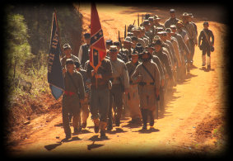
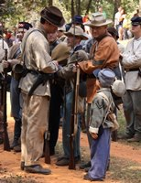

At 117 E. Church Street, 109 E. Church Street, Andersonville, GA, 31711, history comes alive on the first weekend in October when re-enactors set up camps and stage two battles, the first at 3 p.m. Saturday, Oct. 5, 2013, and the second at 2 p.m. Sunday, Oct. 6, 2013. Sutlers selling uniforms and accoutrements and civilian clothing add color and interest, as do craftsmen such as blacksmiths, basket makers, quilters, weavers, and artists of all kinds. Gates open at 10 a.m. both days. The first big activity is the 80-unit parade on the main street on Saturday, Oct. 5, 2013, at 11 a.m. Special entertainment includes performances by The Southern Gunslingers, puppet shows, line dancing, clogging, bluegrass band performances, and gospel singing. Admission is $4 for adults, $1.50 for children 12 and under. No animals over 20 pounds are allowed, and all animals must be on leashes. For more information, call 229-924-2558 or visit http://andersonvillegeorgia.info.
-4-
HERE IS A COPY OF THE 2011 ANDERSONVILLE SCHEDULE. WE CANNOT VERIFY IT'S ACCURACY FOR 2013, IT GIVES A GENERAL IDEA OF THE ACTIVITIES:
GREAT TRIP - GOOD TO BE HOME
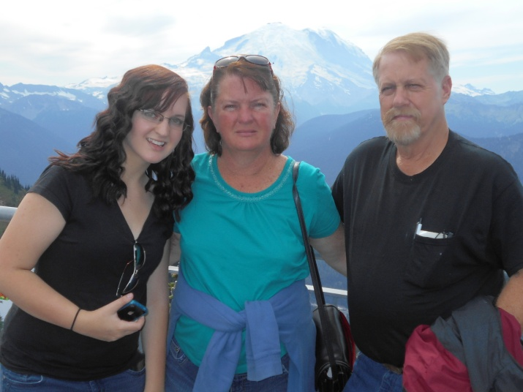
Kellie, Brenda and Wayne enjoyed an August 17-31st visit to Washington State and Oregon. Brenda, as many know, hails from the northwest. It is beautiful country, made even more so by all the cherished family there.
-5-

MEMORIES OF CHICKAMAUGA
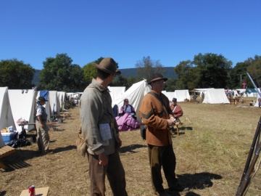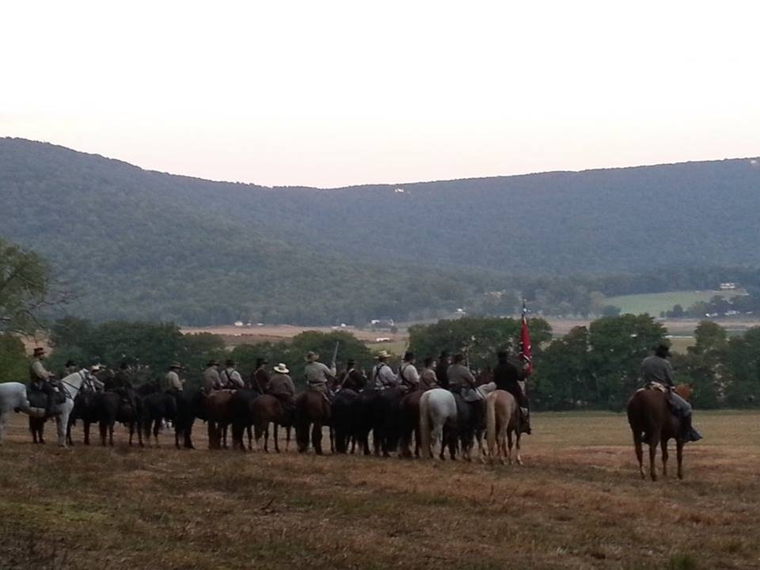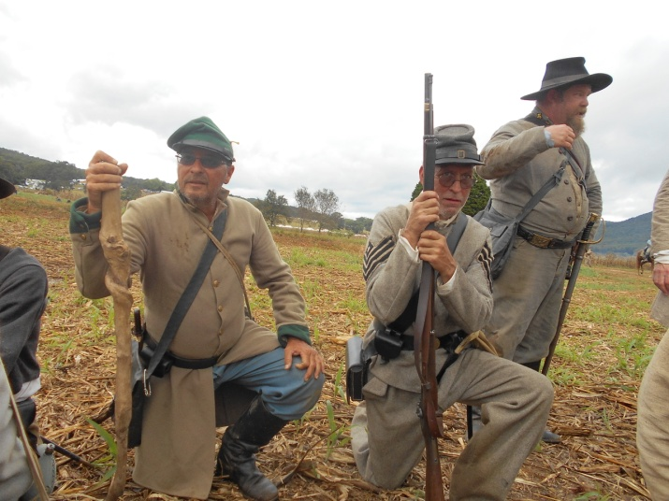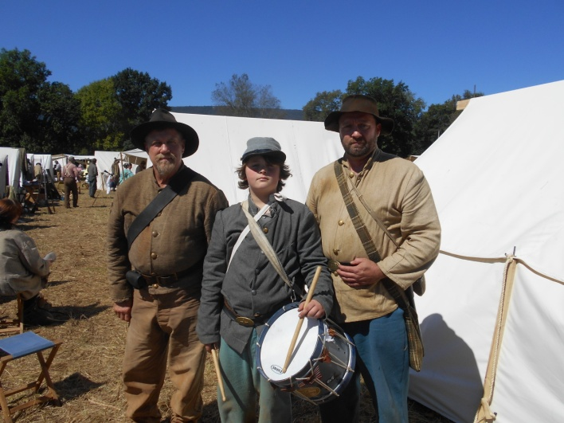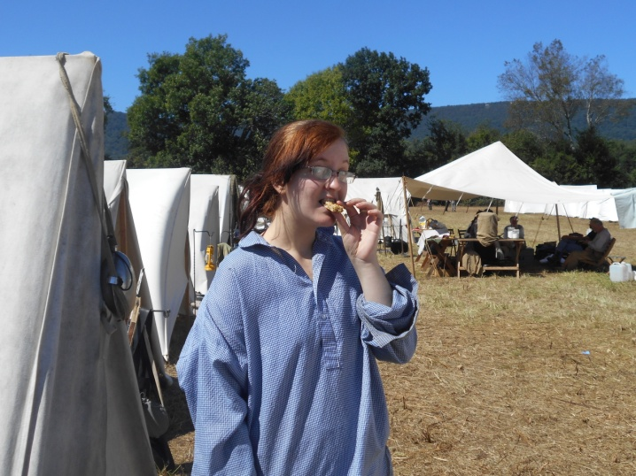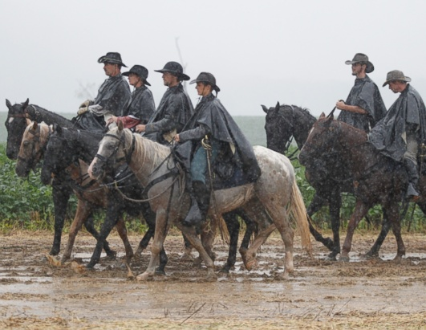

-6-

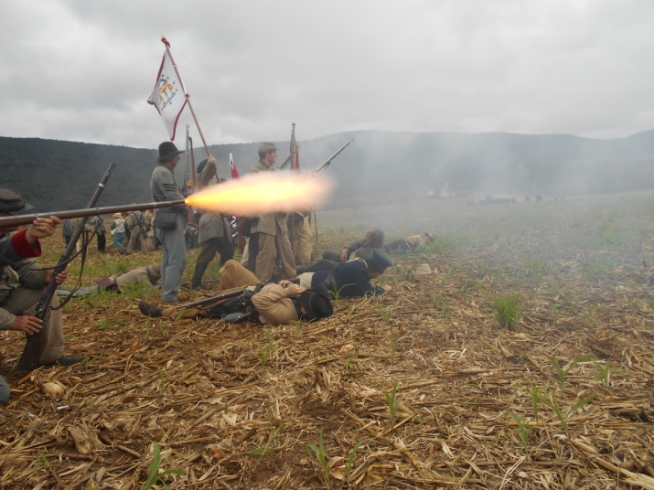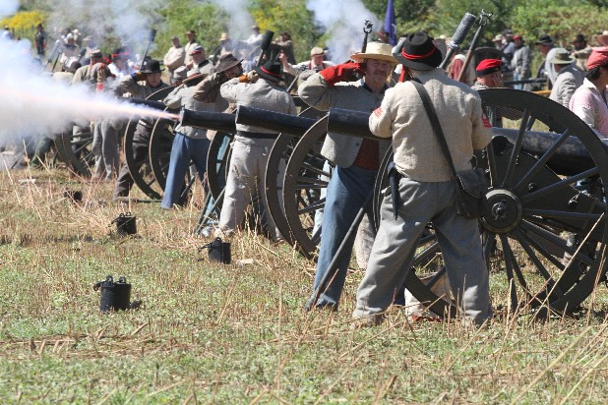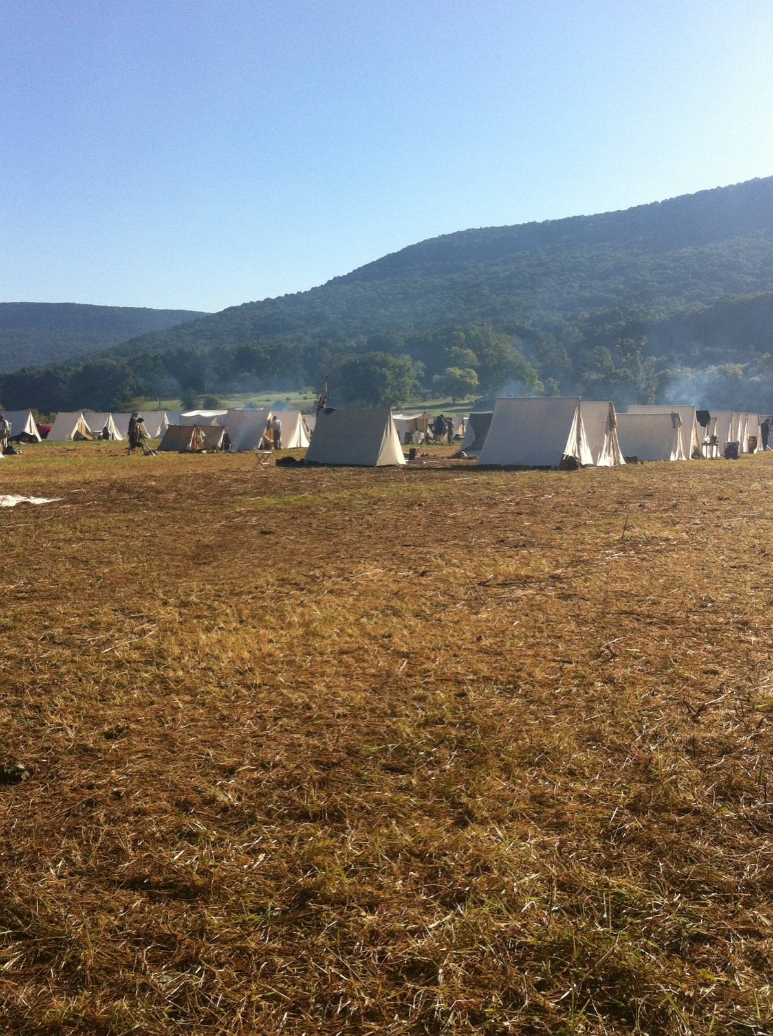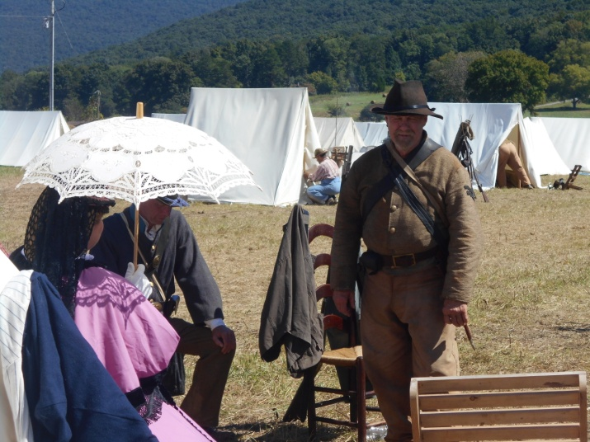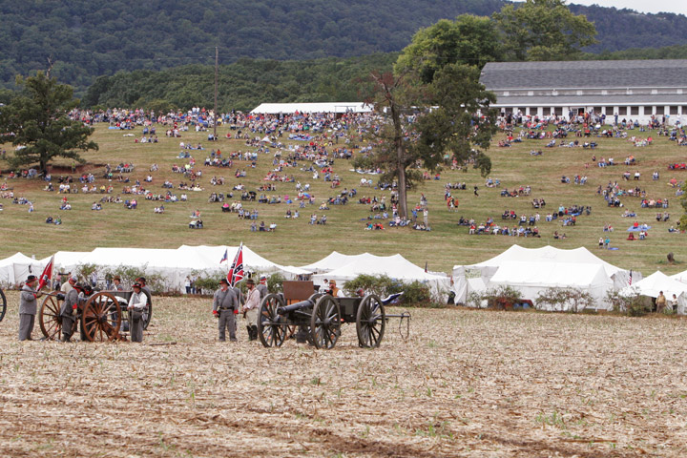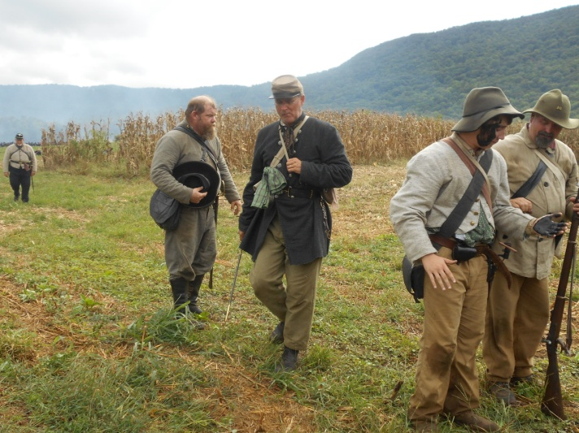

-7-

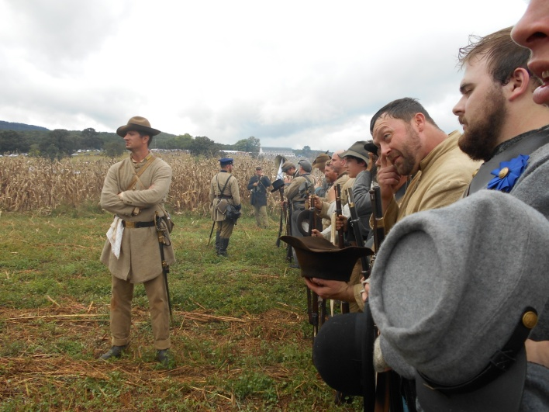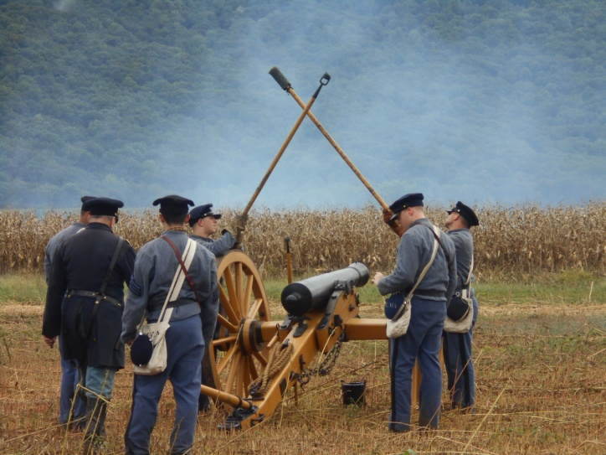
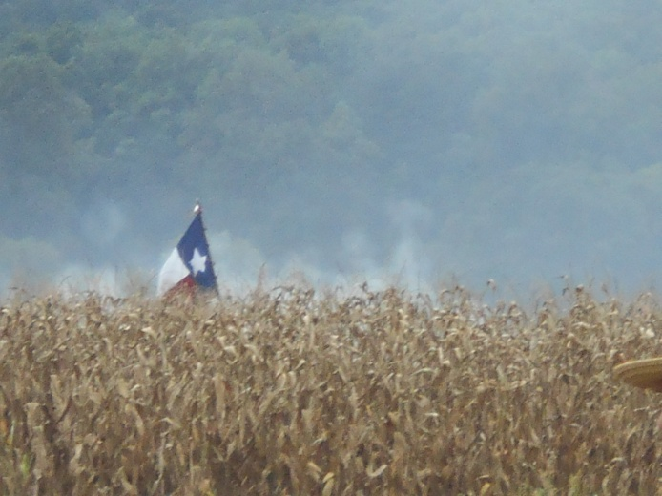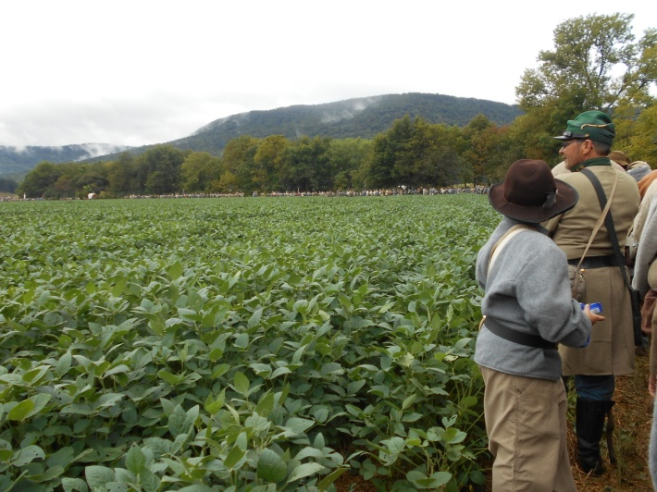
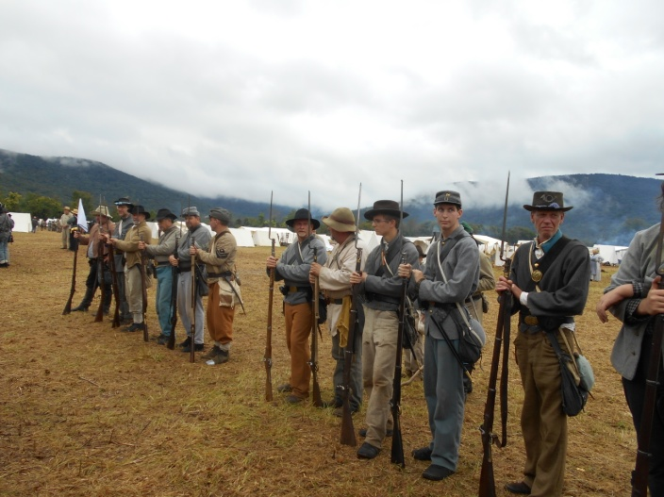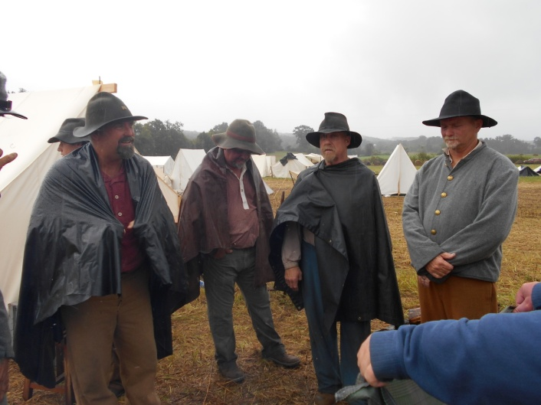

-8-

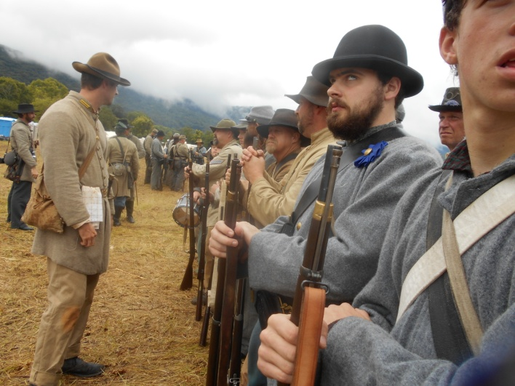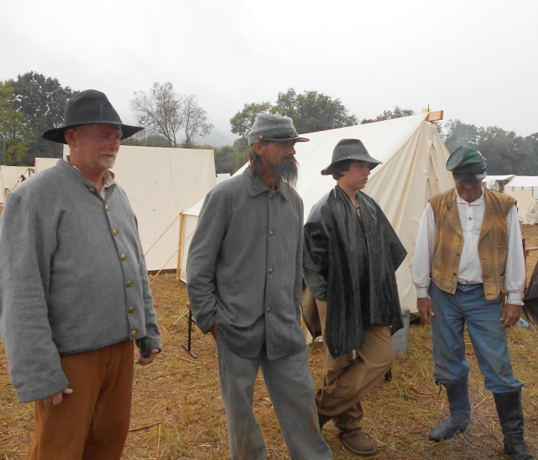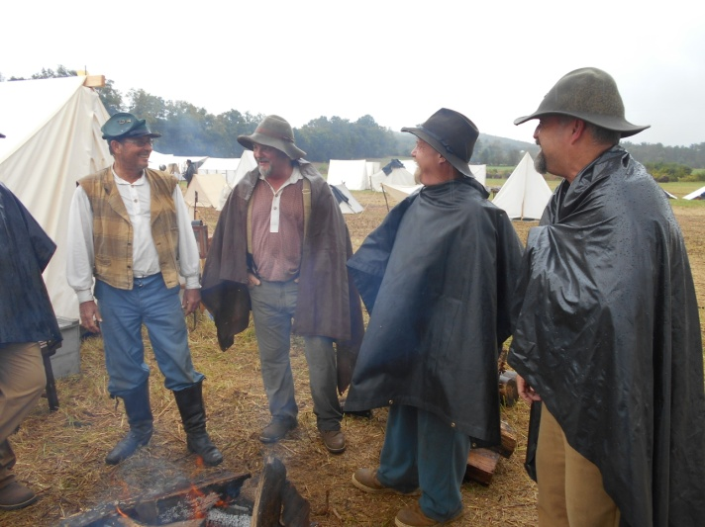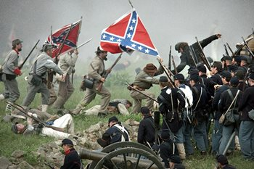
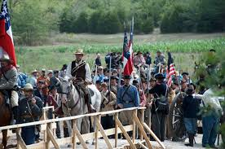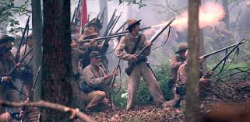

-9-

LEGENDS of the 16TH Geo. Co. G

-10-
GRISWOLDVILLE BATTLE COMMEMORATION
Honoring those that
Served at the battle of Griswoldville and
environs, November, 1864

The Jarrell Plantation Historic Site and the 16th Georgia Volunteer Infantry,
Co. G, "The Jackson Rifles", and The Camp of the Unknown Soldier, Camp # 2218, of Clinton, Jones County, Georgia, cordially invite one and all to the annual

Griswoldville Battle Commemorative Service
Saturday, November 23, 2013

A living history program will begin at 9:30am with the commemoration at 12:00 noon.

Guest speaker

Alan Richards

of the 16th Georgia Infantry, Co. G and the Logan E. Bleckley SCV Camp #1998

For more information, contact:
John Wayne Dobson @ 478-731-5531
waynedobson51@yahoo.com
Brenda Dobson @ 478-396-4838
brendadobson61@yahoo.com
Gary Thomas @ 478-986-5172
Gary.Thomas@dnr.state.ga.us
*****
GPS: 32°52′00″N 83°28′10″W
Directions: From Macon at the junction of U. S. 80 and U. S. 129 (near I-16 Exit 2 and Macon Centreplex), take U.S. 80 east to Georgia 57; at junction with Jeffersonville Rd. bear left on Georgia 57 (Irwinton Rd.). Road name changes to Kenneth W. Birdsong Hwy. Turn left onto Battlefield Dr., at the end of the road turn left onto Old Griswoldville Rd., right onto Baker Rd. Battleground Memorial and parking are on the left. From Griswoldville go south on Henderson Rd. (named Ridge Rd. also) then left onto Old Griswoldville Rd., left onto Baker Rd., Battleground Memorial and parking are on the left.
------------------------------------------------------------------------------------------------------------
From Macon, take U. S. Hwy 80 east, go 2.3 miles, turn left onto Ga. Hwy 57 (Kenneth W. Birdsong Hwy.) and go 4.9 miles, turn left onto Battlefield Dr., at 0.5 miles turn left onto Old Griswoldville Rd., go 2.5 miles and turn right onto Baker Rd., the parking area for the Battlefield is about 1/3 mile on the left. All of the roads are paved. The battlefield is at 32.86690N, 83.46648W.
-11-

GREAT BOOKS
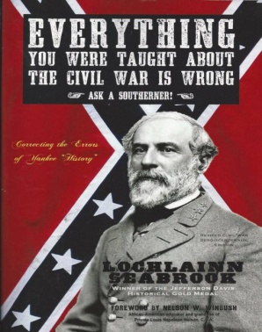
Citizens, Soldiers & Sites of 1860's Macon, Georgia - by Cheryl Bloodworth Aultman - $20 -In keeping with the observance of the sesquicentennial of the War Between the States Cheryl Autlman has issued an absolute gem of a book that does so much to keep the history of a essential Confederate city from being lost to time. It is a must for anyone's historical collection and a wonderful guide to touring Macon. Available at the Cannonball House.

Everything You Were Taught About the Civil War is Wrong, Ask a Southerner-$17.95 - by Lochlainn Seabrook This is an easy-to-read, well documented handbook that confronts the North’s many falsehoods about the War. This exposé of Yankee anti-South propaganda has the power to reeducate the world about Lincoln’s War and give Northerners a better understanding of the conflict itself, while making Southerners, of all races and political persuasions, proud to be Southern.
A GOOL OL' NORTHERN TRADITION - DENY ANY PART IN SLAVERY
Charles Henry Smith was an American writer from the state of Georgia who used the pen-name Bill Arp. The following is taken from his memoirs. This narrative was published in 1902. After reading this passage the thing that struck me was that it is no new thing that the North’s role in the institution of slavery has been diminutized. His observation ...is as follows: "It is sad and mortifying that our young and middle-aged men and our graduates from Southern colleges know so little of our ante-bellum history. The Northern people are equally ignorant of the origin of slavery and the real causes that precipitated the civil war. Most of them have a vague idea that slavery was born and just grew up in the South - came up out of the ground like the seventeen-year-old locusts--and was our sin and our curse. Not one in ten thousand will believe that the South never imported a slave from Africa, but got all we had by purchase from our Northern brethren. I would wager a thousand dollars against ten that not a man under fifty nor a schoolboy who lives north of the line knows or believes that General Grant, their great military hero and idol, was a slave holder and lived off of their hire and their services while he was fighting us about ours. Lincoln's proclamation of freedom came in 1863, but General Grant paid no attention to it. He continued to use them as slaves until January, 1865. So, in 1861 our Northern brethren made war upon us because we enslaved the negroes we had bought from them; but at the same time they kept on bringing more from Africa and begging us to buy them. I wish to impress it upon our boys and girls so that they may be ready and willing to defend their Southern ancestors from the baseless charge of suffering now for the sins of their fathers." Source: Bill Arp from the Uncivil War to Date, 1861-1903, by Bill Arp, 1902.
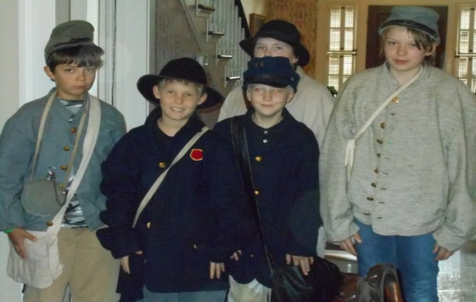

These "new recruits" are a portion of a September 25th Civil War class, " The Life and Uniform of a Solider", taught by Brenda Dobson Earl Colvin and Joel Whitehead at the Cannonball House.

-12-
IN THE NEWS

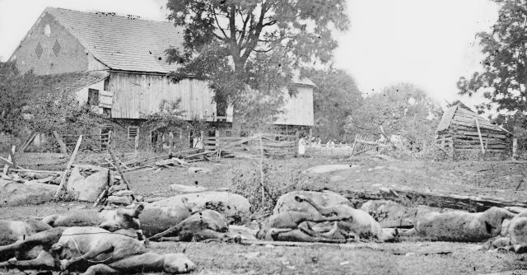
BEATING A DEAD HORSE
After the War, many Americans brought war loss claims against the U.S. government, often for dead or missing horses. A post-war industry emerged of agents who would press war loss claims for a fee, usually a percentage of the claim collected. Soon, claim values were being fraudulently inflated. In response, the government started regulating these intermediaries, barring unscrupulous ones and certifying honest ones as "enrolled agents," a title that is still used today by people who represent clients in matters before the IRS. The Obama administration on September 24 defended its effort to regulate the tax return preparation business for the first time in U.S. history, basing its case largely on a 19th century law dealing with horses lost or killed in the Civil War. At an appellate court hearing on a challenge brought by libertarian lawyers challenging the administration, Justice Department Tax Division lawyer Gilbert Rothenberg said: "I hate to beat a dead horse, especially one from the Civil War era."But he explained that the administration sees the "Horse Act of 1884" as providing ample authority for the U.S. Internal Revenue Service to regulate the tens of thousands of preparers who fill out millions of Americans' federal tax returns. A three-judge panel of the U.S. Court of Appeals for the District of Columbia Circuit heard the administration's argument. Rothenberg said the IRS should be allowed to force tax return preparers -- who are now unregulated -- to pass a competency test and take annual continuing education classes. But the Institute for Justice, a libertarian advocacy law firm, disagreed."Congress never gave the IRS authority to regulate tax preparers," said Dan Alban, an attorney for the institute. The case has broad implications for the industry, which includes H&R Block Inc, a few mid-tier companies and thousands of tiny, mom-and-pop firms. A decision from the judges is still months away. In oral arguments, the judges -- all appointed by Republican presidents -- gave no clear sign of how they will rule, yea or neigh, but did question why the IRS was citing an 1884 law to justify trying to police tax return preparers in 2013.
OLUSTEE UNDER ATTACK - AGAIN !
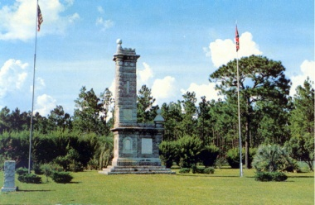
A new heritage attack has been launched at Olustee (near Lake City, Florida). In anticipation of the 150th anniversary of the battle that protected Florida’s capital from falling, the Sons of Union Veterans has obtained approval from the State of Florida Parks Department to place an obsidian obelisk to the Federal invaders on the site where Southerners spilled their blood protecting Tallahassee from capture. The State may have a legal right to do so. In order to stop this we must win the war through citizen objection. Two monuments to Federal forces already exist on or adjacent to the site, but the SUV doesn’t feel that is enough, and regrettably, park officials have ALREADY approved the plan for a large black Darth Vadar-esque shaft to disrupt the hallowed grown where Southern blood was spilled in defense of Florida and her allies in the Southern Confederacy. Please note the MAIN MONUMENT was established by the State of Florida as a remembrance not only of the battle but to honor the fallen from both sides. THE SUV sought approval stating that the fact that there were Confederate monuments and no Federal monuments needs to be corrected. www.dofsuvcw.org/images/Olustee_Monument6.ppt
Editor's Note: I wonder if we will ever see this happen at Griswoldville?
-13-
LETTERS (OR EMAILS) TO THE EDITOR
8th Regiment Band - "We are glad you enjoyed the concert. Please spread the word that we will be at the back in Macon on May 4th at the Vineville Methodist Church for another concert. We really appreciated the warm response and support your group showed us while we were there. It was a pleasure to perform for you. Best Regards, Stephanie Ragsdale, President Eighth Regiment Band Rome, GA"
16th Georgia - I am a member of the Major William E. Simmons Camp 96 SCV that meets at the historic Female Seminary in Lawrenceville, Georgia. For several years, I have researched the 16th Georgia Volunteer Infantry, and the 3rd Battalion Georgia Sharpshooters formed in the spring of 1863 from General William Tatum Wofford's Brigade. My interest stems from an ancestral connection with several family members who were in Company I (Gwinnett Volunteers/Hutchins Guards) of the 16th Georgia, some of whom were in the 3rd Battalion. My great-great uncle, Major William E. Simmons, was acting commander of the sharpshooters when he was captured at Crooked Run near Front Royal, Virginia on August 16, 1864.
To help facilitate my research, I have compiled a data base comprised of nearly 6,000 men who served in the Cobb/Wofford/DuBose Brigade during the WBTS. As you may already know, from 1862 until the end of the War, the brigade was made up of the 16th Georgia, 18th Georgia, and 24th Georgia Volunteer Infantry Regiments, and the Infantry Battalions of Cobb's and Phillips Legions. In the data base are 1,491 men from the 16th Georgia and 170 men from the Jackson Rifles. To date, I have identified the following six men from the Jackson Rifles who were in the 3rd Georgia Sharpshooters:
Private James R. Woods, Private William J. Haynie (Haney), Private Benjamin F. Fields, Private Thomas J. Fields (1843-1930), Thomas J. Fields (1840-1913), and Private John M. Archer.
The data base includes over 60 numerical and categorical fields as well as one open-end field. I have gathered the information from Lillian Henderson's Georgia Confederate Roster, Confederate service records, and 25 other sources. This is a work in progress, but, time permitting, I hope to have a more complete and comprehensive data file by the end of the year.
I am blessed to possess one of only four known manuscripts of a scholarly/documented (but unpublished book) about Major William E. Simmons that traces his footsteps throughout the WBTS that has proved to be invaluable in my research and writing. I also have copies of a number of letters written from men who served in the 16th Georgia and other regiments of the brigade.
The purpose of this email is twofold:
1. I am willing to share this information, as appropriate, with you and other interested members of your organization. I also have PowerPoint programs on Major Simmons and the 16th Georgia which have been presented to several North Georgia SCV camps.
2. I would be very interested in information, data, or documentation you would be willing to share to help fill any missing gaps in my research. In particular, I would love to improve my knowledge of the Jackson Rifles and the men who served in that company.
I am planning to attend the annual Griswoldville Battle Commemoration Service on Saturday, November 23rd. I have close friends who live nearby and will invite them to join me. I would like to discuss these matters in more detail at your convenience. You can reach me at (404) 917-7199. My mailing address is 6410 Manor Lake Court, Cumming, Georgia 30028. Very respectfully, Joe Byrd
-14-
DOG SOLDIERS
In the late 1980's and early 1990's Corporal Bones of the 16th Georgia Co. G distinguished unit members who were the most faithful and trusted by the term DOG SOLDIERS. The Dog Soldiers or Dog Men (Cheyenne Hotamétaneo'o) was one of six military societies of the Cheyenne Indians. Beginning in the late 1830s, this society evolved into a separate, militaristic band that played a dominant role in Cheyenne resistance to American expansion in Kansas, Nebraska, Colorado and Wyoming, where the Cheyenne had settled in the early 19th Century. After the deaths of nearly half the Southern Cheyenne in the cholera epidemic of 1849, many of the remaining Masikota band joined the Dog Soldiers. It effectively became a separate band, occupying territory between the Northern and Southern Cheyenne. Its members often opposed policies of peace chiefs such as Black Kettle. In 1869, most of the band were killed by United States Army forces in the Battle of Summit Springs. In the 21st-century, there are reports of the revival of the Dog Soldiers society in the Northern Cheyenne Indian Reservation in Montana and among the Cheyenne and Arapaho Tribes in Oklahoma.

EARNEST PRAYERS NEEDED
RAY CROSS - Alan Richards stepfather
TIM PILGRIM - GA SCV Adjutant
RICKY SMITH - 16th Geo
STEVE SMITH - 16th Geo
TIM FOWLER - 16th Geo
FRANK FOULKE - 96th PVV (heart surgery September 21)
CAPT.BRADBERRY'S FAMILY - 16th Geo (loss of a loved one)
**********
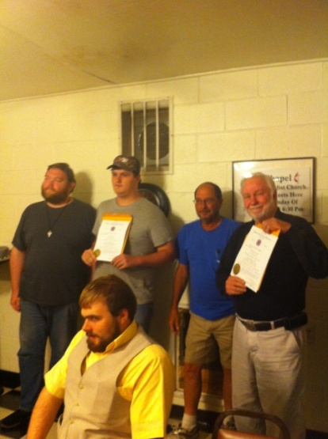
The Camp of the Unknown Soldier, # 2218 of Clinton, Jones County, Georgia, met on September 26 at Chevy's Café on Hwy. 49 in Jones County, where they enjoyed a presentation about the MACON ARMORY by 2nd Lt. Cmdr. Earl Colvin. All officers were re-elected and Will Butler appointed historian. New compatriots David Dunning and Rodney Morgan were inducted. October will mark our last meeting at Chevy's as we will hold our November meeting at the Griswoldville Commemoration (November 23), forego a December session and likely move to the new location of Firefly's Restaurant in January 2014 (4th Monday). We will be mailing dues payments to SCV National and State HQ well in advance of the October 31st deadline. Anyone who does not have them in to Camp 2218 by then will risk late fees or must handle the matter themselves. Many thanks to Compatriot Al McGalliard for developing our Camp logo and our web site. Check it out at scv2218.com
-15-

OCTOBER 5-6 - ANDERSONVILLE
OCTOBER - BATTLE @ IRWINVILLE - POC - LEE MURDOCK @ 478-986-5290.
NOVEMBER 1-3 - BATTLE OF ATLANTA - Re-enactor registration for both November 1-3, 2013 and September 19-21, 2014 is now open. The registration fee for 2013 and 2014 is $15.00 per person until October 15, 2013. After October 15th, the walk on fee is $25.00. The registration fee of $15.00 per person for 2014 is good until September 1, 2014. After September 1st, the walk on fee is $25.00. Children under 12 are free for both re-enactments but they must register.
NOVEMBER 9 - CANNONBALL HOUSE APPARITIONS PROGRAM - Tours start at 5pm. Reservations required.
NOVEMBER 23 - GRISWOLDVILLE 149th ANNIVERSARY COMMEMORATION
DECEMBER 14 - A CANNONBALL HOUSE CHRISTMAS - 6pm.
…and coming in 2014
JANUARY - Winter Muster
FEBRUARY - 150th Olustee
MARCH - Manassas
APRIL - Kennesaw & Confederate Memorial Day
MAY - Old Clinton War Days

16TH GA Co. G. “Jackson Rifles”
Brig. Gen. Herbert Burns - 478-668-3598
Capt. Wm.“Rebel”Bradberry–404-242-7213
1 Lt. Noah Sprague – 706-491-9755
1st Sgt. Kevin Sark – 478-731-8796
2nd Sgt. Nathan Sprague – 478-320-8748
Adjutant John Wayne "Duke” Dobson 478-731-5531
1st Corp. Alan "Cookie" Richards 478-308-9739
2ndCorp. Chas."Goodtime" Whitehead 478-986-8943
3rd Corp. Lee "Pappy" Curtis -478-365-6785
Lead Chaplain – Joel Whitehead, Jr. - 478-986-8798
Hon. Chaplain Ronnie “Skin” Neal – 478-994-0958
Assistant Chaplain – Charles Hill – 770-845-6878
Treasurer - Pvt. Earl Colvin – 478-214-0687
Honorary Colonel J. C. Nobles - 478-718-3201
Musician - Landon Allen - 478-294-9870
Musician - Jacob Thompson – 478-214-0687
Musician - Aaron Bradford – 302-668-8029
Musician - Oliver Lummus – 302-668-8029
ON FACEBOOK:"JACKSON RIFLES" - 2,154 FRIENDS (as of September 27). All 2011-12 issues of The Howling Dawg are available @ (scvcamp1399.org), thanks to Steve Scroggins and soon will be at scv2218.com as well, courtesy of Al McGalliard.
-16-
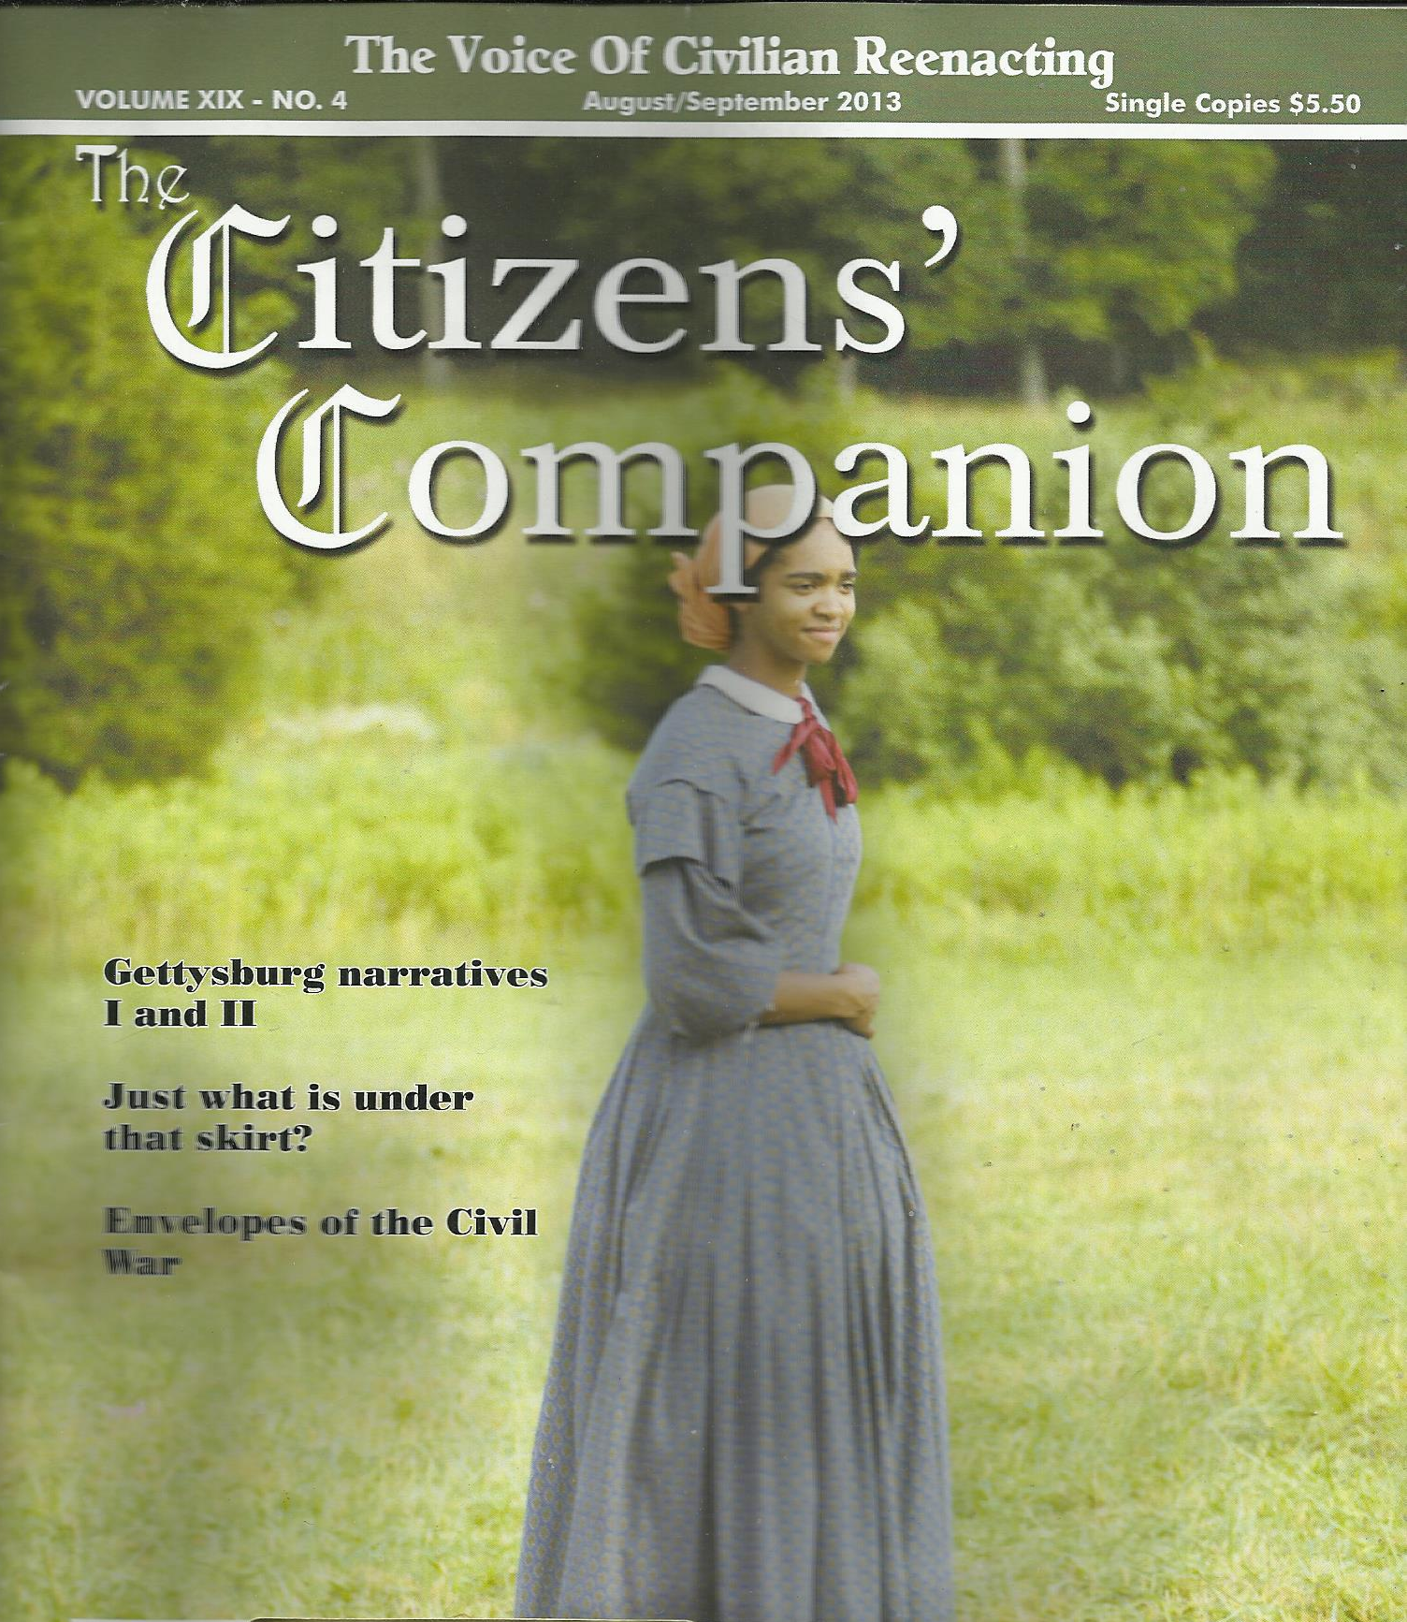
LOOK WHO'S ON THE COVER

As many readers know, former Cannonball House (Macon, GA) docent, Mia McKie, departed this year for new employment at Historic Williamsburg (VA). We were so proud and pleased to see her image on the cover of the new issue of The Citizen's Companion. As we say here in Georgia - "ya' done good !!!"

HAVE YOU SEEN THIS HAT ?????????? or one similar to it. The straw bowler was reported lost by Pvt. Ethan Bloodworth, 16th Georgia, probably during our summer drill at Clinton. Also missing during that same time was a tin cup belonging to 16th Pvt. Kellie Banks, 16th Georgia. Call 478-731-5531

***

-17-
WHO OR WHAT DO YOU TRUST ?

"Go and cry unto the gods which ye have chosen; let them deliver you in the time of your tribulation." - Judges10:14

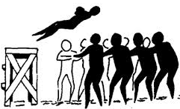
I have been reading through the Bible again this year - I don't mean one of those reading plans where you must scan chapters each day in order to finish with a year. No, at my pace, I may be a bit longer than that. I have often marveled at how people read the Bible - if they do - they will read a chapter here and there, go to Psalms for a while or read something in the Old Testament, then re-read the Gospel of John - nothing wrong with all that, mind you, it is just an odd way to read any book. Normally, we do so by starting at the beginning and proceeding to the end and that is the way I am reading the Bible through. God shows me a lot of new things this way. I am now reading in the book of Judges, a book I always liked because it is a history of the nation of Israel slipping away from God, getting in a jam, running back to Him for help, then doing it all over again - JUST LIKE US. Recently, I was meditating over one such episode in chapter 10, where God had seemed to have gotten quite enough of Israel's unfaithfulness. Over and over it says in Psalm 136 that God's mercy endures "forever", yet, Genesis 6 relates that God's "spirit shall not always strive with man" and Proverbs 1:24-26 sternly states that "because I have called, and ye refused … I will laugh at your calamity; I will mock when your fear cometh." These are not contradictions as some scoff. God's mercy will endure forever, into Heaven and all eternity if you have placed your trust in His shed blood for the salvation of your soul. As far as your time on earth it seems possible to provoke God enough that He just says "I've had it with you!" So, seems to be the case in Judges 10, when trust was placed in others - not God. Maybe your god is money - to tell you the truth, I think I could be quite susceptible to that lure, but it is a vain god to trust in. Have you ever noticed how many times you hear of someone who is rich and famous dying some dread disease. Can you imagine lying on your death bed and looking over at a pile of cash stacked on your night stand and knowing it cannot save your life! I mean money fixes some things but for others, that god is powerless. In Judges 10, once again, God's people have strayed and worshiped other gods. Again their enemies have come upon them and predictably they run back to God Almighty crying, "if you just help us out this time, we will never turn from You again." Do you recall the old hymn that says "prone to wander, Lord I feel it, prone to leave the God I love?" God's people have always been that way - then and now. Think of your life; when have you been closer to God - in good times or bad? When times are good we tend to feel we have things under control. We often hear that asinine phrase these days that so many mimic like a trained parrot - "I got this." Yeah, "I got this, Lord." And though it breaks His great heart, He says, go ahead, if "you've got it." God blatantly tells the Israelites in Judges 10:14 that they had "chosen other gods" and that perhaps they should seek help from those gods rather than knocking on his door. As the scripture continues: " Yet ye have forsaken me, and served other gods: wherefore I will deliver you no more. And the children of Israel said unto the Lord, We have sinned: do thou unto us whatsoever seemeth good unto Thee; deliver us only, we pray Thee, this day." And they put away the strange gods from among them, and served the Lord: and his soul was grieved for the misery of Israel." God helped them when they repented - when they came back to Him. He will do the same for you and this troubled Country of ours. "If my people, which are called by my name, shall humble themselves, and pray, and seek my face, and turn from their wicked ways; then will I hear from heaven, and will forgive their sin, and will heal their land." (2 Chronicles 7:14) In whom or what do you trust?
-18-

