Saint Joseph School  Co-Curricular and Extracurricular Activities  - Weekly school Liturgy as the center of our Catholic identity.  - Generous contributions to local, national, and international mission projects.  - Sacramental preparation program.  - Option C online grade and communication program.  - Full accreditation by the Ohio Catholic School Accrediting Association.  - Spelling Bee participation.  - A state licensed Early Childhood program.  - Religion teachers who have acquired “Growing in Faith” certification.  - Kindergarten through grade 8 music instruction with a state-  certified teacher.  - Reinforcement of reading skills with an Accelerated Reading Program online.  - Field trips to extend the performing arts and science curriculums.  - A comprehensive technology program with wireless connectivity, laptop computers, and classroom Active boards.  - Participation in History & Science Fairs.  - Before & After school Children’s Center.  - Family Groups activities include students K-8.  - Remedial and tutoring programs for all grade levels.  - Handwriting Contest sponsored by Zaner-Bloser.  - Full school year athletic program with Monroeville Public Schools.  - Middle school Academic Challenge competition.  - Computer tablets for Preschool through Kindergarten students  and Chromebooks for grades 1-8.  - Algebra on premise and/or Foreign Language at the High School.  - College Credit Plus option for 7th & 8th grades.  The St. Joseph Catholic School admits students of any race, color, national and ethnic origin to all rights, privileges, programs, and activities generally accorded or made available to students at the school. It does not discriminate on the basis of race, color, national and ethnic origin in administration of its educational policies, admissions policies, scholarship and loan programs, and athletic and other school-administered programs. |  | 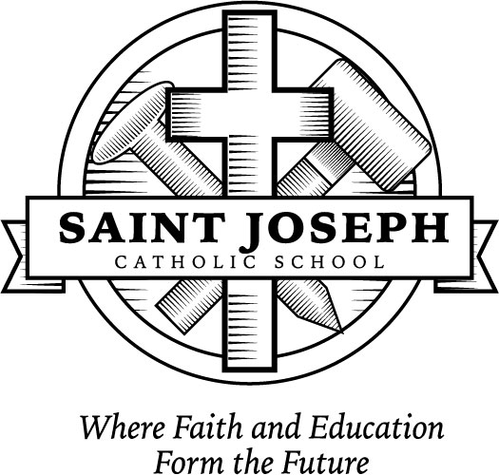  Saint Joseph School  …11:1 Student-Teacher ratio…  Registration Information  2018-2019 School Year  79 Chapel Street – Elementary  43 W. Broad Street – Middle School  Monroeville, Ohio 44847  Phone: (419) 465-2625  Fax: (419) 465-2170  E-mail: sjs@msjcs.org  Website: www.msjcs.org  Fr. Ron Schock, Pastor  Mr. David McDowell, Principal

Saint Joseph School
“Catholic Schools Raise the Standards”
Registration for the 2018-2019 School Year
Dear Parents,
Choosing the right school for your child is an extremely important decision. Here at Saint Joseph School we believe our school is a wonderful place for children. We are alive with academics and faith values because of the rich heritage of our past. We are here today because of pioneer spirits who recognized that faith is at the very basis of everything one accomplishes in life. As I continue to see local businesses and parishioners give to us in our Annual Fund, I know that they give because they believe strongly that our school is meant to be here as the clearest sign of evangelization.
You are the parents who yearn for the very best for your children. You are convinced that we can extend to your child/ren the vision that these pioneers had. So you entrust us with the mission of education that we take very seriously. When have we needed the message of the gospel more than right now?
Through the combined efforts of the parish Finance Committee and the St. Joseph Administrative Staff, a tuition scale has been developed that reflects good stewardship of parish and school resources and an understanding of the difficult economic climate. Our subsidy from the parish is extremely generous and is in addition to the profits realized from the parish festival and internal school fundraisers. When you look at the $2,550.00 that we ask for, it is not even half of the cost. How do we do it? It continues to be a walk of faith and trust in God. It is by His grace, and the provision of so many, that we are able to move forward spiritually and academically.
If you are in need of financial assistance, please apply using the forms for the next school year available in the school office or on our website. Please also be aware that scholarships are available for those who qualify. Please call me at school for more information. In addition, we have set aside funds for families who might experience a significant change in their income next year. No student will be turned away needing financial assistance. Please ask us and we will find a way!
Lastly, please call me or stop in for a visit if I can be of any assistance. My door is always open to you and I am praying with and for you. The most important gift that we can give our children is a deepening of their faith which is more needed in this world today than any material gift you can give. Thank you for choosing St. Joseph School!
Sincerely,
David McDowell, Principal

Saint Joseph School Tuition 2018-2019

Preschool -- Parishioners & Non-Parishioners
Tuition Snack Registration Total Due
Preschool-- 3/4 yrs $1,050.00 $65.00 $50.00 $1,165.00
Pre-K-- 4/5 yrs $1,200.00 $85.00 $50.00 $1,335.00
**Snack & drink will be provided daily for the mandatory fee listed above

Days & Times
P3…………… Tuesday, Wednesday, Thursday 7:45am – 10:15am
PK………. Monday, Tuesday, Wednesday, Thursday 12:00pm – 2:30pm

*Tuition assistance does not apply to Preschool.
**Preschool includes $100 continuation fee for Preschool and $150 continuation fee for Pre-Kindergarten. This fee will be deducted from your tuition as your child reaches Kindergarten and First Grade.

Kindergarten – Grade 8 St. Joseph & St. Alphonsus Parishioners (BEFORE 6/1/18)*
Tuition** Registration Total Due
One Child $2,550.00 $50.00 $2,600.00
Two Children $4,590.00 $100.00 $4,690.00
Three Children $6,270.00 $150.00 $6,420.00
Four Children $6,935.00 $200.00 $7,135.00

Kindergarten – Grade 8 St. Joseph & St. Alphonsus Parishioners (AFTER 6/1/18)*
Tuition** Registration Total Due
One Child $2,800.00 $50.00 $2,850.00
Two Children $4,840.00 $100.00 $4,940.00
Three Children $6,520.00 $150.00 $6,670.00
Four Children $7,185.00 $200.00 $7,335.00

**Cost per pupil is approximately $5,500.00, if you are able to pay more.

Kindergarten – Grade 8 Non-Parishioner Tuition
If you are not a parishioner of St. Joseph or St. Alphonsus, we ask you to set up an appointment in our office to discuss tuition rates.

*Registration Fee $50.00 per student & is non-refundable.
**Multiple children rates do not apply to Preschool.

