2020  USA SOFTBALL of MARYLAND DC DELAWARE | 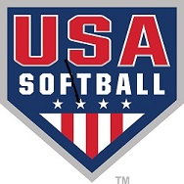  Of Maryland DC Delaware
Identification Sheet

Players Name

Date of Birth

Signature of Player

Signature of Parent

Commissioner ________________________
Commissioner or Designee Date

JUNIOR OLYMPIC
e

ASA Code at all National Tournaments, in order to be eligible, a player must produce proper identification (which shall include a current photograph of the player and the player’s signature) to the tournament director before the start of the competition. The Tournament Director shall compare the identification with the name and signature on the team’s roster.”

