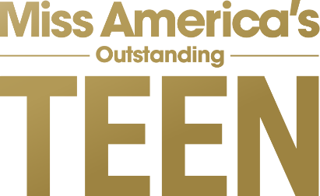

Miss Blackhawk Valley Scholarship Program, Inc.
Outstanding Teen Sponsor Form 2022

Sponsor(s} Name:

Address:

City: State: Zip:

Phone: ( )

Signature:

I agree to sponsor a 2022 Miss Blackhawk Valley’s Outstanding Teen candidate for $100.00.
I understand this fee is not refundable and enables the teen to compete in the Miss Blackhawk Valley’s
Outstanding Teen Competition.

I would like to sponsor (name of candidate):

*Make checks payable to Miss Blackhawk Valley Scholarship Program, Inc.
Return this form with check to:
Mary Snyder, Treasurer
3550 Tam-O-Shanter Drive
Bettendorf, IA 52722

_ _ _ _ _ _ _ _ _ _ _ Detach the section below for your records _ _ _ _ _ _ _ _ _ _

Outstanding Teen Candidate Sponsor
Miss Blackhawk Valley Scholarship Program

Thank you for helping the teens of the 309-area code to obtain scholarships to improve their education and talents.

Sponsorship fee receipt $________

Pageant representative or Candidate: ____ ____ ____ ____ ____ ____ ____ ____ ____ Date: ____ ____ ____

Revised 8/25/2021

