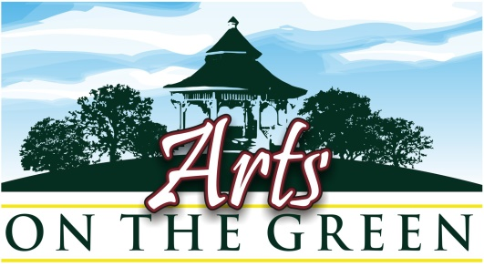


4th Annual Arts on the Green June 27th 2015 : Prospectus
Place: Town Green, Main Street, New London, N.H.
Date: Saturday June 27th , 2014 -rain or shine Time: 10 am-4 pm

Arts on the Green is a Fine Arts and Fine Crafts juried show. Acceptable works are:

Fine Arts: painting-oils, acrylics, watercolors, monotypes, pastels, drawings, photography, block prints, sculpture, (matted works: unframed originals, matted giclee prints- must be in bins). Greeting cards and hand painted cards are acceptable.

Fine Crafts: pottery, fine jewelry, gold and silver work, weaving, fiber arts, wood, metal, stone, sculpture.

Each participant must display at least 10 original artworks during the show of their own personal work. Display only works for general viewing (all ages will be at the event, so nudes or images that are not acceptable for children to see are prohibited).

No tent sharing; no organizational groups or commercial retail stores may participate.
For questions please email aog@centerforthearstnh.org
- All works must have been created by the person displaying at the site
- There are no commissions taken by CFA.
- You are responsible for your own sales and you, or your representative, must be in attendance during the show at your booth.

Fees: The following fees are payable by check or online with PayPal:
    - New Applicant Jury Fee: Non-refundable $25 ($20 CFA members)
See jury application form for 1st time jury submission.

    - Site Fee for All Past and Newly Accepted Participants:
$100 site fee ($90 members) along with your signed registration form

    - If you would also like to become a 2015 Artist Member of
the Center for the Arts at this time please send $115

    - Fees must be received no later than April 15th to reserve a space, and to be included in all publicity (postcards, posters, press releases and ads). We will not reserve your space without a check.

- Mail checks and forms to: Center for the Arts AOG -PO Box 872 -New London, NH 03257
OR Email forms to aog@centerfortheartsnh.org
and pay with PayPal online at http://www.centerfortheartsnh.org/arts-on-the-green.html

- Site fees will not be refunded after April 15th for any reason.

June 27th /Site Information:
- Show times are 10 am to 4 pm. Plan to arrive early enough to have your set up done before 10 am. No break down before 3:45 please.

- CFA will provide coffee at the information booth the morning of set up.

- Your tent space is 10’ x 10’ with a 3ft. space between each tent. Please be respectful of the neighboring tents. Freestanding racks or bins should be placed with your exhibiting neighbors in mind. You may use tent stakes.

- Exhibitors may display works only in the category registered on the application form below. You may not display past awards, ribbons or advertisements.

- On Saturday morning please bring your site map and packet and plan to arrive early to set up in a timely fashion. The show starts promptly at 10 am. You may drive up to your site to unload but as soon as your equipment is unloaded you must move your car to the parking area shown on your map. Please leave Whipple Parking lot and the Main Street parking spaces free for our customers!

- Do not leave your car on the street or in the park later than 9 am or you will be asked to move your vehicle. If you have any questions when you arrive please see the Center for the Arts representatives at the information booth near the Whipple Hall side of the park.

- You may again drive up to your tent after 4 pm to load it.

- The park needs to be vacated by 6 pm. Please pick up and dispose of all paper and refuse in and around your site. You are responsible for the appearance of your site when you leave.

You will be notified of your site number in May.
At that time you will receive an orientation packet with the site map, directions to New London Arts on the Green, and some postcards/ handouts for your own announcements.

Ads will be placed in the Hippo Press, Kearsage Magazine, Soo Ni Pi, NH ToDo magazine, Lake Sunapee papers and info guides to advertise the event.

Artists and artisans are strongly encouraged to use e-mail, website announcements, and social media like Facebook, Linked In, and Twitter to notify clients and friends about the show ahead of time.

