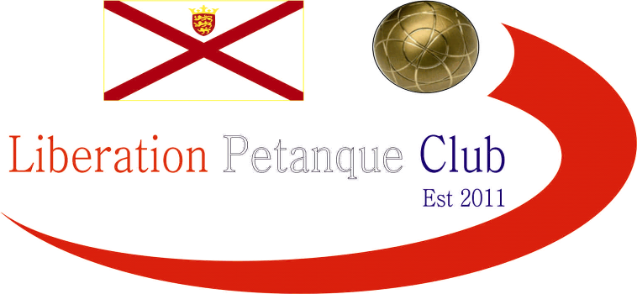

Winter 20198 / 20 Season
Charity Christmas Doubles Open
Saturday 7th December 2019
A perfect 16 teams entered this year’s competition helping raise £276 towards Jersey Children’s Charity, this means we have now raised £451 this year despite having less entries than last year.
Four rounds of matches were played before the top eight were split into the main and the plate competition.
In round one, Harrison Marie & Percy almost beat Matt Pinel & Mark Nicol just losing out 13 – 11 after a 5 on the final end for Matt & Mark. Another close result was Keith Pinel & Graeme Follain who just pipped Daniel & James Villalard 12 – 10. Playing in their first Liberation competition were Christine Joshua & Dave Souter who play for St saviour’s Parish team. They beat Gary Cowburn & Wendy Ritzema 11 – 9 who were runners up last year.
Big wins, all 13 – 4 for Jake & Ross over Tommie & Peter, Matt Buesnel & Toby over Chris & Ted (who were 4 – nil up) and Andrew Limbrick & Stephen over Martin & Mo.
Christine & Dave beat Matt & Toby 11 – 10 in round two after Toby took the coche out on the final end. There were two 13 – 12 results as Matt & Mark survived another scare beating Andrew & Stephen and Cassie & Jean beat Chris & Ted.
Tommie & Peter just won a timed out match against Martin & Mo 10 – 9, but there was a big win for Colin & Helene 13 – 4 over Jake & Ross and Keith & Graeme beat Brian & Paul Harris 13 – 2.
The third round saw Matt & Toby beat Cassie & Jean 11 – 10 despite conceding a four on the final end. This was the same score line as Brian & Paul overcame Tommie & Peter. Jake & Ross lost again, this time to Gary & Wendy.
Chris & Ted won their first game, over Harrison & Percy as did Martin & Mo, over Daniel & James. Geoffroy & Laurent gave themselves a chance of getting through with a win over Andrew & Stephen.
The final round saw a host of teams looking for a top four spot. Matt & Toby gave themselves a great chance by beating Gary & Wendy 13 – 0. This proved vital as despite Geoffroy & Laurent big win 13 – 3 over Christine & Dave they finished fifth by four points on points difference to Matt & Toby.
Keith & Graeme finished top winning all four matches after they beat Matt & Mark 13 – 12. Colin & Helene also made the top four finishing third with a win over Brian & Paul.
Making the plate competition was Andrew & Stephen after their win over Ross & Jake 13 – 2, they were joined by Cassie & Jean and Christine & David.
In the Plate competition the semi-finals were as follows:
Geoffroy Buffetrille & Laurent Pellaton v Cassie & Jean Stewart
Andrew Limbrick & Stephen Leathem v Christine Joshua & Dave Souter
Geoffroy & Laurent won a close game 13 – 9 over Cassie & Jean to make the final as did Andrew & Stephen who handed out a 13 – 0 defeat to Christine & Dave. The final wasn’t close though as Geoffroy & Laurent won 13 – 3 for victory in the Plate competition.
In the Main competition the semi-finals were as follows:
Ranked 1st Keith Pinel & Graeme Follain v Matt Buesnel & Toby Northern Ranked 4th
Ranked 2nd Matt Pinel & Mark Nicol v Colin Myers & Helene Retrosi Ranked 3rd
Neither Semi-Final was close as undefeated Keith & Graeme lost out 13 – 2 to Matt & Toby with a crucial over the top boule to boule carreaux by Toby at 10-2 helping get the three points needed on that end to win.
Matt & Mark had already beaten Colin & Helene in round three 13 – 5, this time they didn’t even give them a point as Matt & Mark ran out 13 – 0 winners.
So, four of the Islands top players in the final, it was going to be close. Although Matt & Mark lead most of the way it was never by much and with Toby pushing his own boule up to give himself and Matt three points to make it back to 10-11. Unfortunately, on the next end Mark placed one next the coche and although Toby hit it the boule moved with the coche and despite Matt Buesnel placing next to it Mark managed to get his next boule in for the two points needed to win the match and the tournament.
Thank you to all those who helped organise, played and donated on the day your support was amazing for a great Charity.

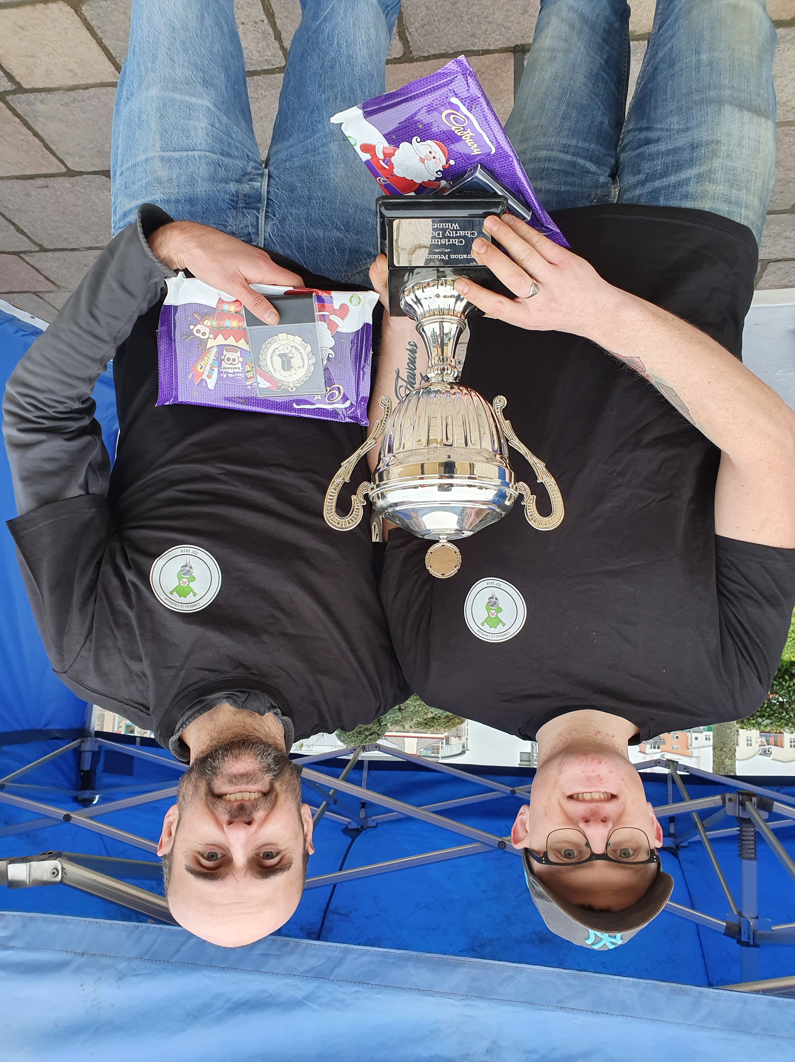

More photos on Facebook

Club email address - liberationpc@gmail.com

Club Website - www.liberationpetanque.co.uk

Kind Regards

Toby Northern

Chairman

Liberation Petanque Club

SPONSORED BY

