 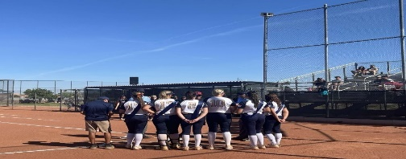 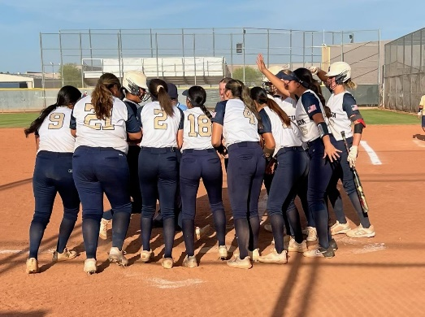

Thunder Softball

Where: DVHS Weight Room & Softball Fields

When: June 5 – June 29, 2023

Weight Room Monday – Thursday 9:15am –10:15am

Softball Small Gym Monday -Thursday 10:15am– 11:45am

Who: 9-12 DVHS Grade Softball Players

What: The opportunity to enhance our skills and our strength during the off-season. We will be lifting, doing speed and agility work as well as we be working on our softball skills during this time.

How: Sign Up through TUHSD Community Education:

The Bookstore Online Payment Portal URL is:  <https://az-tempeunion.intouchreceipting.com/signin.aspx>

Cost: $70.00

Camp Director: Coach Crowl:

Contact Information: ccrowl@tempeunion.org / Phone 480-459-0874

