THIRTY-THIRD SUNDAY
IN ORDINARY TIME
NOVEMBER 16 & 17, 2019
LIFE IS HARD, BUT HAVE NO FEAR
Today’s readings take a fearless look at reality and reach a conclusion that we all know; life is hard. The Prophet Malachi preaches fire and brimstone, warning us that evildoers will perish in flames. Saint Paul offers in his own warning to the Thessalonians: keep busy, but never become a busybody. He reminds Christians that the Apostles themselves worked in “toil and drudgery” as a model for how we ought to contribute to our community. The Gospel returns to the apocalyptic tone of Malachi, describing the utter chaos of the end-times. We will know the end is near when violence, catastrophe, and hatred dominate the earth. But we most not fear! God’s saving plan brings peace to our hearts. Malachi speaks of the sun’s “healing rays,” and Jesus himself promises to protect every hair on our heads.

SUFFERING
By Dennis Tavares
No human being escapes suffering in life. Everyone, even wealthy pampered persons, get sick at some point in time, and sickness is certainly a form of suffering. Thus, suffering is normal in human life; it is only a sad thing when it is wasted and not used to redeem us from evil into sanctity. It has to be offered up as Christ offered His life, so that God the Father could use it to make good out of tragedy. We can cooperate with God in this process of creating good by using our willpower, the only thing that is definitely our own. Everything else we have or control will be taken from us eventually, surely at death. But, we take our will to heaven or hell for eternity. What we do with our will during life is the only thing that matters in our life story.

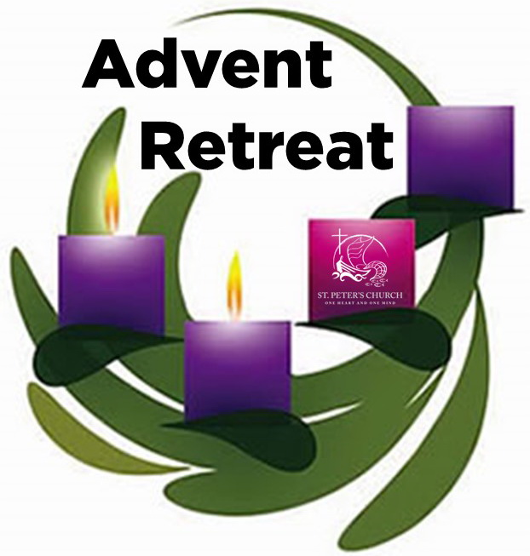
THERE WILL BE A SPANISH ADVENT RETREAT TO BE LED BY COUPLES FOR CHRIST ON
SATURDAY, DECEMBER 7TH FROM 9AM – 1PM
IN THE PARISH HALL.
FOR THIS RETREAT ALL THE COMMUNITY IS INVITED, BUT
IT IS MANDATORY FOR ALL CATECHISM STUDENTS AND THEIR FAMILIES TO ATTEND.

ALSO, WE INVITED MR. & MRS. MARCOS ESPINOZA TO LEAD OUR ENGLISH ADVENT RETREAT
AND WILL TAKE PLACE ON SATURDAY, DECEMBER 14TH FROM
9AM- 1PM
FOR THIS RETREAT
IT IS MANDATORY FOR CONFIRMATION STUDENTS, PARENTS AND FUTURE SPONSORS TO ATTEND.

PASTORAL RUMINATIONS
By Father Andre Querijero

Some time ago, we began exposition of the Blessed Sacrament at our Parish, wherein the tabernacle was just kept open for silent prayer and meditation. Now, by overtly putting Christ’s Body in the monstrance, the Real Presence of Our Lord becomes the center of our faith community’s act of worship, and almost all of our parishioners have had the wonderful experience of encountering Jesus in the Blessed Sacrament exposed and adored prior to daily and weekend masses. As St John Paul once said: “Our communal worship at Mass must go together with our personal worship of Jesus in Eucharistic adoration in order that our love may be complete.”
What has grabbed my attention, though, is the thought that Jesus is not only present in his transformed body while retaining the external material form of bread (the mystery of transubstantiation). In His flesh and blood, our Lord is, above all, offering us a deeper personal relationship with Him. The miracle of Jesus’ Real Presence starts the moment we grasp the true meaning of this divine friendship forged by the shedding of His lifeblood. In other words, Jesus desires to personally give Himself to each and everyone of us who keeps vigil and patiently wait on the Lord in prayer. Only then can the Holy Spirit transform us as the bread and wine are transubstantiated to be a Eucharist and spiritual soul food for others.
Beginning this weekend, as we approach the end of our Liturgical Year, we shall reflect on the “Last Things” and the Second Coming of Christ since we all long for Jesus’ return in glory. It may seem to some that Christ could be palpably absent in the lives of the poor, the sick, and the marginalized in society, but those of us who encounter Christ in the Blessed Sacrament and receive His Body and Blood in our communal celebration of the Eucharist can make our Lord’s presence, in physical and material form, by reaching out in love to our brothers and sisters who are most in need. “Every member of the Church must be vigilant in seeing the sacrament of Love shall be at the center of the life of the people of God so that through all the manifestations of worship due Him shall be given back “love for love” and truly become the life of our souls” (St. John Paul II, Redemptoris Hominis).

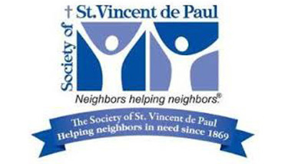

Saint Vincent de Paul Ministry

Free Lunch Program
Every Sunday after the 10 am Mass, the St. Vincent de Paul Ministry of Our Lady of Good Counsel prepares 30-40 sack lunches to be handed out to those in need in our community. We start immediately after Mass and start handing out the lunches at 12 noon-1 pm.
The Ministry provides all the food and supplies needed. All we need is YOUR help! There’s a sign-up sheet on the bulletin board in the vestibule of the Church on North wall. This is a great Ministry to share with your family and friends to carry out our directives to care for the poor and the hungry as Jesus has asked of us. Catechism and Confirmation students can earn 1.5 hours community service by volunteering to help!
The Ministry also needs donations of granola bars, juice packs, small individual bags of chips and cookies, and tax-deductible donations (we actually assist families in financially difficult times).
Let St. Vincent de Paul assist you in your Catholic mission of caring for those less fortunate and in need!
For more information, please call Will Lee at 707-367-8060 or Lynn Black at 707-734-0087.

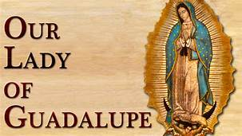
FEAST OF OUR LADY OF GUADALUPE

December 12th is coming up and we would like you to mark your calendars for the Feast Day of the Patroness of the Americas, Our Lady of Guadalupe.
We request your participation and generous donation for this SPECIAL event.
You may drop off your donations at the office, Monday-Friday from 10am-2pm or in the collection basket. Please mark your envelope: Feast Of Our Lady Of Guadalupe.
Our Lady’s feast will start with the Mañanitas at 5am, followed by a Mexican treat of hot chocolate, pastries, etc.
At 5:30pm, there will be a Procession and Mass at 6pm.
May our Mother’s mantle of love bring blessings of peace and harmony to families in our faith community.
Thank you so much!

THERE WILL BE NO GATHERING AFTER 6PM MASS!

OUR LADY OF GOOD COUNSEL HAS AMAZON SMILE.
WHEN YOU MAKE ANY PURCHASES THROUGH AMAZON, MAKE SURE YOU CHOOSE AMAZON SMILE AND “SELECT” PASTOR OF OUR LADY OF GOOD COUNSEL CATHOLIC CHURCH A CORPORATION SOLE.
YOU WILL BE ABLE TO MAKE A DONATION TO OUR CHURCH IN EVERY PURCHASE.
FOR MORE INFORMATION, PLEASE CALL
THE OFFICE 964-0229.

OUR LADY OF GOOD COUNSEL MEMORIAL TREE
In the vestibule of the Church, on the southern wall,
is a beautiful Memorial Tree.
Its bright leaves represent permanent memorials to the
departed of our Parish.
For the sum of $200.00, you can give to the Parish Secretary, the correct spelling and dates of the departed and in due time the leaf is printed and attached to the tree: a permanent reminder of a loved one who is gone.
For more information, call the Parish Office at 964-0229.

ATTENTION
WE STILL HAVE PICTURES FROM ALL SOULS DAY. COME AND PICK THEM UP. THEY ARE IN THE OFFICE AND IT IS OPEN MONDAY – FRIDAY
FROM 10AM – 2PM.

MASS INTENTIONS
NOVEMBER 18-24, 2019
Monday (18)  Tuesday (19)  Wednesday (20)  Thursday (21)  Friday (22)  Saturday (23)  Sunday (24) | 12:05pm  12:05pm  12:05pm  12:05pm  12:05pm  5:00pm  6:30pm  8:00am  10:00am | Margarito Martín †  Rubén Villegas, Sr. †  Eurico y Dorothy Carolo †  Joseph y Sarajane Cebula †  Emeterio Gaeta †  Fred & Clara White †  Rito Echeverria †  Elvira Jimenez †  Servando Gómez †  Deceased Members of the Mello Family †  Rito Echeverria †  Elvira Jiménez †  Miguel Alcalá (cumpleaños)

PLEASE PRAY FOR OUR SICK PARISHIONERS
Gina Soria, Francisco Fernández, Antonia Rentería, Pauline Ortiz, Ana María López, María Cristina Reyes, Karma Mendez, Juan Hernández, Frank Richards, Lisa Wright, Ricardo Contreras, Florencia Chávez, Refugio Yáñez, Tarcicio García, Sofía García, María de Jesús Mendoza, Antonio Cazares, Ana García, Ryan Moore, Marianne Brannan, Lilia Parrish, Nancy Smith, Julián Palomar, Jennifer Vera, John Braet, Kim Koskinen, Margaret Valencia, Matthew Marcoulier, Dennis Tavares, Jose Freitas, Alfredo Sousa, Juana Arreguín, Aron Yasskin, Victoria Walzer, Fidela Yáñez Jara, Erika Ramos, Carla Tomas, Erasmo Yáñez, Memo Soria, Patricia Vargas, Fidela Yáñez, Elvia Flores, Yonel Ruíz, Angie Freitas, Russel Bryant, Derrick Heater, Luis Angel, Juan Barrera-Terán, Gabriel Hurtado, Gerald Butler, Helen Reynolds, Toni Clark, Ann Gallagher, Brianna Lopez, Margaret Milliken, Gina Pivirotto, Nick Quin, Mary Servis, Denis Sousa, Victor Venegas, Matty Walker, Charles Lorenz, Rebecca Lorenz, Ofelia Ibarra, Leonardo Naal, Gina Leal.

WEEKLY COLLECTION
NOVEMBER 9 & 10, 2019……..$2,337.00
MAINTENANCE FUND….$719.00

THIS WEEKEND’S SECOND COLLECTION:
ARCHDIOCESE FOR MILITARY SERVICES
NEXT WEEKEND’S SECOND COLLECTION:
COMMUNICATIONS & CATHOLIC UNIVERSITY

THANK YOU
FOR YOUR SUPPORT & CHRISTIAN GENEROSITY

A CALL TO ACTION
WE ARE UPDATING OUR PARISH
REGISTRATION LIST.
PLEASE TAKE A FORM AND GIVE US
YOUR CURRENT INFORMATION.
YOU CAN PUT IT IN THE COLLECTION BASKET,
RETURN IT TO THE OFFICE, CALL US AT 707-964-0229
OR EMAIL US AT olgcinfb@gmail.com.

PRAY FOR OUR FAMILY AND FRIENDS THAT ARE IN THE MILITARY SEVICE
Rebeca Sánchez, José Araiza Jr., Edgar Toscano,
Marina González, Alondra Jara, Sonia Jara, Jason Lorenz, Matt Mills & Jared Schoeder.

