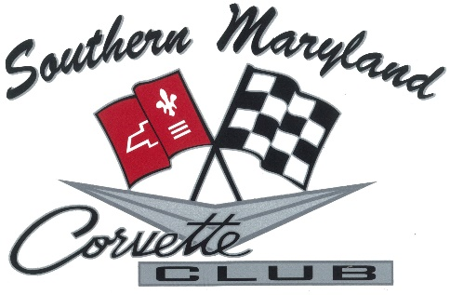SMCC MEETING MINUTES
JUNE 22ND, 2019

. President Bobby Padgett called the meeting to order at 4:19pm
. 28 Active members present
. Location: 8431 Penns Hill Rd. – Bobby & Maria’s residence
. Pledge of Allegiance
. Roll call of Board of Directors – all present

Chair Reports:
. Treasurer’s report by Don Bryne - $3,948.47 – was given a check from new members Will & Jess Steckman for $50.00
Web Master:
. Report given by Rick Davis – please check the website for new updates and pictures added.
. Revised upcoming events list
. Activities in green are updated – activities in red we do not have dates for yet.

Membership Report:
. Report by Danielle Eldredge – 4 new members have joined

Old Business:
. The President thanked all for coming to Pop’s Car Show – and thanked all that helped with the activities and food.

New Business:
. Mt Zion car show coming up on July 13th, 2019.
. The President advised that member Mike Thumm asked about getting the club to come to a Chicken dinner at Ridge – date to be determined.
. Cruise Ocean City – 1st weekend in October – you can go to Freestatecorvette.com to register.
. The President is setting up a 100 mile ride to Mallows Bay – then lunch at Port Tobacco Marina – date to be announced at a later time.
. The club presented Paul Fritz with a certificate for being the first Lifetime Member of the SMCC.
. The President advised all that the September meeting will be election of officers-Don Bryne has advised he would like to stay as Treasurer; Rick Davis advised he would like to stay as Vice President; Maria Padgett advised she would like to stay as Secretary. The President was elected into a 2 year term. If you would like to run for any office – please send a message to the President or Vice President prior to the September meeting. The September meeting location will be announced as soon as the arrangements have been made.
. Bob North bought up the Club license plates that Esov had discussed at an earlier meeting – Pam Donahue discussed how the license has changed since we discussed this. After a show of hands approximately 5 people are interested. It has been tabled for now.
. Did a 50/50 with Pat Strain winning. Thanks to all who helped.
. All members who attended received a Koozie with the SMCC logo from Bobby & Maria as a gift. All members who have not received a Koozie will be getting one at the next meeting. There will be extras for sale for $1.00.
. Bob North made a motion to adjourn the meeting – Chris LaQuay seconded and the meeting adjourned at 5:05pm.

Minutes recorded and submitted by;
Maria Padgett
Secretary

