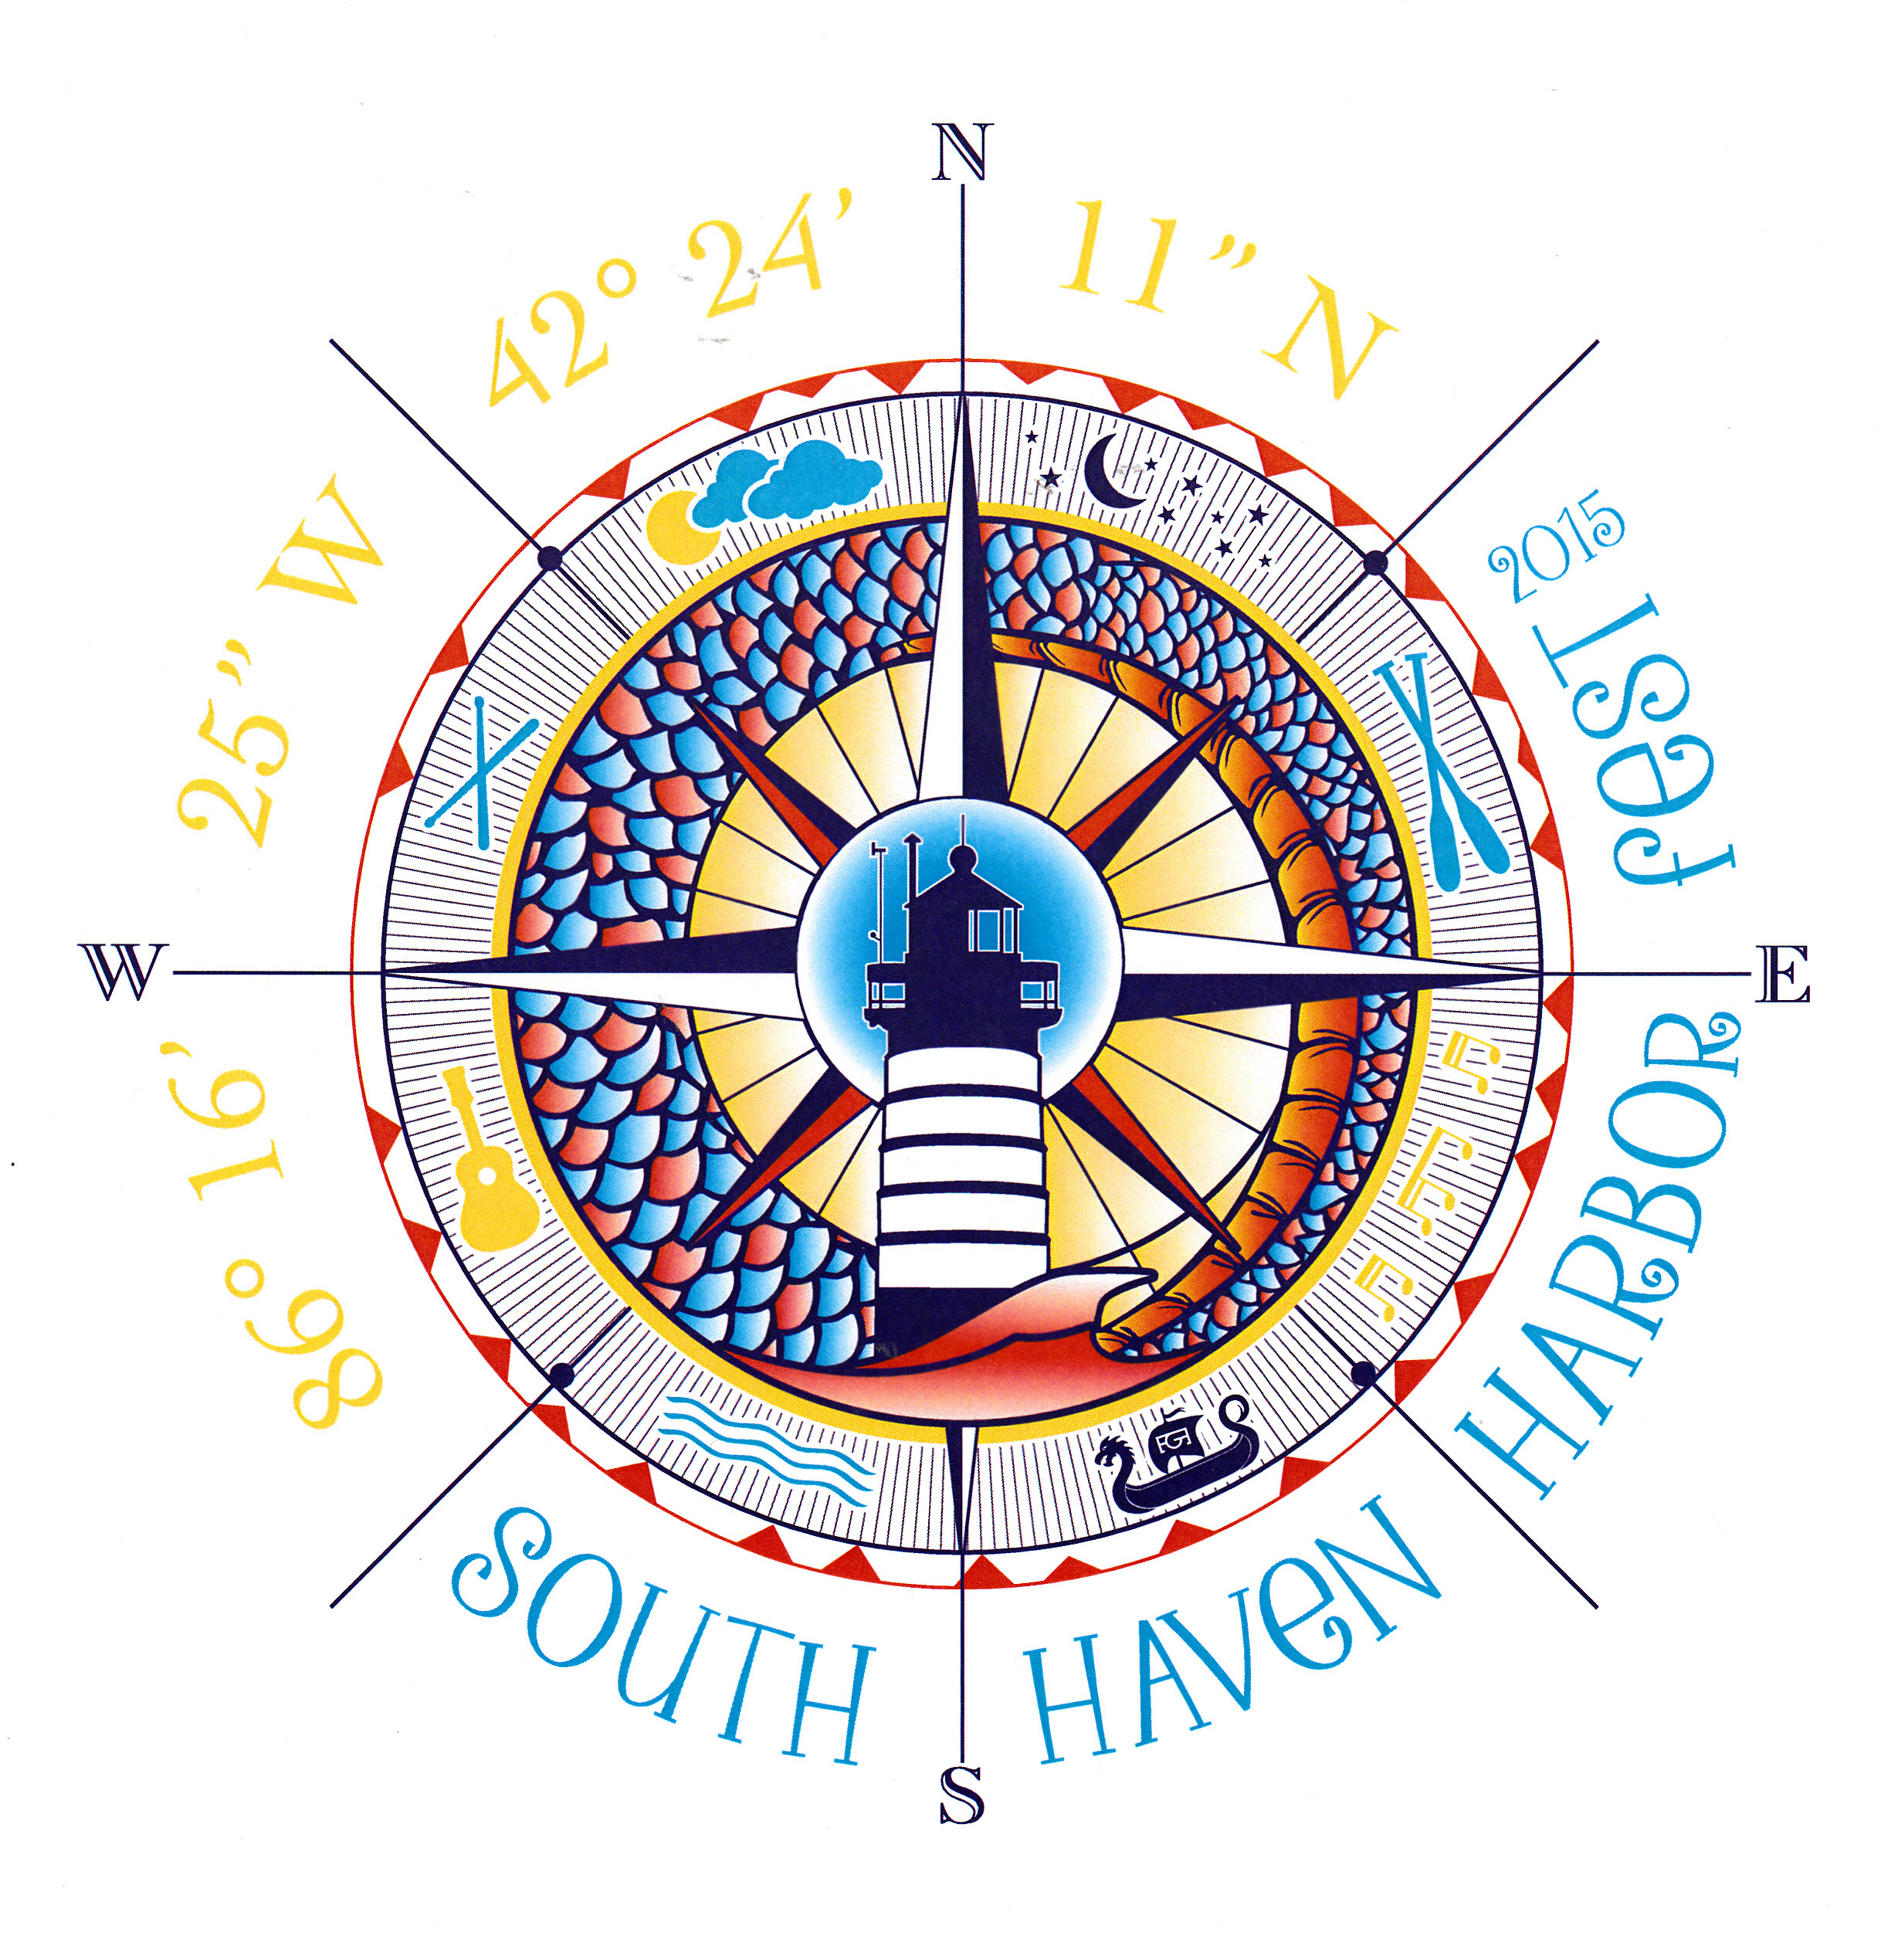
January 2nd, 2016

Dear Craft Vendor,

This year Harborfest celebrates its 25th year and will be held June 16th through19th. The craft show runs from Friday June 17th – Sunday June 19th.You are receiving this letter and application because you have participated as a vendor in the past or have requested an application. Thank you for the interest in being a part of South Haven Harborfest 2016! The Harborfest Committee looks forward to working with you in June.

Our crafters’ area is limited to arts and crafts, no commercially produced goods, other than gourmet food items
(see gourmet food application) will be allowed. Vendors exhibiting commercial merchandise that is not handmade will be asked to remove such items and will not be asked back to participate in future shows.
Show Rules:
The Harborfest Committee has vot our craft fair area. This is for food items that are not meant to be consumed on site and will include but not limited to, cheeses, sausages, jerky, food mixes, dips, spices, seasonings, honey, sauces, jams, syrup and salsa.

- Set up on Friday 6:30a.m.-12:00p.m. (no exceptions)
- No grilling or overnight camping, (visit www.southhaven.org for accommodations)
- All applications must be accompanied by the required fee and sales tax id number
- Overnight security will be provided, but Harborfest or the City of South Haven, are not responsible for any losses or damages due to weather or theft.
- No generators on the crafter’s site for the duration of the festival.
- Exhibit areas will be assigned in advance. Harborfest has the right to assign spaces. It is based on when your application is received and previous participation. You will be assigned a set up time. Please be punctual in order to keep set ups moving as scheduled.
- All exhibitors should be prepared for setup on asphalt. No stakes are allowed. No exceptions. Booths are 10 x 10. Electric is not guaranteed.
- The exhibitor agrees to hold harmless and indemnify the Harborfest Committee and the city of South Haven for any loss arising from exhibitors.

We do have a designated Handicap parking space-for VENDORS ONLY. For more information, contact us.

Directions to South Haven Harborfest 2016:

From I-196 north, take South Haven exit 20. Turn Right onto Phoenix Road going west. Stay on Phoenix Road the through third light. At the fourth light you will be directed where to set up when you get to the barricades.

From I-196 South, take South Haven Exit 20. Turn Left onto Phoenix Road going west. Stay on Phoenix Road the through third light. At the fourth light you will be directed where to set up when you get to the barricades.

Any questions can be directed to Carol Young at 269-9065297 or Harborfest2015@comcast.net

Crafter Vendor Booth Application for Harborfest 2016

All applications must be accompanied by the required fee and MI Sales Tax Id Number or Concessionaire’s
Sales Tax Return Payment Form

Business Name: ______________________________________________________________________________
Street Address: ______________________________________________________________________________
City/State/Zip: _______________________________________________________________________________
Phone: (________) _____________________ Email _________________________________________________
SALES TAX ID: ____________________________________________________________________ (Required)
Brief Description of Items: _____________________________________________________________________
_____________________________________________________________________________________
BOOTH SIZE: 10 x 10, Show is for three days, June, 17th, 18th, and 19th, 2016

Spaces with electric are limited and on a ‘first come basis’ they will be assigned upon receipt of
payment, until gone.

____ Crafters’ space - $125 Electric; $110 Non-Electric
Submit Check or Money Order, paid in full, no later than May 15, 2016.
Electricity required: [ ] YES [ ] NO

No applications will be accepted after May 15, 2016

If more booths are needed, consider renting more than one space.
More than one space needed? [ ] Yes [ ] No –
Two Booth Special is $205.00 no electricity & 225.00 with electricity

Set up on Friday 6:30a.m.-12:00 pm. No exceptions or refunds if not present by allotted time.
Booth hours during Festival are Friday, 12-8pm, Saturday 10-8pm, Sunday 10-4pm
Teardown is to be fully completed no later than 8 pm on Sunday, June 19, 2016, no exceptions.

I understand and agree that neither South Haven Harborfest or the City of South Haven will be held responsible or liable in any way, whatsoever, for any loss, theft, damage, or defacement of any vehicle or property displayed or used in display of any exhibit, no matter how same may have been caused.
I HAVE READ THE RULES AND AGREE TO COMPLY WITH THEM.

______________________________________________________ Date____________________________
SIGNATURE

Complete Application & make Check or Money Order payable in full to South Haven Harborfest & mail to: South Haven Harborfest 2016, c/o Craft Vendor Account, P.O. Box 282, South Haven, MI 49090

