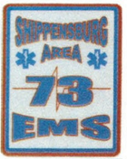

D

UPDATED: 6/12/2022

CLASS | DATE/TIME | CON ED ALS AND BLS | COST
EPC | AUG 19-20 (0830-1600) | BOTH 16 HOURS | $175
PTEP | SEPT 10 (0830-1600) | BOTH 8 HOURS | $100
AMLS | OCT 15-16 (0830-1600) | BOTH 16 HOURS | $175
PHTLS | NOV 15-16 (0830-1600) | BOTH 16 HOURS | $175
GEMS | DEC 10 (0830-1600) | BOTH 8 HOURS | $100

