SPECIAL MEETING
SEPTEMBER 25, 2014

A Special Meeting of the Town Board of the Town of Hampton, County of Washington and the State of New York was held at the Town Hall, 2629 State Route 22A, Hampton, New York on the 25th day of September 2014.

PRESENT: David K. O’Brien----------Supervisor
Tamme Taran---------------Councilwoman
David Jensen----------------Councilman
Donald Sady----------------Councilman
Andrea Sweeney-----------Councilwoman
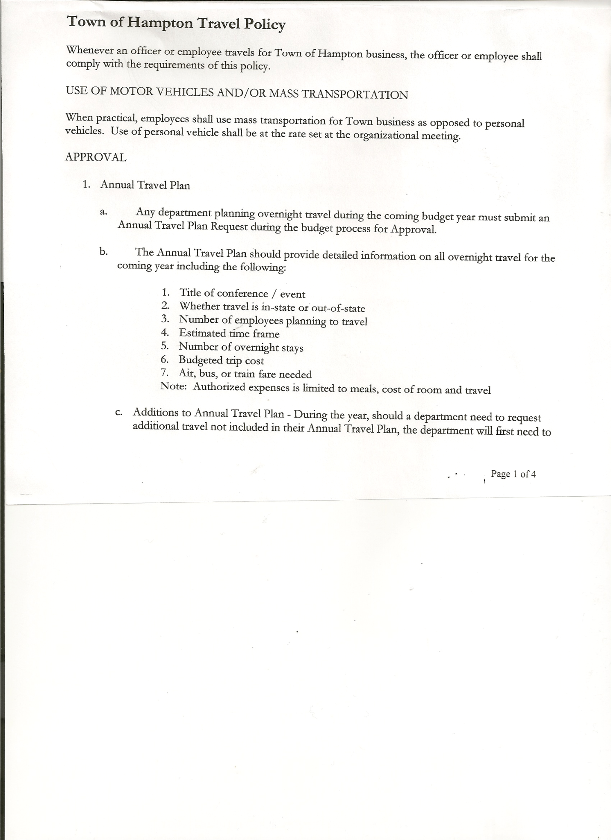
Rebecca Jones--------------Town Clerk
Camilla Shaw---------------Tax Collector/Deputy Town Clerk
Herbert Sady, Jr.------------Highway Superintendent

Also present: Kim Perry, Budget Officer/Bookkeeper, Artie Pratt, Doran Pratt, Leonard Reed and Shelly Sady

The Special Meeting of the Town Board was called to order by Supervisor O’Brien at 7:00 pm followed by the Pledge of Allegiance. Locations of Fire Exits were given.

Supervisor O’Brien stated that the Medical Insurance renewal has been moved from February 1st to December 1st and that the premium increase would be approximately $13.00.

Leonard Reed asked to see the Warrant for September….questioned bill from Meyer & Fuller, (Town Attorney Firm)..why was correspondence with Supervisor and not Highway Superintendent over the hearing on the highway matter? Supervisor O’Brien stated Highway Superintendent was on vacation and items needed to be addressed, Supervisor O’Brien also stated that the Hearing Officer, Mr. Robert Henke donated his time.

Received correspondence from the County, that Hampton will have a Rabies Clinic on May 21st, 2015

Following a discussion regarding benefits of a possible retirement, the following was decided:
RESOLUTION NO. 85 -2014
HIGHWAY EMPLOYEE BENEFITS
On a motion of Councilwoman Taran, seconded by Councilwoman Sweeney the following resolution was ADOPTED
Ayes 5 O’Brien, Taran, Jensen, Sady, Sweeney
Nays 0
RESOLVED, to pay (thirty) 30 days sick time and to pay medical insurance premium thru the end of 2014.

Continued to review and modify Tentative Budget.

TOWN BOARD MEETING
September 25, 2014 PAGE 2

RESOLUTION NO. 86 -2014
ADOPTION OF TENTATIVE BUDGET
On a motion of Councilwoman Taran, seconded by Councilman Jensen the following resolution was ADOPTED:
By Roll Call vote: Supervisor O’Brien AYE
Councilwoman Taran AYE
Counilman Jensen AYE
Councilman Sady AYE
Councilwoman Sweeney AYE
RESOLVED, that the 2015 Tentative Budget be adopted and becomes the 2015 Preliminary Budget for the Town of Hampton.

RESOLUTION NO. 87 -2014
PUBLIC HEARING ON HAMPTON FIRE PROTECTION DISTRICT NUMBER 2
On a motion of Councilman Sady, seconded by Councilwoman Taran the following resolution was ADOPTED
Ayes 5 O’Brien, Taran, Jensen, Sady, Sweeney
Nays 0
RESOLVED, to set the Public Hearing to discuss the proposed contract between the Town on behalf of the Town of Hampton Fire Protection District Number 2 and the Town of Fair Haven, VT for October 15th, 2014 at 6:55pm.

On a motion of Councilwoman Taran, seconded by Councilman Sady the meeting adjourned at 8:44 pm. All in favor Aye.

Respectfully submitted,

Rebecca S. Jones, RMC
Town Clerk

