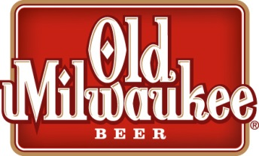
OLD MIL RANCH RODEO
GLASGOW RODEO COMMITTEE

OFFICIAL ENTRY FORM
Entry fee: $400.00

Ranch/Team Name:_______________________________________________________________
Ranch Owner:_____________________________________________ Brand:
Pronunciation of Brand: ___________________________________________
Ranch Manager: _____________________________________Year Ranch Established: ___________
Ranch Address: _____________________________________________________________________
Type of Operation:__________________________________________________________________

Team members: Minimum of 4, maximum of 5 – must designate a Team Captain
TEAM CAPTAIN: _____________________________________Phone #: _______________________
Address: __________________________________________________________________________
Team Member: _________________________________________Phone#: ____________________
Address: __________________________________________________________________________
Team Member: _________________________________________Phone#: ____________________
Address: __________________________________________________________________________
Team Member: _________________________________________Phone#: ____________________
Address: __________________________________________________________________________
Team Member: _________________________________________Phone#: ____________________
Address: __________________________________________________________________________
Ranch Rodeo is located at the Valley County Fair Grounds & will be held Saturday, July 29, 2017.
Ranch Horse entries will be available on the day of the event. Only two horses per team may be entered.
Rules meeting at 3:00pm, Calcutta at 3:30
For more information contact:
Del Hanson: 406-263-2451

Old Mil Ranch Rodeo is NOT sanctioned with the NILE

