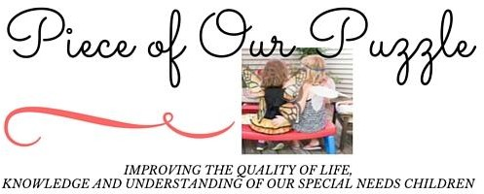

Piece of Our Puzzle LLC 3150 Tremont Ave
Trevose, PA 19053
(484) 569-0377
erin@pieceofourpuzzle.com http://www.pieceofourpuzzle.com

AUTHORIZATION FOR RELEASE AND EXCHANGE OF INFORMATION

I, , hereby authorize Piece of Our Puzzle LLC and the person/organization listed below to release and exchange psychological, educational, medical, and other information about:
Client’s Name:

DOB:
Reason for Release: Continuity of Care

Person/Organization receiving/communicating information: Name: Address: City, State and Zip: Phone and Fax:

I understand that this authorization is valid for the period of time in which my child is an active client with Piece of Our Puzzle LLC. I understand that I may see the information that is to be sent, and that I may revoke the authorization at any time by written, dated communication.

Signature Date

Signature of Piece of Our Puzzle Staff Date

Relationship to client:
Self
Parent
Guardian

Date of Form:
Expiration Date (one year from above date):

