St. Francis de Sales Parish
Pastoral Plan July 2021- June 2022

St. Francis de Sales Catholic Church
2000 Elizabethtown Road
Lumberton, North Carolina

St. Francis de Sales Parish
Pastoral Plan July 2021- June 2022

Table of Contents ………………………………… page i
Pastoral Council Members ………………………… page ii
Vision Statement…………………………………… page 1
Mission Statement…………………………………. page 1
Overview of the Process…………………………… page 2
Financial Environment…………………………….. page 3
Priorities and Goals………………………………... page 4-11
Parish Commission and Ministry Structure………... page 12
Pastoral Weekly Schedule…………………………. page 13
Pastoral Plan from Various Ministries ...………….. page 14-16

Pastoral Council Members

Eveland Wooten – Chair
Rafael Vazquez - Vice Chair
April Pittman – Secretary, Social Commission Chair
Winston Arokiasamy - Adult Movements Commission Chair
Stephen Bukowy - Finance Council Chair
Lydia Capote - Parish Member
Melissa Edwards - Youth Faith Formation Commission Chair
Bob Fisher - Parish Member
Luz Jimenez - Parish Member
William Kakuru - Financial Commission Chair
Andres Lopez (represented by Jorcaef) - Parish Member
Greg Malinsky – Maintenance Commission Chair
Meghan Miller – Communication Commission Chair
Robert Schneider - Parish Member
Patrick Snyder – Parish Deacon, Liturgy Commission Chair
Fr. Zacharie L. Tati – Parish Priest

Vision Statement
With firm belief in God’s love and a commitment to serve Him and welcome Him in one another, the mission of the Catholic Diocese of Raleigh and St. Francis De Sales Parish is to:
- Celebrate the Presence of God in Word and Sacraments.
- Strengthen the unity in Christ Jesus and through the Eucharist.
- Proclaim the Gospel of Jesus Christ for the salvation of souls.
- Respond to the needs of those in our midst through the spiritual and corporal works of mercy and Catholic Social Teaching.
- Establish and maintain a strong Faith Formation program for children and adults in order to contribute to the evangelization of the world.
With God’s grace, we will work to fulfill this mission through the collaborative involvement of priests, deacons, consecrated religious and lay faithful. We do this always as members of the Universal Church and in union with the Holy Father and our Bishop.

Mission Statement
Saint Francis De Sales is a Catholic Community consisting of a multicultural base committed to Christ and his teachings and dedicated to proclaiming the Gospel through faith filled lives. Inspired by our patron saint, we seek to pass on our faith to our children, and nurtured through the Church’s sacraments, we reach out to all God’s people especially those who are marginalized and most in need in our wounded world.

Overview of the Process
This current pastoral plan was developed in July 2021 with input from the Pastoral Council. The purpose of the plan is to provide a framework for parish functions over the current year. Six priorities have been identified to include the seven-commission structure of St. Francis de Sales. The six priorities are:
- Strengthen the Liturgical and Sacramental life of the parish
- Enhance all Faith Formation Programs
- Maintain and grow in financial security
- Reinforce a safe and welcoming church environment
- Promote cultural diversity and social outreach
- Increase evangelical efforts with technology.
The seven commissions structures to aid in these priorities are:

- Liturgical
- Youth Faith Formation
- Adult Catholic Movement
- Finance
- Maintenance
- Social
- Communication.

Committees and ministries are encouraged to use this plan to address goals and timelines for their activities throughout the year.
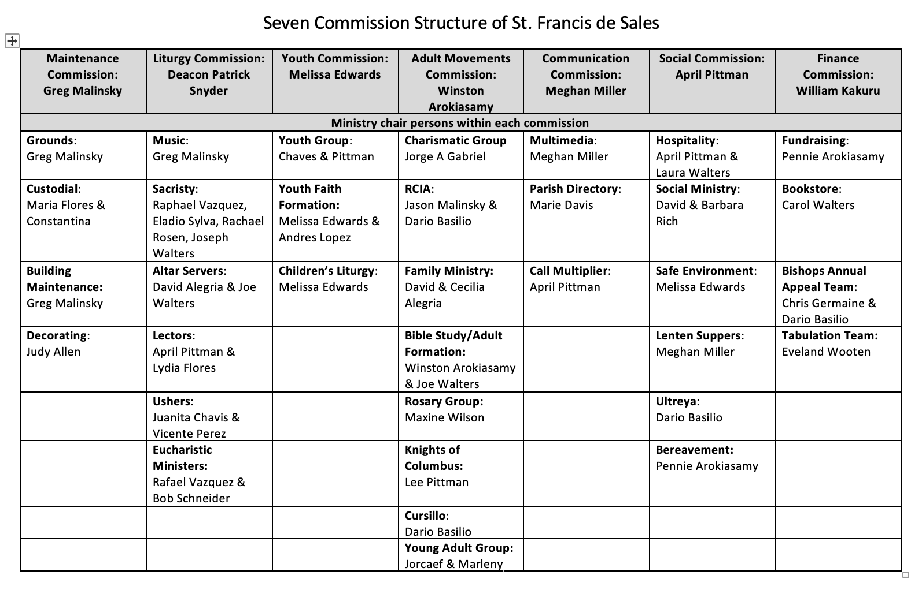
Financial Environment
The Finance Council of St. Francis De Sales Parish has the duty to work in collaboration with the Finance Commission to establish a strong financial environment. The goal is to provide support for all parish financial challenges for the upcoming fiscal year and the future of the church. The St. Francis De Sales Parish is in Robeson County, which is currently one of the poorest counties in the state of NC. Fortunately, the parish is maintaining our financial stability and meeting financial needs, despite the impact COVID-19. St. Francis de Sales’ collection did suffer a significant decrease from March 2019 – Dec 2020. Parishioners are beginning to return, and collections are once again increasing. All debts are being paid to the Diocese of Raleigh for the building of the Madeleine Sophie Social Hall. In addition to providing space for Faith Formation and other activities, the social hall is instrumental in providing more space for parishioners to participate in Mass. This church extension is made possible because we have the Mass televised to avoid overcrowding in the church building. Each summer, a budget is developed with the Pastoral Council, Finance Council, and Committee Chairs that will determine the expenses and activities for the upcoming fiscal year. Each budget is balanced with expected income and expenses. Overall, St. Francis De Sales Parish continues to be financially stable; it continues to live within its financial means; and it will continue to make progress towards meeting its objectives in the plan while utilizing its existing financial resources.

Priorities and Goals
Priority One: Strengthen the Liturgical & Sacramental Life of the Parish
St. Francis de Sales will aim to effectively promote and maintain life through the celebration of the sacraments.
- Goal 1: Liturgical Ministry- Maintain a vibrant and accurate liturgical schedule and calendar by all liturgical ministry chairs. This includes the music ministry, lectors, extraordinary ministers of Holy Communion, altar servers, ushers, and sacristans. The Liturgical schedule is created on a bi-monthly or quarterly basis and distributed to all ministers.
- Goal 2: Altar Servers - Develop and maintain a regular training program for children to serve at Mass as well as hear and respond to a call by God to the Priesthood or Consecrated Life through prayer, group gatherings, and trainings.
- Goal 3: Choir- organize and encourage an all-inclusive choir to sing at the main weekend Mass on Sundays, in order to create an atmosphere of worshiping the Lord through song and praise.
- Goal 4: Offer prayers and targeted homilies to vocations on Vocation Awareness Sunday and follow up and refer those interested in the Priesthood or Consecrated Life to the Diocese of Raleigh for discernment and education.
- Goal 5: Special Seasonal Activities- Plan to organize, educate, and enhance programs during the Advent, Christmas, Lent, and Easter seasons for all parish families. For example, we will resume weekly Soup and Bread after the Stations of the Cross during Lent after stopping due to COVID.
- Goal 6: Social Committee must be involved in the yearly celebration of our patron saint, St. Francis de Sales.

Priority Two: Enhance All Faith Formation Programs
St. Francis De Sales Parish will continue to invite all Catholics to a deeper relationship with Jesus Christ in the Church through formation focused on Sacred Scripture, Tradition, and Sacraments, especially the Eucharist.
- Goal 1: Commit to the re-evangelization of the community and Parish on Church teachings with moral issues.
- Goal 2: Faith Formation Program currently runs from September to May of each year. The program is provided in both English and Spanish languages. We will strive to maintain a growing program that educates our children about the importance of the Catholic Faith.
- Goal 3: Continue to encourage all catechists to become certified through the Diocese of Raleigh. (Activa in Spanish & Franciscan University in English are current resources for this goal.)
- Goal 4: Continue to invite and provide opportunities for parents of children in Faith Formation to attend parent meetings, attend mass regularly, and remain active parishioners.
- Goal 5: Youth Group - Revisit and reorganize a new vision to merge both English and Spanish into one youth group. The goal is to create a strong youth group that will attend Diocesan (6) Conventions and Retreats, Parish wide Recollection Days, participate in adult faith formation activities, and aid in faith formation classes, participate in charity, community service projects, religious and social celebrations, and explore and talk about vocations to the priesthood and religious life.
- Goal 6: Evaluate the need for a ministry for middle school aged parish members.
- Goal 7: Adult Faith Formation- Especially after COVID-19 many adults have stopped attending church activities; our goal is to be more progressive and inviting to help them return to their faithful life and adult faith formation activities. The Franciscan University was purchased for a second year, and offers workshops in both English & Spanish, and remains a free resource for educating all our parishioners.
- Goal 8: Combine adult faith formation programs for both the English and Spanish speaking parishioners for Lectio Divina, Adoration of the Blessed Sacrament, Ultreya celebrations, and Cursillo group meetings.
- Goal 9: Design and implement parish activities that will provide opportunities for discussion and discernment on vocations to occur annually, specifically during National Vocation Awareness Week.
- Goal 10: RCIA- Help participants learn about the Catholic Faith, receive the sacraments and become active parishioners upon their completion of the RCIA program.
- Goal 11: Continue to strengthen the quality of the sacramental Preparation Faith Formation classes. This is the first year that both English and Spanish youth faith formation is requiring a two-year first communion program. Both Confirmation & First Communion are now a two-year program.
- Goal 12: Marriage Prep and Counseling- Currently, engaged couples are sent to Diocesan Engaged Workshops or Retreats. Our future goal is to have a well-established marriage preparation for both the English and Spanish speaking parishioners that is organized by the Pastor, Deacon, and married couples in the parish. St. Francis de Sales will continue to distribute communication from the Bishop on Marriage and Family Life.
- Goal 13: To encourage all married couples and families to participate in Diocesan events focused on marriage and family life.

Priority Three: Maintain and grow in financial security
Recognizing that we are all stewards of God’s gifts to us and are called to share God’s gifts with our brothers and sisters in Christ, the St. Francis de Sales Parish is committed to the sharing of time, talent, and treasure throughout Robeson County. This will be achieved by offering various initiatives and programs that will engage the faithful in responding to those in need.
- Goal 1: Identify the needs of our parish, its ministries, and the families of our parish.
- Goal 2: Establish a program by the Pastoral Council or Social Ministry to help parish members understand good stewardship of time, talent, and treasure, and the sharing those gifts.
- Goal 3: Follow the guidelines of the Diocese of Raleigh and conduct a successful program for the Bishop’s Annual Appeal.
- Goal 4: Focus on ministries that will encourage the conservation and wise use of our natural resources.
- Goal 5: Continue to use collection envelopes and the online giving to verify financial contributions to the church.
- Goal 6: Update the church statistics for accurate bookkeeping records when parishioners join or stop contributing financially.
Goal 7: Design and institute a procedure for any large donations to be accompanied with a notarized letter declaring the donation is a gift and will never be asked to be reimbursed or returned in the future.
- Goal 8: Continue to apply for grants throughout to help offset expenses on growth and developmental initiatives. Last year St. Francis de Sales received 2 grants.

Priority Four: Reinforce a safe and welcoming church environment
St. Francis De Sales Parish will strive to use its resources in the most efficient and effective manner to provide for the needs of the faithful in a continually changing environment.
- Goal 1: Conduct an annual Census, maintain a Parish Roster, and a public a Parish directory.
- Goal 2: Assess attendance at Mass, Faith Formation, and other group gatherings to ensure adequate space is provided for all ministries.
- Goal 3: Crisis Plan – Develop and train ministers and parishioners for what to do in the event of a crisis during Mass or any parish function.
- Goal 4: Maintain a Building and Grounds committee to properly maintain and care for our Parish building and grounds.
- Goal 5: Provide to the custodial volunteers all materials and cleaning products necessary to keep the church clean and sanitized, especially during this time of Covid.
- Goal 6: Follow all safety precautions recommended by the diocese and state governor during the Covid pandemic.

Priority Five: Promote Cultural Diversity and Social Outreach
Our parish is a direct reflection of the diverse population in Robeson County, NC. Our parishioners have origins and cultures from Venezuela, Chile, Honduras, Burma, Nicaragua, Uganda, Congo, Guatemala, Mexico, Japan, Philippines, local Lumbee Heritage, India, Pakistan, Costa Rica, Haiti, France, Canada, and Germany. Our goal is to invite all people, whatever their social or cultural background, to hear the message of salvation in Jesus Christ, to be united in participating in the Sacraments, and to live their Catholic faith as part of a welcoming parish family and culturally diverse community.
St. Francis De Sales Parishioners will work to increase the awareness of God in our daily lives while promoting goodwill and a sense of belonging in members and their culturally diverse neighbors. Parishioners will affirm the intrinsic value of human life, the dignity of every human being, and a heightened awareness of social and economic justice while ministering to the needy through the following social and fellowship ministry goals, adhering to COVID restrictions.
- Goal 1: Build stronger relationships between English and Spanish speaking parishioners in all church activities and be deliberately all-inclusive in all parish-wide events such as the Parish Picnic, Lady of Guadalupe reenactment, Stations of the Cross, Lenten suppers, Christmas Socials and Handbell Choir.
- Goal 2: Plan and conduct an International Festival for the Parish to celebrate all nationalities of parish members.
- Goal 3: Encourage youth group activities: Attendance at the Pro-Life Rally, Meetings on Pro-Life Information, Serving the needy at Soup Kitchen, and packaging care items for the needy.
- Goal 4: Promote the growth of a parish wide social ministry committee.
- Goal 5: Maintain and encourage participation in Hospice, Elderly Facility, Hospital, and Homebound visits
- Goal 6: Maintain monthly contributions to the Lumberton Christian Care Center.
- Goal 7: Address the needs of families in our parish and our community.

Priority Six: Increase Evangelical efforts with technology
- Goal 1: Continue to livestream Mass for those that are still unable to attend Mass in person due to health concerns surrounding Covid-19.
- Goal 2: Update the parish directory into an accurate excel document.
- Goal 3: Continue to use the bulletin list serve to email all parishioners the bulletin in this time of COVID and update the list with all the parishioner emails from the directory.
- Goal 4: Identify and train an individual to keep current the St. Francis de Sales Website, google calendar, YouTube channel, Facebook, Twitter, Instagram, and My Parish App.

Pastoral Schedule: Weekly
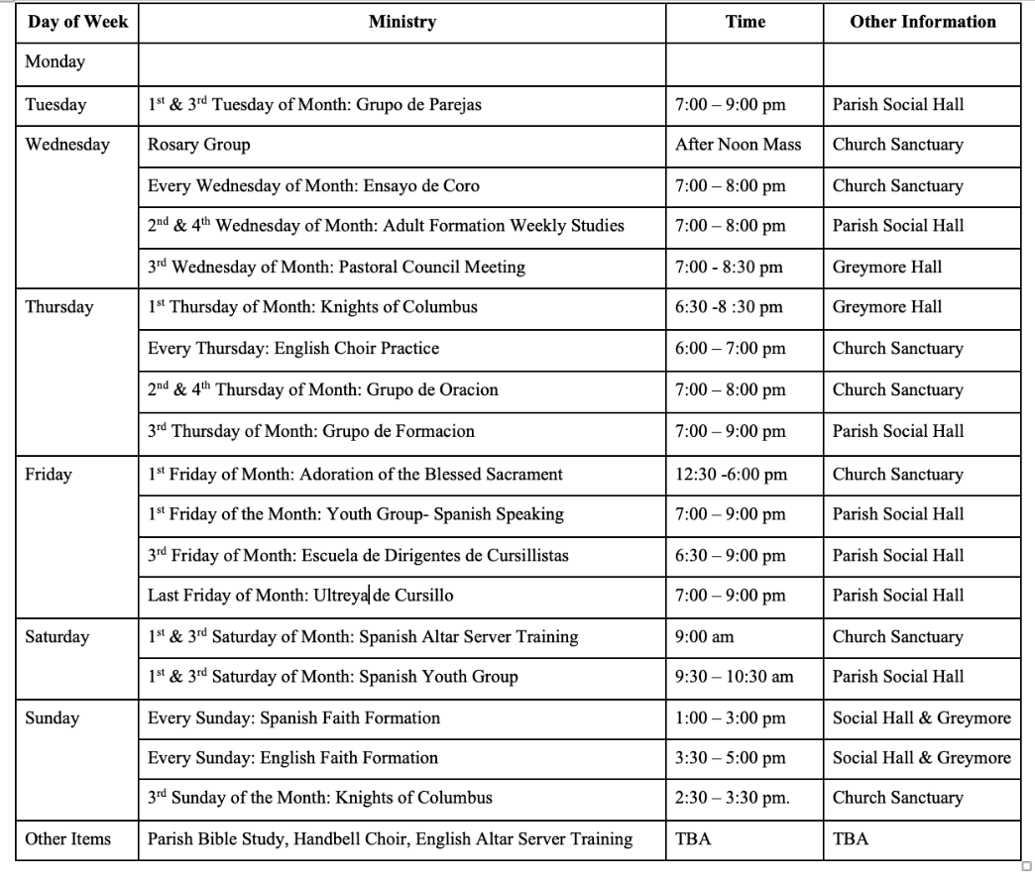
(Not Including Weekday and Weekend Mass Times)

Plan Pastoral de Cursillo de Cristiandad
Ultreya 2021-2021

Actividad | Mes y fecha | Año | Horario
Ultreya | Junio 25 | 2021 | 6:00 - 10:00 pm
Ultreya | Julio 30 | 2021 | 6:00 - 10:00 pm
Ultreya | Agosto 27 | 2021 | 6:00 - 10:00 pm
Ultreya | Septiembre 24 | 2021 | 6:00 - 10:00 pm
Ultreya | Octubre 29 | 2021 | 6:00 - 10:00 pm
Ultreya | Noviembre 26 | 2021 | 6:00 - 10:00 pm
Ultreya | Diciembre 31 | 2021 | 6:00 - 10:00 pm
Ultreya | Enero 28 | 2022 | 6:00 - 10:00 pm
Ultreya | Febrero 25 | 2022 | 6:00 - 10:00 pm
Ultreya | Marzo 25 | 2022 | 6:00 - 10:00 pm
Ultreya | Abril 29 | 2022 | 6:00 - 10:00 pm
Ultreya | Mayo 27 | 2022 | 6:00 - 10:00 pm
Ultreya | Junio 24 | 2022 | 6:00 - 10:00 pm

Grupos de Amistad
Todos los Viernes – 6:00 – 7:00 pm

Plan Pastoral de Cursillo de Cristiandad
Escuela de Dirigentes 2021-2021

Actividad | Mes y fecha | Año | Horario
Escuela de Dirigentes | Junio 18 | 2021 | 6:30 – 9:00 pm
Escuela de Dirigentes | Julio 16 | 2021 | 6:30 – 9:00 pm
Escuela de Dirigentes | Agosto 20 | 2021 | 6:30 – 9:00 pm
Escuela de Dirigentes | Sep 17 | 2021 | 6:30 – 9:00 pm
Escuela de Dirigentes | Octubre 15 | 2021 | 6:30 – 9:00 pm
Escuela de Dirigentes | Nov 19 | 2021 | 6:30 – 9:00 pm
Escuela de Dirigentes | Dic 17 | 2021 | 6:30 – 9:00 pm
Escuela de Dirigentes | Enero 21 | 2022 | 6:30 – 9:00 pm
Escuela de Dirigentes | Febrero 18 | 2022 | 6:30 – 9:00 pm
Escuela de Dirigentes | Marzo 18 | 2022 | 6:30 – 9:00 pm
Escuela de Dirigentes | Abril 15 | 2022 | 6:30 – 9:00 pm
Escuela de Dirigentes | Mayo 20 | 2022 | 6:30 – 9:00 pm
Escuela de Dirigentes | Junio 17 | 2022 | 6:30 – 9:00 pm

Coordinador: Darío Basilio Santos (910) 549 – 6024
Secretaria: Maria Flores (910) 608 -3088
Poscursillo: Benito Carranza. (910) 618 7894

