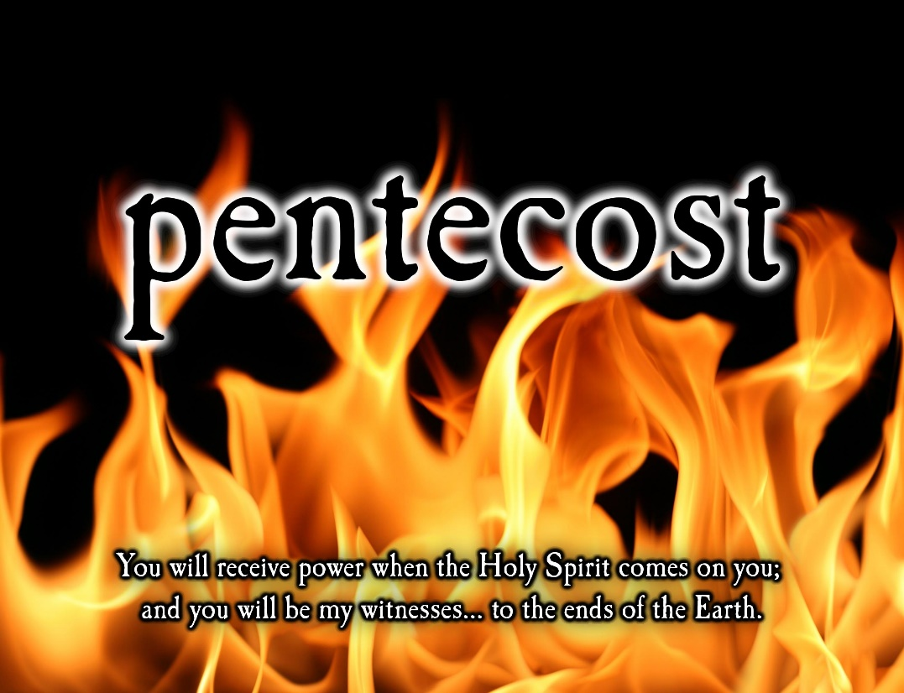

June 5, 2022

Day of Pentecost

Carson City United Methodist Church

10:30 am

Greeting/Announcements

Call to Worship

L: Hear the promise of God from the prophet Joel.
P: And everyone who calls on the name of the Lord will be saved.
L: Hear the promise of God from gospel of John.
P: All who receive Christ, all those who believe in the name of Christ, are children of God— children born not of natural descent, nor of human decision or a husband’s will, but born of God.
L: Hear Christs promise to us.
P: “I am the resurrection and the life. The one who believes in me will live, even though they die; and whoever lives by believing in me will never die.
L: How do you answer Christs question to us “Do you believe this?”
P: Yes, Lord, we believe that you are the Messiah, the Son of God, who was, and is, and is to come.

*Hymn: Breathe on Me Breath of God UMH 420

Opening Prayer: (unison)
Almighty God, your Holy Spirit came to Jesus’ disciples, hidden in an upper room in Jerusalem. A mighty wind and tongues of fire were the symbols of a promise fulfilled in their lives. May your Holy Spirit burst into our lives again today, encouraging and inspiring us to proclaim boldly the good news of Jesus Christ who offers healing and hope to all people. AMEN.

Offering

Doxology UMH 95

Offertory Prayer

Sharing of our Joys and Concerns

Call to Prayer: Spirit of the Living God UMH

Pastoral Prayer

Gospel Reading: LUKE 24:45-49

Old Testament: JOEL 2:28-29
Epistle Lesson: ACTS 2:1-21
Contemporary Song: Don’t Tread on Me
(We the Kingdom)

Communion

MESSAGE

*Hymn: There’s a Spirit in the Air UMH 192
(Verses 1-4, 6)

Benediction

CCUMC – Announcements & Upcoming Events:

As a courtesy to others please silence or shut off cellphones

==================================================
Hall rentals for June:
Sat, June 4th 3:00 pm to ? Sat, June 11th 9:00 am to ?
Sat, June 18th Sat, June 25th 10:00 am to ?
==================================================
Sun, June 12th is Peace with Justice Sunday. Peace With Justice Sunday is one of the special Sundays of The United Methodist Church. Each year on this special Sunday, United Methodists across the globe give offerings to promote peace all over the world. There are pamphlets located on the church Welcome Center or to give online go to
https://www.umc.org/en/content/peace-with-justice-sunday-ministry-article
==================================================
Graduation Sunday is June 12th. The church needs to know who is graduating from college or high school this year. We would like a picture in addition to obtaining each graduate plans of where they are going and field of study so we can share at our Sunday services. Please turn in to the church office as soon as possible.
==================================================
Vacation Bible School for 2022: July 17th to July 21st, 6:00-8:30 pm. We need crew leaders and helpers. Please contact Roberta Kile if you are willing to help. Register via email here: vbs.register@gmail.com Or call the office 989-584-3797.
==================================================
VBS Supplies needed: white flat sheets, cylindrical oatmeal boxes, tissue paper, pool noodles, boxes, brown packing paper. Please place in tub under the Monumental table.
==================================================
Church Picnic: Sun, Aug 7, 2022, following 10:30 am Worship Service. See the flyer located throughout the Church for more information.
==================================================
Christmas 2022 Service: With Christmas Day falling on Sunday for 2022 we would like to go with the following schedule so people can spend Christmas Day with family and friends. Please let us know your thoughts.
- Christmas Candlelight Service: 12/24/22 @ 7 pm
- Christmas Day Service: No Sunday Worship Svc

Serving & Supporting Sunday Worship
Audio/Video: Lauren Monroe

Joys, Concerns & Prayer Request
For those battling cancers:
Jim Dunlap, Carolyn Nykerk, Ray Seaman, Dillan Abell, Andrew Hogan, Amorena Newman-Wojciakowski

For those who need support, guidance or have health concerns: Mike Decker, Jeff Beechler

Monthly Giving
5/1 $4306.02 5/8 $3382.68
5/15 $2593.14 5/22 $4189.13 5/29 $3479.35

Nursery Schedule
Open for the summer but no supervision

Lighting of Candles

Passing of Collections Plate

Our Church in Ministry This Week
Mon: PT Class 6:30-8 pm
Tue & Thu: COA Meal @ Noon

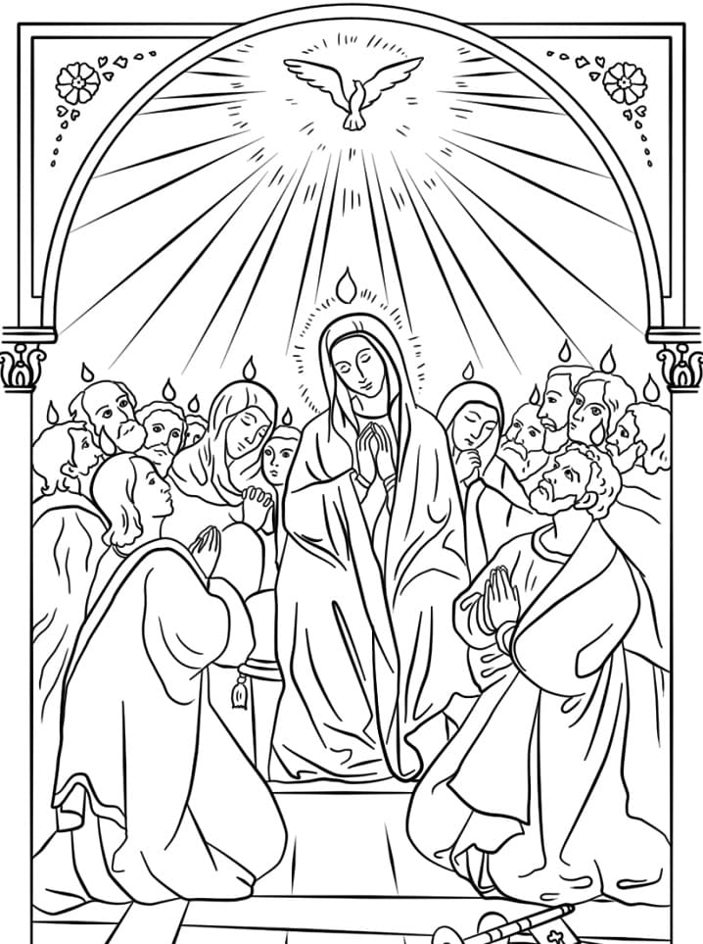
Coloring Page

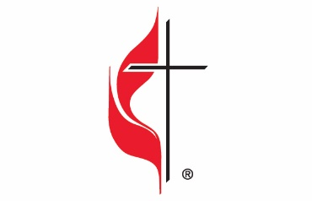

Carson City United Methodist Church
Location: 119 East Elm St., Carson City, MI
Mail: PO Box 298, Carson City, MI 48811
Phone: 989-584-3797 Email: carsoncityumc@gmail.com
Website: carsoncityumc.com
Sunday Worship Service: 10:30 am
Office Hours: Monday-Thursday, 9:00 am-12:00 pm
After hours by appointment
Pastor: Ian McDonald 906-322-5318
Secretary: Bonnie Seaman 989-763-1674

Weekly Sunday Bulletin now available on our website
@ www.carsoncityumc.com

“Loving God, it’s amazing to imagine that You would sing songs of joy over me. I praise You and sing my own song of praise to You”

