

SUMMER – 2020 SEASON
WEEK 1 – 1st July 2020
SINGLES LEAGUE

Well I hope everyone enjoyed getting back into action this week with some big league fixtures and all but one match played.

2019 Summer champion Andrew Bellamy-Burt has clearly not lost his touch during lockdown as he beat what would have been expected to be his closest rival in Winter 2019/20 champion Geoffroy Buffetrille, despite Geoffroy keeping up his shooting practice he lost 13-3, 13-3. Andrew clearly the favourite to retain his title.

Doubles partners Neil and Ross shared the spoils in their match as did Callum and Alice. Matt Ryan consistently a top three player lost heavily to Joey who sits in third place behind Brian Harris who had a bigger win against Alex.

Division 1 saw usual Premier League big hitters Laurent and Keith play each other with Laurent taking all 3 points in a close match.

Natasha Romeril won a big match against James Gennoe 13-11, 13-11 for a good start top her Division 1 campaign. Jean and David gain a good point to start their season.

Division 2 saw club newcomer Gavin Scott win his first match of his Liberation league campaign against Tim Jackson. Daniel and Brandon sharing the spoils in their match.

NEXT WEEK - 8th July - DOUBLES LEAGUE

Club email address - liberationpc@gmail.com

Club Website - www.liberationpetanque.co.uk

Kind Regards

Toby Northern

Chairman

Liberation Petanque Club

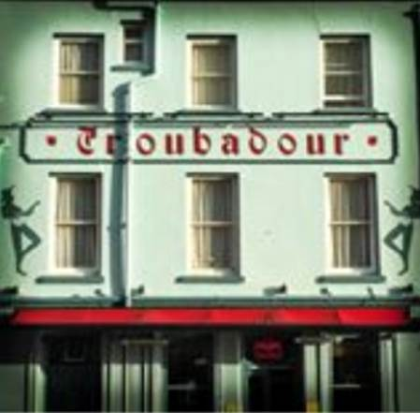
SPONSORED BY

SUMMER – 2020 SEASON
WEEK 2 – 8th July 2020
DOUBLES LEAGUE

Andrew, this time with the help of Callum overcame Geoffroy again with his doubles partner Matt Buesnel not able to swing the result in their favour. Andrew & Callum also beat Alan & Joey in a match played in Advance so they top the league early on.

Alan & Joey though did pick a point against Winter Doubles Champions Alice & Brigitte who are looking at making it back to back titles.

Brian & Paul just managed to get 1 point against Graeme & Keith in the first game before recovering well to get a valuable draw.

Laurent & Matt Pinel playing together in the league for the first time overcame Gary & Wendy who lost their 8, match unbeaten run.

In Division1, there were no draws as new team Gavin & James won their first league match together and look to be good for a top three position. Alan & Mike beat regular league rivals in John & Nick who are usual tough to be so a good result for Alan & Mike.

The were wins all around for the Stewarts as Cassie and partner Chris beat Daniel & James to 5 in each match and Alex & Jean took the spoils against Branden & Tim.

NEXT WEEK - 15th July – SINGLES LEAGUE

Club email address - liberationpc@gmail.com

Club Website - www.liberationpetanque.co.uk

Kind Regards

Toby Northern

Chairman

Liberation Petanque Club

SUMMER – 2020 SEASON
WEEK 3 – 15th July 2020
SINGLES LEAGUE

What a difference a week makes. Champion Andrew Bellamy-Burt had a nightmare against top player Neil Selby who outplayed Andrew and handed out the first certificate of the season. Neil winning 13 – 5 and 13 – 0! This is Andrews third certificate of his Liberation League career and it destroyed Andrew’s points difference and his 22 match unbeaten run stretching back to 17th November 2018 when he last lost (To Brian Harris).

Neil now on 4 points in his bid for his first Premier League title but Brian Harris now top’s the league with back to back wins as Brian beat Joey to move clear of the field.

Callum and Matt Ryan shared the spoils in their match with both still looking for that first win of the season. A few matches to play in this division.

In Division 1 another long unbeaten record fell as Jean Stewart lost to Andrew Limbrick losing her 18 match unbeaten run stretching back to 22nd May 2019 when Jean last lost (To Branden De La Haye). This means Andrew is another player on 100% record.

James Gennoe beat David Ibitson to get his first points of the season in his bid for a top three place.

Gavin Scott’s Liberation Career has got off to the best possible start in Division 2 having recorded back to back wins, this time over Daniel. Mo and Tim share a very close match with Tim winning 13-11 and Mo taking the second game 13-12.

NEXT WEEK - 22nd July - SINGLES LEAGUE

(Double Fixture Week)

Club email address - liberationpc@gmail.com

Club Website - www.liberationpetanque.co.uk

Kind Regards

Toby Northern

Chairman

Liberation Petanque Club

SUMMER – 2020 SEASON
WEEK 4 – 22nd July 2020
SINGLES LEAGUE

Neil Selby is now the current league leader following up his emphatic win over Andrew last week won back to back matches against Matt Ryan and Alice for 10 points from a possible 12 as one of the best Island players finally starts to convert his cup form in the league wins, could this be Neil’s year?

Well it could also be Joey’s year as he toppled the Winter Champion Geoffroy to move into second place just one point behind Neil, with Geoffroy having lost 2 of his first 4 matches with a win over Alex as well.

Matt Ryan and Ross both struggling for wins with a draw against each other with Matt Ryan sitting in the relegation zone with Alex and Alice.

Callum broke his duck taking all three points from Brian for his first win of the season. This was Brian’s first loss of the season. Callum also drew an advance match against Andrew as well as drawing with Geoffroy for 4 draws and 1 win so far.

Brian then drew with Ross who has now drawn all four matches this season, Brian just pipping Callum to third place for now on points difference.

Just three players remain unbeaten with Neil, Callum and Ross.

In Division 1, James Gennoe has pulled out meaning the scrapping of some results. I am sure Andrew will be disappointed having played him just a few days before.

Jean and Keith played out a draw as did Brigitte and David Ibitson. Andrew though did beat Brigitte to move top.

In Division 2 Gavin continues his winning form with a 13 – 2, 13 – 4 victory over James Villalard. James drawing his other match against Branden

Tim and Cassie and Mo and James played out draws which currently see’s Gavin some 6 points clear at the top but Paul Bell has two matches outstanding and needs all 6 points to catch Gavin.

NEXT WEEK - 29th July - DOUBLES LEAGUE

Club email address - liberationpc@gmail.com

Club Website - www.liberationpetanque.co.uk

Toby Northern

Chairman

Liberation Petanque Club

SUMMER – 2020 SEASON
WEEK 5 – 29th July 2020
DOUBLES LEAGUE

Well, they were expected to be a formidable team and they certainly proved it this week.

Who ? Laurent and Matt Pinel that’s who, as despite a narrow 13-12 win in game one against Andrew & Callum they then handed out the first doubles certificate of the season 13 – 0, the second one Andrew has received already this season! How many more will he receive 😊.

Laurent and Matt then handed out a big defeat to two time Island Doubles Champions Geoffroy and Matt Buesnel who could only score three points, 13 – 2, 13- 1. Geoffroy & Matt also losing against Brian & Paul and now sit bottom of the table with three straight defeats and -44 points difference.

Another big team won two matches with Neil & Ross recovering from 11 – 1 down to beat Alice & Brigitte 13 – 12 in one game. They also beat Graeme and Keith for a 100% record so far. Alan & Joey had also recorded two wins in this week’s rounds of fixtures.

Division 1 saw 2 of the 10 scheduled matches played with Kat & Paul playing and winning both of their matches against Cassie & Chris and Alan & Mike to top the table.

NEXT WEEK - FREE WEEK

Club email address - liberationpc@gmail.com

Club Website - www.liberationpetanque.co.uk

Kind Regards

Toby Northern

Chairman

Liberation Petanque Club

SUMMER – 2020 SEASON
WEEK 6 – 5th August 2020
FREE WEEK

NEXT WEEK - 12th August – DOUBLES LEAGUE

Club email address - liberationpc@gmail.com

Club Website - www.liberationpetanque.co.uk

Kind Regards

Toby Northern

Chairman

Liberation Petanque Club

SUMMER – 2020 SEASON
WEEK 7 – 12th August 2020
DOUBLES LEAGUE

The Premier League is shaping up to be a battle between Laurent & Matt and Neil & Ross who both now have 4 wins from 4 but 25 points in points difference mean Laurent & Matt sit at the top of the league.

Neil & Ross conceded an average of less than 7 points per game in their matches against Geoffroy & Matt and Gary & Wendy as they keep the pressure on.

Laurent & Matt beat Brian & Paul who have a minus 28 points difference but sit mid table due to 1 win. However they also received a certificate from Andrew & Callum who won 13 – 5, 13 – 0 and are third place but 2 points off the top and having played a match more. This was due to them playing out a draw with Alice & Brigitte who are yet to pick up a win in their first 4 matches as they also drew with Graeme & Keith.

Well Division 1 it could not be closer as Kat & Paul lead Alex & Jean by 1 point on points difference.

John & Nick took points off both teams this week drawing both their matches against the top two.

It was close between Kat & Paul and Daniel & James who are showing much improvement this season. Alex & Jean beat Matt & Mo who are also getting close to picking up their first points of the season.

Gavin & James Drew with Alex & Jean in a catch up match and have two matches outstanding so could go top if they win both.

Alan & Mike picked up their second win this season against Brandon & Tim who also drew with Daniel & James.

NEXT WEEK - 19th August - SINGLES LEAGUE

Club email address - liberationpc@gmail.com

Club Website - www.liberationpetanque.co.uk

Kind Regards

Toby Northern

Chairman

Liberation Petanque Club

SUMMER – 2020 SEASON
WEEK 8 – 19th August 2020
SINGLES LEAGUE

Champion Andrew dropped more points, as he could only draw with Joey, who sits in third place and having his best season yet after handing Callum his first defeat of the season, so far. Andrew though picked up a big win against Matt Ryan to take second place at the moment.

Neil Selby beat Brian before drawing with Geoffroy and is one point above Joey with both players having played six matches to Andrews seven.

Alice could only draw against Brian so yet to find a win, this draw though saw Brian also drop further off the pace at the top of the league.

A number of matches outstanding from this week with Ross still to play Geoffroy and Alex who also has to play Callum. With Alice and Matt Ryan also due to play.

Division 1 has unfortunately seen another withdrawal, with David Ibitson unable to complete the season. See tables and updated fixtures for this league.

Laurent was looking good for the title with a catch up win over Natasha who is yet to gain any points. However he lost his first match of the season to Jean who moved up to third as a result with Andrew just three points behind Laurent with a match in hand against Natasha.

The Division 2 title looks like its only going one way now as Paul Bell dropped points against Tim with a close draw before losing to Gavin who made in five wins from five after a win over Brandon as well. What a start to the season, can he maintain his 100% record. Only Matt Ryan has ever achieved this before in the history of the club.

Tim did pick up his first win of the season over Daniel to move up to third with a chance of a medal position. Cassie also picked up her first win of the season as the second and third places are within reach of all the remaining players.

NEXT WEEK - 26th August - DOUBLES LEAGUE

Club email address - liberationpc@gmail.com

Club Website - www.liberationpetanque.co.uk

Kind Regards

Toby Northern

Chairman

Liberation Petanque Club

SUMMER – 2020 SEASON
WEEK 9 – 26th August 2020
DOUBLES LEAGUE

No Report

NEXT WEEK - 2nd September - DOUBLES LEAGUE

Club email address - liberationpc@gmail.com

Club Website - www.liberationpetanque.co.uk

Kind Regards

Toby Northern

Chairman

Liberation Petanque Club

SUMMER – 2020 SEASON
WEEK 10 – 2nd September 2020
SINGLES LEAGUE

As we head into the home straight three players still have a chance of the Premier League title. Current holder Andrew dropped points in the closest of matches against doubles team mate Callum 13 – 12, 12 – 13. This means Andrew has dropped three points off the pace.

Joey is having by far his best season ever and is just one point off the top spot having beaten Ross in his 200th league match. This means Neil is not only the current league leader but he is now the only player unbeaten in the Premier League after his win over Alex Stewart.

Geoffroy improved his league position with a win over Alice, who remains in the bottom three, as does Matt Ryan who drew with Brian. In fact none of the bottom four players have yet to win a match.

The next schedule fixtures w/c 21st September see’s the top two play each other, should be great to watch.

In Division 1 all of the top players are losing matches as Jean lost to Brigitte before Brigitte lost to Keith but Laurent still sits above the rest but must win his last match of the season to guarantee the title.

The top three in this division though is anyone’s guess.

CONGRATULATIONS to Gavin Scott who has taken Division 2 by storm winning six straight matches which along with results going his way has already sealed the title. The only question now is can he become only the second player ever to end the season with a 100% record?

One such result was Paul drawing with Daniel, this means Paul is third only on points difference over Cassie, who narrowly beat Branden winning the second game 13 – 12.

Tim Jackson also won one game 13 – 12 against James but this was towards a win that see’s Tim sit in second place.

NEXT WEEK - 9th September - DOUBLES LEAGUE

Club email address - liberationpc@gmail.com

Club Website - www.liberationpetanque.co.uk

Toby Northern

Chairman

Liberation Petanque Club
SUMMER – 2020 SEASON
WEEK 14 – 9th September 2020
DOUBLES LEAGUE

What a giant leap Laurent & Matt took towards the title conceding just 2 points against Alice & Brigitte means the pair now just need a draw against Graeme & Keith to win the title. This included a 13 – 0 win, the seventh time (extending their unfortunate record) and second season in a row for thew Winter champions.

The only team that can catch them is Andrew & Callum following a win over Gary & Wendy but they need to win all their last remaining matches with big points gains to have any chance.

Andrew & Callum v Graeme & Keith

v Neil & Ross

Laurent & Matt v Graeme & Keith

Alan & Joey four match unbeaten run at the start of the season, is a clear tale of two half’s as they have now lost their last four, this time to Ross & Neil.

Bottom two teams Geoffroy & Matt B drew with Graeme & Keith with both teams now on three points and without a win, question is will they be the bottom two at the end of the season?

Division 1

Another win for Gavin & James, this time over Branden & Tim means a draw in their last match of the season against John & Nick should be enough for the title.

Second placed Alex & Jean gave themselves the best possible chance of snatching the title as they also just conceded 2 points handing Daniel & James a certificate in the process.

Kat & Paul sit in third after drawing against bottom team Matt & Mo who have now drawn three in a row.

Andrew & Lorna beat Alan & Mike virtually ending a potential top three place for the pair, but Andrew & Lorna can still make third.

NEXT WEEK - 16th September – CLUB SUPER 7’s CUP

Club email address - liberationpc@gmail.com

Club Website - www.liberationpetanque.co.uk

Toby Northern

Chairman

Liberation Petanque Club

2020

Liberation Super 7’s Cup Report

We were pleased to be able to put on this year’s competition held on a regular club evening with 22 club members taking part. The Super 7’s involves playing 7 rounds of matches and in each match playing 7 ends, this results in some interesting scores.

In round one three big shocks occurred as champion Toby Northern lost 8 – 6 to Brandon De La Haye who is making a habit of beating big name players. Matt Pinel a later entry to replace the Ill Brian Harris lost to Alex Stewart 9 – 6. Neil Selby also lost to Lorna Limbrick 7-4.
The biggest win of the round went to Matt Hutchings 9 – 1 over Tom Le Sueur.

Round 2 saw Toby score the most points in a match so far in his 10-4 win over Daniel Villalard. Neil lost again, this time to Wendy Ritzema. Laurent Pellaton won big over Alex Stewart 8 – 1 and Matt Hutchings made it two in a row against Andrew Limbrick and Geoffroy Buffetrille beat Callum Stewart for two big wins. Brandon also won again, this time beating Ross Payne.

Round 3 saw Matt Hutchings beat Brandon De La Haye 6 – 5 for three from three but Geoffroy failed to join him on three wins losing for the third competition in a row to Toby 7- 2. Some close matches as Gary Cowburn beat Lorna 7 – 6 and Laurent beat Tim Jackson 6 – 4 but Matt Pinel made double figures in his 10 – 2 win over Ross.

Some surprises as Tom Le Sueur beat Jake Romeril and James Villalard beat Jean Stewart.

Round 4 saw Daniel become just the third player to hit double figures in his 10 – 2 win over Cassie. Toby beat Paul Bell 9 – 2 and Laurent beat former doubles partner Matt Hutchings 7 – 2 for his first defeat and Matt Pinel beat Brandon.

Round 5 saw three players score 11 points as Tim Jackson beat doubles partner Brandon 11 – 5, Andrew Limbrick beat Callum Stewart 11 – 1 and Geoffroy beat Matt Hutchings 11 – 2. Toby lost a very close match on the last end 5 – 6 to Matt Pinel.

Round 6 saw Jake Romeril move into contention beating Toby, with Andrew Limbrick winning again 6 – 5 against Gary. Daniel won again but Cassie reversed her loss against Daniel by beating James 11 – 2 and Geoffroy defeated Laurent.

Round 7 despite losing 13 – 1 to Matt Pinel, Andrew Limbrick finished 4th place with five wins. Geoffroy the 2018 champion finished top of the rankings on six wins by beating Gary who despite this loss finished 7th. Matt Pinel finished 2nd also with 6 wins.

Jake Romeril finished 3rd after a win over Laurent who still made the top 8 with 4 wins, finishing 6th place. Matt Hutchings beat 2019 champion Toby to finish 5th with Toby missing out on a top 8 spot failing in his attempt to defend his title. Paul Bell 8- 3 win over Tom Le Sueur gave him 8th place.

FINAL RANKINGS
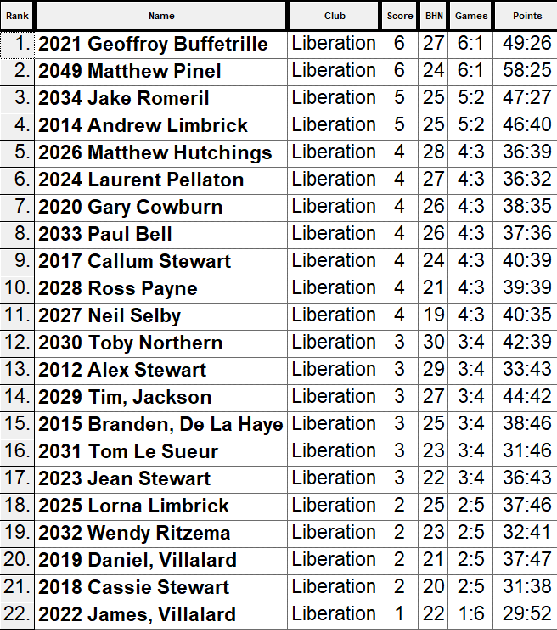

So, the Quarter Finals were as followed.
Ranked 1st Geoffroy Buffetrille V Paul Bell Ranked 8th
Ranked 2nd Matt Pinel V Gary Cowburn Ranked 7th
Ranked 3rd Jake Romeril V Laurent Pellaton Ranked 6th
Ranked 4th Andrew Limbrick V Matt Hutchings Ranked 5th

Geoffroy kept up his form in the quarter finals against Paul, winning comfortably 7 – 1, second placed Matt Pinel also won 7 – 3 against Gary who struggled with the fading light.
Jake Romeril beat Laurent for the second time making the semi-finals with a 6 – 4 win and Andrew Limbrick gained revenge against Matt Hutchings for his 7 – 5 lost in round 2 with a 5 – 4 win.
Jake couldn’t match Matt’s firing power as he fell 8 – 4 in his semi-final and Andrew Limbrick sprung a shock making the final with a 6 – 5 win over Geoffroy.
Jake took third place with a 7 – 4 win over Geoffroy and Matt didn’t let up in the final as the last-minute entrant took the title with a 8 – 4 win over Andrew.
Congratulations to everyone who took part and huge thanks to all those who helped on the day.



WEBSITE www.liberationpetanque.co.uk
EMAIL liberationpc@gmail.com

Kind Regards
Toby Northern
Chairman
Liberation Petanque Club
SUMMER – 2020 SEASON
WEEK 13 – 23rd September 2020
SINGLES LEAGUE

Crunch time in the leagues with only a few matches to play. This week saw the top two in the Premier League play each other.

Joey took the early advantage taking the first game 13 – 7, but Neil played well to take back control in the title race earning a 13 – 9 win for a crucial draw.

Both players were helped by Brian Harris who won the first game against Andrew 13 – 4 before losing the second 13 – 2. This draw means Andrew now needs Neil to lose and Joey to draw or lose in their last matches of the season to retain his title.

Andrew needs a big win over Ross who drew his seventh match of the season against Callum.

Matt Ryan drew with Geoffroy and its now very likely that he will finish in the bottom three.

In Division 1 Laurent sealed the title with a win over Andrew Limbrick and an early draw against Brigitte.

Just two matches left in this division and all four players can get a medal position.

Andrew v Keith

Jean v Natasha

In Division 2, Gavin did it. After already sealing the title he won a close match against Cassie Stewart to make it seven wins from seven for a 100% record.

The Villalard’s shared a draw which meant James moved off the bottom spot.

NEXT WEEK - 30th September – FREE WEEK

Club email address - liberationpc@gmail.com

Club Website - www.liberationpetanque.co.uk

Kind Regards

Toby Northern

Chairman

Liberation Petanque Club

SUMMER – 2020 SEASON
WEEK 14 – 30th September 2020
FREE WEEK

NEXT WEEK - 7th October – DOUBLES LEAGUE

Club email address - liberationpc@gmail.com

Club Website - www.liberationpetanque.co.uk

Kind Regards

Toby Northern

Chairman

Liberation Petanque Club

SUMMER – 2020 SEASON
WEEK 15 – 7th October 2020
DOUBLES LEAGUE

Laurent Pellaton & Matt Pinel capped off the title winning season with another win over Graeme & Keith with Andrew & Callum sealing second place over Neil & Ross by beating the latter.

Despite handing over a 13 – 0 defeat to Gary & Wendy the match ended in a draw for Geoffroy & Matt Buesnel as both teams finished in the relegation zone.

Alice & Brigitte’s win over Brian & Paul didn’t change anyone positions.

In Division 1 Gavin & James had already won the league with Alex & Jean having already taken second place but their draw with Kat & Paul meant Branden & Tim win over Matt Hutchings & Mo jumped them into third place with Matt & Mo finishing bottom of the leagues.

Cassie & Chris 13 – 12 loss in one game against Alan & Mike meant the latter stay above Cassie & Chris who ended in the bottom three.

NEXT WEEK - 14th October – SINGLES LEAGUE

SEASON ENDS FRIDAY 16TH OCTOBER 2020

Club email address - liberationpc@gmail.com

Club Website - www.liberationpetanque.co.uk

Kind Regards

Toby Northern

Chairman

Liberation Petanque Club

SUMMER – 2020 SEASON
WEEK 16 – 14th October 2020
SINGLES LEAGUE

Well what an end to the season as Joey’s win over Alice combined with Neil’s draw with Callum meant Joey took the title by one point on the last week of the season despite trailing Neil for most of it. Neil finishing the only undefeated player in the league.

Andrew’s win over Ross, just with one match going to 12 cemented Andrew third place finish. Ross stayed up by the narrowest of possible margins with 7 league points -14 to Alice 7 league points -15 and Matt Ryan 7 league points -32.

Alex Stewart finished bottom with just two points after a loss to Matt Ryan, his first win of the season not enough to stay up.

Laurent Pellaton got the draw against Brigitte to win Division 1 with Brigitte finishing third behind Andrew Limbrick. Despite also finishing on 7 points Natasha Romeril finished fourth.

In Division 2 Gavin Scott finished on 100% record and Tim beat playing partner Branden to take third with Branden getting the wooden spoon.

Paul Bell took second place with a win over James.

SEASON ENDS FRIDAY 16TH OCTOBER 2020

Club email address - liberationpc@gmail.com

Club Website - www.liberationpetanque.co.uk

Kind Regards

Toby Northern

Chairman

Liberation Petanque Club

