Vendor Brochure

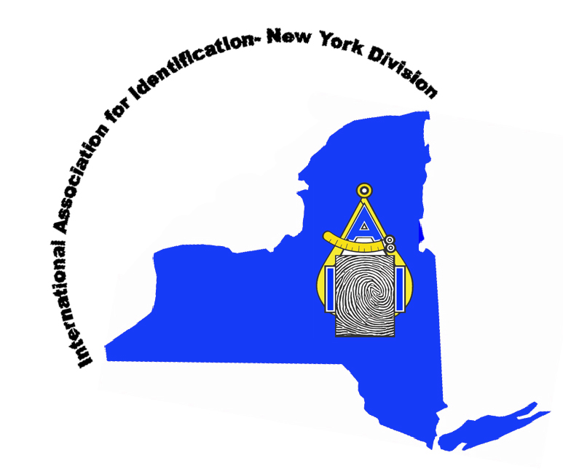

New York Division –
International Association for Identification
2014 Educational Conference Vendor Registration Form

__ Exhibitor Table $250 (Includes two day vendor area and one admission to opening banquet)
__ Donation of Door Prize(s) to be distributed at closing meeting
__ Sponsorship of one of the following events (Please contact ASAP to reserve):
- Welcoming gift for registrants
- Welcoming reception
- Luncheon and vendor demonstration
- Student Poster Presentation, Scholarship and wine social

Company Name: _________________________________
Please make Checks Payable to the New York IAI and submit the completed form and payment to:

Janet Hoin, Secretary/Treasurer
13 King Street
Albany, NY 12203
Name of attendee: ________________________________
Business Address: ________________________________
City: _________________ State: ____ Zip: ____________
Phone: ____________________ Fax: _________________
Email contact: ___________________________________
Total enclosed: __________________________________

Registration may also be submitted online by visiting our website: www.nyiai.org/conference.html and following the link to vendor registration. In addition to the online submission, payment may also be done via PayPal for the table. Sponsorship for one of the social events will be handled separately in coordination with the Division and the Crowne Plaza Hotel. Please direct any questions to Andrew Reitnauer at NYIAIPresident@gmail.com.

