

UNPLUG WITH

Miss Nora and Miss Melissa

April 25TH from 9AM-3PM

Tap Time with combos/games/turns

Ages 6-18

April 26th from 9:00am-5:00pm

Jazz/Turn & Leap/Combos

Ages 6-18

Have ***Fun*** with your dance friends over break while staying physically and mentally active! Bring a lunch or Firehouse is right next door!

Register at nsdcalendar@gmail

or at the front desk.

**Open House Class Schedule**

**Saturday, May 18th**

**10:00am-1:00pm**

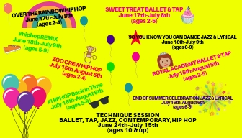

10:15-10:45am Tiny Steppers

(Ages 2-4) Studio D

10:15-10:45am Hip Hop

(Ages 5-8) Studio S

11:15-11:45am Hip Hop

(Ages 9-12) Studio S

11:45am-12:15pm Hip Hop

(Ages 13 & up) Studio S

The KONA ICE TRUCK will be here!



**INVITE YOUR FAMILY & FRIENDS TO COME DANCE WITH YOU AND GRAB SOME KONA ICE!**

C:\Users\Stephanie\Pictures\Microsoft Clip Organizer\j0416014.wmfC:\Users\Stephanie\Pictures\Microsoft Clip Organizer\j0416014.wmfC:\Users\Stephanie\Pictures\Microsoft Clip Organizer\j0416014.wmf

**#class of the month**

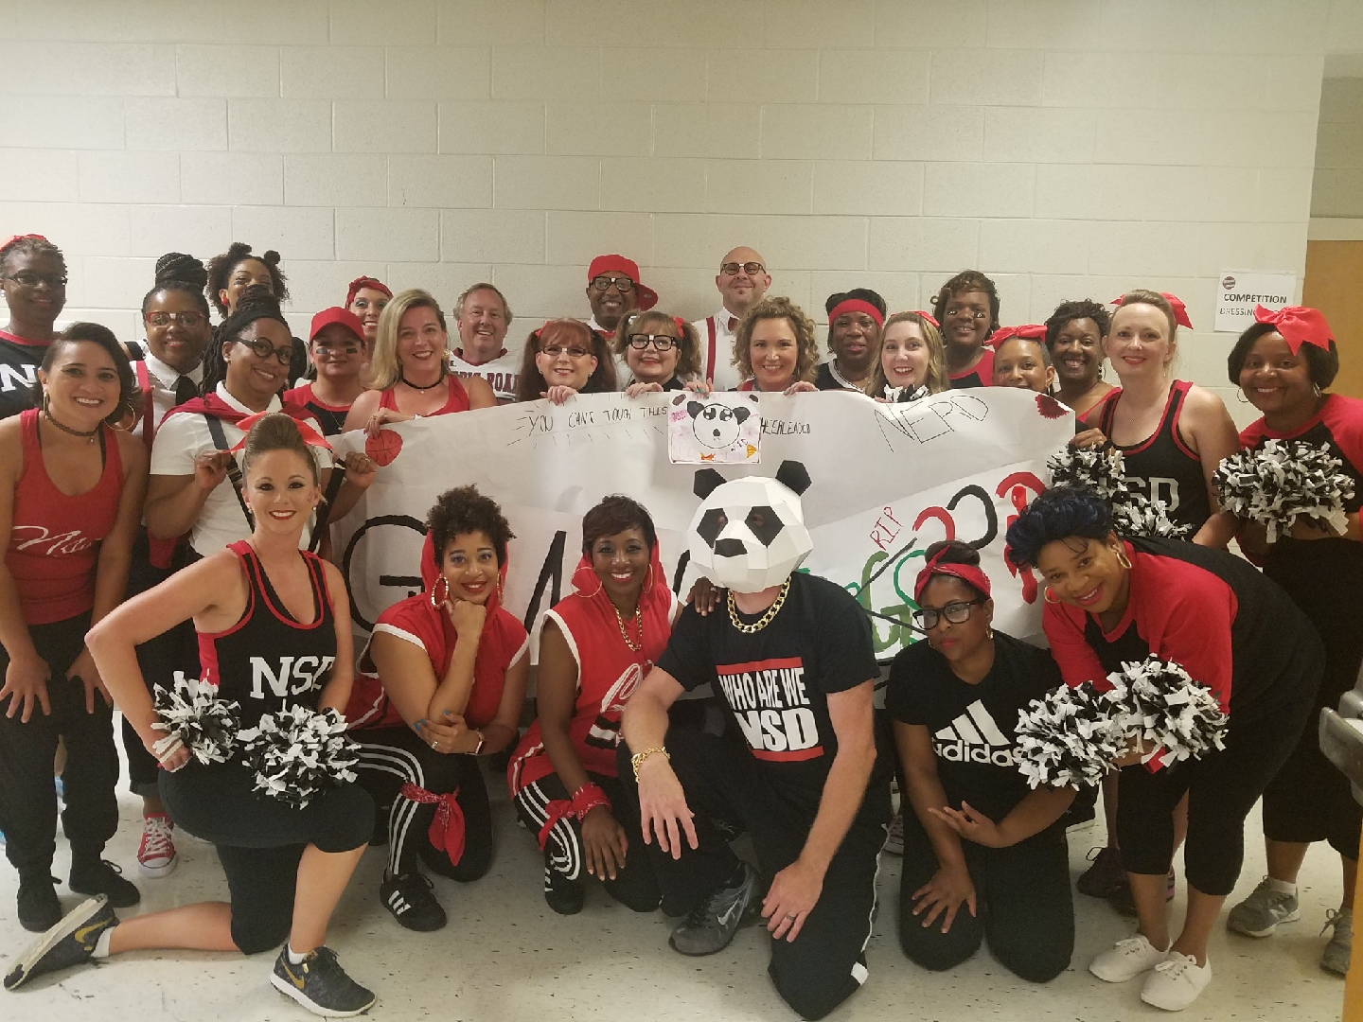

***PARENT DANCE!***

It’s time to sign-up for the 2019 Parent Dance. This routine is always the hit of the show! The kids are so proud; they can’t wait to see their parents perform! Register at the front desk or give us a call (704) 786-7837 and we can get you on the email list for practices!

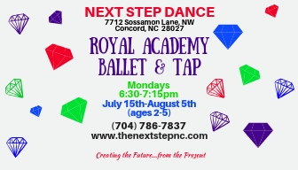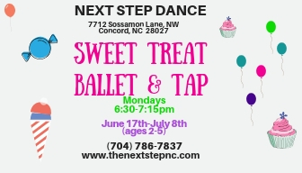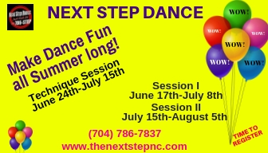 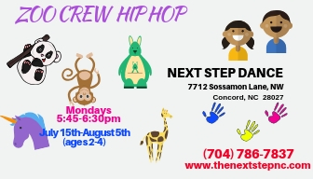

Our **SUMMER** ***Fun*** classinformation is online and ready for registration. You can grab a schedule now (color coded for ease in finding classes) at the front desk and we can assist you in picking the perfect class(es) for each of our summer sessions. Private lessons are also available during the summer with flexible times to fit your schedule. This is a great chance for working new skills or improving technique no matter what the age.

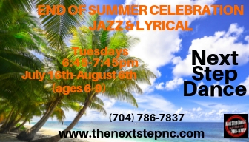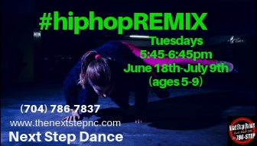

Steppin’ into **APRIL 2019** with Next Step Dance

[**www.thenextstepnc.com**](http://www.thenextstepnc.com)

**7712 Sossamon Lane, NW Concord, NC 28027 (704) 786-7837 nsdcalendar@gmail.com**

**OPEN HOUSE**

Thinking ahead to SUMMER Fun or fall 2019? Have a friend or relative interested in dance? Have a younger sibling that will be old enough for our Tiny Steppers program? Find out schedules and all the important stuff at our Open House on Saturday, May 18, 2019 from 10:00am-1:00pm. There will be classes to try out and treats to eat! Join our dance family this year!



**SAVE THE DATE**

April 2, 2019-Parent dance rehearsal

(8:30-9:15pm)

April 8th-11th -Recital Pictures taken during class time

April 22nd-26th –Spring Break

April 27th - Alumni Dance Rehearsal

(3:00-5:00pm)

April 29th - May 2nd–Parent Dance Week in our Hip Hop Classes

**Shoe orders take approximately 1-week for delivery and some we have in stock!**

REMEMBER TO JOIN US ON

Facebook, Twitter, & Instagram!