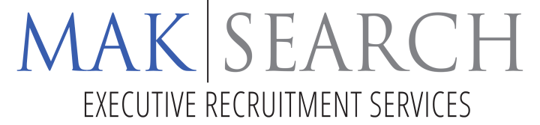

MECHANICAL ENGINEER

Location: Los Angeles, CA

Our client is one of the most highly modernized Aluminum mills in North America. They are recognized as an industry leader in terms of technology, safety and environmental performance, product quality and customer service and receive broad-based recognition for its team-based work system.
They are currently seeking a Mechanical Engineer with 5+ years of manufacturing experience
POSITION SUMMARY:
This position is the Mechanical resource for the Unit and exists to provide direction to project, process and maintenance operations of production equipment, in a manner that improves the Unit’s relative competitive position. Provides mechanical engineering direction for both people and processes in the Business Units. Provides advice and counsel to Unit operational plans. Analyzes downtime and identifies and implements corrective actions. Responsible for audit and control design and redesigns and the manufacture, installation and operation of equipment to improve operational processes. Develops and implements mechanical and process training programs that support individual and Team improvement based on demonstrated performance. Establishes reliability improvement plans and provides proactive direction to the reliability process. Provides advice and counsel to Unit Manager, Engineering/Reliability Leader, Team Leaders and Technicians to ensure continual improvement of processes and the safety environment.
EDUCATION & REQUIREMENTS:
Bachelor of Science in Mechanical Engineering required.
Minimum of 5 years of experience.
SALARY:
Salary based on your level of experience ($80,000 - $100,000) and bonus program. Engineers at this organization have many opportunities to grow. Career development can take the path of technical expertise or operational leadership. An engineering ladder is available for continued growth and promotional opportunities.
The company has over 1000 employees and is located in the Greater Los Angeles area, and offers a host of benefits to take care of their families, both now and in retirement.

In addition to competitive compensation, benefits include company match 401k, pension, comprehensive medical, pharmacy and dental benefits, variable compensation plan, bonus program, tuition assistance, on-site fitness center and wellness programs.

Apply by sending a copy of your resume in Word to info@maksearch.com

