REGULAR MEETING
NOVEMBER 20, 2013

A Regular Meeting of the Town Board of the Town of Hampton, County of Washington and the State of New York was held at the Town Hall, 2629 State Route 22A, Hampton, New York on the 20th day of November 2013.

PRESENT: David K. O’Brien----------Supervisor
Tamme Taran--------------Councilwoman
Herbert Sady, Jr.-----------Councilman
David Perry-----------------Councilman
David Jensen---------------Councilman
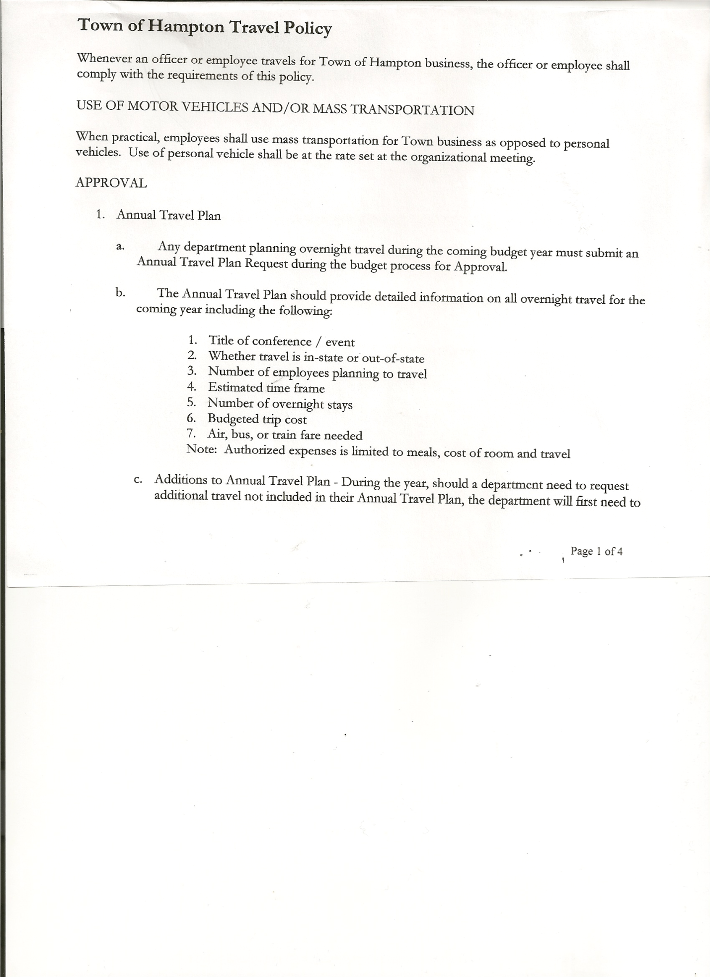
Rebecca Jones--------------Town Clerk
Camilla Shaw---------------Deputy Town Clerk/Tax Collector
Francis Baker---------------Highway Superintendent

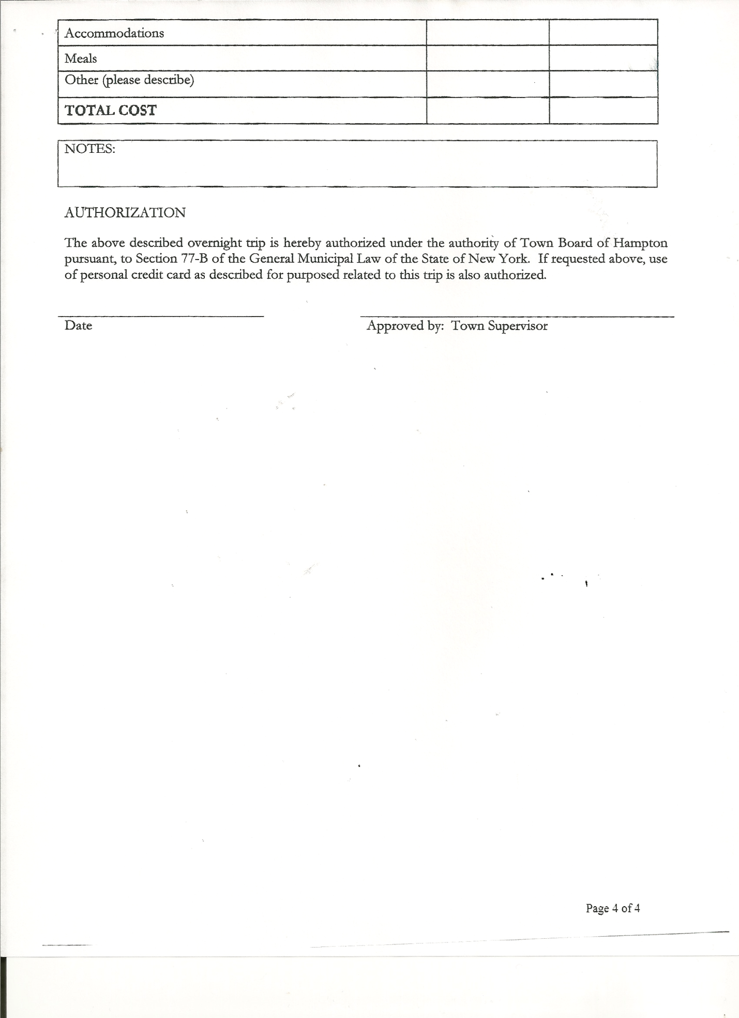
Planning Board Member(s): Bonnie Hawley, Chair and Joe Panoushek

Also present: Derek Liebig, Whitehall Times Reporter; Kim Perry, Budget Officer (came at 8:13pm); Rebecca Beayon, David Bridges, Artie Pratt, Leonard Reed, Donald Sady (came at 7:10pm), Andrea and Olivia Sweeney , Members of the Hampton Fire Department-Eric Mead and Joe Mead.

The meeting was called to order by Supervisor O’Brien at 7:02 pm followed by the Pledge of Allegiance. Locations of Fire Exits were given.

RESOLUTION NO. 101-2013
APPROVAL OF THE MINUTES
On a motion of Councilwoman Taran, seconded by Councilman Sady, the following resolution was
ADOPTED: Ayes 5 O’Brien, Taran, Sady, Perry, Jensen
Nays 0
RESOLVED that the Regular Town Board Minutes for October 16th, 2013 and the Special Town Board Minutes for November 7th, 2013 be accepted.

Larry Carman, Dog Control Officer submitted his report, which was read by Supervisor O’Brien…a copy is attached.

No Permits or Subdivisions.

Planning Board Report… Bonnie Hawley, Chair gave report
-next meeting will be November 26th, 2013 at 7:00pm at the Town Hall
-finishing up Mobile Home Ordinance… hope to have it to Town Board for review at
Town Board’s December Meeting
-may have a new member
-November 21st, 2013…2 hrs. training being offered at County Annex Building in Fort
Edward (Bonnie, Joe and Frank hoping to attend)
-December 4th, 2013….4 hrs. training offered by Meyer & Fuller at Fort Edward
Firehouse

TOWN BOARD MEETING
NOVEMBER 20, 2013 PAGE 2

Camilla Shaw, Tax Collector….no activity, zero balance. Town Board Members reviewed and signed bank reconciliation statement for the Collector.

Francis Baker, Highway Superintendent gave his report:
- cleaning leaves out of ditches
- getting trucks ready for winter
- hauled sand up to shed at the Town Hall for residents use
- helped plant trees by the Town Hall

Hills Pond Road….Petty Family has moved the fence closer to the road…maybe a safety hazard and may create a problem maintaining the road. This particular section of Hills Pond Road is considered a “road by use” meaning the owners on each side (Petty’s on one side and Reed’s on the other) own to the middle of the road. One other section by Connolly’s (current owner) is the same way. The rest of the road is owned by the Town. Highway Superintendent Baker answered some questions regarding past work there on that section of the road.

Supervisor O’Brien stated that the County Budget passed with an approximately 2.5% increase.
County will be out of all Health Care Services by the end of 2013.

RESOLUTION NO. 102-2013
BUDGET AMENDMENT
On a motion of Councilman Sady, seconded by Councilwoman Taran, the following resolution was
ADOPTED by Roll Call Vote Supervisor O’Brien AYE
Councilman Perry AYE
Councilman Sady AYE
Councilwoman Taran AYE
Councilman Jensen AYE
RESOLVED the following Budget Amendment to the General Fund is approved:
Decrease Supervisor Personal Service A1220.1 in the amount of $513.56
Increase Supervisor Contractual Expense A1220.4 in the amount of $513.56

RESOLUTION NO. 103-2013
APPROVAL OF SUPERVISOR’S MONTHLY REPORT
On a motion of Councilwoman Taran, seconded by Councilman Jensen, the following resolution was ADOPTED Ayes 5 O’Brien, Taran, Sady, Perry, Jensen
Nays 0
RESOLVED the Supervisor’s Monthly report be accepted as submitted for OCTOBER 2013
09/30/13 10/31/13
ACCOUNT BALANCE RECEIPTS DISBURSEMENTS BALANCE
General Fund $ 66531.92 $ 5352.21 $ 5657.61 $ 66226.52
Highway Fund $ 61591.75 $ 5.95 $ 10998.36 $ 50599.34
Equipment Reserve $ 64139.84 $ 5.27 $ 0.00 $ 64145.11
Building Fund $ 1541.81 $ 180.13 $ 379.70 $ 1342.24
Fire #1 $ 15155.00 $ 0.00 $ 0.00 $ 15155.00
Fire #2 $ 2270.50 $ 0.00 $ 0.00 $ 2270.50
Totals $211236.09 $ 5543.74 $ 17035.67 $ 199744.16
All Board Members present signed Supervisor’s Report.
TOWN BOARD MEETING
NOVEMBER 20, 2013 PAGE 3

RESOLUTION NO. 104-2013
EMPLOYEE COMPUTER, EMAIL, INTERNET, & SOCIAL MEDIA USAGE POLICY

MOTION BY: COUNCILMAN DAVID JENSEN

SECONDED BY: COUNCILWOMAN TAMME TARAN

TITLE: TOWN OF HAMPTON EMPLOYEE COMPUTER, EMAIL, INTERNET, & SOCIAL MEDIA USAGE POLICY

WHEREAS, the Town has determined that it is desirable to have an Employee Computer, Email, Internet, & Social Media Usage Policy for the Town of Hampton to govern employees and officials.

NOW THEREFORE, BE IT RESOLVED: That the Town of Hampton hereby adopts the Town of Hampton Employee Computer, Email, Internet, & Social Media Usage Policy attached hereto; and

BE IT FURTHER RESOLVED that all employees, elected and appointed officials are directed to adhere to this Employee Computer, Email, Internet, & Social Media Usage Policy.

BE IT FURTHER RESOLVED that the Town Clerk is hereby authorized and directed to add the following policy to the policy manual/employee handbook for the Town of Hampton.

DATED: November 20, 2013 Supervisor O’Brien AYE
Councilman Perry AYE
Councilman Sady AYE
Councilwoman Taran AYE
Councilman Jensen AYE

Town Of Hampton Employee Computer, Email, Internet, & Social Media Usage Policy

- Overview

  - This document constitutes a Town-wide policy intended to outline the proper use of all Town of Hampton computer and network resources, the effective protection of individual employees, and proper management of those resources.

  - These guidelines are intended to supplement, not replace, any and all existing laws, regulations, policies, agreements, and contracts which may apply to these resources.

  - Employee access to computers and network resources owned or operated by the Town of Hampton imposes certain responsibilities and obligations and is granted subject to relevant Town policies and local, State, and Federal laws. Appropriate use should always be legal, ethical, for the furtherance of the Town's mission and

TOWN BOARD MEETING
NOVEMBER 20, 2013 PAGE 4

goals, reflect community values, uphold the Town's reputation, maintain public confidence in the Town organization, and show restraint in the consumption of shared resources.

  - This policy also addresses the use of various forms of social media by Town employees, either with Town computer and network resources or their own personal computer and network resources, to insure that such usage is not detrimental to other Town employees or the Town organization.

  - For the purpose of this policy only, employee shall include Elected or Appointed Officials.

- Employee Rights & Responsibilities

  - Use of resources:
    - Town computer, email, network, and internet resources are provided to assist the employee in performing duties and assigned work in an efficient and effective manner for the benefit of the citizens of Hampton.
    - These resources should be used for official Town business only, with the exception of incidental personal use outlined in Section VI of this policy.
  - Privacy:
    - To the greatest extent possible in a public setting, the Town seeks to preserve the employee's privacy. However, the Town reserves the right to monitor any use of Town computer, email, network or internet usage in any manner and at any time as the Town Board may determine.
    - Electronic and other technological methods must not be used to infringe upon privacy. However, users must recognize that Town computer and network resources are public, the property of the Town of Hampton, and as such may be subject to review under the New York State Freedom of Information Law and are subject to periodic review by authorized Town personnel. Employees should utilize such systems at their own risk, and with the awareness that Town computer and network resources are not to be treated in the same way as one's personal computer and network resources.

  - Freedom of expression:
    - The constitutional right to freedom of speech applies to all employees of the Town no matter the medium used. However, Town employees are liable and accountable for all words and forms of expression exhibited during the performance of official Town duties. Thus, in accordance with this policy, Town employees should recognize the difference between freedom of expression as a general citizen and freedom of expression as a public employee of The Town of Hampton.

  - Ownership of data and information:
    - All forms of data created, stored or transmitted on or with Town computer and network resources are the property of the Town of Hampton.

TOWN BOARD MEETING
NOVEMBER 20, 2013 PAGE 5

  - Freedom from harassment and undesired information:
    - All employees have the right not to be harassed by computer or network usage by others.

  - Common courtesy and respect for rights of others:
    - Each employee is responsible to all other Town network users, including respecting and valuing the rights of privacy for all, to recognize and respect the diversity of the population and opinion in the community, to behave ethically, and to comply with all legal restrictions regarding the use of information that is the property of others.

  - Privacy of information:
    - Files of personal information, including programs, no matter on what medium they are stored or transmitted, may be subject to the New York State Freedom of Information Law if stored on Town computer and network resources. That fact notwithstanding, no one should look at, copy, alter, or destroy another individual's personal files without explicit permission (unless authorized or required to do so by law or regulation). Simply being able to access a file or other information does not imply permission to do so.

  - Harassment:
    - No employee of the Town may, under any circumstances, use Town computer and network resources to libel, slander, or harass any other person. The following shall constitute computer harassment:
      - Intentionally using the computer to annoy, harass, terrify, intimidate, threaten, offend or bother another person by conveying obscene language, pictures, or other materials or threats of bodily harm to the recipient or the recipient's immediate family.
      - Intentionally using the computer to contact another person repeatedly with the intent to annoy, harass, or bother, whether or not any actual message is communicated, and/or where no purpose of legitimate communication exists, and where the recipient has expressed a desire for the communication to cease.
      - Intentionally using the computer to invade the privacy, academic
or otherwise, of another or the threatened invasion of the privacy of another.

  - Information integrity:
    - It is the employee's responsibility to be aware of the potential for and possible effects of manipulating information, especially in electronic form, to understand the changeable nature of electronically stored information, and to verify the integrity and completeness of information that the employees compiles or uses.

TOWN BOARD MEETING
NOVEMBER 20, 2013 PAGE 6

  - Data Storage and security and protection of backups:
    - All data files including official forms, correspondence, resolutions, minutes, or other documents used or created by Town officials or Employees shall be stored on the computers supplied by the Town for use by Town officials. This allows for automatic backup of the data in order to provide insurance that the data is not lost through corruption of data, computer malfunction or other issues. If such data is created on other devices they shall be archived within a reasonable time on the Town Owned computers for backup and access at a later time.
    - Backups or copies of data which are removed from the Town premises must be protected by encryption. The Town has provided a Backup Drive for each computer to be used for encrypted Weekly Backups. These backups shall be removed from the Town Hall and stored at the Officials Residence for safekeeping. If any changes are made to the data they must be restored to the computer on which the original data is stored. If backup media containing Town data is removed from the Town Hall it must safeguarded to prevent against loss. Any loss must be reported immediately to the Town Supervisor.

  - Responsibility for security, maintenance, and proper care of assigned computer resources:
    - Each employee is responsible, in coordination with the employee's department head, for the security and integrity of Town information and data stored on Town computers assigned to the employee. This responsibility includes making or allowing regular disk backups, controlling physical and network access to the machine, and using the available virus protection software. Automatic computer backups for Town Owned computers are in place. Employees should avoid storing passwords or other information that can be used to gain access to other Town computing resources provided, however, that current passwords shall be provided to the Town Supervisor or other official delegated by the Town Board.

- Email and other electronic communications

  - Electronic communication systems provide a useful way to exchange ideas, share files, and maintain relationships with colleagues, and are a valuable asset. Messages sent and received through the Town network, email, the internet, and social media sites (including notes, memos, purchase orders, letters, and other documents created on Town computer and network resources) are the property of the Town.

  - Employees should not have any expectation of privacy with respect to messages or files sent, received, or stored on the Town's computer or network resources.

TOWN BOARD MEETING
NOVEMBER 20, 2013 PAGE 7

  - Messages and files, like other types of correspondence and Town documents, can be accessed and read by authorized Town personnel and may be subject to the New York State Freedom of Information Law.

  - Authorized access to employees' electronic communications by other employees or authorized individual includes, but is not limited to, the following:
    - Access by any information technology company or firm during the course of system maintenance or administration as may be determined by the Town Board;
    - Access approved by the employee, the employee's supervisor, or the Town Manager when there is an urgent need to access the employee's mailbox or other computer files;
    - Access approved by the employee's supervisor when there is reason to believe the employee is using the communication system in violation of the Town's policy, and
    - Access approved by the Town's legal counsel in response to the Town's receipt of a court order or request from law enforcement officials for disclosure of an employee's email messages.

  - The Town's computer and network resources should not be used to communicate sensitive or confidential information. Employees should appreciate that an electronic message might be disclosed to or read by individuals other than the intended recipient(s), since the message can easily be forwarded to other individuals. In addition, while the Town endeavors to maintain the reliability of its electronic communication system, employees should be aware that a variety of human and system errors have the potential to cause inadvertent or accidental disclosure of electronic messages.

- Use of the Internet

  - The Town of Hampton provides access to the vast information resources of the internet to help employees perform their work in an efficient and effective manner.

  - The Town's facilities that provide access to the internet represent a considerable commitment of resources for telecommunications, networking, software, storage, etc. Town computing and network resources are provided for Town employees for official Town business activities only, with the exception of incidental personal use outlined in Section VI of this policy.

  - All existing Town personnel policies apply to employee conduct on the internet, especially (but not exclusively) those that deal with employee performance, personal conduct, intellectual property protection, privacy, misuse of Town resources, sexual harassment, information and data security, and confidentiality.

TOWN BOARD MEETING
NOVEMBER 20, 2013 PAGE 8

  - Employees must conduct themselves honestly and appropriately on the internet, and respect the copyrights, software licensing rules, property rights, privacy, and prerogatives of others.

  - Unlawful or inappropriate internet usage may garner negative publicity for the Town and expose the Town to significant legal liabilities.

- Social Media

  - While the Town encourages its employees to enjoy and make productive use of their personal time, certain activities on the part of employees may become a concern if they have the effect of impairing the work of any employee, harassing, demeaning, or creating a hostile working environment for any employee, disrupting the smooth and orderly flow of work within the organization, harming the goodwill and reputation of the Town among its citizens, or eroding public confidence in the Town organization.

  - In the area of social media (print, broadcast, digital, blogs, personal websites, and online services such as Facebook, Linkedln, MySpace, Plaxo, Twitter, news media comment boards, and others), employees may use such media in any way they choose as long as such use does not produce the adverse consequences noted above for the Town. For this reason, the Town of Hampton reminds its employees that the following guidelines apply in their use of social media on their own personal time and personal computer resources:

    - If an employee publishes any personal information about the employee, another employee of the Town, the organization, a citizen, or a customer in any public medium (print, broadcast, digital, or online) that:

      - Has the potential or effect of involving the employee, their coworkers, or the Town in any kind of dispute or conflict with other employees or third parties,
      - Interferes with the work of any employee,
      - Creates a harassing, demeaning, or hostile working environment for any employee,
      - Disrupts the smooth and orderly flow of work, or the delivery of services to the Town's citizens,
      - Harms the goodwill and reputation of the Town among its citizens or in the community at large,
      - Erodes the public's confidence in the Town organization, or
      - Tends to place in doubt the reliability, trustworthiness, or sound judgment of the person who is the originator or subject of the information,
then the employee(s) responsible for such problems will be subject to counseling and/or disciplinary action, up to and potentially including termination of employment, depending upon the severity and repeat nature of the offense.

TOWN BOARD MEETING
NOVEMBER 20, 2013 PAGE 9

  - Employees who conduct themselves in such a way that their actions toward and relationships with each other interfere with or damage work relationships, disrupt the flow of work or customer relations, or cause unfavorable publicity in the community, should be concerned that their conduct may be inconsistent with one or more of the above guidelines. In such a situation, the employees involved should request guidance from their supervisor to discuss the possibility of a resolution that would avoid such problems. Depending upon the circumstances, failure to seek such guidance may be considered evidence of intent to conceal a violation of the policy and to hinder an investigation into the matter.

  - Use of social media that involves any kind of criminal activity or harms the rights of others may result in criminal prosecution or civil liability to those harmed, or both.

  - Social media access and use involving Town equipment and resources are subject to the Town of Hampton’s Computer, Network, Email, and Internet Usage Policy at all times.

  - How an employee uses social media is not a matter of concern as long as it is consistent with the above guidelines.

  - Employees may address any questions on this policy to the respective department head.

- Personal use of Town computer and network resources

  - Town computer facilities, services, and networks may not be used in connection with compensated outside work or for the benefit of individuals or organizations not related to Town of Hampton, except in connection with official Town activities (such as employees publishing public and employee activities).

    - Provided, however, incidental and short duration personal use of Town computer and network resources, including access to the internet, is authorized, provided such use occurs on the employee's own time and such use is legal, ethical, reflects community values, does not compromise the Town's reputation or the public's confidence in the Town organization, and does not compromise the Town's networks and systems.

  - Any incidental use (such as electronic communications or storing data on single-user machines) must not interfere with other users' access to resources (computer cycles, network bandwidth, disk space, printers, etc.) and must not be excessive.

TOWN BOARD MEETING
NOVEMBER 20, 2013 PAGE 10

EMPLOYEE CONSENT FORM

Employee Name: ________________________________________________
Print Employee Name

I, the above-named employee of the Town of Hampton, New York (hereinafter referred to as
"Town"), have read this policy consisting of seven (7) pages, including this page, and agree to comply with all its terms and conditions. I agree that all computer and network activity conducted while doing business on behalf of the Town and being conducted with Town resources is the property of the Town. The Town reserves the right to monitor and log all computer and network activity including e-mail and other electronic communications, with or without notice, and therefore users should have no expectations of
privacy in the use of these resources.

Employee Signature:____________________________________ Date: ______________

Supervisor Signature:___________________________________ Date: ______________

Record Storage Policy will review at December meeting.

Records Room will be located in the basement…will construct using concrete blocks to make wall and Roxol for ceiling top (to make fireproof), approximate cost will be $1100.00 to $1200.00.

Town Clerk/Tax Collector Office window….still looking for way to close in when office isn’t open.

Supervisor O’Brien stated he had just received a Lease Agreement for Fire Department Building…has not reviewed…will discuss at future meeting.

Supervisor O’Brien read the Citation received from Tony Jordan of the New York State Assembly…(copy is attached).

Additional information received on different Health Insurance Plans for 2014….looking at CDPHP “Silver Plan” for Highway Employees.

Accepting of Credit Cards….after discussing, it was decided not to at this time.

TOWN BOARD MEETING
NOVEMBER 20, 2013 PAGE 11

2014 BUDGET DISCUSSION….. as previously stated the County Budget will be going up approximately 2.5%... if Hampton Fire Department accepts 15% increase…they would receive $31985.00 for 2014. Town’s overall budget (General, Highway & Fire Dept.) would increase 4.4%. Fire Protection District #1 would be 4.69% and Fire Protection District #2 would be 3.18%. The 20% increase would mean Hampton Fire Dept. would receive $33376.00. Town’s overall budget (General, Highway & Fire Dept.) would increase 4.9%. Fire Protection District #1 would be 5.4% and Fire Protection District #2 would be 3.18%. Difference between 15% and 20% is $1391.00. After a lengthy discussion between Fire Dept. members present, town board
members and residents present, the board decided to put a 15% increase for Hampton Fire Dept in the budget.

RESOLUTION NO. 105-2013
HAMPTON FIRE DEPARTMENT
On a motion of Councilwoman Taran, seconded by Councilman Jensen, the following resolution was
ADOPTED AYES 4
NOES 1
by Roll Call Vote: Supervisor O’Brien AYE
Councilman Perry AYE
Councilwoman Taran AYE
Councilman Jensen AYE
Councilman Sady NAY
RESOLVED to increase the Hampton Fire Department’s contract by 15% or a total of $31,985.00 for 2014 and will help raise additional money.

Supervisor O’Brien reported that the Workers Compensation amount was not going to be as high as originally anticipated and that the Town Wide Tax Assessment increased by 4% for 2014.

The Town Clerk’s report for October 2013 was submitted to the Board. The Town Clerk had Board Members review and sign bank reconciliation statements for Town Clerk Account and Special Town Clerk Account dated October 31, 2013.

RESOLUTION NO. 106-2013

AUDIT OF CLAIMS
On a motion of Councilwoman Taran, seconded by Councilman Perry, the following resolution was ADOPTED Ayes 5 O’Brien, Taran, Sady, Perry, Jensen
Nays 0
RESOLVED that the bills have been reviewed by the Town Board and are authorized for payment in the following amounts.
General Fund No. 152 through No. 169 $ 5678.56
Highway Fund No. 114 through No. 121 $ 5410.51
Building Fund No. 28 through No. 29 $ 83.38
Total all funds $ 11172.45

TOWN BOARD MEETING
NOVEMBER 20, 2013 PAGE 12

RESOLUTION NO. 107-2013
APPROVAL OF THE 2014 BUDGET
On a motion of Councilman Perry, seconded by Councilman Jensen, the following resolution was
ADOPTED AYES 5
NOES 0
by Roll Call Vote: Supervisor O’Brien AYE
Councilman Perry AYE
Councilwoman Taran AYE
Councilman Jensen AYE
Councilman Sady AYE
RESOLVED the 2014 Budget is adopted as presented and amended.

RESOLUTION NO. 108-2013
AUTHORIZE PAYMENT OF RETIREMENT BILL
On a motion of Councilman Sady, seconded by Councilman Perry, the following resolution was
was ADOPTED Ayes 5 O’Brien, Taran, Sady, Perry, Jensen
Nays 0
RESOLVED to pay Retirement Invoice when received in order to receive the prepay discount.

RESOLUTION NO. 109-2013
ORGANIZATIONAL MEETING
On a motion of Councilman Jensen, seconded by Councilwoman Taran, the following resolution was ADOPTED Ayes 5 O’Brien, Taran, Sady, Perry, Jensen
Nays 0
RESOLVED to set the Organizational Meeting for January 2nd, 2014 at 7:30pm at the Town Hall.

On a motion of Councilman Sady, seconded by Councilman Taran, the meeting adjourned at 9:34 pm. All in favor Aye.

Respectfully submitted,

Rebecca S. Jones, RMC
Town Clerk

