RSAI Position Paper Student Equality - State and District Cost Per Pupil
A 2017 Legislative Priority

History: when the Iowa school foundation formula was created, school districts had previously funded schools almost entirely with local property taxes. The level of support varied due to many factors, including community support for the priority of education and local property tax capacity. The formula defined a State Cost per Pupil (SCPP) and brought all districts spending less than that amount up to the minimum, paid for with a combination of local property tax and state foundation aid. Only those districts previously spending more than the newly defined SCPP were allowed to continue to spend more, paid for with local property tax. Although the formula was created in the mid-1970s, a significant difference between the SCPP and a higher District Cost Per Pupil (DCPP) remains. This graphic shows the property tax and state aid components of the SCPP and the DCPP above the $6,591 (FY 2016-17 SCPP).
DCPP +$1 - $175
Up to $175 above SCPP funded with local property tax

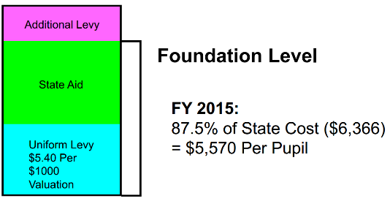
$6,591 State Cost Per Pupil
FY 2017:
87.5% of State Cost ($6,591) = $5,797

DCPP
Current reality: In FY 2017, the State Cost per Pupil (SCPP) is $6,591. 164 districts (48.8%) are limited to this amount as their District Cost per Pupil (DCPP). The other 172 districts (51.2%) have a DCPP ranging from $6,591 to $6,766, or $1 to $175 more. This extra amount is funded with property taxes. Under current law, this $175 difference continues into the future, accessible to some district but not others.
FY 2017 Count of Districts | Amount DCPP is Greater than SCPP
162 | $0
65 | $1 to $35
48 | $36 to $70
25 | $71 to $105
19 | $106 to $140
14 | $141 to $175
Total = 333
When the Legislature determines the increase in the SCPP, that dollar amount is added to the DCPP, so the gap continues at the same dollar amount. On a percentage basis, the $175 is much less today than it was in 1975. However, when school budgets are tight and every dollar matters, additional attention is focused on any inequity. This table shows the count of districts based on the range of authority in the formula to exceed the SCPP.
Inequity impacting students:
The amount of funding generated per pupil for regular education is not the same for all districts. Thus, a student, based solely on the historical practice of the district of residence, generates more funding or less funding. After nearly 40 years of the current formula, the question is, “Should ALL Iowa public school students generate the same amount of funding, on a per student basis, for their regular education costs?” Another critical question for policy makers, is should the state allow some districts to exceed the SCPP without granting the same permission to others?
The following graphic explains the revenue sources of the funding for the state and district cost per pupil:
Source of Funding for DCPP | Notes | Cumulative Amount
DCPP above SCPP property tax | $1 - $175 | $6,592 - $6,766
Additional Levy property tax (rate as necessary to generate last 12.5%) | $824 which is 12.5% of SCPP | $6,591
State foundation aid | 87.5% of SCPP | $5,767
Uniform Levy  $5.40 per $1,000 property tax | Varies based on property value per pupil

Solutions: Short of state appropriation of an estimated $84.5 million, the amount required for the state to assume the entire amount of DCPP already paid with property taxes in those districts that have authority (just over $11 million) plus the supplement for those districts that don’t have it, there are other possible solutions that would promote equity without lowering the per pupil amount available for any school district:
- Give all local districts spending authority for the difference and allow school boards to decide locally whether to fund it.
- Set the state cost per pupil at the highest amount but lower the foundation percentage threshold from 87.5% to an amount that balances the impact on the state and on property taxes. Since many districts have sufficient cash, it’s likely there will be little cash reserve levy impact for several years in many districts.
- Allow local district authority to use cash reserve to fund the difference under certain circumstances. SSB 1254 and HSB 240, both introduced in the 2015 Legislative Session, include a parameter that the cash reserve levy in the base year may not be exceeded in a future year if providing funds for this purpose. . HF 2182, introduced in the 2016 Session, was a short-term limited authority to use cash reserve, giving the legislature time to come up with a more permanent solution. SF 2104 creates both a transportation and formula equality phase in, beginning with $5 per pupil July 2017, $10 per pupil July 2018, $20 per pupil annually thereafter until the $175 gap is eliminated (by 2027).
- A combination of two of the above would also be possible – authority in the meantime, close the gap over the long haul.

- The entire difference could be paid with state funds ($85 million) or maintain the current property tax contribution of $11 million with a state contribution of $74 million.

RSAI supports raising the state cost per pupil to the maximum district cost per pupil in the formula.

